|  |
| --- |
|  |
| Smarter Resolutions evaluation |
|  |
| Advisory, Conciliation and Arbitration Service (Acas) |
|  |
| May 2024 |
|  |

Contents

Smarter Resolutions evaluation 1

Preface 5

Glossary of terms 7

Executive summary 12

Introduction 12

Background to the Smarter Resolutions programme 12

About the evaluation 13

Summary of overall programme impact 13

Impact of individual strands 15

Evaluation limitations and considerations 23

1. Introduction 25

About the Advisory, Conciliation and Arbitration Service (Acas) 25

Background to the Smarter Resolutions programme 26

About the evaluation 27

2. Findings on Workstream 1: Post-notification content 29

Key findings 30

Methodology overview 31

Research questions for this trial 33

Evaluation limitations and considerations 34

Overview of evaluation outcomes 35

Findings 38

3. Findings on Workstreams 1 and 2: pre-notification content and assisted notification form 52

Key findings 53

Methodology overview 54

Research questions for this trial 56

Evaluation limitations and considerations 57

Overview of evaluation outcomes 59

Findings 62

Perceived understanding of early conciliation process 70

Understanding time limits 71

Understanding the validity of a claim 73

4. Findings for Workstream 3 (optimised distribution) and overall impacts of Workstreams 1 to 3 80

Key findings 80

Methodology overview 83

Research questions for this evaluation strand 85

Evaluation limitations and considerations 86

Overview of evaluation outcomes 87

Findings 89

5. Findings for Workstream 4: Large Group Cases 109

Key findings 110

Methodology overview 111

Research questions for this evaluation 112

Overview of evaluation outcomes 113

Findings 114

6. Conclusions 125

What impact have individual workstreams and the programme overall had on efficiencies within the early conciliation process? 125

What impact have individual workstreams and the programme overall had on outcomes of the early conciliation process? 126

Claimant-side service user experience of the Smarter Resolutions programme 128

Considerations for future evaluation 128

Appendix 130

A.1.1 Methodology: Data sources 130

A.1.2: Methodology: Overview of evaluation approach 132

A.1.3 Data against key indicators 133

A.2.1 Workstream 1: Pre- and post-notification content 143

A.2.2 Randomised control trial A (RCT A): user journey 145

A.2.3 Randomised control trial A (RCT A): logic model 147

A.2.4 Randomised control trial A (RCT A): Indicators 151

A.2.5 Randomised control trial A (RCT A): Background on Case management system (CMS) analysis and Acas case level data 154

A.2.6 Randomised control trial A (RCT A): Non-significant findings 157

Perceived understanding of early conciliation process 166

A.2.7 RCT A: Findings on new content usefulness (non-significant) 169

A.3.1 Overview of new assisted notification content 170

A.3.2 RCT B Content and Notification Form Logic Model 171

A.3.3 RCT B user journey 176

A.3.4 RCT B: Indicators 178

A.3.5 RCT B: Background on case management system (CMS) analysis and Acas case level data 182

A.3.6 RCT B: Non-significant findings 187

A.3.7 RCT B findings on new content usefulness (non-significant) 195

A.4.1 Workstream 3: User journey map 197

A.4.3 Workstream 3 Indicators 201

A.4.4 Workstream 3: Background on Case management system (CMS) analysis and Acas case level data 204

A.4.5 Workstream 3: Non-significant findings 208

A.5.1 Workstream 4: Logic Model 211

A.5.2 Workstream 4: Indicators 214

A.5.3 Workstream 4: Background on Case management system (CMS) analysis and Acas case level data 217

A.5.4 Workstream 4: Non-significant findings 221

## Preface

This report presents findings from the evaluation of the Smarter Resolutions programme. This programme introduced changes to Acas's early conciliation (EC) service (between 2021 to 2023), in order to make it more efficient and prevent disputes going to employment tribunals. As well as exploring overarching, programme-level outcomes, the research consisted of 4 strands, each focused on a different element of the Smarter Resolutions programme. Programme-level outcomes are presented in the first instance, then followed by sections dedicated to each strand.

Two of the evaluation strands used a randomised control trial (RCT) design. Due to various practical constraints, an RCT was not feasible for the remaining 2 strands. Instead, these evaluations used a quasi-experimental, pre- and post-implementation approach.

Evaluation of all aspects of the programme involved analysis of Acas's case management system (CMS), Dynamics 365, comparing outcomes for cases that went through intervention or post-implementation processes to those who went through legacy or pre-implementation processes. For 3 of the strands, an end of early conciliation survey was also administered to claimant and claimant representatives (in both intervention and control groups) to explore further outcomes, views on the intervention outputs, and satisfaction with the early conciliation service.

Acas's early conciliation process has a statutory, standard 6-week period during which a conciliator will help both parties to resolve the issue. After this point, it is up to the discretion of Acas if they feel early conciliation is worth continuing. To ensure comparability, all analysis of outcomes from case management system data is at this 6-week point. This cut-off point was necessary due to the short evaluation timeline, however, it is important to note that settlement and resolution rates reported at this point are not therefore directly comparable to Acas's overall settlement and resolution rates, as quoted in Acas's annual report and statistical bulletin figures. Measure between arms of the trials are directly comparable, however.

Typically, quantitative results are reported only where they are 'statistically significant' at the 95% confidence level or above– that is, there is at least a 95% chance that the results reported are not due to chance or random variation, but rather to a real effect or relationship that would be present if the wider population was studied. Findings presented that are not statistically significant are clearly described as such. Where percentages do not sum to 100, this may be due to rounding of percentages or multiple answers.

Across all evaluations, case management system and survey data was supplemented with qualitative fieldwork with Acas staff and claimants or claimant representatives.

Throughout the report reference is made to 'claimant-side' and 'employer-side' service users. 'Claimant-side' service users are the total sample of claimants and their representatives, combined unless otherwise stated. 'Employer-side' service users are employers and their representatives, combined unless otherwise stated.

## Glossary of terms

**Advisory, Conciliation and Arbitration Service (Acas):** An independent public body in England, Scotland and Wales that receives funding from the government. Acas aims to improve organisations and working life through better employment relations, working with employers and employees to resolve workplace conflict, and improve performance.

**Assisted Notification Form:** A new version of the notification form (see ET1) which enables a user to request Acas's conciliation services, and if required, allows access to the employment tribunal (ET) service. Accurate and complete notifications via this form enable Acas to allocate cases correctly and speedily to the person who can provide the best service. The improved form incorporates simple explanations, new clearer questions, the opportunity to provide more detail about a dispute and signposting to relevant resources, along with the ability to save and return to the form, and progressive disclosure and channelling.

**Auto-allocation (of cases):** The allocation of cases to conciliators using automated digital processes.

**Department for Business, Energy and Industrial Strategy (BEIS):** A UK government department, now restructured into the Department for Science, Innovation and Technology, the Department for Energy Security and Net Zero and Department for Business and Trade. This department was responsible for promoting economic growth, increasing productivity, and ensuring that the UK had a reliable and affordable supply of energy.

**Case or claim:** These terms are used interchangeably depending on context but mean an ongoing employment dispute between a claimant and employer, that has been notified to Acas and is going through early conciliation.

**Case allocation team (CAT):** A team of Acas staff who are responsible for manually assigning claimant cases to conciliators.

**Case management system (CMS):** A software application or tool that enables Acas staff to create and manage case entries and associated data. Acas's case management system is Microsoft Dynamics 365.

**Conciliator:** A trained mediator who facilitates communication and negotiation between parties in an employment dispute, with the aim of reaching a mutually acceptable resolution during EC.

**COT3:** A formal document which sets out a legally binding settlement agreement reached between the claimant and the employer. The case is settled on acceptance of the terms for agreement and the COT3 document records the agreement for the parties future reference. This represents an end to the dispute and generally prevents the need for an Employment Tribunal Hearing.

**Early conciliation (EC):** A free, voluntary service offered by Acas which aims to resolve employment disputes between employees and employers within a 6-week period (conciliation can continue beyond this, if resolution feels possible). Claimants are required to notify Acas of their intention to lodge an employment tribunal claim and are then offered the opportunity to engage the services of an Acas conciliator, who will seek to resolve the dispute without going to an employment tribunal. The service is also offered as a legal duty when employment tribunal claims are made.

**Early conciliation certificate:** A document issued by an Acas conciliator when they have been unable to resolve an employment dispute between an employer and an employee. The certificate confirms that the parties have attempted conciliation and have been unable to reach a resolution. Once a conciliation certificate has been issued, the employee can use it to make a claim to an employment tribunal.

**Early conciliation support officers (ECSO):** Acas staff who finalise and triage cases before they are allocated to a conciliator.

**Employment tribunal (ET):** A legal forum in England, Scotland and Wales where employment disputes are heard and resolved. It is an independent body that is separate from Acas, but Acas may offer assistance to parties involved in employment tribunal proceedings in attempting to resolve the dispute. In April 2014, a new legal requirement was introduced that means individuals must notify Acas of their intention to make an employment tribunal claim.

**ET1:** An online form claimants or claimant representatives use to make a claim to an employment tribunal.

**Google Analytics:** A web analytics service offered by Google that tracks and reports website traffic and user behaviour.

**Group cases team (GCT):** A dedicated team within Acas for handling and conciliating large group cases (cases consisting of 10 or more individuals that belong to the same workplace dispute). This team was introduced into the Acas service in Autumn 2021.

**His Majesty's Treasury (HMT):** The UK government department responsible for economic policy and financial management.

**Individual conciliation (IC):** The handling of individual claims through both early conciliation and post-employment tribunal (ET1) conciliation. The word 'individual' is used to distinguish the service from collective or group case conciliation. Individual conciliators work with individual claimants.

**Invalid claim:** A notification that does not meet the requirements for early conciliation or is not related to an employment dispute covered by Acas. Examples of invalid claims include complaints not about employment matters, or those already resolved.

**Legacy (process, content, or form):** Acas content and processes prior to the Smarter Resolutions programme's interventions.

**Logic model:** A visual tool used in research evaluation that outlines the expected relationships between a program's inputs, activities, outputs, outcomes, and impacts.

**Ministry of Justice (MOJ):** The government department responsible for criminal justice, prison and probation services, civil courts, and tribunals, in the UK.

**Notification:** The process of notifying Acas that you have decided to make a claim to an employment tribunal. This is done through a notification form (or group notification for a group claim), also known as an early conciliation form, on the Acas website. After notification, Acas will offer the early conciliation service.

**Randomised Control Trial (RCT):** A trial in which the subjects are randomly distributed into groups which are either subjected to the intervention (in this instance, Acas service changes) or legacy (pre-intervention) service conditions. They are used to understand the effects of an intervention by comparing it with those who do not receive it. One evaluation made use of the cluster randomised trial approach – where groups are randomised as opposed to randomisation at an individual level. Groups in this instance were determined by which conciliator their case was assigned to.

**Respondent Allocation Report:** A report, produced through Power BI, which helps the Acas group cases team spot cases with 'same facts same respondent'. This was introduced to the group cases team in August 2022.

**Service users:** Anyone interacting with Acas's services or content. This includes:

* a claimant (person who has made a claim or complaint against their employer or former employer) or claimant representative (person who acts on behalf of a claimant in an employment dispute; this may be a trade union representative, a legal representative, or a friend or family member). In this report, these individuals are collectively referred to as claimant-side service users
* respondents (an employer that is the subject of a complaint or dispute) and employer representatives (person who acts on behalf of an employer in an employment dispute; this may be a human resources representative, a legal representative, or a senior manager). In this report, these groups are collectively referred to as employer-side service users

**Shared Outcomes Fund:** A UK government fund testing innovative ways of working across the public sector with an emphasis on thorough evaluation. This has funded the current evaluation.

**Smarter Resolutions:** In 2021, the Ministry of Justice (MOJ) and the Department for Business, Energy and Industrial Strategy (BEIS) were awarded funds over a 2-year period (2021 to 2023) from the HM Treasury (HMT) Shared Outcomes Fund, to work with Acas to test a series of changes in the employment dispute resolution system – collectively, these changes (or 'interventions') are referred to as the Smarter Resolutions programme.

**Statistically significant:** For the purpose of this report, findings that reached statistical significance at a 95% confidence level or above have been reported. This means that there is a 95% chance that the results reported are not due to chance or random variation, but rather to a real effect or relationship between variables being studied.

**Workstream 1 (WS1):** The 'content strategy' workstream within the Smarter Resolutions programme. This workstream focuses on developing several new forms of content, to provide potential claimants or their representatives with information that helps them better understand the dispute resolution process as it applies to them at various points in their journey.

**Workstream 2 (WS2):** The 'assisted notification' workstream within the Smarter Resolutions programme. This workstream aims to improve the notification form completion experience.

**Workstream 3 (WS3):** The 'optimised distribution' workstream within the Smarter Resolutions programme. This workstream aims to efficiently and automatically allocate incoming early conciliation cases to the conciliators best placed to handle a case.

**Workstream (WS4):** The 'large group cases' workstream within the Smarter Resolutions programme. This workstream aims to make improvements to the handling of large group claims.

## Executive summary

### Introduction

The Advisory, Conciliation and Arbitration Service (Acas) has a statutory duty to promote the resolution of employment dispute claims before they reach employment tribunal (ET). In April 2014, a new legal requirement was introduced that means individuals must notify Acas of their intention to make an employment tribunal claim. Acas then has a statutory, standard 6-week period in which it offers the opportunity for both parties involved in the dispute (that is, the individual claimant and the employer) to resolve the claim through a voluntary early conciliation (EC) process. If the offer of early conciliation is refused or fails to reach agreement, the individual can still pursue an employment tribunal claim. The early conciliation process has been designed so that Acas can provide an impartial conciliation service with the aim of parties reaching a settlement and avoiding the potentially time consuming and costly employment tribunal process.

### Background to the Smarter Resolutions programme

In 2021, the Ministry of Justice (MOJ) and the (then) Department for Business, Energy and Industrial Strategy (BEIS) were awarded funds over a 2-year period (2021 to 2023) from the HM Treasury (HMT) Shared Outcomes Fund, to work with Acas to test a series of changes (or 'interventions') to the early stages of the employment dispute resolution system. This is known as the Smarter Resolutions programme.

The Smarter Resolutions programme is composed of 4 operational workstreams, that focus on different parts of the early conciliation service. The 4 workstreams and workstream visions are:

* Workstream 1 (WS1), content strategy: content introduced through a claimant-side service users' journey, supports them to grasp the basic principles of employment law related to their dispute, and have clear expectations of how Acas can help
* Workstream 2 (WS2), assisted notification: claimant-side service users are guided to supply accurate information that conciliators need, to ensure Acas provide the best possible service at the earliest point to users
* Workstream 3 (WS3), optimised distribution: cases are quickly directed to the most appropriate and available conciliator to efficiently resolve their dispute
* Workstream 4 (WS4), large group claims: cases that belong to the same workplace dispute are quickly brought to the attention of a team with the expertise, tools and resources to resolve them efficiently

The overall programme vision was that people involved in a workplace dispute had a clearer understanding of how they can reach a quicker, more cost-effective resolution at the earliest point possible. It was expected that this will deliver cost savings across Government and Arm's Length Bodies such as Acas.

### About the evaluation

At the start of 2022, Acas commissioned an evaluation of the 4 workstreams that make up the Smarter Resolutions programme. This evaluation was funded by the HM Treasury (HMT) Shared Outcomes Fund. The evaluation was delivered in partnership between [IFF Research](http://www.iffresearch.com) and [Belmana](http://www.belmana.co.uk).

The central aim of this evaluation was to understand the attributable impact of each of the Smarter Resolutions workstreams and the overall programme on the efficiency, effectiveness, and user experience of the early conciliation service. The evaluation also sought to produce insights into how and why intended outcomes have or have not come about, and considerations for the service moving forward.

To ensure the evaluation was robust, Acas sought views from government and wider experts including MOJ, BEIS, the Evaluation Taskforce and the Evaluation Advice Panel.

The evaluation was delivered through 4 strands; the purpose, methodology, and key findings of each are explored in turn below.

In this report, we have used a 95% confidence level or above for reporting differences unless otherwise stated. Non-statistical results are available in the appendix of the report.

### Summary of overall programme impact

The overall intended aims of the Smarter Resolutions programme were:

* parties spend less time in the employment tribunal system
* fewer cases require judicial time
* conciliators are focused on resolution and not administration
* parties engage in discussion with conciliators which is focused on resolution

Time spent in the employment tribunal system, and the proportion of cases requiring judicial time could not be specifically measured within the evaluation; these impacts would only come to fruition a certain amount of time after notification had elapsed, beyond what was possible to measure within the timeframe for the evaluation. However, indicators towards these outcomes include the proportion of cases settled and the proportion of cases reaching a definite outcome within the early conciliation window, with the assumption that improvements against these would mean fewer cases requiring judicial time and reaching employment tribunal. As such, the primary research questions were:

* What is the difference in the average number of cases reaching a definite outcome within 6 weeks of notification between claimant-side service users in the intervention group compared to the control group?
* What is the difference in the average number of cases 'settled' within 6 weeks of notification between claimant-side service users in the intervention group compared to the control group?

A definite outcome indicates that a case cannot be taken any further by Acas. This case status encompasses a number of outcomes including settling, reaching an impasse, the claimant or respondent declining early conciliation and the claimant being uncontactable.

A case being settled is defined as reaching COT3, a formal document which sets out a legally binding settlement agreement reached between the claimant and the employer.

Within each evaluation strand, evidence was collected to assess the impact of the programme on overall aims, and the contribution of each workstream to these outcomes. For some strands, the primary outcomes aligned with the overall programme outcomes, however, each evaluation strand also had specific outcomes they sought to measure relevant to the specific interventions in that workstream. Some of these would inevitably contribute to the overall outcomes, for example efficiencies added to specific processes within the early conciliation window should help more cases to reach a definite outcome. Other strand-specific primary outcomes tended to relate to the service user experience.

Overall, the Smarter Resolutions programme brought benefits to the early conciliation process. In terms of effectiveness, the programme had a positive impact in terms of one of its key outcomes: increasing the proportion of cases reaching a definite outcome within the 6-week period. Across most workstreams, this was more likely following programme implementation. Workstream 2 also saw an increase in the proportion of cases settled within the 6-week period. While the programme aimed to decrease the proportion of cases reaching an employment tribunal, this could not be measured within the evaluation timeframe and will continue to be monitored.

In terms of efficiencies, the impact was largely positive. Speed of case allocation improved following most of the workstreams. While there were improvements in the proportion of cases reaching a definite outcome, the impact on the time taken to reach an outcome was mixed. Under Workstream 4, this improved, however it took longer for cases to reach a definite outcome after Workstream 1 and Workstream 2. These results indicate that while the overall intended programme outcomes were achieved, there may have been some trade-offs in terms of efficiencies.

The workstreams also improved efficiencies in their respective areas of focus. For example, the 'post-notification' content under Workstream 1 was described as improving efficiency in the early conversations between claimant-side service users and conciliators, and auto-allocation under Workstreams 3 and 4 resulted in cases being allocated to the conciliator faster. The impact of the 'pre-notification' content and assisted notification form was more mixed in this regard (Workstream 1 and 2); while data quality coming through was improved, more cases required triage (further support from early conciliation support officers). That said, those experiencing the intervention were more likely to reach a definite outcome and settlement, so these impacts did not have a detrimental influence on the ultimate intended outcome.

### Impact of individual strands

#### Workstream 1: Post-notification content

The evaluation of the post-notification content sought to test the impact of new content provided to claimant-side service users after they submit a notification to Acas that they wish to make a claim. This content, developed under Workstream 1, included 2 automated emails: an introductory email sent when a conciliator had been assigned, containing a video outlining the early conciliation process; and, an early conciliation certificate email (issued where relevant), with a video explaining the certificate's purpose and use. Three additional pieces of content were developed that were up to the discretion of conciliators to send to claimant-side service users (as and when they felt relevant): a webpage on time limits within the early conciliation process; an emotional support webpage; and a video on wage disputes. This content was aimed specifically at claimant-side service users (as opposed to employer-side claimant users) and only these service users were included in the primary research.

##### **Intended outcomes**

The aim of the post-notification content was to equip claimant-side service users with the right information at the right time and, as a result, improve their understanding of the early conciliation process and improve efficiency. This was expected to lead to an increase in the proportion of cases reaching a definite outcome and settling (reaching a COT3) in the 6-week early conciliation period.

As such, the primary research questions were:

* What is the difference in the average number of cases that reached any definite outcome and that settled within 6 weeks of notification between claimant-side service users in the intervention group compared to the control group?
* What is the difference in the efficiency of the early conciliation process?
* What is the difference in perceived knowledge about the whole journey and process reported by claimant-side service users?

##### **Methodology**

Intended outcomes were assessed through a cluster randomised control trial (RCT A), with conciliators split into 'intervention' or 'control' groups. Conciliators in the intervention group had access to and were encouraged to use the new content in their early conciliation process. Conciliators in the control group did not have access to the new content and made use of legacy processes and materials in their early conciliation process. Upon notification, claimant-side service users were then randomly allocated to a conciliator in either group, making this a cluster randomised control trial. Differences in outcomes and experiences for the 2 groups were then assessed through: analysis of Acas's case management system (CMS) data, and an end of early conciliation survey of claimant-side service users. Analysis of each focused on the early conciliation process and achieved outcomes within the 6-week period. Findings from this analysis were supplemented by in-depth interviews with 10 conciliators in the intervention group, and 20 in-depth interviews with claimant-side service users who had completed the survey.

##### **Key findings**

Analysis of the case management information showed that there was no difference between the intervention and control cases in terms of the proportion of cases settled or reaching a definite outcome within the 6-week early conciliation period.

In terms of efficiency, there was one negative finding: the intervention group took, on average, 1.5 days longer to reach an early conciliation outcome than those in the control group.

That said, there is positive evidence in relation to the final primary research question, the impact of the post-notification content on the perceived knowledge about the process:

* the intervention group was less likely to disagree that they received the right information at the right time (15% compared to 20% of the control group) and more likely to agree that the information provided by Acas was accurate (75% compared to 71% of the control group)
* claimants in the intervention group (findings excluding claimant representatives) were more likely to agree they had received the right information at the right time (70% compared to 64% of the control group claimants) and felt better informed through the early conciliation process (64% compared to 57% of the control group claimants)

In qualitative interviews, claimant-side service users and conciliators were broadly positive about the information, stating that it felt suitable and clear. Some conciliators agreed that it streamlined their initial communications with claimant-side service users, although flagged that this was reliant on the service user engaging with the content.

#### Workstreams 1 and 2: Pre-notification content and assisted notification form

The evaluation of workstreams 1 and 2 tested the impact of new content introduced into the claimant-side service user journey before notification and a new assisted notification form, which claimant-side service users use to notify Acas that they wish to make a claim. The new pre-notification content was built into the 'notify Acas' webpages, with an aim to provide information and context to help these claimant-side service users understand the next steps in the early conciliation process, the time limits for making a claim and what would be required after they agree to EC. The new assisted notification form included features such as progressive disclosure, channelling, and the inclusion of relevant information throughout. The aim of the new form was to minimise errors and incomplete form fields and ensure necessary information was collected.

##### **Intended outcomes**

The main aim of the new pre-notification content and assisted notification form were to improve data quality coming through on the notification forms and improve claimant-side understanding on whether they had a valid claim. This was expected to creating efficiencies in the early conciliation process, and, ultimately, more cases reaching a definite outcome or 'settled' in the 6-week early conciliation period.

As such, the primary research questions were:

* What is the difference in the average number of cases that reached any definite outcome and that settled 6 weeks of notification between claimant-side service users in the intervention group compared to the control group?
* What is the difference in accuracy and completeness of information in the notification form?
* What is the difference in the proportion of invalid notifications between claimant-side service users in the intervention group compared to the control group?
* What is the difference in the perceived knowledge of whether their claim is valid or invalid?

##### **Methodology**

Outcomes were assessed through a randomised control trial, with half of the claimant-side service users entering the 'notify Acas' website allocated to the intervention group (directed to pages containing the new content and assisted notification form) and the other half to a control group (directed to the legacy notification webpages and form). Differences in outcomes and experiences for the 2 groups were then assessed through: analysis of Acas's case management system data, and an 'end of early conciliation' survey to claimant-side service users. Analysis of each focused on the early conciliation process and achieved outcomes within the statutory 6-week period. Pop-up surveys were also administered to users exiting the notification process (both early or on completing the form). Findings from this analysis were supplemented by focus groups with 9 early conciliation support officers (ECSOs), Acas staff who finalise and triage cases before they are allocated to a conciliator, and in-depth interviews with 42 claimant-side service users.

##### **Key findings**

Overall, there is evidence of these changes improving service user experience, notification form data quality, and the proportion of cases reaching a definite outcome and settlement within the 6-week early conciliation period:

* cases in the intervention group were more likely to reach a definite outcome (15% compared to 14% of the control group) and, among users who reached a definite outcome, have this case settled (15% compared to 9% of the control group)
* intervention group cases were less likely to have incomplete fields in the notification form (0% compared to 1% of the control group)

However, there were some negative findings relating to other outcomes:

* intervention group notifications took 2.4 days longer to reach the conciliator, and were less likely to go directly to a conciliator (18% compared to 21% of cases in the control group)
* relatedly, cases in the intervention group were more likely to require triage (22% compared to 18% of cases in the control group)

There were no significant differences between the intervention and control group in terms of the proportion of invalid claims or claimant-side service users' perceived knowledge of whether a claim was valid (measured by confidence in the claim being accepted for early conciliation).

During qualitative interviews with intervention group, claimant representatives reported that the new form was faster to complete as only relevant information was gathered.

Some early conciliation support officers reported more relevant and complete information was gathered in the assisted notification form compared to the legacy form. This improvement helped early conciliation support officers to process cases more efficiently.

#### Workstream 3: Optimised distribution and overall impacts of Workstreams 1 to 3

Workstream 3 (WS3) focused on an optimised system for distributing cases to conciliators. A primary feature of this workstream was the development of an algorithm which automatically organises and distributes cases to the right conciliator or team according to this information. Previous to this, most case distribution was done manually by the case allocation team (CAT), a team of Acas staff who are responsible for manually assigning claimant cases to conciliators. Workstream 3 also sought to improve the capture of and system for logging conciliator availability, location and work profiles; for example, expertise, preference and reasonable adjustments. The timeline for the programme implementation meant that Workstream 3 could not be assessed in isolation. The Workstream 3 evaluation is therefore an evaluation of Workstreams 1, 2 and 3.

##### **Intended outcomes**

The main aim of Workstream 3 was for cases to be allocated to an appropriate conciliator, faster. Ultimately, this should create more time for conciliation and result in more cases reaching an outcome within the 6-week period.

As such, the primary research questions for this evaluation strand were:

* What is the difference in the average number of cases that reached a definite outcome and that settled within the 6-week early conciliation period, pre- and post-implementation?
* What is the difference in the time elapsed from notification to initial allocation to an individual conciliator pre- and post-implementation?

##### **Methodology**

A comparison of cases pre- and post-implementation of Workstream 3 was carried out to assess improvements in efficiencies and outcomes, using case management system data. Propensity score matching was used to match the post-implementation cases to a set of cases that were as comparable as possible in the pre-implementation period. It is important to note that the pre-implementation period fell prior to any Smarter Resolution interventions being implemented, so findings explore the overall impact of the programme on the handling of individual claims, not just the impact of Workstream 3 changes.

Case management system analysis was supplemented by end of early conciliation survey data. Comparisons between outcomes for the RCT A control group (that is that is before any Workstream 1 to 3 changes were implemented) and those in the Workstream 3 post-implementation period were made. Qualitative discussions with the case allocation team, individual conciliators and 12 claimant-side service users were also conducted.

##### **Key findings**

Analysis of the case management system data showed that a definite outcome had been reached in proportionately more cases in the post-implementation sample (66% compared to 55%) although cases were less likely to settle (reach a COT3 outcome) in the post-implementation group: <1% compared to 7% in the pre-implementation cases.

Post-implementation cases were more efficient regarding case allocation (a key outcome for Workstream 3), when compared to pre-implementation cases:

* the allocation count (average number of allocations before reaching the final conciliator) reduced by 0.31 post-implementation (2.4 allocations on average, post-implementation, compared to 2.7 pre-implementation); similarly, the proportion of cases that were reallocated reduced to 7%, from 20% pre-implementation.
* the time taken from notification to allocation also reduced nearly a day (0.91) from 6.1 days pre-implementation to 5.2 days post-implementation.

In qualitative interviews, conciliators acknowledge that cases were getting to them faster, but felt efficiency in this was sometimes perceived to be lost as they were spending more time doing administrative tasks such as gaining contact details, clarifying case details, or correcting spelling errors, that used to sit outside of their remit.

Positively, in qualitative interviews, claimant-side service users were impressed with the speed in which they received contact from a conciliator; one claimant representative noted that this was considerably quicker than previous cases due to the removal of the early conciliation support officer step.

#### Workstream 4: Large group cases

Workstream 4 (WS4) focuses on improving the handling of large groups cases, involving 10 or more individuals belonging to the same workplace dispute, and quickly bringing them to the attention of the dedicated group cases team with the expertise, tools, and resourcing to resolve a case efficiently. Changes to the process and system under Workstream 4 included: auto-allocation to the group cases team rather than a manual process; changes to the group notification form, to enable claimant representatives to add additional information and give permission for conciliators to speak to respondent(s) first; and a respondent allocation report which helps the group cases team spot cases with 'same facts same respondent'.

##### **Intended outcomes**

The aim of Workstream 4 changes was to increase efficiencies within the group cases team process (namely time taken between stages within early conciliation), and ultimately increase the proportion of cases reaching a definite outcome or settled within the 6-week period.

As such, the primary research questions were:

* What is the difference in the average number of cases that reached a definite outcome and that settled before and after Workstream 4 changes were implemented?
* What is the difference in the efficiency of the process for handling large group cases before and after Workstream 4 changes were implemented?

##### **Methodology**

To assess this, a comparison of large group cases pre- and post- Workstream 4 implementation was carried out using case management system data to assess improvements in efficiencies and outcomes. These findings were supplemented with discussions with the group cases team manager, a focus group with group cases team conciliators, and 20 interviews with claimant representatives (many of whom had experienced the service pre- and post-implementation).

##### **Key findings**

There was a positive finding relating to cases reaching a definite outcome:

* the proportion of cases reaching a definite outcome in the 6-week early conciliation period increased from 37% to 94% (although the proportion of cases being settled was no different)

There were also positive findings relating to the efficiency of processes within early conciliation:

* allocation of group cases to the group cases team was much faster in the post-implementation period, at 3.0 days. This is significantly faster than the 5.3 days pre-implementation (difference of 2.3 days).
* relatedly, there was a reduced time gap between allocation to contacting the employer-side respondent, from 6.5 days pre-implementation to 0.9 post-implementation (difference of 5.6 days, and to reaching a definite outcome, from 11.4 days to 7.0 days (difference of 4.5 days).

One negative finding was that the average allocation count (that is, how many times a case changes hands before it reached its final conciliator) increased from 2.2 to 2.3 post-implementation.

In qualitative discussions, the group cases team felt the new respondent allocation report was reducing some of the manual burden of identifying 'same respondent, same facts' cases.

Claimant representatives and the group cases team considered changes to the new group form to be positive, albeit not too impactful in terms of efficiencies.

The group cases team identified a few areas negatively impacting efficiencies, which could be addressed: lead cases being disconnected from linked cases in auto-allocation; and, auto-allocation of individual cases (through Workstream 3) disrupting identification of group cases.

### Evaluation limitations and considerations

The limitations of the evaluations are outlined below. These should be considered when reviewing the findings.

During the randomised control trials, only those in the intervention group should have been exposed to the new materials being tested. In both trials, however, those in the control groups reported that they had seen the new materials. If true, this could impact the robustness of the trials. We hypothesise that findings for the control group may be based on engagement with older materials, which would not impact the robustness of the trial.

There was an issue regarding randomisation which impacts the findings of RCT B specifically. A number of cases bypassed randomisation and were automatically allocated to the control group. These cases only entered the system via the legacy route and form. We conducted further analysis to understand the impact of this. There was evidence that these cases did differ from the average so have the potential to bias results. The findings of RCT B should therefore be treated with some caution.

The timeline for the programme implementation meant that not all workstreams could be assessed in isolation. The evaluation of Workstream 3 took place after the changes under Workstream 1 and Workstream 2 were introduced. The Workstream 3 evaluation is therefore an evaluation of all changes rather than those introduced under the individual workstream.

It is also important to note that the evaluation was necessarily a snap-shot of an evolving programme of agile and user-centred development. It was anticipated that the service changes would require further fine tuning to make them work effectively on the basis of learning from this evaluation. As part of the longer-term process of iteration, a number of the issues that were identified have since been resolved.

## 1. Introduction

### About the Advisory, Conciliation and Arbitration Service (Acas)

Acas provides free and impartial information and advice to employers and employees on all aspects of workplace relations and employment law.

Employment Tribunals make decisions about employment disputes. Nearly all legal cases about employment are heard in Employment Tribunals. This includes cases about unfair dismissal, redundancy and discrimination. There are also many other sorts of claim that can be brought, such as non-payment of wages. Acas has a longstanding statutory duty to promote the resolution of claims before the Employment Tribunal (ET) in order to avoid recourse to a full hearing, by means of its conciliation service. In April 2014, a new legal requirement was introduced that means individuals must notify Acas of their intention to make an Employment tribunal claim. Since this change in the law, Acas offers the opportunity for both parties involved in the dispute (that is, the individual and the employer) to resolve the issue through a voluntary early conciliation process. Early conciliation notifications can be made by an individual against their employer or on behalf of a group against their employer.

The early conciliation process has been designed so that Acas can provide an impartial conciliation service with the aim of parties reaching a settlement and avoiding the potentially time consuming and costly Employment tribunal process. Cases progressing through Early conciliation will be assigned an impartial conciliator who may:

* explain the conciliation process
* discuss the issues with both sides
* give an overview of the law
* discuss how employment tribunals have considered similar cases
* help both sides explore the strengths and weaknesses of the case
* discuss possible options without making any recommendations
* remain independent of the dispute – they will not take sides or tell either party what to do
* outline the employment tribunal process
* record a binding settlement of the legal dispute in the form of a COT3 agreement so that the case does not need to proceed to a hearing

Since 2014, Acas early conciliation has had a statutory 6-week period. It is possible for conciliation to continue beyond this, if resolution feels possible and the claimant would like to do so (this is up to the discretion of Acas).

If the offer of early conciliation is refused or fails to reach agreement, the individual can still pursue an Employment tribunal claim. In this case, the respondent (the individual or organisation subject of a complaint or dispute) usually has to reply to a claimants' claim in writing within 28.0 days of getting the claim form. Once they have replied, the tribunal will decide whether there will be a full hearing. These cases are normally held at the employment tribunal office closest to where the claimant lives. All tribunal hearings will be heard by a judge sitting alone or by a judge and 2 side members. The respondent (usually the employer) will have an opportunity to respond to the claim in writing and in person at the hearing.

### Background to the Smarter Resolutions programme

In 2021, the Ministry of Justice (MOJ) and the (then) Department for Business, Energy and Industrial Strategy (BEIS) were awarded funds over a 2-year period (2021 to 2023) from the HM Treasury (HMT) Shared Outcomes Fund, to work with Acas to test a series of changes to the early stages of the employment dispute resolution system. This is known as the Smarter Resolutions' programme.

The Shared Outcomes fund incentivises and funds innovative pilots, with departments working collaboratively to improve cross-governmental outcomes. It places a high value on robust, high quality impact evaluation and sharing results.

The Smarter Resolutions programme is composed of 4 operational workstreams that focus on different parts of the early conciliation service, which is Acas's service for resolving individual disputes. Each workstream explores how changes at the early stages of employment dispute resolution can help Acas to improve the service offered to customers in order to resolve disputes more quickly and effectively, therefore preventing the escalation of issues and reduce the flow of cases into the Employment Tribunal (ET) system. It is expected that this will deliver cost savings across Government and Arm's Length Bodies such as Acas. As Figure 1.1 shows, the 4 workstreams and workstream visions are:

* Workstream 1, Content strategy: Users grasp basic principles of employment law related to their dispute, the most appropriate way to resolve it, and have clear expectations of where Acas can help
* Workstream 2, Assisted notification: Users are guided to supply accurate information that Acas conciliators need, to ensure they provide the best possible service at the earliest point to users
* Workstream 3, optimised distribution: Cases are directed to the most appropriate and available conciliator to quickly and efficiently resolve their dispute
* Workstream 4, Large group claims: Users who belong to the same workplace dispute are quickly brought to the attention of a team with the expertise, tools and resources to resolve it efficiently

The overall programme vision is that people involved in a workplace dispute have a clearer understanding of how they can reach a quicker, more cost-effective resolution at the earliest point possible.

The overall outcomes the programme hopes to bring about are that parties spend less time in the employment tribunal system; fewer cases require judicial time; conciliators are focused on resolution and not administration; and parties engage in discussion with conciliators which is focused on resolution.

Figure 1.1: Smarter Resolutions Programme vision

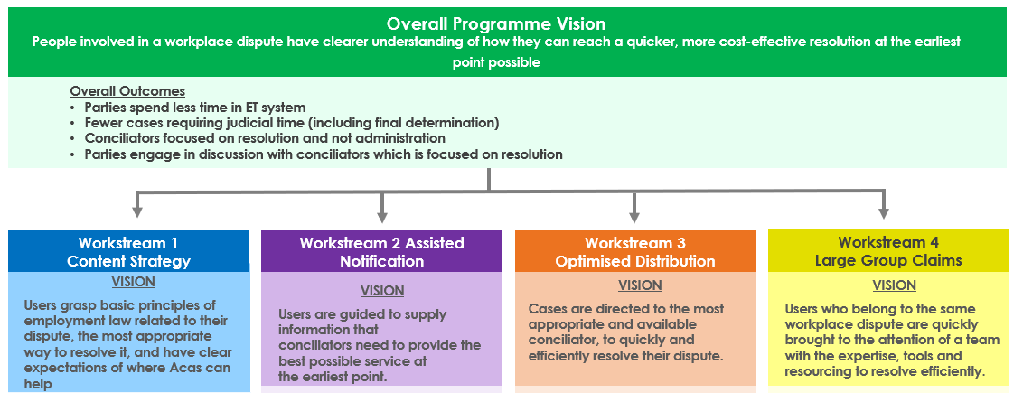

### About the evaluation

At the start of 2022, Acas commissioned an evaluation of the 4 workstreams that make up the Smarter Resolutions Programme. This evaluation was funded by the Ministry of Justice (MOJ) and the then Department for Business, Energy and Industrial Strategy (BEIS) from the HM Treasury (HMT) Shared Outcomes Fund. The evaluation was delivered in partnership between [IFF Research](http://www.iffresearch.com) and [Belmana](http://www.belmana.co.uk).

To ensure the evaluation was robust, Acas sought views from government and wider experts including MOJ, BEIS, the Evaluation Taskforce and the Evaluation Advice Panel.

The central aim of this evaluation was to understand the attributable effect of each of the Smarter Resolutions 4 workstreams on the efficiency, effectiveness and user experience of the early conciliation service. The evaluation also sought to produce insights into how and why intended outcomes have or have not come about, and considerations for the service moving forward. The [trial protocol plans](https://www.acas.org.uk/about-us/evaluations/smarter-resolutions-programme-randomised-control-trials) for the evaluation are published online.

Various data sources were used within the Smarter Resolutions programme evaluation. Definition and details of these data sources can be found in Appendix A.1.1. The methodology for each evaluation strand is presented in their respective chapters.

## 2. Findings on Workstream 1: Post-notification content

Workstream 1 of the Smarter Resolutions programme focuses on developing several new forms of content, to help potential claimant-side service users (claimants and representatives acting on behalf of claimants) understand the dispute resolution process as it applies to them at various points in their journey. Content is wide ranging and has been embedded across various points of the user journey, with the underlying principle that users need to see 'the right content delivered at the right time'. The content aims to ensure claimant-side service users have a holistic understanding of the conciliation journey, for them to make informed choices about their next steps and have realistic expectations about the dispute resolution process.

This section focuses on a trial of the 'post-notification' content. This content is provided to claimant-side service users after they have notified Acas that they would like to make a claim to an employment tribunal and have reached early conciliation (EC). Once a claim has been submitted, the case is allocated to a conciliator: an Acas staff member who acts as an intermediary between claimant-side and employer-side (or 'respondent') service users. Conciliators have access to the new content and can use it at their discretion during early conciliation when communicating with claimant-side service users. Some of these resources are also shared with these claimant-side service users in automated emails during the early conciliation process. The intention of sharing content post-notification is to improve efficiencies in communications between claimant-side service users and their conciliators.

The 5 new pieces of post-notification content are: an early conciliation process video, a time limits page, an emotional support page, a video about wages, and an early conciliation certificate (EC certificate) video. Further details on this content and information each covered are in Appendix A.2.1. Details of when and how a claimant-side service user could receive each piece of content is shown in a 'user journey map' in Appendix A.2.2.

A range of measures were tested using a cluster randomised control trial to understand the impact of this new content. A logic model, showing the key outcomes which were measured for Workstream 1 content can be found in Appendix A.2.3; however, the findings explored in this section will focus on statistically significant findings at the 95% confidence level or above. All findings that did not reach statistical significance at this level can be found in Appendix A.2.6.

As noted, this trial focuses solely on the 'post-notification' content. A second trial tested the other elements of Workstream 1 alongside changes from Workstream 2 of the Smarter Resolutions programme. These findings are presented in the 'Pre-notification content and assisted notification' section of this report.

### Key findings

Overall, there is evidence of the new post-notification content improving the early conciliation process. There were significant differences between the intervention group (those exposed to the new materials or process) and control group (those going through the legacy process) for key measures relating to the efficiency of the early conciliation process, the user experience and stress levels. These findings were at either an overall level, or when analysing claimants only (that is, removing claimant representatives who are likely to be knowledgeable about the process and have less need for these materials).

#### Efficiency of early conciliation

Analysis of Acas's case management system (CMS) showed a mixed impact on efficiency.

* One measure of efficiency was positive: allocating the case to a conciliator was 0.4 days quicker in the intervention group (9.1, compared to 9.5 days in the control group). That said, we would not expect speed of allocation to be impacted by the changes related to this trial given the interventions occurred after cases are allocated to a conciliator.
* Another measure of efficiency was negative: cases from the intervention group took longer to reach an early conciliation outcome than those in the control group (with a difference of 1.5 days within the 6-week early conciliation period).

#### Claimant-side service user experience

* Claimant-side service users in the intervention group were less likely to disagree that they received the right information at the right time (15% compared to 20% of the control group), and more likely to agree that the information provided by Acas was accurate (75% compared to 71% in the control group).
* When looking at claimants only, those in the intervention group were more positive about the timing of information received: claimants in the intervention group were more likely to agree they had received the right information at the right time (70% compared to 64% of control group claimants).
* Claimants in the intervention group felt better informed through the early conciliation process: 64% tended to agree that this was the case, compared to 57% of control group claimants.
* However, survey findings also showed that claimant representatives in the intervention group were more likely than those in the control group to disagree that the early conciliation outcome matched their claimants' expectations (30% compared to 19%).

#### Impact on stress levels

* Claimants in the intervention group were more likely to have reduced worry following initial contact with their conciliator: 41% had lower levels of worry after initial contact compared to before initial contact. This compares to 35% of control group claimants showing a reduction.

#### Views on the new post-notification content

* Broadly, the new content was well received by both conciliators and claimant-side service users. Some conciliators felt that their explanations of the process were streamlined and made more efficient with the introduction of the new content, allowing more time to focus on resolution. Others highlighted that this was reliant on claimant-side service users engaging with the content, which didn't always happen. Conciliators and claimant-side service users both felt that the information itself was suitable, but introducing text to accompany videos, and more generally thinking about accessibility and variability in mode preferences could improve engagement.

### Methodology overview

The post-notification content was evaluated using a cluster randomised control trial. In this trial, half of claimant-side service users entering early conciliation were randomly selected for the intervention group. Intervention group service users were assigned to conciliators briefed to make use of the new discretionary content. In addition, these claimant-side service users received the new automated introductory email containing the early conciliation process video and, if relevant, the early conciliation certificate and accompanying video. Claimant-side service users in the control group were assigned to conciliators who were asked not to share the new content and received the legacy (that is, original, pre-Smarter Resolutions) email templates. This trial is referred to as randomised control trial A (RCT A) throughout.

Evidence in this trial is based on data in Acas's Dynamics 365 case management system and an end of early conciliation survey (EC survey) administered to both the intervention and control group 6 weeks after notifying, aligning with the end of the 6-week early conciliation period. Table 2.1 presents the number of case management system cases analysed, and survey completes achieved in the quantitative strands of RCT A. Cases were included in the case management system analysis and survey sample if notification was submitted within the RCT A trial period, 25 July to 30August 2022. The end of early conciliation survey ran from 12 September to 26 October 2022. The focus for the case management system data were cases reaching an outcome within the 6-week statutory period.

Table 2.1 Cases or survey completes in quantitative strands of RCT A

|  |  |  |
| --- | --- | --- |
| **Methodology** | **Intervention** | **Control** |
| Case management system | 1,439 | 1,429 |
| End of early conciliation survey | 756 | 731 |

These findings are supplemented by qualitative fieldwork. Table 2.2 shows the breakdown of qualitative interviews for RCT A, and their fieldwork periods. All individual conciliators and claimant-side service users were from the intervention strand of the trial.

Table 2.2 Participants and interview volumes in qualitative strands RCT A

|  |  |  |  |
| --- | --- | --- | --- |
| **Participant** | **Method** | **Fieldwork period** | **Number of participants** |
| Individual conciliators | In-depth interviews | Sept 2022 | 10 |
| Claimant-side service users | In-depth interviews | Oct-Nov 2022 | 20 |

### Research questions for this trial

In this randomised control trial, the difference in outcomes between claimant-side service users randomised to the new process (intervention) and claimant-side service users randomised to legacy processes (controls) were compared. The primary research question addressed in this trial was:

1. What is the difference in the average number of cases reaching a definite outcome and settling within 6 weeks of notification between claimant-side service users in the intervention group compared to the control group?
2. What is the difference in the efficiency of the early conciliation process?
3. What is the difference in perceived knowledge about the whole journey and process reported by claimant-side service users?

The secondary research questions explore the differences between the control group and intervention group, asking:

1. What is the difference in claimant-side service users' understanding of the timetable after being assigned a conciliator?
2. What is the difference in claimant-side service users' perceived levels of stress during the early conciliation process after being assigned a conciliator?
3. What is the difference in the claimant-side service user experience of the overall process?
4. What is the difference in agreement that conciliation got off to a good start after being assigned a conciliator reported by claimant-side service users?

### Evaluation limitations and considerations

It is important to outline some of the issues that occurred due to the trial design. Firstly, for the purpose of this evaluation, only half of conciliators were instructed to signpost and share the new post-notification content with claimant-side service users (those in the intervention group). However, intervention conciliators had a choice on sending things out (so this was not done consistently across intervention conciliators). An 'intention to treat' approach was used in this analysis; all individuals allocated to the intervention group were included in the base for that group, regardless of whether their conciliator did share the materials or not.

Secondly, information pages were hosted on the Acas website, meaning some claimant-side service users (regardless of whether they were in the intervention or control group) may have come across them through carefully searching the Acas web pages for information. In-depth interviews showed how common it was for claimant-side service users to actively search for information before their early conciliation process; they sought clarity on what would lie ahead before engaging in the process.

This has impacted whether individuals in the intervention and control groups saw the new post-notification content. Table 2.3 shows proportions in both the intervention and control groups stating they had viewed each type of material, and that there is some contamination in the control group.

Table 2.3 Proportion of claimant-side service users stating that they had seen the new content

|  |  |  |
| --- | --- | --- |
| **Content** | **Intervention group** | **Control group** |
| Early conciliation process video | 37% | 28% |
| Time limits page | 62% | 59% |
| Emotional support page | 19% | 18% |
| Wages video | 7% | 8% |
| Early conciliation certificate video | 16% | 13% |

Base: Intervention (756), Control (731)

If those in the control group have seen the new content, it could result in underestimation of the impact of the trial. Reassuringly, case management system data indicated that very few emails containing the new content were shared by conciliators in the control group (17 compared to nearly 2,000 in intervention group). Furthermore, evidence from the survey showed that those in the control group are more likely to have come across materials through self-search. Given that this trial is testing conciliators sending out the new content (and doing so at the right time), the robustness of this trial is not impacted.

It is also highly possible that, despite visual prompts, some claimant-side service users could also be referring to legacy materials explaining the early conciliation process (which existed online and were searchable). We hypothesise that findings for the control group may be based on engagement with legacy materials. Again, this does not impact on the robustness of the trial: if the new content and process is more effective than the legacy content, we should be able to see a positive difference between the 2 groups.

### Overview of evaluation outcomes

Overall, findings against the evaluation outcomes tended to be in a positive direction (that is, those in the intervention group usually had a more positive outcome than those in the control group); however, the difference between the 2 groups did not often reach the level of statistical significance required to report on difference confidently. In this report, we have used a 95% confidence level or above for reporting differences. That is, we are only focusing on differences where there is at least a 95% chance that a true difference is present. Likelihood of reaching this level of sensitivity in difference is constrained by sample volumes.

To illustrate this broader positive trend in the absence of presenting non-significant findings, however, Table 2.4 below sets out all key indicators measured in RCT A and whether the intervention group statistically differs from the control group at either a 90% or 95% confidence level. Differences at a 90% level and in a positive direction (normatively) are indicated by 'Positive, 90%', those at the 95% level and in a positive direction are indicated by 'Positive, 95%'. Likewise, those in a negative direction (normatively) are marked by either a 'Negative, 90%' or 'Negative, 95%' to indicate 90% and 95% confidence levels, respectively. 'No sig. difference' indicates that there is no statistically significant difference (at either 90% or 95%) between the intervention and control groups, in either direction. If data was not available, 'not available' has been used.

Many of the expected outcomes for this strand relate to improvements in knowledge and understanding of the early conciliation process. Claimant representatives, particularly those who are representatives in a professional capacity, are likely to have a better baseline of understanding than direct claimants due to previous experience of the process. It could therefore be expected that the impact on knowledge and understanding will be greater for claimants. As such, as well as comparing all claimant-side service users in the intervention group to the control group, we report the difference when claimants in each group are compared (that is, when representatives are excluded). Evidence from case management system is reviewed on a case basis and therefore it is not applicable to analyse differences between claimant and claimant representatives.

The following tables give an overview of RCT A outcomes and findings. All outcomes were measured in survey data unless '(CMS)' specified.

Table 2.4.1: Cases reaching definite outcome and settlement (CMS)

|  |  |  |  |
| --- | --- | --- | --- |
| **Indicator** | **All** | **Claimant** | **Claimant Rep.** |
| Proportion of cases reaching definite outcome in EC window | No sig. difference | Not available | Not available |
| Proportion of cases settled in EC window | No sig. difference | Not available | Not available |

Table 2.4.2: Efficiency of early conciliation

|  |  |  |  |
| --- | --- | --- | --- |
| **Indicator** | **All** | **Claimant** | **Claimant Rep.** |
| Days taken to reach EC outcome (CMS) | Negative, 95% | Not available | Not available |
| Days taken to allocate case (CMS) | Positive, 95% | No sig. difference | No sig. difference |
| Agreement that the EC process is efficient | No sig. difference | No sig. difference | No sig. difference |

Table 2.4.3: Claimant-side service user experience of EC

|  |  |  |  |
| --- | --- | --- | --- |
| **Indicator** | **All** | **Claimant** | **Claimant Rep.** |
| EC process helped claimant-side service users feel better informed | Positive, 90% | Positive, 95% | No sig. difference |
| EC helped claimant-side service users understand case strengthens/weaknesses | No sig. difference | No sig. difference | No sig. difference |
| Claimant-side service users had access to the right information at the right time | Positive, 95% | Positive, 95% | No sig. difference |
| Information given by Acas during the case was accurate | Positive, 95% | Positive, 90% | No sig. difference |
| Claimant satisfaction with outcome of EC | No sig. difference | No sig. difference | Negative, 90% |
| Claimant satisfaction with overall EC service | No sig. difference | No sig. difference | No sig. difference |
| EC process felt fair | No sig. difference | No sig. difference | No sig. difference |
| EC service reflected expectations | No sig. difference | No sig. difference | No sig. difference |
| Agreement that award/outcome matched claimant expectations | No sig. difference | No sig. difference | Negative, 95% |
| Claimant-side service users understood the conciliator's role | No sig. difference | No sig. difference | No sig. difference |
| Initial contact with conciliator helped EC get off to a good start | No sig. difference | No sig. difference | No sig. difference |
| The conciliator listened and understood the dispute | No sig. difference | No sig. difference | No sig. difference |
| The conciliator had the right skills and knowledge to resolve the dispute | No sig. difference | Positive, 90% | No sig. difference |
| The conciliator gave useful information, that was relevant to the dispute | Positive, 90% | Positive, 90% | No sig. difference |
| EC process helped claimant-side service users decide whether to take the claim to employment tribunal | No sig. difference | Positive, 90% | No sig. difference |

Table 2.4.4: Service user EC understanding after initial contact with conciliator

|  |  |  |  |
| --- | --- | --- | --- |
| **Indicator** | **All** | **Claimant** | **Claimant Rep.** |
| Understanding of 6-week time limit | No sig. difference | No sig. difference | No sig. difference |
| Understanding of options when EC ended | No sig. difference | No sig. difference | No sig. difference |
| Understanding that EC can help resolve dispute without going to employment tribunal | No sig. difference | No sig. difference | No sig. difference |
| Whether service user had unanswered questions about EC | No sig. difference | No sig. difference | No sig. difference |

Table 2.4.5: Impact on service user stress levels

|  |  |  |  |
| --- | --- | --- | --- |
| **Indicator** | **All** | **Claimant** | **Claimant Rep.** |
| Client less worried after initial contact with conciliator | Positive, 90% | Positive, 95% | No sig. difference |

Key to Tables 2.4.1 to 2.4.5: 'Positive, 90%' shows a positive finding at 90% confidence level; 'Positive, 95%' shows a positive finding at 95%; 'Negative, 90%' shows a negative finding at 90%; 'Negative, 95%' shows a negative finding at 95%; 'No sig. difference' shows no significant difference between the intervention and control group. Base (Intervention/Control). End of early conciliation survey: All (756/731); Claimants (619/603); Claimant Representatives (137/128). Case management system data: All (1,439/1,429).

Mapping of all outcomes against their respective indicators and evaluation data sources can be found in Appendix A.2.4. The following subsection will focus on statistically significant findings at the 95% confidence level. A full breakdown of RCT A findings that did not meet statistical significance can be found in Appendix A.2.6.

### Findings

#### Cases reaching definite outcome and settlement

Analysis of case management system data allows RCT A's efficiency outcomes to be assessed, through exploration of indicators such as the proportion of cases reaching a definite outcome within the 6-week early conciliation period, and time gaps between notification and case outcome.

The introduction of the new post-notification content had no statistically significant impact on the number of cases reaching a definite outcome or those being settled in the early conciliation window (indicated by achieving a COT3 outcome; see Appendix A.2.6 for full data). This is somewhat unsurprising, however, as the intervention's focus is on the early stages of a case, ensuring parties are well-informed about the process and able to provide information needed to progress the case in its first steps.

#### Efficiency of early conciliation

It could be expected that case efficiency improves, however, with more streamlined conversations between a claimant-side service user and the conciliator. The efficiency of the early conciliation process was assessed using case management system data and perceptions of efficiency were gathered via the service user survey.

In the case management system data, the time between case start and various intermediate outcomes was explored. Table 2.5 shows the average (mean) days taken from initial case notification to 4 different stages, including the end of the case, where early conciliation is within the statutory 6-week period. In allocating the case to a conciliator, the 0.4 fewer days needed to allocate in the intervention group is statistically significant. The intervention cases took 9.1 days to be allocated, while the control took 9.5.

Table 2.5: Time from case start to intermediate outcomes by trial arm (days)

|  |  |  |  |  |
| --- | --- | --- | --- | --- |
| **Days taken to…** | **Difference between arms** | **Significance level of difference** | **Intervention (days taken)** | **Control (days taken)** |
| Allocate case | -0.4 | 95% | 9.1 | 9.5 |
| Early conciliation outcome | 1.5 | 99% | 29.9 | 28.4 |

Base: All intervention (1,439); All control (1,429). Source: case management system.

There appears to be a negative intermediate outcome, however, cases in the intervention group are taking longer to achieve an early conciliation outcome (any definite outcome in the conciliation process, including 'informal resolution', 'COT3', 'respondent declines early conciliation', 'cannot contact respondent' and so on.). An early conciliation outcome is achieved, on average, 1.5 days sooner in the control. This is statistically significant. Settlement (achieving the COT3 outcome) occurs at the same rate of around 10% of cases in the 2 arms; it also takes a similar length of time with the difference in the 2 arms also being similar.

There were no significant differences between the intervention and control group in terms of service user experience of efficiency (see Appendix A.2.6).

During qualitative interviews with intervention group claimant-side service users, most considered their conciliator and the overall process efficient. The main reasons behind this were good communication with their conciliator (with strong emphasis on their will and patience to answer claimant-side service users' questions) and conciliators' professionalism (following a clear step-by-step process).

'It's about achieving what you said you were going to achieve in the timeframe you set out, and that is what exactly happened'.

(Service user, Claimant)

'Anything he said he'd do, he did. There weren't promises made that weren't met.'

(Service user, Claimant)

From the conciliator perspective, some felt that the post-notification content improved efficiency, saving time by reducing the amount of time needed explaining things to customers.

'It gives us more time to conciliate more effectively.'

(Acas staff, Conciliator)

However, some conciliators flagged that claimant-side service users did not engage with the post-notification content, preferring to speak to the conciliator directly rather than read or watch the content first.

'They want to speak to you as a person… hardly any of them will read it or they just forget it'.

(Acas staff, Conciliator)

Regardless of whether the content had been viewed, some conciliators mentioned they still preferred to talk through the information to protect themselves from instances of claimant-side service users claiming information was not communicated to them.

#### Claimant-side service user experience of early conciliation

In the survey, claimant and claimant representatives were asked for their experiences of the early conciliation process. These included questions regarding the informativeness of the process, including timeliness and accuracy of the information provided, their experiences of the early conciliation process and outcome in general, and how their experiences compared to their expectations. As shown in Figure 2.1, significant positive findings were found against 3 key indicators:

* claimant-side service users in the intervention group were significantly less likely than the control group to disagree that they received the right information at the right time (15% compared to 20% of the control group). When looking at claimants only, those in the intervention group were more likely to agree they had received the right information at the right time (70% compared to 64% of controls) (Figure 2.1.1)
* claimant-side service users in the intervention group were more likely to agree that the information provided by Acas was accurate (75% compared to 71% of controls) (Figure 2.1.2)
* when asked if the early conciliation process helped claimant-side service users feel better informed, overall, there was no significant difference in agreement between the intervention and control groups. When looking at claimants only, however, claimants in the intervention group were significantly more likely to agree than control group claimants (64% compared to 57% respectively). They were also significantly less likely to disagree (21% compared to 26% in the control group) (Figure 2.1.3)

Figure 2.1.1: Findings on 'overall, I got the right information at the right time in the early conciliation process' (percentages)

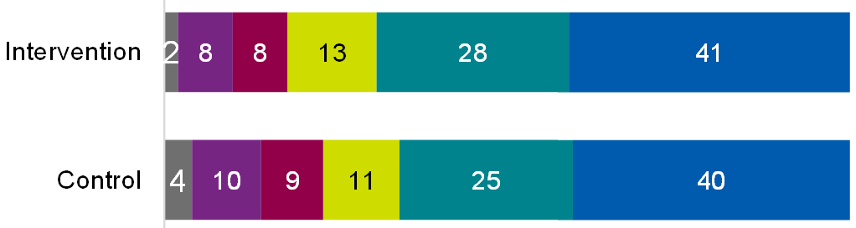



Base: All intervention (756); All control (731) or Intervention claimants (619); Control claimants (603)

Table of data for figure 2.1.1

|  |  |  |
| --- | --- | --- |
| **Response** | **Percentage of intervention group** | **Percentage of control group** |
| Don't know | 2% | 4% |
| Strongly disagree | 8% | 10% |
| Tend to disagree | 8% | 9% |
| Neither/nor | 13% | 11% |
| Tend to agree | 28% | 25% |
| Strongly agree | 41% | 40% |

Figure 2.1.2: Findings on 'to date, the information given by Acas during the case has been accurate' (percentages)

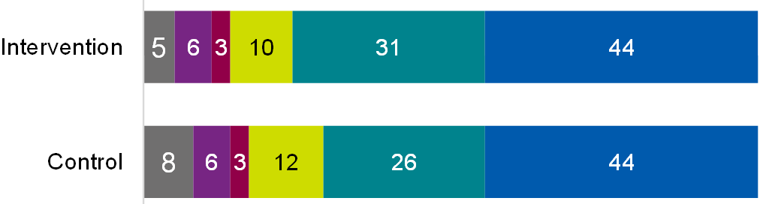



Base: All intervention (756); All control (731) or Intervention claimants (619); Control claimants (603)

Table of data for figure 2.1.2

|  |  |  |
| --- | --- | --- |
| **Response** | **Percentage of intervention group** | **Percentage of control group** |
| Don't know | 5% | 8% |
| Strongly disagree | 6% | 6% |
| Tend to disagree | 3% | 3% |
| Neither/nor | 10% | 12% |
| Tend to agree | 31% | 26% |
| Strongly agree | 44% | 44% |

Figure 2.1.3: Findings on 'overall, the early conciliation process helped me feel better informed' (percentages)

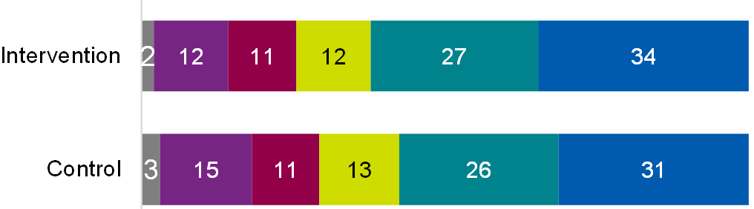



Base: All intervention (756); All control (731) or Intervention claimants (619); Control claimants (603)

Table of data for figure 2.1.3

|  |  |  |
| --- | --- | --- |
| **Response** | **Percentage of intervention group** | **Percentage of control group** |
| Don't know | 2% | 3% |
| Strongly disagree | 12% | 15% |
| Tend to disagree | 11% | 11% |
| Neither/nor | 12% | 13% |
| Tend to agree | 27% | 26% |
| Strongly agree | 34% | 31% |

One negative significant finding was found among claimant representatives. As shown in Figure 2.2, at an overall level, there was no significant difference in agreement or disagreement that the case settlement or outcome met expectations. However, claimant representatives in the intervention group were more likely than those in the control group to disagree that the case outcome met their claimant's expectations (30% compared to 19%).

Figure 2.2: Impact on claimant representatives stating early conciliation outcome met their/claimants' expectations

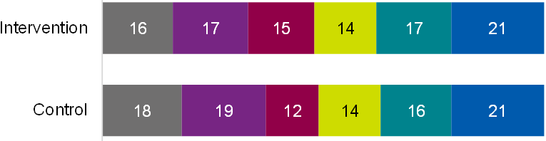



Base: All intervention (756); All control (731) or Intervention claimant representatives (137); Control claimant representatives (128)

Table of data for figure 2.2

|  |  |  |
| --- | --- | --- |
| **Response** | **Percentage of intervention group** | **Percentage of control group** |
| Don't know | 16% | 18% |
| Strongly disagree | 17% | 19% |
| Tend to disagree | 15% | 12% |
| Neither/nor | 14% | 14% |
| Tend to agree | 17% | 16% |
| Strongly agree | 21% | 21% |

In terms of overall satisfaction, there were no significant impacts when comparing intervention and control groups; around two-fifths were satisfied with the outcome of their case (42% and 41%, respectively), and three-quarters were satisfied with Acas's early conciliation service more broadly (67% and 66%; full findings shown in Figure 7.6 in Appendix A.2.6).

Generally, those who found resolution were far more likely than those either still conciliating or going to an employment tribunal to be satisfied with their outcome; 79% of claimant-side service users were satisfied with their outcome where the case was resolved, compared to 16% for those still conciliating and 26% going on to employment tribunal. A similar pattern was found when comparing outcome to overall satisfaction with the service, although the difference was not as stark; 89% who found resolution were satisfied, compared to 64% of those still conciliating, and 58% going to employment tribunal.

This was supported in qualitative interviews; when asking claimant-side service users about their overall satisfaction with the early conciliation process there was a divide between those who were pleased with the process and considered it met their expectations (even if it did not achieve the desired outcome) and those who were dissatisfied by the process and were disappointed with the results.

'[The service] was what it claimed it would be. It was caring and supportive and, you know, treated me in a nice and good and professional manner and presented me with clear information along the way about what was happening, kept me updated.'

(Service user, Claimant)

Reasons for dissatisfaction varied but was usually rooted in claimants hoping to reach a resolution and being unable to. In a small minority of cases, some felt Acas could have been more proactive in trying to achieve this (for example, by engaging employers better).

'The employer did not respond … I was sending emails – they didn't reply back and then [Acas] said no [resolution was possible] I was expecting a much better result, but I don't know how Acas works if the employer does not answer.'

(Service user, Claimant)

Although experiences of their conciliators were largely positive, evidence from the claimant-side service user interviews did show some variation in the level of contact they had with their conciliators, and therefore levels of satisfaction.

'The conciliator didn't tell us about the end steps, we just got the automated email with the early conciliation certificate, and because of the lack of dialogue with the conciliator I filed the ET1.'  
(Service user, Claimant)

#### Impact on stress levels

Claimants and claimant representatives were asked to what extent they or the individuals they represented felt worried about their dispute both before and after initial contact with their conciliator. Overall, claimant-side service users in the intervention group were no more likely than the control group to have reduced worry about their employment dispute following initial contact with their conciliator (that is, they did not have a lower level in the 5-point score after initial contact, compared to before). However, looking at claimants only, those in the intervention group were significantly more likely to have reduced worry about their employment dispute after initial contact (41% compared to 35% of claimants in the control group).

When asked about feeling stressed or worried after initial contact with the conciliator, some claimant-side service users in the intervention group mentioned that the initial contact increased their understanding and confidence of the early conciliation process by reassuring them they were accessing the right information. As explained by one claimant:

'I was confident that I could take it forward because I got the information, it was very good information that she gave me and where to go.'

(Service user, Claimant)

While some conciliators did not perceive any positive impact on service user stress levels, those that did explained that less stress among claimants usually meant fewer questions for conciliators and thus, less absorption of their time.

'It's a pain for us and a waste of time if we're constantly having the same conversations with people that are essentially not to do with actually settling the case, these are administrative conversations… it's not the substantive part of our job… so we're able to focus on doing the job and settling the cases.'

(Acas staff, Conciliator)

#### Views on post-notification content

##### Conciliator engagement and experience of new content

When asked about their first engagement with the new content, many conciliators claimed initial confusion on how and when to use it, but most were able to resolve their queries throughout the process. Additionally, there was variation in the usage of the new material. Some conciliators sent it to all their claimants or representatives after their initial conversation while others sent it only when they felt it would be useful to a specific user. For example, some conciliators would only send the link to the emotional support page if they felt the individual was emotionally distressed.

When asked about the purpose of the new content, most conciliators considered it as a tool to provide information to claimant-side service users and make the process more efficient, benefiting both claimant-side service users and conciliators.

'To be more customer based… to streamline some of the information we provide… making sure we're getting the right, same message to our customers… explaining the processes and the procedures... to make it easier.'

(Acas staff, Conciliator)

When asked about the experienced benefits of the new content, conciliators were most likely to mention efficiency. As mentioned earlier in the section, some conciliators felt the content reduced the time needed for explaining the early conciliation process to claimant-side service users. Conciliators felt they were then able to use that time to focus on the actual conciliation or resolution.

Another benefit mentioned during conciliator interviews was the standardisation of shared information. Some conciliators indicated that, in previous years, shared information could vary from conciliator to conciliator, whereas the new content allowed for the same information to be delivered in similar formats to all claimant-side service users.

'There's been a lot of variation previously; conciliators have had a really broad freedom in how they conciliate and how they manage the case, so I think there's an effort to bring a little bit more coherency and a bit more consistency to the information... that we're all putting out.'

(Acas staff, Conciliator)

A few conciliators were concerned about service user engagement with the new content. The most common concern was the limitations of this type of communication, considering some claimant-side service users do not take notice of this mode of information as they prefer verbal communication. Some conciliators showed concerns about possible barriers to claimants' usage of the new content, such as internet access, computer literacy, language, disability accessibility, among others. In this sense, a handful of conciliators expressed it would be useful to have a way to know if claimant-side service users had seen or used the materials.

##### Service user perceived usefulness of new content

This section explores service user views on each one of the 5 new online pieces of content introduced by Smarter Resolutions:

Early conciliation process video ('What Happens during Acas early conciliation?')

Wages video

Early conciliation certificate video

Time Limits page

Emotional Support page

As outlined in the 'Evaluation limitations and considerations' section, it is important to outline some of the issues that occurred due to the trial design. Both intervention and control group claimant-side service users reported that they have seen the new post-notification content, but:

* we can be more confident that the intervention group have seen the new post-notification content, as opposed to legacy online content which covers similar themes due to case management system analysis; and,
* the timing that this content is viewed can have a bearing on usefulness; the conciliators in the intervention trial arm should make this information available at the most useful time points.

As such, you could still expect some difference in how useful claimant-side service users perceive the materials they engaged with to be. However, claimant-side service users across both groups were broadly positive, and no significant differences between the intervention and control groups were seen at an overall level. The volume of claimant-side service users stating they had viewed these materials were too low to explore claimant and representative views respectively. Findings at an overall level are presented in Appendix A.2.6.

The remainder of this section presents insights into the views on each piece of content among the intervention group, based on responses in the end of early conciliation survey and follow-up in-depth interviews.

###### Early conciliation process video

Three-fifths (61%) of claimant-side service users in the intervention group found the video about 'What Happens During Acas early conciliation?' useful, while 5% did not find it useful.

Of those who found it useful, nearly half (46%) stated the content was informative, 11% stated the information was clear or easy to understand.

During qualitative interviews, most claimant-side service users mentioned this video was informative, the right-length, reassuring and helped clarify the process.

'I found it yet very useful because it told you everything you needed to know, and I thought it was in simplistic terms as well. It wasn't too corporate it told you exactly how it was'.

(Service user, Claimant)

'It was just the right length… I liked this one. It was straight-forward and easy to understand.'

(Service user, Claimant)

However, a few claimant-side service users did not find it useful as they felt it repeated already known information or because it felt impersonal or too basic.

'I was feeling pretty bad about the whole situation and this was just one of these, oh, I'm being shown another PowerPoint – great. It doesn't really have any bearing on the way I was feeling.'

(Service user, Claimant)

Regarding the ways in which this video could be improved, some claimant-side service users mentioned that having more interactive content (for example, animation or flow diagrams) or a supporting information page that outlines the same information in text form would make it easier to understand, especially for those whose first language is not English.

###### Time Limits page

Advice on time limits was perceived as the most useful content (71% useful compared to 4% not useful). During qualitative interviews, most of these claimant-side service users attributed this to the usefulness of having timescales clearly set out, to get a better understanding of the overall process, as well as some clarity on time limits.

'Definitely useful because at least you know how much time you have to do anything about your situation.'

(Service user, Claimant)

'I think what it gave me was the opportunity to now read and look at things, when you talk to somebody on the telephone that's helpful and as kind as they are conversations leave you with an awful lot of information you can't quite remember. […] So, when you go on to a website and you've got information you can read through, and actually I can see that, and I come back to that.'

(Service user, Claimant)

While discussing the ways in which the Time Limits page could be improved, claimants mentioned the need to address confusing wording. An example was given about how the online content states time limits for making a claim are '3 months minus one day'.

###### Wages video

Regarding the wages video, 67% of claimant-side service users of the intervention group found it useful, compared to 10% who found it not useful. When asked about the main reasons for this, 38% mentioned the content was informative, 6% said the information was clear or easy to understand; while 6% claimed the information was not useful or considered it irrelevant.

During qualitative interviews, most claimant-side service users had positive views on the wages video especially about its length and information.

'I think this was the better one than the rest because it was a simple understanding of what is happening, and it was not that long … very straightforward … gave me a good understanding of wages.'

(Service user, Claimant)

###### Early conciliation certificate video

Two-thirds (66%) of claimant-side service users in the intervention group found the early conciliation certificate video useful; 6% did not find it useful.

Overall, claimant-side service users provided positive views on the early conciliation certificate video during qualitative interviews.

'Very glad I saw it really because if I had not seen that, when I got [the early conciliation certificate] through, I would have thought what's this. At least I knew once I had got the certificate, I could proceed … it gave me confidence just to get on with it. There was somebody here telling me but I knew it already'

(Service user, Claimant)

'I really liked this one on the video. It's short and to the point and at the same time, all the information I needed was in there.'

(Service user, Claimant)

When asked about any improvements for the content, a couple of claimant-side service users mentioned the timing for sending the video. Nevertheless, there were contradictions on when the 'right timing' was. While one claimant mentioned the video should be sent earlier in the process to get a bigger picture, one claimant representative stated it should be sent when concluding the early conciliation process as it would allow for better absorption of the information and avoid wasting time in going back to look at the content again.

###### Emotional Support page

Finally, although still perceived as useful by the majority, claimant-side service users in the intervention group found the advice on 'Getting Emotional Support' the least useful piece of new content (59% useful compared to 12% not useful).

Some claimant-side service users mentioned they found it helpful or reassuring that Acas had considered this kind of support for them, even if they did not personally need it.

'That made me feel better about the whole process.'

(Service user, Claimant)

One claimant representative that had not seen the content before highlighted the importance of its existence both for claimants and for representatives.

'It's interesting to know that this does exist because part of our role is to support the members — the members are often in a bad place and we end up being that emotional crutch for them…'

(Service user, Claimant representative)

In terms of how the content could be improved, one claimant expressed it would have been good to be signposted to this content the moment the claim was made, and another claimant expressed a video version for this information would be preferred.

##### General reflections on post-notification content

Generally, claimant-side service users in the intervention group perceived the 5 new pieces of content as useful particularly because they were informative, easy to understand and reassuring. Moreover, some claimant-side service users stated they were not only useful for them, but also for conciliators.

'Because the more knowledge I've got makes it easier on the conciliator that they don't have to keep explaining everything over and over and over. '

(Service user, Claimant)

When asked about their views on how to improve the post-notification content generally, some claimant-side service users would have preferred more communication with their conciliators, as opposed to clicking on links, videos, and reading. One service user wanted to emphasise that the information should be shared in conversation:

'It didn't feel like a dialogue at all … spend more time on the phone with people and much less of the links and YouTube clips because it is easy and cheap. Time is not cheap, but time is what you need with people who are in difficult situations.'

(Service user, Claimant)

Furthermore, there were questions around accessibility, for example how a service user could get the information if they had an accessibility issue or didn't have access to the internet. One service user suggested having text next to the videos. Some also mentioned the content could be made more interactive.

## 3. Findings on Workstreams 1 and 2: pre-notification content and assisted notification form

This section explores the impact and user experience of 'pre-notification' content (Workstream 1) and the assisted notification form (Workstream 2). The findings relate to the implementation of both Workstream 1 and Workstream 2.

Workstream 1 focused on developing several new forms of online content, to help potential claimant-side service users (claimants and representatives acting on behalf of claimants) understand the dispute resolution process as it applies to them at various points in their user journey. The content included an emotional support page, a time limits page, and a video about wages.

During RCT A (outlined in the previous chapter) conciliators in the intervention group had access to this content and, if relevant, could send it to claimant-side service users after they made a claim (post-notification). As part of RCT B (outlined in this section), this content was embedded across the Acas website and therefore available for claimant-side service users to access before making a claim (pre-notification). While some of the materials are the same, the 2 trials tested them at different points in the user journey.

For Workstream 2, a new assisted notification form was developed for claimant-side service users to notify Acas that they intend to submit an employment tribunal claim. The aim of the new form was to minimise errors and incomplete form fields (fields left blank, or with insufficient or invalid data in them) and ensure necessary information was collected from claimant-side service users to determine whether a valid claim is captured. The new form includes the following features:

* progressive disclosure, where the user is taken step-by-step through each page with a new question and associated help text, instead of seeing long single pages asking for multiple inputs of information
* channelling, so only the questions or sections that are relevant are shown, based on previous responses
* the ability to save and return
* new embedded, informative content and signposting throughout

More information on the new assisted notification form features and content can be found in Appendix A.3.1. An overview of how the new content and form sits within a user journey is shown in Appendix A.3.3.

A range of measures were tested using a randomised control trial to understand the impact of this new content and notification form. A logic model, showing the key outcomes which were measured for these Workstream 1 and 2 features can be found in Appendix A.3.3. However, the findings explored in this section will focus on statistically significant findings at the 95% confidence level. All findings that did not reach statistical significance at this level can be found in Appendix A.3.6.

### Key findings

Findings on the impact of the new pre-notification content and assisted notification form were mixed.

#### Cases reaching definite outcome and settlement

The changes had a positive impact on case outcome:

* the intervention group were more likely to succeed in reaching a definite outcome within the 6-week early conciliation period (15%) compared to the control group (14%)
* of those who reached a definite outcome, those in the intervention group were more likely to settle (that is, reach a COT3 outcome; 15%) compared to the control group (9%)

#### Efficiency of early conciliation

* There was a negative impact on overall efficiency, where the intervention group took longer to reach a conciliator: 18% were sent straight to a conciliator (compared 21% in the control group), and, on average, the intervention group took 10.7 days to have their case allocated to a conciliator compared to 8.3 days for the control group.
* The intervention group also took longer to reach a definite early conciliation outcome; on average 32.0 days, compared to 26.0 days for the control group. However, this is not necessarily a negative or poor reflection, as the intervention group were still more likely to reach a definite outcome within the 6-week window.

#### Quality of notification data

There was one positive impact on the quality of data coming through the new notification form, compared to the old: most claimant-side service users had complete forms. The intervention group were less likely to have incomplete form fields (0%) than the control group (1%). However, negatively, case management system data analysis showed the intervention cases were more likely to require early conciliation support officers (ECSOs) to triage (22%) compared to the control group (18%).

#### Claimant-side service user experience of early conciliation

Positively, when looking at claimant representatives only, those in the intervention group were less likely to have questions about early conciliation both prior to starting the form and after submitting, compared to the control group claimant representatives (86% and 83% compared to 93% and 91%, respectively).

#### Views on the new pre-notification content and data quality

During qualitative interviews with the intervention group, claimant representatives reported that the new form was faster to complete as only relevant information was gathered.

Some early conciliation support officers reported more relevant and complete information was gathered in the assisted notification form compared to the legacy form. This improvement helped early conciliation support officers to process cases more efficiently.

Some claimant-side service users were dissatisfied with the new content, as they felt there was too much information to digest on the website that caused them to feel overwhelmed.

### Methodology overview

The pre-notification content (part of Workstream 1) and assisted notification form (Workstream 2) were evaluated together using a randomised control trial (RCT). In this trial, half of the claimant-side service users entering the website were allocated to the intervention group and half were allocated to the control group using a randomisation algorithm. This trial is referred to as randomised control trial B (RCT B) throughout.

In RCT B, claimant-side service users in the intervention group were signposted to the new pre-notification materials including the emotional support page and time limits page prior to starting their notification form and were directed to the new assisted notification form. Claimant-side service users in the control group were shown legacy pre-notification advice pages and were directed to the legacy form. All claimant-side service users received an automated email to confirm they had notified.

Evidence in this trial is based on data in Acas's Dynamics 365 case management system (CMS), a pop-up survey administered to users leaving the pre-notification pages and to users completing the form, and an end of early conciliation survey administered to both intervention and control groups.

Table 3.1 presents the number of cases included in case management system analysis and the number of people who completed each of the RCT B surveys. Cases were included in the case management system analysis and end of early conciliation survey sample if the notification was submitted within the RCT B trial period, 24 October to 25 December 2022. The end of early conciliation survey was administered to all claimant-side service users 6 weeks after notifying Acas, and ran from 13 December to 24 February 2022.

Individuals who exited the notification form in the trial period were presented with the pop-up surveys on leaving the page.

Table 3.1 Cases or survey completes in quantitative strands of RCT B

|  |  |  |
| --- | --- | --- |
| **Methodology** | **Intervention** | **Control** |
| Case management system | 8,668 | 12,821 |
| Pre-notification exit survey | 341 | 261 |
| Form submission exit survey | 1,419 | 1,372 |
| End of early conciliation survey | 1,011 | 1,266 |

As Table 3.1 shows, the split between the intervention and control group cases is not 50:50, as you would expect in a randomised sample of this size. This is due to a body of specific cases notifying in an unusual way during the trial period; a single claimant representative appears to have used an automation to make a large number (1,779) individual notifications against the same respondent. This automation avoided the randomisation, and, resultingly, these cases only entered the system via the legacy route and form. To understand the impact of this, we conducted further analysis which is available in Appendix A.3.5.

These findings are supplemented by qualitative fieldwork: 9 early conciliation support officers (Acas staff who finalise and triage cases before they are allocated to a conciliator) across 2 focus groups, and in-depth interviews with 42 claimant-side service users. Table 3.2 shows the breakdown of qualitative interviews for RCT B, and their fieldwork periods. All claimant-side service users were from the intervention strand of the trial.

Table 3.2 Participants and interview volumes in qualitative strands of RCT B

|  |  |  |  |
| --- | --- | --- | --- |
| **Participants** | **Method** | **Fieldwork period** | **Number of participants** |
| Early conciliation support officers | 2 focus groups | Dec 2022 | 9 in total |
| Claimant-side service users | In-depth interviews | Jan to Feb 2023 | 42 |

### Research questions for this trial

The RCT B primary research questions were:

1. What is the difference in the average number of cases reaching a definite outcome and 'settled' within 6 weeks of notification between claimant-side service users in the intervention group compared to the control group?
2. What is the difference in accuracy and completeness of information in the notification form?
3. What is the difference in the proportion of invalid notifications between claimant-side service users in the intervention group compared to the control group?
4. What is the difference in the perceived knowledge of whether their claim is valid or invalid?

The secondary research questions were:

1. What is the difference in satisfaction with the pre-notification content and notification form process?
2. What is the difference in the perceived knowledge of the early conciliation timetable?
3. What is the difference in the belief that internal appeal processes have been exhausted?
4. What is the difference in the levels of stress about the early conciliation process?
5. What is the difference in the belief that the right information about the early conciliation process were accessed at the right time?
6. What is the difference in digital take-up of the notification form?
7. What is the difference in time spent by early conciliation support officers to triage cases before being allocated to a conciliator?

### Evaluation limitations and considerations

This section outlines the challenges that occurred during the trial and factors to consider when reviewing the findings.

Firstly, there was an issue regarding randomisation which impacts the findings of RCT B. A number of cases, which had similar characteristics and outcomes, bypassed randomisation and were automatically allocated to the control group. This was due to a single claimant representative using an automation to make a large number of individual notifications (1,779) against the same respondent. This automation avoided the randomisation, and, resultingly, these cases only entered the system via the legacy route and form.

To understand the impact of this, further analysis was conducted which is available in Appendix A.3.5. This analysis shows that the cases that bypassed randomisation did differ from the average so have the potential to bias results. When the affected cases were excluded, the impact was modest on the outcomes related to efficiency and timings: the speed of allocation, time taken to reach a definite outcome and proportion of cases going straight to a conciliator still deteriorate and the findings remain statistically significant. However, the findings related to the other indicators are mixed and become statistically insignificant when the affected cases are removed. As a note, excluding and including these cases impacts the validity of the trial and so results should be treated with some caution.

Secondly, there appeared to be contamination between the intervention and control groups seeing the new content. For the evaluation of the pre-notification content and assisted notification form, half of the claimant-side service users were assigned to the legacy journey and half were assigned to the trial journey using a randomisation algorithm. In the intervention group, the claimant-side service users should have seen the Time limits page, Emotional support page and video about wages during their trial journey. The control group were not specifically shown the content, however, the end of early conciliation survey findings show that some of the control group saw the content or believed they had seen the new content. Similar to randomised control trial A (RCT A), claimant-side service users (regardless of whether they were in the intervention or control group) said that they came across the information pages prior to submitting their notification, when searching the Acas web pages for information.

Table 3.3 shows proportions in both the intervention and control groups stating they had viewed each type of material, and that there is some contamination in the control group.

Table 3.3 Proportion of claimant-side service users stating that they had seen the new content

|  |  |  |
| --- | --- | --- |
| **Content** | **Intervention** | **Control** |
| Time limits page | 67% | 64% |
| Emotional support page | 33%* (* denotes a figure that is significantly higher) | 27% |

Base: Intervention (1,011) Control (1,266). **.**

If those in the control group have seen the new content, it could result in a dilution of the impact of RCT B.

We hypothesise that findings for the control group may be based on engagement with legacy materials. If this is the case, this does not impact on the robustness of the trial as the proportion of the control group who actually were exposed to the new content would be far less than the proportions reported in Table 3.3. If the new content and process is more effective than the legacy content, we should be able to see a positive difference between the 2 groups.

Finally, there was difficulty testing the experience of claimant-side service users who arrive on the Acas website but decide not to make a notification (known as leavers). This was due to the low engagement in the pop-up survey targeting this group. Additionally, when recruiting and screening those marked as leavers for qualitative interviews, there were few who met the quota as most had gone on to submit a notification form later and were therefore 'completers', who were familiar with the early conciliation process and had no barriers to submitting.

### Overview of evaluation outcomes

Overall, the difference between the intervention and control groups in this trial did not often reach the level of statistical significance required to report on difference confidently. In this report, we have used a 95% confidence level for reporting differences. That is, we are only focusing on differences where there is at least a 95% chance that a true difference is present. Likelihood of reaching this level of sensitivity in difference is constrained by sample volumes. Mapping of all outcomes against their respective indicators and evaluation data sources can be found in Appendix A.3.4. A full breakdown of findings that did not meet statistical significance can be found in Appendix A.3.6.

To illustrate this broader positive trend in the absence of presenting non-significant findings, however, Table 3.4 below sets out all key indicators measured in RCT B and whether the intervention group statistically differs from the control group at either a 90% and 95% confidence level. Differences at a 90% level and in a positive direction (normatively) are indicated by 'Positive, 90%', those at the 95% level and in a positive direction are indicated by 'Positive, 95%'. Likewise, those in a negative direction (normatively) are marked by either a 'Negative, 90%' or 'Negative, 95%' to indicate 90% and 95% confidence levels, respectively. 'No sig. difference' indicates that there is no statistically significant difference (at either 90% or 95%) between the intervention and control groups, in either direction. If data was not available, 'Not available' has been used.

Many of the expected outcomes for this strand relate to improvements in knowledge and understanding of the early conciliation process. Claimant representatives, particularly those who are representatives in a professional capacity, are likely to have a better baseline of understanding than direct claimants due to previous experience of the process. It could therefore be expected that the impact on knowledge and understanding will be greater for claimants. As such, as well as comparing all claimant-side service users in the intervention group to the control group, we report the difference when claimants in each group are compared (that is, when representatives are excluded). Evidence from the case management system is reviewed on a case basis and therefore it is not applicable to analyse differences between by claimant and claimant representatives.

The following tables give an overview of RCT B outcomes and findings. All outcomes were measured in survey data unless '(CMS)' specified.

Table 3.4.1: Cases reaching definite outcome and settlement (CMS)

|  |  |  |  |
| --- | --- | --- | --- |
| **Indicator** | **All** | **Claimant** | **Claimant Rep.** |
| Average number of cases reaching a definite outcome | Positive, 95% | Not available | Not available |
| Average number of cases settled in EC window | Positive, 95% | Not available | Not available |

Table 3.4.2: Efficiency of early conciliation (CMS)

|  |  |  |  |
| --- | --- | --- | --- |
| **Indicator** | **All** | **Claimant** | **Claimant Rep.** |
| Notifications going straight to conciliator | Negative, 95% | Not available | Not available |
| Average time taken between notification and allocation | Negative, 95% | Not available | Not available |
| Average time taken to reach early conciliation outcome | Negative, 95% | Not available | Not available |

Table 3.4.3: Quality of notification data

|  |  |  |  |
| --- | --- | --- | --- |
| **Indicator** | **All** | **Claimant** | **Claimant Rep.** |
| Submissions requiring ECSO to triage case (CMS) | Negative, 95% | Not available | Not available |
| Incomplete form fields (CMS) | Positive, 95% | Not available | Not available |
| Understand if claim is valid or invalid | No sig. difference | Not available | Not available |

Table 3.4.4: Understand early conciliation time limits

|  |  |  |  |
| --- | --- | --- | --- |
| **Indicator** | **All** | **Claimant** | **Claimant Rep.** |
| Confident they understand EC time limits | No sig. difference | No sig. difference | No sig. difference |

Table 3.4.5: Claimants exiting early conciliation process before starting

|  |  |  |  |
| --- | --- | --- | --- |
| **Indicator** | **All** | **Claimant** | **Claimant Rep.** |
| Claimants exiting EC process before starting notification form | Not available | Not available | Not available |
| Confident claim will progress to EC | No sig. difference | No sig. difference | No sig. difference |

Table 3.4.6: Appeal processes

|  |  |  |  |
| --- | --- | --- | --- |
| **Indicator** | **All** | **Claimant** | **Claimant Rep.** |
| Exhausted internal appeal processes | No sig. difference | No sig. difference | No sig. difference |

Table 3.4.7: Claimant-side service user experience of early conciliation

|  |  |  |  |
| --- | --- | --- | --- |
| **Indicator** | **All** | **Claimant** | **Claimant Rep.** |
| Understood what the EC service involved | No sig. difference | No sig. difference | No sig. difference |
| Access to the right information at the right time | No sig. difference | No sig. difference | Positive, 90% |
| Remaining questions about the EC process | No sig. difference | No sig. difference | Negative, 95% |
| The notification form was easy to complete | Not available | Not available | Not available |
| Returned to complete the notification form later (CMS) | Not available | Not available | Not available |
| Digital users of notification form compared with paper (CMS) | Not available | Not available | Not available |

Table 3.4.8: Impact on service user stress levels

|  |  |  |  |
| --- | --- | --- | --- |
| **Indicator** | **All** | **Claimant** | **Claimant Rep.** |
| Claimant less worried after initial contact with conciliator | No sig. difference | No sig. difference | No sig. difference |

Key to Tables 3.4.1 to 3.4.8: 'Positive, 90%' shows a positive finding at 90% confidence level; 'Positive, 95%' shows a positive finding at 95%; 'Negative, 90%' shows a negative finding at 90%; 'Negative, 95%' shows a negative finding at 95%; 'No sig. difference' shows no significant difference between the intervention and control group. Base: End of early conciliation survey (Intervention/Control): All (1,011/1,266); Claimants (815/1056); Claimant Representatives (196/210). Base: Leavers: All intervention (459); All control (377). Base Completers: All intervention (1479); All control (1450). Base case management system (CMS) data: All intervention (8,668); All control (12,821).

The following subsection will focus on statistically significant findings at the 95% confidence level. Outcomes that did not reach statistical significance will be explored qualitatively, for further insight. Quantitative data for findings in RCT B that did not reach statistical significance at a 95% confidence level can be found in Appendix A.3.6.

### Findings

#### Case settlement and reaching definite outcome

Cases in the intervention group were more likely to reach an outcome at early conciliation stage than those in the control group. Case management system data analysis showed the intervention group were more likely to succeed in reaching a definite outcome within the 6-week period (15%) compared to the control group (14%), with a significant difference of 2% (after rounding).

Of those who reached a definite outcome, those in the intervention group were more likely to settle as indicated by a COT3 outcome (15%) compared to the control group (9%). In terms of the overall cases, this translates into a 2% COT3 rate in the intervention group, almost double the rate in the control at 1%.

There was also another positive finding, with a smaller proportion of cases in the intervention group with claimant declining early conciliation than in the control group (57% compared to 71%).

Figure 3.1: Outcomes after 6-week Early conciliation period (percentages)

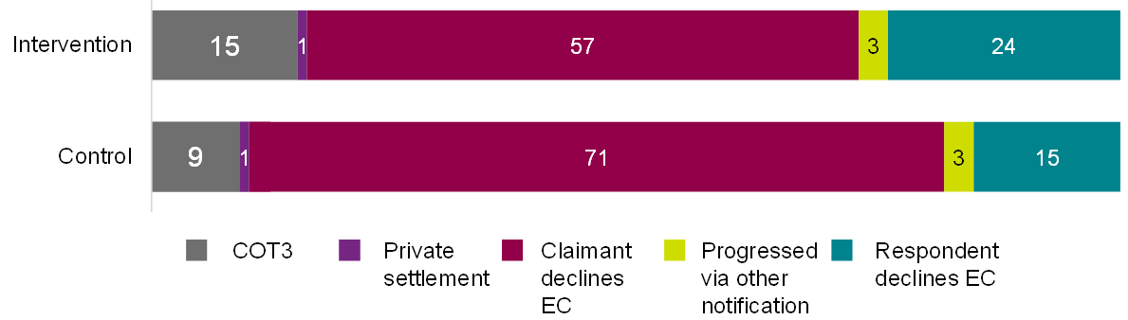

Base: Cases with an outcome after 6-week period; Intervention (2,785) and control (5,590).

Table of data for figure 3.1

|  |  |  |
| --- | --- | --- |
| **Outcome** | **Intervention group (percentage)** | **Control group (percentage)** |
| COT3 | 15% | 9% |
| Private settlement | 1% | 1% |
| Claimant declines EC | 57% | 71% |
| Progressed via other notification | 3% | 3% |
| Respondent declines EC | 24% | 15% |

#### Efficiency of early conciliation

In terms of the efficiency of early conciliation following the introduction of the pre-notification content and assisted notification form, analysis of case management system data produced some mixed negative findings.

Analysis of case management system data showed the intervention group took longer to reach a definite early conciliation outcome, on average 32.0 days, compared to 26.0 days for the control group. This may relate to the positive finding of intervention cases being more likely to settle, however. COT3 resolutions will take longer than closed cases, but all are still within the 6-week window given for early conciliation. The gap observed between the 2 may also be overstated somewhat, due to the cases that automatically bypassed randomisation. All of these cases went into the control group, and all were closed as the claimant-side service user declined early conciliation. This would increase the proportion of cases in the control group quickly reaching this outcome. The effect persists when these cases are removed but is smaller. More information on this issue and its impact can be found in Appendix A.3.5, on the effects of the bypassing of randomisation.

This analysis also found that the intervention group were significantly less likely to have their notification sent straight to a conciliator (18%), compared to the control group (21%). This was calculated based on the allocation history of cases. A more efficient service would see cases allocated in fewer steps, and a higher proportion allocated to the final conciliator in one step. There are a number of reasons cases can take longer to allocate to a conciliator, for example, there may be missing information in the form meaning the case allocation team (CAT) has to gather more information, or the case may be allocated to the wrong conciliator or to one that is unable to progress the case due to capacity or other constraints. This means the case goes through early conciliation support officers.

As shown in Table 3.5, the intervention group took on average 10.7 days to have their case allocated to a conciliator, compared to an average of 8.3 days in the control group.

Table 3.5 Time from case start to intermediate outcomes by trial arm (days taken)

|  |  |  |  |  |
| --- | --- | --- | --- | --- |
| **Days taken to…** | **Difference between arms** | **Significance level of difference** | **Intervention** | **Control** |
| Allocate case to a conciliator | 2.4 | 99% | 10.7 | 8.3 |
| Early conciliation outcome | 5.8 | 99% | 31.5 | 25.7 |

Base: All intervention (8,668); All control (12,821). Source: case management system.

During qualitative interviews with claimant-side service users in the intervention group, those who went straight to a conciliator without speaking with an early conciliation support officer appreciated the pace. However, they reported wanting to discuss the early conciliation process and get reassurances more quickly after submitting their notification form. The time taken between submission and first conciliator contact, without hearing from anyone else in between, often contributed to the anxiety of the claimants.

'I was wondering how long it would take to process it and for someone to get in touch. I was anxiously checking emails in the days following.'

(Service User, Claimant)

In focus groups, early conciliation support officers reported time savings because fewer notification forms had errors and therefore did not require them to liaise with claimant-side service users. However, staff also reported that some of the early conciliation support officer workload was displaced to Acas helpline staff and conciliators, as some claimant-side service users did not understand the process. This perception is described in more detail below in the section on quality of notification data.

During qualitative interviews with intervention group, claimant representatives often described positive experiences of the assisted notification form. Claimant representatives reported that the new form was faster to complete as only relevant information was gathered.

#### Quality of notification data

There was a mixed picture in how far the new assisted notification form improved the quality of the notification data gathered.

On the one hand, case management system data analysis showed the intervention group were significantly less likely to have incomplete form fields (0%) compared to the control group (1%). However, the intervention group was also more likely to require early conciliation support officer triage support compared to those in the control group (22%, compared to 18% in the control group). This finding may relate to the aforementioned cases that surpassed randomisation; the latter finding is no longer significant when these cases are accounted for, as outlined in Appendix A.3.5.

During focus groups with early conciliation support officers, some reported more relevant and complete information was gathered in the assisted notification form, compared to unnecessary information that was being gathered in the legacy form. This improvement in the relevance of the data helped early conciliation support officers to process cases more efficiently.

'I think it's positive that we're only gathering exactly what we need now and not like, you know, a big wide variety of information that we don't.'

(Acas staff, Early conciliation support officers)

While the assisted notification form is collecting more complete case information, early conciliation support officers noted some gaps in information remain.

'Some of them come through alright with all the information you need and some don't, but that was the same as it was before, so you would have to chase up half of them and not the other half. So, I don't think much has changed on that front for me.'  
(Acas staff, Early conciliation support officer)

Claimant contact information was a key area where information gaps remained for intervention group cases, because claimant email addresses and phone numbers were not required fields. As a result, early conciliation support officers sometimes found it difficult to contact the claimant if required.

Early conciliation support officers identified 2 other areas that they felt impacted data quality and accuracy:

* some respondents were over-filling fields to convey as much information as possible. For example, the additional information box was being used to 'dump information', creating inefficiencies in processing the information. Early conciliation support officers wanted a stricter character limit, yet claimant-side service users felt the current limit of 500 characters was already too low
* in multiple choice notification form questions, such as case type, early conciliation support officers reported some claimant-side service users were ticking options that were not relevant to their case. Early conciliation support officers hypothesised that this was an attempt to fast-track the case. An option that was often ticked despite being irrelevant to a case was equal pay discrimination

Early conciliation support officers flagged one inefficiency of the process: cases with the same claimant not linking. This resulted in one individual with multiple cases having multiple conciliators.

#### Claimant-side service user experience of notification

Satisfaction with the early conciliation service (regardless of outcome) did not differ significantly between claimant-side service users in the intervention and control groups (see Appendix A.3.6). Most found the notification form easy to complete across the control and intervention groups. Those who were dissatisfied felt there was too much information to digest on the website that caused them to feel overwhelmed.

The Smarter Resolutions programme aimed for the notification form to be easy to complete, ensuring users had access to the right information at the right time. During qualitative interviews with claimant-side service users in the intervention group, they described that they were satisfied because they found the early conciliation service straightforward and quick. Claimants reported this was because it was easy to access the information online, and some felt the information was clear, making the process of completing the form easy.

'Perfect in terms of accessibility, knowledgeable support, easy to use online information, clear and concise information.''

(Service user, Claimant)

Other claimants were satisfied by the supportive service provided by an Acas advisor. Those claimants who spoke to staff appreciated the reassurance they received and the clear guidance given on next steps.

'I spoke to a human being, and I was reassured and that reassurance contained the basic bones of what I had to do.'

(Service user, Claimant)

Claimant representatives were also positive about the early conciliation service. In the qualitative interviews, claimant representatives who had represented before found the assisted notification form was now easier to fill in as it was user friendly with tick box options, making form completion faster.

'It is much quicker (to complete). Because the options are easier. It is easier to tick box options and I think there are fewer questions to get through.'

(Service user, Claimant)

There were no significant differences between the intervention and control group in terms of service user satisfaction with when they received information in the early conciliation process (see Appendix A.3.6).

Whilst the form was generally seen as easy to complete and the majority of users felt the information was available at the right time, the key reason for claimants' dissatisfaction was the large volume of information on the Acas website. Some claimants found it overwhelming to navigate and digest this information, especially when they felt distressed by their case. Streamlining information by including hyperlinks to short pages of key information rather than long webpages could help reduce information overload and easily direct users to information that's most relevant to them.

'There were too many pages and too much information, it felt exhausting.'

(Service user, Claimant)

Claimant-side service users were asked how easy they found the notification form to complete, a key outcome and indicator. There were no significant differences between the intervention and control group in this regard (See Appendix A.3.6).

During qualitative interviews, claimant-side service users in the intervention group described what they found more or less easy about using the assisted notification form. Several features of the form supported claimant-side service users in completing the form easily, and in many cases, enabled claimants to complete the form in one sitting rather than returning to it later after a break. For example, the checkbox format of questions and room to provide additional information and attach supporting documents.

'It was quite quick. I was able to get straight into what I needed to. 45 minutes filling out the form and I was done. I thought it would take me days.'

(Service user, Claimant)

Although some were surprised with how long the form took them to complete, the straightforward nature of the form matched expectations. Expectations were exceeded largely where there were interactions with an Acas advisor. Claimants contacted Acas themselves because they felt anxious about the procedures, found it hard to process information on the website, and wanted human contact. Claimants valued speaking with the Acas helpline staff and early conciliation support officers, describing staff as knowledgeable on the processes and helpful to signpost to the correct information, enabling efficient complete of the notification form.

'I think they were significantly more helpful than I expected them to be, particularly thinking about the woman who was assigned to me. I think that she spent a bit more than one telephone conversation with me to make sure she explained everything to me as clearly as possible.''

(Service user, Claimant)

Some claimants whose second language was English and those who felt anxious about the early conciliation process sought out support to complete their form. They either called the Acas helpline to clarify the steps they needed to take to submit their form or asked a native English speaker to translate terms, which helped them to complete the form.

Some claimant-side service users who found the process confusing called the Acas helpline when deciding whether to submit a notification or when completing the notification form. Occasionally early conciliation support officers helped claimant-side service users who were struggling to complete the form by talking through it on the phone or sending a physical copy in the post.

Regardless of if claimants' first language was English or if they were anxious about their claim, there are features of the form that contribute to claimant confusion and anxiety. Some were uncertain of the level of detail and format required when answering open-ended questions. This resulted in users facing hurdles when completing the form, delaying form completion and submission.

'What should I put and in what format and what detail do I provide. Should I put in names of the persons or not?'

(Service user, Claimant)

Claimant-side service users also reported a lack of clarity around the meaning of technical language.

''There needs to be more definitions on the form. A lay person may struggle with some of the language used.''

(Service user, Claimant)

Some claimants were unsure of the employer's address to provide when prompted if the employer has multiple addresses. Some claimants reported they would have liked to receive their verification code to start the form faster. Other claimants felt anxious about what they had submitted and wanted a copy of their submission.

'I would love to have a copy of the form, then you know what you have said when Acas call you, you know what is on there.'

(Service user, Claimant)

#### Impact on stress levels

Another aim of the programme was to reduce stress levels through simple explanations and signposting to resources, including emotional support advice. There were no significant differences between the intervention and control group in terms of whether worry was reduced, stayed the same, or increased after submitting a notification claim (see Appendix A.3.6).

In qualitative interviews, claimant-side service users tended to describe the experience of submitting a notification to Acas as stressful. As mentioned above, the format of the information could feel overwhelming for some services users, particularly if they were already worried.

Most claimant-side service users interviewed recognised that this stress was not caused by Acas website content, notification procedures, or staff interactions. Instead, it was caused by a range of external factors such as fear of losing their job or the emotional toll of being in a dispute with an employer.

'It was massive stress, but I know I had to do it and couldn't wait to do it and the immediacy [of contact] afterwards was brilliant … the Acas process is not stressful, it is the whole thing and the position you find yourself in'  
(Service user, Claimant)

Some claimant-side service users felt that the Acas online content helped to relieve the stressor worry that they were experiencing. Some users put this down to the fact the content contained clear next steps and responsibilities, for example the Time limits page. A user noted that the fact the website content was immediately available went some way to alleviate stress, unlike, for example, if they were waiting in a telephone queue. They praised the fact they could return to the page in their own time.

Perceived understanding of early conciliation process

Overall, there were no significant differences between the intervention and control group in terms of whether claimant-side service users had questions about the early conciliation process before starting the form and after submitting the form (see Appendix A.3.6). However, when looking at claimant representatives only, those in the intervention group were less likely to have questions about early conciliation both prior to starting the form and after submitting, compared to the control group claimant representatives (86% and 83% compared to 93% and 91%, respectively).

In qualitative interviews, claimant-side service users in both groups generally felt that they understood what was involved in the early conciliation service at the time of submitting their claim notification form. On the whole, claimant-side service users described how the early conciliation pre-notification and notification service met their expectations. Claimant representatives were often familiar with the service, and for claimant-side service users who were unfamiliar with Acas and early conciliation, there was a positive response to the service and occasionally it exceeded expectations.

'I think they were significantly more helpful than I expected them to be.'

(Service user, Claimant)

'I genuinely felt like they were people trying to help in whatever capacity… So I was happy.'

(Service user, Claimant)

Some claimants felt the pre-notification and notification service did not meet their expectations. Reasons for dissatisfaction included: feeling the volume of information on the website was off putting; feeling overwhelmed by steps in the process; expecting the conciliator to play a more supportive role rather than neutral; wanting legal advice; feeling frustrated they had missed the time limit cut off; feeling the heavy emotional impact of making a claim; having a delay in being assigned a conciliator; feeling disappointed their case had gone straight to tribunal without contact from Acas staff.

During the qualitative interviews, claimant-side service users questioned the length of time it would take for a conciliator to contact them. Most were happy to receive the automated email after submitting the form as it provided reassurance that their claim was received. However, they found it didn't include information on when they would be contacted for early conciliation.

''Some sort of indication of the timescale. I'll give you a comparison example, [region name] employment tribunal have an automated response that says at the moment it's taking us X amount of days for correspondence, and that changes quite frequently. It might be useful to have something similar from Acas.''

(Claimant representative)

Whilst the automated email was received and seen by claimants, engagement with the early conciliation process video in the email was low. Claimant-side service users often viewed the automated email as confirmation of submission and did not read the embedded information.

''I didn't read it in detail, or watch the video, because I saw it was a confirmation of receipt and that was all I needed.''

(Service user, Claimant)

Some claimant-side service users suggested that, to increase engagement and understanding of information on the early conciliation process, this information could be proactively presented earlier on in the journey and be sent to users in a separate email to the submission confirmation.

''It might be better to have the video explaining everything before notification. A link that was obvious. It would have given you the chance to see if there was anything you didn't understand.''

(Service user, Claimant)

### Understanding time limits

Most claimant-side service users surveyed reported seeing the advice on time limits on the Acas website. Claimant-side service users in the intervention group were significantly less likely to state they had not seen the advice on time limits (20%) compared to the control group (24%).

Figure 3.2: Service users on viewing advice about time limits

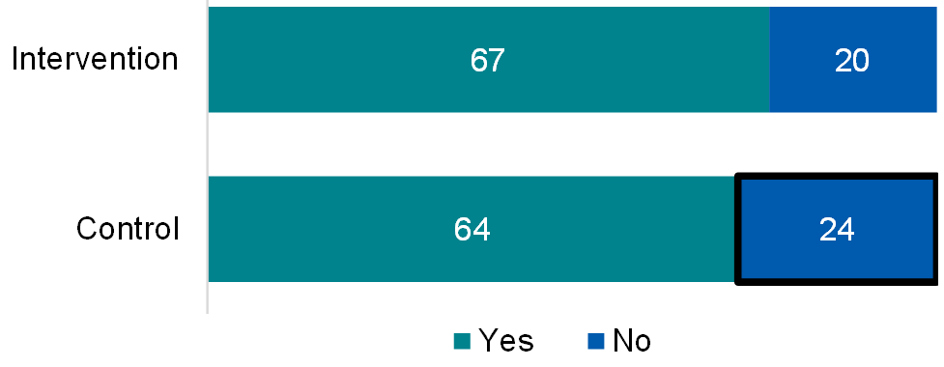

Base: All intervention (1,011); All control (1,266)

Table of data for figure 3.2

|  |  |  |
| --- | --- | --- |
| **Response** | **Intervention group (percentage)** | **Control group (percentage)** |
| Yes | 67% | 64% |
| No | 20% | 24% |

Dispute status influenced whether time limit advice was viewed. Claimant-side service users surveyed whose case was resolved through early conciliation were significantly more likely to have seen the time limits advice (70%) compared to cases still going through early conciliation (57%) and cases going on to employment tribunal (61%).

Claimant-side service users were asked if they understood the time limits at the time of submitting their notification. There were no significant differences between the intervention and control group in terms of understanding the 6-week time limits for early conciliation (see Appendix A.3.6).

In the qualitative interviews, time limits were generally reported to be well understood. Claimants stated that the time limits were clearly presented on the webpage and liked how they could refer to it when they needed to. Some users spoke to an Acas advisor because they wanted to speak to a person about time limit on their specific case and needed added reassurance. This provided added confidence to submit their case.

'I think that was very clear to me. In my initial conversation [with Acas] and in the conversation I had in January, the time scale was flagged up because obviously it's not really a deadline you can afford to miss.'

(Service user, Claimant)

Occasionally, claimant-side service users were not clear on the time limit for their case. There were misunderstandings around when the time limit should start; whether the time limit started when the grievance began or when an employer stated they would no longer deal with the grievance.

''I was a bit confused. Dating the problem is extremely difficult'.

(Service user, Claimant)

Understanding the validity of a claim

Most claimant-side service users understood if they had a valid claim and at the time of submitting felt confident the claim would progress to early conciliation. There were no significant differences between the intervention and control group in terms ofconfidence in the claim being accepted for early conciliation (see Appendix A.3.6). The sections below present qualitative findings from the intervention group that point to further considerations needed to improve understanding.

#### Challenges to understanding validity

First-time claimants and claimant representatives sometimes found it difficult to understand if their claim was valid; they appreciated the information provided and felt it helped them to assess whether they had a valid claim. Claimants and claimant representatives who had used the early conciliation service multiple times were more familiar with the service and had a better understanding of whether a case was valid or not.

Reasons given for starting but not submitting the notification form were unique to the circumstances of the small number of claimant-side service users interviewed.

Based on limited qualitative interviews (3) with claimant-side service users who visited the website but did not submit a notification, below are some of the reasons they started the form but did not complete it:

* A claimant reviewed the information on the website. They missed the stated time limits for submitting a claim to employment tribunal when first reviewing what the notification form. They left to reflect on whether to make the claim, and to collate the necessary documents and information to complete the claim but upon returning to submit they had missed the date by one day.
* A claimant had a discrimination case. They started the form but did not submit because they had not completed their disciplinary and grievance procedure, which they were recommended to do by union representative. They were still weighing up the option of submitting and were aware of the time limits.
* A claimant with a discrimination case found the form when searching the website for information. The claimant started the form, they were unsure if they had a valid claim but saw the action of completing the form to test to see if they had a claim. They stopped part way through completing to seek advice from a lawyer and decided not to submit the notification because the process was felt to be too confrontational and stressful.

#### Completing the disciplinary and grievances procedure

There were no significant differences between the intervention and control group in terms of whether they had engaged in the Disciplinary and Grievances (D&G) procedures, and if the D&G process had finished (see Appendix A.3.6).

Qualitative interviews with claimant-side service users showed there was some confusion around the disciplinary and grievance D&G procedure. Some claimant-side service users were confused about the relevance of D&G to their case, the timing of D&G in the early conciliation process, and whether it had been exhausted.

#### Service user engagement and views of pre-notification content

This section summarises claimant-side service user engagement levels with both of the new pre-notification pages, and the 'You've notified' email.

##### Time limits page

The Time limits webpage is 1 of 2 new [Notify Acas](https://www.acas.org.uk/notify/start) webpages. The page is intended to be accessed prior to notification and aims to provide information and context to help claimants and claimant representatives understand the next steps in the early conciliation process, the time limits and responsibilities.

Viewership of the Time limits page was low compared to the traffic on the assisted notification form. Google Analytics webstats (data relating to web traffic and user behaviour within websites) indicates around 18,000 unique visits to the assisted notification form in the trial period. Yet, there were 1,924 total unique visits to the Time Limits webpage during the trial period, and of these, 827 visited the assisted notification form.

Google Analytics webstats showed users arrived at the Time limits webpage via a variety of routes: around a quarter each from a Google search (26%), from within the Acas website (25%), and from an email (24%). Ten per cent arrived directly (that is. entered the webpage directly into their address bar), and 7% from Bing. Arrival from other organisations or service websites were limited.

Of the claimant-side service users who saw the Time limits page, most saw it before they notified. Claimants reported deliberately self-seeking this type of information early in their journey. Time limits were clearly a priority, and a source of anxiety, for many claimant-side service users.

'It was something very strong in my mind that I knew I had to stay within time constraints.'  
(Service user, Claimant)

Claimant-side service users were asked how useful they found the Time limits page. There were no significant differences between the intervention and control group in terms of how useful they found the page (see Appendix A.3.6).

Qualitative interviews with claimant-side service users suggests those that have seen the Time Limits webpage retain the rule of '3 months minus 1 day' overall time limit after they notify. The worked example of a date given on the page supported claimant understanding of what this meant for their case.

Two representatives suggested strengthening the webpage by including another worked example that uses February, because it is the shortest month and their claimants query this with them.

'You need 2 examples - one should definitely include February because [in their experience] they've thought 'do we count it as 28 days? What happens if there's a leap year?''  
(Service user, Claimant Representative)

Claimants and representatives alike noted that in some cases pinpointing the date of an incident is difficult. A claimant highlighted that was particularly difficult with ongoing discrimination, harassment or bullying cases where a one-off event cannot be identified. More guidance on such case types would have been appreciated.

'Dating the problem is extremely difficult'  
(Service user, Claimant)

Claimant-side service users felt the Time limits page left them with a clear idea of the steps they personally needed to take, and when they needed to take them.

'I remember coming away from seeing it thinking I had a clear timeline in my head - I need to get this done by this point, that by this point … I had a plan in place.'  
(Service user, Claimant)

Services users also had high recall of the 6-week conciliation period, but some were unclear on whether there were exceptions if there was a delay from their employer or Acas, and what they personally could do in that situation. Further information on such delays, including some examples would have been appreciated.

'The reality is that if Acas either are behind, or if someone makes a mistake and someone doesn't contact [claimants], the clock is still ticking ... if something has gone wrong, its incumbent on the claimant to chase it up.'  
(Service user, Claimant)

Other suggestions to improve the accessibility and usefulness of the Time limits page included creating a more visual version, use different colours (especially for those with visual impairments) and include a visual timeline graphic.

Within the Time limits page, the most common action was seeking further help via a helpline: there were 253 unique clicks on the 'Call the helpline' button, and 103 unique clicks on the 'Contact the Acas helpline link'. There were 134 unique clicks on the 'early conciliation' link, and 93 on the 'Notify Acas' link in the trial period. The fact that the most unique clicks were for the helpline button suggests people need more support.

##### Emotional support page

The emotional support webpage is 1 of 2 new [Notify Acas](http://www.acas.org.uk/tell) webpages. The page is intended to be accessed prior to notification and also throughout the early conciliation journey as necessary. The page is designed to give users a range of actionable options to consider if they feel stressed or upset by the dispute process, and to overall reduce stress levels.

Views of the Emotional Support page was low compared to the traffic on the assisted notification form. Google Analytics webstats indicates around 18,000 unique visits to the assisted notification form in the trial period. Yet, there were 863 total unique visits to the Emotional Support webpage within the trial period, and of these, 564 visited the assisted notification form.

Google Analytics webstats showed users arrived at the Emotional support webpage via a variety of routes: 29% came from within the Acas site, 27% via an email link, 18% arrived directly (for example, by typing the web address, or clicking on a saved bookmark), 15% from a Google search, and 2% from a Citizen's Advice webpage.

In interviews, claimants described seeing the page whilst browsing the Acas information pages; none were referred by claimant representatives, conciliators or other sources (this links to the contamination issue outlined earlier in this chapter). Some claimant representatives were unaware of the page, due to it not being relevant to them personally.

'Not useful to me, as a professional, but it would be useful to my clients. A lot of my work is usually building them up, building their confidence. This would help.'  
(Service user, Claimant Representative)

Claimant-side service users in the intervention group were more likely to see the Emotional support page (33%) compared to the control group (27%). Of the claimant-side service users who saw the page, most saw it before they made their early conciliation notification, as intended (57%). Yet, claimant-side service users noted that there is 'never a bad time' to see such information, and they felt the content should be signposted at multiple stages of the early conciliation journey. A service user suggested that at minimum the information should be signposted twice: once before notification and once after.

There were no significant differences between the intervention and control group in terms of how useful those who had seen the 'emotional support' page found it (see Appendix A.3.6).

Most claimant-side service users praised the impact the Emotional Support page had on stress levels, noting that the existence of the page made them feel in safe hands, and validated their feelings.

'The very fact that that page exists allows people who are struggling to understand that that's a recognised thing ... so I think that is maybe reassuring for people that are struggling a bit.'  
(Service user, Claimant)

Use of the signposted support in the page was low. Google Analytics webstats show 31 people clicked through to the Mind website, 26 to Able Futures, and 15 to each of the NHS links during the trial period. In the qualitative research there was little mention of using the signposting to support provided in the page. Instead, some users spoke to family and friends about their case, called the Acas helpline or contacted their union.

Mind is a mental health charity. Able Futures is a UK-based mental health support service that provides support to individuals who are struggling with mental health issues related to their work. NHS (National Health Service) is a government-funded medical and health services that everyone living in the UK can use, largely for free.

Claimants were particularly hesitant to use the NHS links because they felt the NHS was overstretched and did not wish to add pressure, thought their needs were not urgent enough for NHS services and described that counselling services were not immediately useful due to long waiting lists.

Representatives praised the inclusion of Employee Assistance programmes (Typically employer-funded benefit that provides support and practical advice on issues that might be impacting employee wellbeing and performance), and noted that awareness of these schemes is generally low. On the other hand, claimants tended to feel conflicted about accepting help via an employee route whilst in dispute with an employer. A note about the impartiality of the schemes may increase the usefulness of the inclusion.

##### You've Notified email and early conciliation process video

The 'You've Notified' email is automatically sent to the claimant-side service user once the notification form has been submitted. The email is intended to confirm the submission and signpost the claimant-side service user to further information. This information includes the early conciliation process video.

There were no significant differences between the intervention and control group in terms of whether they had received the 'You've notified' email (See Appendix A.3.6).

Engagement with the content within the email was mixed – some claimant-side service users thoroughly engaged as they felt the information was important, whilst others recognised the automatic nature of the email so didn't engage. Contrary to the end of early conciliation survey, in qualitative fieldwork few claimant-side service users had watched the embedded video, and those who did noted that it didn't catch their eye.

A minority of claimant-side service users noted that information within the email was repetitive. Specifically, links to the web content.

'It will take you to the same page that you had about early conciliation, it takes you to the same page… It's not as useful because I've already seen it'  
(Service user, Claimant)

Claimant-side service users appreciated the immediate automatic email as it reassured them that their application had been successfully submitted. They felt the immediate timing was appropriate as some mentioned they would have been waiting anxiously until they had received something.

'Immediately there is an automatic email confirming receipt of the info that says when they will be in touch or that they will. One fear you have in filling out online forms, where time is of the essence and deadlines apply, is somehow what you've done will be lost and not actioned. So important to know Acas has received it and you can prove it in case.'  
(Service user, Claimant)

## 4. Overall impacts of Workstreams 1 to 3

This section explores the impact of Workstream 3 (optimised distribution) and the overall impact of the programme on individual claims. Given there was no clean 'time gap' between the rollout of Workstream 1 and Workstream 2 service-wide and the implementation of Workstream 3 changes, the impact of Workstream 3 could not be explored in isolation. Findings in this section therefore relate to the overall impact of the programme (Workstreams 1, 2 and 3).

Under Workstream 3, a new system was developed which captured and logged conciliator availability, location, and work profiles (for example, expertise, preference, reasonable adjustments). Previously, information relating to conciliator workloads and availability was not collected consistently, and awareness of it relied heavily on communication between conciliators and case allocation team members.

Additionally, Workstream 3 saw the development of an algorithm which automatically organises and distributes cases to the right conciliator or team according to this information. Before this, most case distribution was done manually by the case allocation team (CAT). The new algorithm also sought to address administrative issues like finding, merging, and deleting duplicated claims and filtering cases with respondents that have ceased trading. Previously, these instances relied on human processing and identification.

Acas sought to improve the efficiency and effectiveness of case allocation and resolution through Workstream 3. The logic model, mapping the rationale, assumptions, inputs, activities, and key outcomes of Workstream 3, can be found in Appendix A.4.2. Appendix A.4.1 presents a diagram showing the differences in allocation processes pre- and post-implementation.

A range of measures were used to assess the impact of Workstream 3 and the overall programme, using pre- and post-implementation analysis of data from Acas's case management system (CMS) and claimant-side service user surveys. The findings explored in this section will focus on statistically significant findings at the 95% confidence level. All findings that did not reach statistical significance at this level can be found in Appendix A.4.5.

### Key findings

It is important to note that the pre-implementation period was prior to any Smarter Resolutions interventions being introduced into the service, so findings cited below summarise the overall impact of the Smarter Resolutions programme for individual claims (Workstreams 1 to 3), post-implementation of Workstream 3.

Overall, findings on the impact of Workstreams 1 to 3 on case outcomes, efficiency and claimant-side service user experience were very positive.

#### Case reaching definite outcome and settlement

Analysis of the case management system data showed that a definite outcome had been reached within 6 weeks of start in proportionately more cases in the post-implementation sample (66% compared to 55%). However, cases were less likely to settle (reach a COT3 outcome; less than1% compared to 7% in the pre-implementation cases). As discussed above, this is not comparable to Acas's final settlement figures as reported in the annual report due to the timeframes of the data cuts. In 2022 to 23 Acas's final COT3 settlement rate across all cases was 11%.

#### Efficiency of early conciliation

Analysis of the case management system data showed that the post-implementation cases were more efficient regarding case allocation (a key outcome for Workstream 3), when compared to pre-implementation cases:

* the allocation count (average number of allocations before reaching the final conciliator) reduced by 0.31 (2.7 allocations on average pre-implementation compared to 2.4 post-implementation); similarly, the proportion of cases that were reallocated reduced from 20% to 7%
* the time taken from case notification to allocation also reduced nearly a day (0.91) from 6.1 days pre-implementation to 5.2 days post-implementation

In the surveys, post-implementation claimant-side service users were more likely to agree that their case had been handled efficiently (69% agreed compared to 64% of pre-implementation claimant-side service users).

Positively, in qualitative interviews, claimant-side service users were impressed with the speed in which they received contact from a conciliator; one claimant representative noted that this was considerably quicker than previous cases due to the removal of the early conciliation support officer step.

#### Claimant-side service user experience of early conciliation

There were numerous positive impacts of the combined Workstreams 1 to 3 on claimant-side user experience of early conciliation. Post-implementation claimant-side service users were more likely than pre-implementation claimant side service users to agree that:

* the process helped them understand strengths and weaknesses of their case (51% compared to 45%)
* the early conciliation process felt fair (66% compared to 61%)
* the early conciliation process reflected expectations (60% compared to 54%)
* the early conciliation outcome reflected expectations (47% compared to 37%)
* they understood the conciliator's role (80% compared to 72%)
* initial contact meant early conciliation got off to a good start (70% compared to 66%)
* the conciliator had the right skills and knowledge (68% compared to 61%)
* early conciliation could resolve the dispute before reaching employment tribunal (88% compared to 82%)

Furthermore, when looking at claimants only (that is, excluding claimant-representatives), those in the post-implementation period were more positive in terms of the early conciliation process helping them feel better informed (63% agreed compared to 57% in the pre-implementation group) and satisfaction with their outcome (28% stated they were dissatisfied, compared to 37% dissatisfied in the pre-implementation group).

However, when focusing on claimant representatives, the post-implementation group had more negative views in terms of:

* the process helped them feel better informed (47% compared to 53% in the pre-implementation group agreed)
* their claimants being satisfied with the early conciliation outcome (31% reported satisfaction among their claimants, compared to 52% in the pre-implementation group)
* the outcome or settlement meeting the claimant's expectations (43% agreed, compared to 50% in the pre-implementation group)
* ease of the early conciliation process (9% said the process was difficult compared to 6% in the pre-implementation group)
* the early conciliation process felt fair (71% agreed compared to 76%)
* understanding conciliators could help resolve the dispute before it reached employment tribunal (77% agreed compared to 81% in the pre-implementation group)

#### Impact on stress levels

* claimants and claimant representatives (on behalf of their claimants) in the post-implementation group were more likely to cite reduced worry following initial contact with their conciliator (39% compared to 34% with reduced worry in the pre-implementation group)

#### Acas staff views on optimised distribution processes

In qualitative interviews, conciliators acknowledge that cases were getting to them faster, but felt efficiency was sometimes lost as they were spending more time doing administrative tasks such as gaining contact details, clarifying case details, or correcting spelling errors, that previously sat outside of their remit.

### Methodology overview

It was not feasible to deliver the evaluation of Workstream 3 as a randomised control trial (RCT), because of the staggered implementation of changes within this workstream, and the timeframes available for the evaluation and programme delivery. As such, the impact of Workstream 3 was explored through a quasi-experimental design comparing outcomes pre- and post-implementation of the workstream.

Outcomes were predominantly assessed by Dynamics 365 (Acas's case management system). The pre-implementation period for case management system analysis was 1 January 2022 to 31 May 2022; this period represented the best window for a 'return to the new normal' following covid-19 (coronavirus) disruption, and before changes from the workstream discovery work. The post-implementation period took place following the introduction of the final, key Workstream 3 feature – auto-allocation of cases to individual conciliators. The post-implementation period ran from 27 February to 17 March 2023, extracting the cases within this period for the analysis.

As the data about cases was over 2 distinct periods, and the pre-implementation group much earlier, case management system analysis focused only on cases reaching outcomes within 6 weeks of notification. This improved comparability, across samples from the 2 time periods, each with differing data maturity. Statistical matching between pre- and post-implementation cases was also used to ensure comparability.

Due to the timings of the case management data pre-implementation period (January to May 2022) and post-implementation period (February to March 2023), the analysis, in effect, explores the overall impact of the Smarter Resolutions programme on the handling of individual level cases. This is because the pre-implementation period took place before any other workstream changes were introduced, and the post-implementation period took place after all Workstream 1 and 2 changes had been implemented.

The quasi-experimental design using case management system data was complemented by an end of early conciliation survey with post-implementation claimant-side service users 6 weeks after notification (that is, after the end of the early conciliation window). To assess the impact on measures captured in the survey, data from these claimant-side service users was compared to those from the control group of the first randomised-control trial (RCT A, surveys in July and August 2022). Due to the sequential implementation of each workstream, this means, the outcomes of users who experienced the early conciliation service after all Smarter Resolutions programme interventions had been implemented were compared to the outcomes of claimant-side service users who experienced early conciliation prior to any of the programme changes.

This means, data analysis presented in this section (from both the case management data and surveys) essentially explores the overall impact of the Smarter Resolutions programme, but with a focus on the specific outcomes Workstream 3 sought to achieve.

Table 4.1 presents the number of cases included in case management system analysis and the number of people who completed the end of early conciliation surveys for this analysis. The control group for RCT A was used as the pre-implementation comparator for this analysis.

Table 4.1 Cases or survey completes in quantitative strands for pre-implementation of Workstream 1 to 3 changes, and post-implementation of Workstream 1 to 3 changes

|  |  |  |
| --- | --- | --- |
| **Methodology** | **Post-implementation** | **Pre-implementation** |
| Case management system | 4,844 | 4,836 |
| End of early conciliation survey | 1,275 | 731 |

These findings are supplemented by qualitative fieldwork: focus groups with both the case allocation team and individual conciliators, and 12 in-depth interviews with claimant-side service users who experienced the service post-implementation of Workstream 3. Table 4.2 shows the breakdown of qualitative interviews for Workstream 3, and their fieldwork periods.

Table 4.2 Participants and interview volumes in qualitative strands of Workstream 3

|  |  |  |  |
| --- | --- | --- | --- |
| **Participants** | **Method** | **Fieldwork period** | **Number of participants** |
| Case allocation team | 1 focus group | March 2023 | 5 |
| Individual conciliators | 1 focus group | March 2023 | 7 |
| Claimant-side service users | In-depth interviews | April to May 2023 | 12 |

### Research questions for this evaluation strand

In this evaluation strand, the outcomes for claimant-side service users who experienced early conciliation prior to the implementation of any Smarter Resolutions changes (pre-implementation) were compared to those who went through early conciliation post-implementation.

For Workstream 3, the primary research questions addressed were:

1. What is the difference in the average number of cases reaching a definite outcome and settling within the 6-week early conciliation period, pre- and post-implementation?
2. What is the difference in the time from case notification to initial allocation to an individual conciliator pre- and post-implementation?

The secondary research questions for Workstream 3 are:

1. What is the difference in the proportion of cases requiring reallocation pre- and post-implementation?
2. To what extent do Acas staff (conciliators and the case allocation team) feel current and potential conciliator resource availability is being better estimated or aligned with allocations, and claims are being resolved more quickly and efficiently?
3. What is the difference in the average perceived satisfaction with the process of working with a conciliator (outcome) pre and post-implementation?
4. What is the difference in the proportion of cases the case allocation team are focused on that are 'complex or exceptional' pre- and post-implementation?
5. To what extent do Acas staff feel case allocations are fairer following Workstream 3 implementation?

### Evaluation limitations and considerations

There are 2 key factors to consider when reviewing the findings in this section. Firstly, as outlined in the methodology overview, Workstream 3 changes were implemented in a staggered way, alongside the implementation of both Workstream 1 and 2 changes. This, in combination with the timeframes available for the evaluation and programme delivery, meant that we were not able to run a randomised control trial to assess the impact of Workstream 3. Furthermore, when auto-allocation was introduced, Workstream 1 and Workstream 2 changes had not been rolled out to 100% of the service.

What we have been able to assess quantitatively is the impact of all three workstreams combined, as opposed to Workstream 3 in isolation. As such, some of the outcomes presented in this chapter are aligned to overall programme outcomes as opposed to Workstream 3 specifically.

Another important factor to consider on reviewing is that, given the timescales for evaluating, the post-implementation period occurred very close to the auto-allocation algorithm going live. Specifically, the post-implementation period ran for three weeks from 27 February 2023; the auto-allocation went live on 20 January. This means that the service had not 'settled' into the new system, and various teething issues one might expect following the introduction of a big system change, were still occurring, some of which are outlined in this report. When presenting feedback, we have, where relevant, reflected on whether an issue raised has since been addressed and flagged as such by Acas.

### Overview of evaluation outcomes

In this report, we have used a 95% confidence level for reporting differences. That is, we are only focusing on differences where there is a 95% chance that a true difference is present. Likelihood of reaching this level of sensitivity in difference is constrained by sample volumes. Mapping of all outcomes against their respective indicators and evaluation data sources can be found in Appendix A.4.3. A full breakdown of findings that did not meet statistical significance can be found in Appendix A.4.5.

Table 4.3 below sets out the post- and pre-implementation comparison for all key indicators reviewed for Workstream 3 and the overall programme, and whether post- and pre-implementation differences are statistically different at either a 90% or 95% confidence level. Differences at a 90% level and in a positive direction (normatively) are indicated by 'Positive, 90%', those at the 95% level and in a positive direction are indicated by 'Positive, 95%'. Likewise, those in a negative direction (normatively) are marked by either a 'Negative, 90%' or 'Negative, 95%' to indicate 90% and 95% confidence levels, respectively. 'No sig. difference' indicates that there is no statistically significant difference (at either 90% or 95%) between the post-implementation and pre-implementation groups, in either direction. If data was not available, 'not available'' has been used.

Many of the expected outcomes for this strand relate to expectations and understanding of the early conciliation process. Claimant representatives, particularly those who are representatives in a professional capacity, are likely to have a better baseline of understanding than direct claimants due to previous experience of the process. It could therefore be expected that the impact on knowledge and understanding will be greater for claimants. As such, as well as comparing all claimant-side service users in the post-implementation group to the pre-implementation group, we report the difference when claimants in each group are compared (that is, when representatives are excluded). Evidence from case management system data is reviewed on a case basis and therefore it is not applicable to analyse differences between by claimant and claimant representatives.

The following tables give an overview of Workstream 3 and overall programme outcomes and findings. All outcomes were measured in survey data unless '(CMS)' specified.

Table 4.3.1: Cases reaching definite outcome and settlement (CMS)

|  |  |  |  |
| --- | --- | --- | --- |
| **Indicator** | **All** | **Claimant** | **Claimant Rep.** |
| Average number of cases reaching a definite outcome | Positive, 95% | Not available | Not available |
| Average number of cases settled in EC window | Negative, 95% | Not available | Not available |

Table 4.3.2: Efficiency of early conciliation

|  |  |  |  |
| --- | --- | --- | --- |
| **Indicator** | **All** | **Claimant** | **Claimant Rep.** |
| Allocation count (CMS) | Positive, 95% | Not available | Not available |
| Time from notification to allocation (CMS) | Positive, 95% | Not available | Not available |
| Cases reallocated (CMS) | Positive, 95% | Not available | Not available |
| Time to early conciliation outcome (CMS) | No sig. difference | Not available | Not available |
| Agreement that the EC process is efficient | Positive, 95% | Positive, 95% | Positive, 95% |

Table 4.3.3: Claimant-side service user experience of early conciliation

|  |  |  |  |
| --- | --- | --- | --- |
| **Indicator** | **All** | **Claimant** | **Claimant Rep.** |
| EC process helped claimant-side service users feel better informed | No sig. difference | Positive, 95% | Negative, 95% |
| EC helped claimant-side service users understand case strengthens/weaknesses | Positive, 95% | Positive, 95% | No sig. difference |
| Claimant satisfaction with outcome of EC | No sig. difference | Positive, 95% | Negative, 95% |
| Claimant satisfaction with overall EC service | Positive, 90% | Positive, 90% | No sig. difference |
| Ease of using EC service | No sig. difference | No sig. difference | Negative, 95% |
| EC process felt fair | Positive, 95% | Positive, 95% | Negative, 95% |
| EC service reflected expectations | Positive, 95% | Positive, 95% | No sig. difference |
| Agreement that award/outcome matched claimant expectations | Positive, 95% | Positive, 95% | Negative, 95% |
| Claimant-side service users understood the conciliator's role | Positive, 95% | Positive, 95% | Positive, 95% |
| Initial contact with conciliator helped EC get off to a good start | Positive, 95% | Positive, 95% | Positive, 95% |
| The conciliator had the right skills and knowledge to resolve the dispute | Positive, 95% | Positive, 95% | Positive, 95% |

Table 4.4.4: Service user EC understanding after initial contact with conciliator

|  |  |  |  |
| --- | --- | --- | --- |
| **Indicator** | **All** | **Claimant** | **Claimant Rep.** |
| Understanding that EC can help resolve dispute without going to employment tribunal | Positive, 95% | Positive, 95% | No sig. difference |

Key to Tables 4.4.1 to 4.4.4: 'Positive, 90%' shows a positive finding at 90% confidence level; 'Positive, 95%' shows a positive finding at 95%; 'Negative, 90%' shows a negative finding at 90%; 'Negative, 95%' shows a negative finding at 95%; 'No sig. difference shows no significant difference between the post-implementation and pre-implementation group. Base (Post-implementation / Pre-implementation). End of early conciliation survey: All (1,275/731); Claimants (1,003/603); Claimant Representatives (272/128). Case management system data: All (4,844/4,836).

### Findings

#### Cases reaching definite outcome and settlement

An outcome had been reached within 6 weeks of notification in proportionately more cases in the post-implementation sample. Before the programme implementation, 55%, had reached a definite outcome within the 6-week period. In the post-implementation period, this was the case in 66% of cases. This difference is significant at the 99% confidence level.

The outcome of the conciliation process is a variable with categories of 'COT3' (settled), 'Respondent declines EC', 'Cannot contact respondent' and so on. Figure 4.1 indicates the spread across categories focusing on the post-implementation sample and the cases statistically matched to these.

The issuance of a COT3 is a more likely outcome before WS3, occurring in around 6% of all cases that reached an outcome within 6 weeks. There is a very low share after the intervention. Cases in the post-implementation period have reached case settlement (issuing of a COT3) in very few cases. Pre-implementation, this occurred in around 7% of all cases that reached an outcome within 6 weeks. There is a very low share post-implementation of the programme (less than 1%).

Figure 4.1 Outcomes for cases pre- and post- implementation after 6 weeks (percentages)

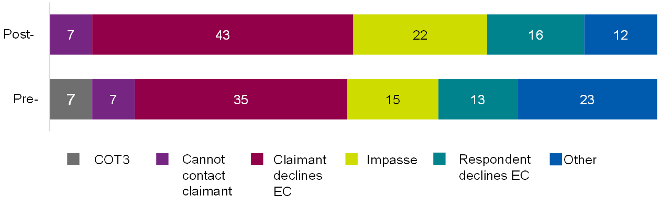

Base: Pre-implementation cases (5,375), post-implementation cases (4,844). Source: case management system.

Table of data for figure 4.1

|  |  |  |
| --- | --- | --- |
| **Outcome** | **Post-implementation** | **Pre-implementation** |
| COT3 | 0% | 7% |
| Cannot contact claimant | 7% | 7% |
| Claimant declines EC | 43% | 35% |
| Impasse | 22% | 15% |
| Respondent declines EC | 16% | 13% |
| Other | 12% | 23% |

#### Efficiency of early conciliation

Overall, case management system data shows that the Smarter Resolutions programme had had a positive impact on the efficiency of individual case allocation. As shown in Table 4.2, the average length of time from notification to allocation has been significantly reduced post-implementation; individual cases in the post-implementation period are taking 0.9 fewer days to reach the final conciliator, compared to cases in the pre-implementation period.

There is then a risk that the auto-allocation is prone to misallocation, resulting in a case being sent to a second conciliator. However, this does not appear to be a significant issue. The allocation count, or number of steps to the final allocation, is 2.4 for the post-implementation cases. This is significantly lower than the 2.7 steps taken before.

A second measure of the reallocation is the proportion of all cases that are allocated to more than one conciliator during the allocation process (excluding allocations to various administrative teams). This is lower post-implementation compared to pre-implementation (7% of cases were reallocated to more than one conciliation post-implementation, compared to 20% pre-implementation).

Table 4.4 provides a metric for days taken from initial case notification to outcome, if the case outcome is within the 6-week period. The table indicates that there are no differences with this measure for cases before compared to after programme implementation.

Table 4.4 Impact of Workstreams 1 to 3 on allocation and case outcomes within 6-week period

|  |  |  |  |  |
| --- | --- | --- | --- | --- |
|  | **Difference before and after** | **Significance level of difference** | **Post-implementation** | **Pre-implementation** |
| Allocation count | -0.31 | At 99% | 2.4 | 2.7 |
| Time from notification to allocation (days) | -0.91 | At 99% | 5.2 | 6.1 |
| Cases reallocated (proportion) | -13% | At 99% | 7% | 20% |
| Time to early conciliation outcome (days) | -0.32 | No | 16.8 | 17.1 |

Base: Pre-implementation cases (4,836), post-implementation cases (4,844). Source: case management system.

In qualitative interviews with post-implementation claimant-side service users, some praised the time between notification and contact as being very quick, often surprisingly so.

'I was very impressed with how quickly they got in touch, made me feel like I was being taken seriously. It also made me feel confident things might get resolved quite quicky [based on the speed of initial response].'  
(Service user, Claimant)

One representative observed the process was noticeably quicker than pre-implementation, putting this down to the removal of the early conciliation support officer step.

'You would also normally have somebody else [from Acas] calling you first before hearing from a conciliator, but with this one the conciliator called first. A much quicker process.'  
(Service user, Claimant representative)

As shown in Figure 4.2, claimant-side service users from the post-implementation period were more likely to agree that the case was handled efficiently than those in the pre-implementation period (69% compared to 64%, significantly higher). This finding remained when focusing just on claimants (that is, removing claimant representatives from the analysis); 67% of post-implementation claimants agreed their case was handled efficiently, compared to 62% of pre-implementation claimants. At the other end of the scale, 21% of pre-implementation claimant-side service users disagreed that the case was handled efficiently, significantly higher that 17% of post-implementation claimant-side service users. For claimants only, 22% of pre-implementation claimants disagreed, significantly higher than 18% post-implementation.

Figure 4.2 Impact of Workstreams 1 to 3 on claimant-side service user views on case efficiency

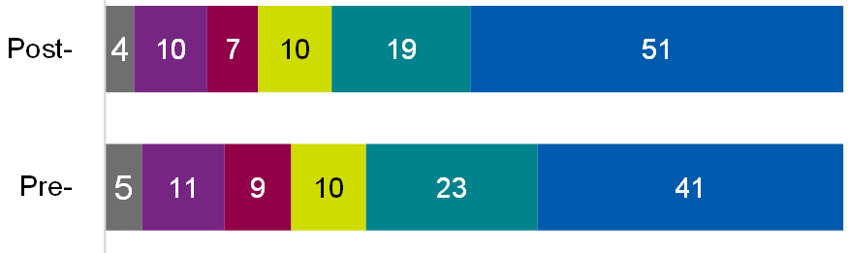



Base: All post-implementation (1,275); All pre-implementation (731). Post-implementation claimants (1,003); Pre-implementation claimants (603).

Table of data for figure 4.2

|  |  |  |
| --- | --- | --- |
| **Response** | **Post-implementation** | **Pre-implementation** |
| Don't know | 4% | 5% |
| Strongly disagree | 10% | 11% |
| Tend to disagree | 7% | 9% |
| Neither / nor | 10% | 10% |
| Tend to agree | 19% | 23% |
| Strongly agree | 51% | 41% |

#### Claimant-side service user experience of early conciliation

As shown in Figure 4.3.2, claimant-side service users were more likely to agree that the process helped them understand the strengths and weaknesses of their case post-implementation of Workstreams 1 to 3 (51% agreed, compared to 45% in the pre-implementation group).

Furthermore, when looking at claimants only (that is, excluding claimant representatives), post-implementation users were more likely to agree that the early conciliation process helped them feel better informed (63% compared to 57% of pre-implementation claimants – Figure 4.3.1), and understand the strengths and weaknesses of their case (54% compared to 47% of pre-implementation claimants).

Figure 4.3.1 Impact of Workstreams 1 to 3 on how informed claimant-side service users feel: better informed

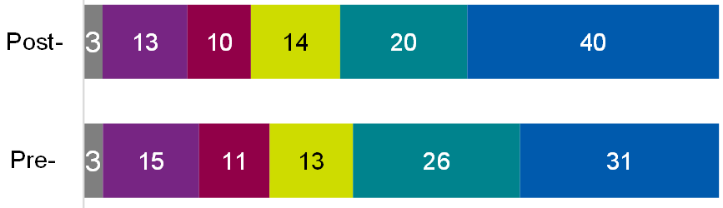



Base: All post-implementation (1,275); All pre-implementation (731). Post-implementation claimants (1,003); Pre-implementation claimants (603)

Table of data for figure 4.3.1

|  |  |  |
| --- | --- | --- |
| **Response** | **Post-implementation** | **Pre-implementation** |
| Don't know | 3% | 3% |
| Strongly disagree | 13% | 15% |
| Tend to disagree | 10% | 11% |
| Neither / nor | 14% | 13% |
| Tend to agree | 20% | 26% |
| Strongly agree | 40% | 31% |

Figure 4.3.2 Impact of Workstreams 1 to 3 on how informed claimant-side service users feel: understood strengths and weaknesses

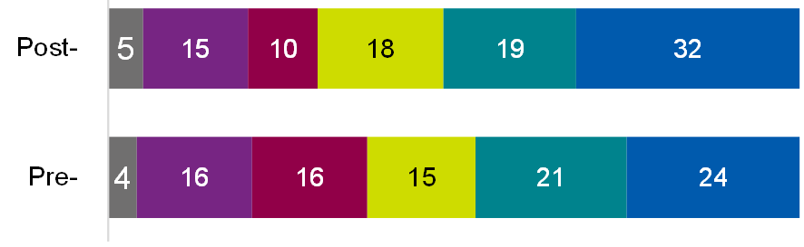



Base: All post-implementation (1,275); All pre-implementation (731). Post-implementation claimants (1,003); Pre-implementation claimants (603)

Table of data for figure 4.3.2

|  |  |  |
| --- | --- | --- |
| **Response** | **Post-implementation** | **Pre-implementation** |
| Don't know | 5% | 4% |
| Strongly disagree | 15% | 16% |
| Tend to disagree | 10% | 16% |
| Neither / nor | 18% | 15% |
| Tend to agree | 19% | 21% |
| Strongly agree | 32% | 24% |

There was a negative finding among claimant representatives, however. Claimant representatives in the post-implementation period were less likely to agree that they felt the early conciliation process helped them feel better informed (47% compared to 53% of claimant representatives in the pre-implementation period).

Comparing views of post-implementation and pre-implementation claimant-side service users in survey showed that, at an overall level, there were no significant differences in terms of satisfaction with the EC service (regardless of outcome) or ease using the service (see Appendix A.4.5).

Positively, as shown in Figure 4.4, when looking at claimants only (that is, when excluding claimant representatives), those in the post-implementation period were less likely to cite dissatisfaction with the outcome from early conciliation than claimants in the pre-implementation period (28% compared to 37%).

Figure 4.4: Impact of Workstreams 1 to 3 on claimant-side satisfaction with early conciliation outcome

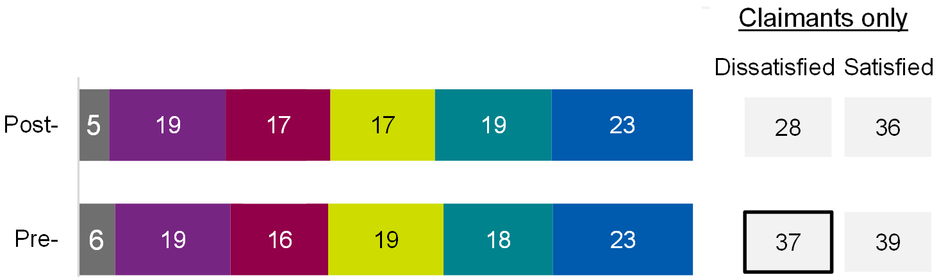



Base: All post-implementation (1,275); All pre-implementation (731). Post-implementation claimants (1,003); Pre-implementation claimants (603)

Table of data for figure 4.4

|  |  |  |
| --- | --- | --- |
| **Response** | **Post-implementation** | **Pre-implementation** |
| Don't know | 5% | 6% |
| Very dissatisfied | 19% | 19% |
| Somewhat dissatisfied | 17% | 16% |
| Neither / nor | 17% | 19% |
| Somewhat satisfied | 19% | 18% |
| Very satisfied | 23% | 23% |
| Dissatisfied (claimants only) | 28% | 37% |
| Satisfied (claimants only) | 36% | 39% |

Again, claimant representatives presented negative findings, however. Claimant representatives in the post-implementation period were less likely to agree that their claimants were satisfied with the outcome of early conciliation (31% compared to 52% of claimant representatives in the pre-implementation period) and more likely to state that the early conciliation process was difficult (9% compared to 6% of pre-implementation claimant representatives).

In relation to how fair the early conciliation process felt, and the extent to which the outcome and process met claimants' expectations, at an overall level and among claimants only (that is, excluding claimant representatives), those in the post-implementation group were more positive than those in the pre-implementation period.

Overall, those in the post-implementation period were more likely to agree that:

* the early conciliation process felt fair (66% compared to 61% for those in the pre-implementation)
* the early conciliation process met expectations (60% compared to 54%)
* the outcome met claimants' expectations (47% compared to 37% of pre-implementation claimant-side service users)

Some of these patterns were evident when looking at claimants only:

* the early conciliation process felt fair (65% of claimants compared to 58% for those in the pre-implementation, respectively)
* the early conciliation process met expectations (57% of claimants compared to 51% for those in the pre-implementation, respectively)

Claimant representatives in the post-implementation period were less likely to agree that the outcome met their claimant's expectations (43% compared to 50% of claimant representatives in the pre-implementation period).

Figure 4.5.1: Impact of Workstreams 1 to 3 on viewing early conciliation as a fair process

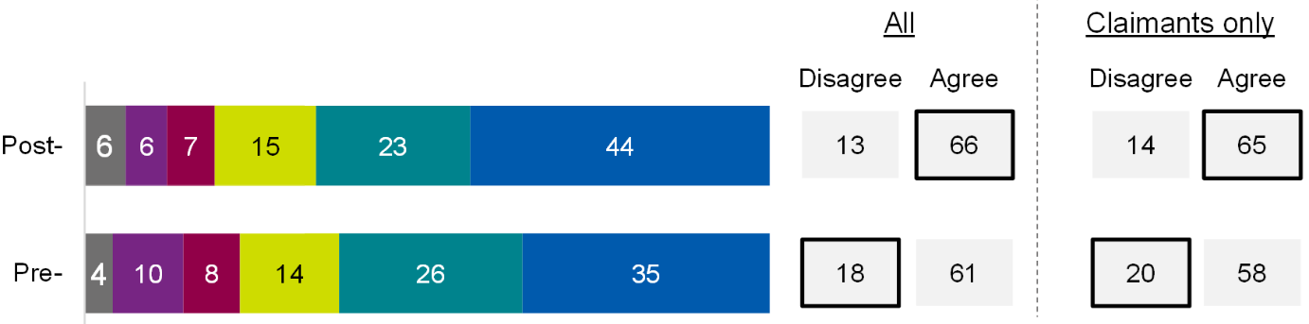



Base: All post-implementation (1,275); All pre-implementation (731). Post-implementation claimants (1,003); Pre-implementation claimants (603)

Table of data for figure 4.5.1

|  |  |  |
| --- | --- | --- |
| **Response** | **Post-implementation** | **Pre-implementation** |
| Don't know | 6% | 4% |
| Very dissatisfied | 6% | 10% |
| Somewhat dissatisfied | 7% | 8% |
| Neither / nor | 15% | 14% |
| Somewhat satisfied | 23% | 26% |
| Very satisfied | 44% | 35% |
| Disagree (all) | 13% | 18% |
| Agree (all) | 66% | 61% |
| Disagree (claimants only) | 14% | 20% |
| Agree (claimants only) | 65% | 58% |

Figure 4.5.2: Impact of Workstreams 1 to 3 on early conciliation outcomes meeting expectations

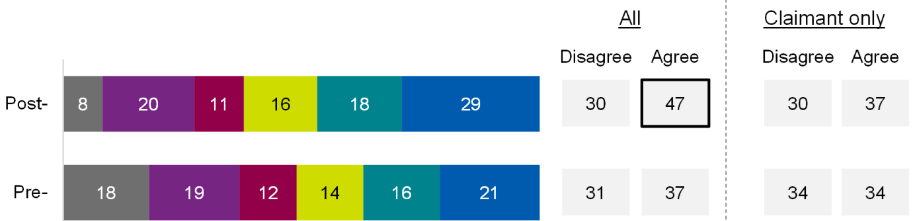

Base: All post-implementation (1,275); All pre-implementation (731). Post-implementation claimants (1,003); Pre-implementation claimants (603)

Table of data for figure 4.5.2

|  |  |  |
| --- | --- | --- |
| **Response** | **Post-implementation** | **Pre-implementation** |
| Don't know | 8% | 18% |
| Very dissatisfied | 20% | 19% |
| Somewhat dissatisfied | 11% | 12% |
| Neither / nor | 16% | 14% |
| Somewhat satisfied | 18% | 16% |
| Very satisfied | 29% | 21% |
| Disagree (all) | 30% | 31% |
| Agree (all) | 47% | 37% |
| Disagree (claimants only) | 30% | 34% |
| Agree (claimants only) | 37% | 34% |

Figure 4.5.3: Impact of Workstreams 1 to 3 on early conciliation overall meeting expectations

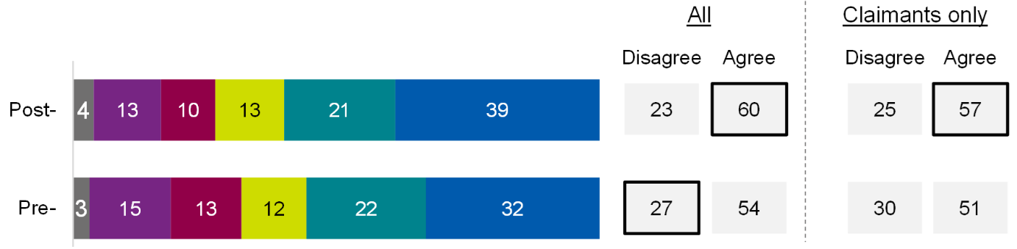



Base: All post-implementation (1,275); All pre-implementation (731). Post-implementation claimants (1,003); Pre-implementation claimants (603)

Table of data for figure 4.5.3

|  |  |  |
| --- | --- | --- |
| **Response** | **Post-implementation** | **Pre-implementation** |
| Don't know | 4% | 3% |
| Very dissatisfied | 13% | 15% |
| Somewhat dissatisfied | 10% | 13% |
| Neither / nor | 13% | 12% |
| Somewhat satisfied | 21% | 22% |
| Very satisfied | 39% | 32% |
| Disagree (all) | 23% | 27% |
| Agree (all) | 60% | 54% |
| Disagree (claimants only) | 25% | 30% |
| Agree (claimants only) | 57% | 51% |

In the interviews with post-implementation claimants, those whose cases had not been resolved generally did not feel their conciliator had done enough. Additionally, some claimants were not prepared for the fact that the employer did not have to respond to Acas, and were disappointed to have to take the case to tribunal. Others were unsure as to whether the conciliator had influenced the outcome of their case:

'Maybe just having him in there helped? I had no idea what he did with the other side.'

(Service user, Claimant)

As shown in Figure 4.6, claimant-side service users in the post-implementation period were more positive than those in the pre-implementation period in terms of their understanding of the conciliator's role being impartial (80% agreed compared to 72% of claimant-side service users in the pre-implementation period), and conciliation getting off to a good start (70% compared to 66% in the pre-implementation period) following initial contact.

Figure 4.6.1: Impact of Workstreams 1 to 3 on understanding following initial contact with the conciliator

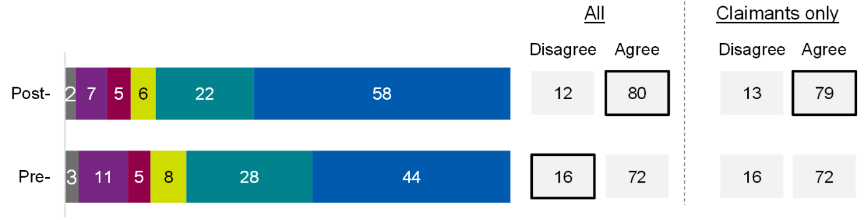



Base: All post-implementation (1,275); All pre-implementation (731). Post-implementation claimants (1,003); Pre-implementation claimants (603)

Table of data for figure 4.6.1

|  |  |  |
| --- | --- | --- |
| **Response** | **Post-implementation** | **Pre-implementation** |
| Don't know | 2% | 3% |
| Very dissatisfied | 7% | 11% |
| Somewhat dissatisfied | 5% | 5% |
| Neither / nor | 6% | 8% |
| Somewhat satisfied | 22% | 28% |
| Very satisfied | 58% | 44% |
| Disagree (all) | 12% | 16% |
| Agree (all) | 80% | 72% |
| Disagree (claimants only) | 13% | 16% |
| Agree (claimants only) | 79% | 72% |

Figure 4.6.2: Impact of Workstreams 1 to 3 on the process getting off to a good start following initial contact with the conciliator

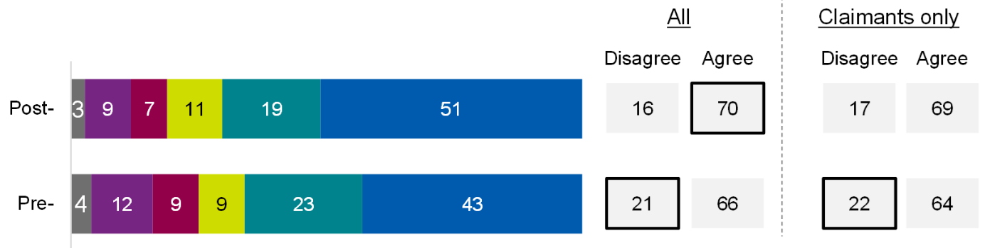

Base: All post-implementation (1,275); All pre-implementation (731). Post-implementation claimants (1,003); Pre-implementation claimants (603)

Table of data for figure 4.6.2

|  |  |  |
| --- | --- | --- |
| **Response** | **Post-implementation** | **Pre-implementation** |
| Don't know | 3% | 4% |
| Very dissatisfied | 9% | 12% |
| Somewhat dissatisfied | 7% | 9% |
| Neither / nor | 11% | 9% |
| Somewhat satisfied | 19% | 23% |
| Very satisfied | 51% | 43% |
| Disagree (all) | 16% | 21% |
| Agree (all) | 70% | 66% |
| Disagree (claimants only) | 17% | 22% |
| Agree (claimants only) | 69% | 64% |

Overall, claimant-side service users explained that their initial contact with conciliators was positive, describing clear and effective communication where users felt put at ease. One representative noted that the process was considerably quicker than their previous experience:

'You would also normally have somebody else [from Acas] calling you first before hearing from a conciliator, but with this one the conciliator called first. A much quicker process.'

(Service user, Claimant Representative)

One claimant was glad to have an initial phone call in which the conciliator spent plenty of time explaining everything, as it gave them greater confidence in the process:

'That was positive, and it made me feel like it was something that was being taken seriously…It didn't feel like it was just a tick box exercise, it was thorough.'

(Service user, Claimant)

Where claimant-side service users felt that there was room for improvement in their interactions, largely due to a lack of proactivity on the behalf of the conciliator. Some felt follow-up emails after any calls or interactions would have improved their experience:

'It was all on me. I'd email her asking if she'd heard any updates, and she'd say, 'if there are any, I will be contacting you.'

(Service user, Claimant)

Conciliators explained that the quicker allocation time as a result of the algorithm may have been to the detriment of the service user on some occasions. When claimant-side service users are allocated automatically to a conciliator who has not had a chance to go through their case, it can lead to a difficult or inefficient conversation with someone whose case they have limited knowledge of.

'I've no idea who this person is, but they presume that I do because they've had an e-mail from 'me'.'

(Acas staff, Conciliator)

The claimant-side service users in the post-implementation were also more likely to agree that, following initial contact with their conciliator, they understood that taking part in early conciliation could help resolve the dispute without going to an employment tribunal (88% compared to 82% of pre-implementation claimant-side service users). This finding remained when focusing just on claimants within each group (87% compared to 82%).

Figure 4.7: Impact of Workstreams 1 to 3 on understanding early conciliation can resolve disputes

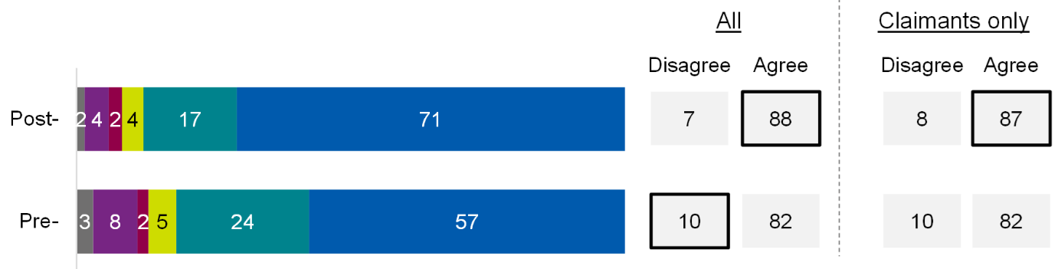



Base: All post-implementation (1,275); All pre-implementation (731). Post-implementation claimants (1,003); Pre-implementation claimants (603)

Table of data for figure 4.7

|  |  |  |
| --- | --- | --- |
| **Response** | **Post-implementation** | **Pre-implementation** |
| Don't know | 2% | 3% |
| Very dissatisfied | 4% | 8% |
| Somewhat dissatisfied | 2% | 2% |
| Neither / nor | 4% | 5% |
| Somewhat satisfied | 17% | 24% |
| Very satisfied | 71% | 57% |
| Disagree (all) | 7% | 10% |
| Agree (all) | 88% | 82% |
| Disagree (claimants only) | 8% | 10% |
| Agree (claimants only) | 87% | 82% |

Post-implementation claimant-side service users were also more positive than pre-implementation claimant-side service users in terms of perceiving their conciliator as having the right skills and knowledge to resolve the dispute. This was the case at both the overall level (68% in the post-implementation group agreed with this statement, compared to 61% in the pre-implementation group) and when looking at claimants only (68% agreed compared to 61%).

Figure 4.8 Impact of Workstreams 1 to 3 on perception that conciliators had the right skills

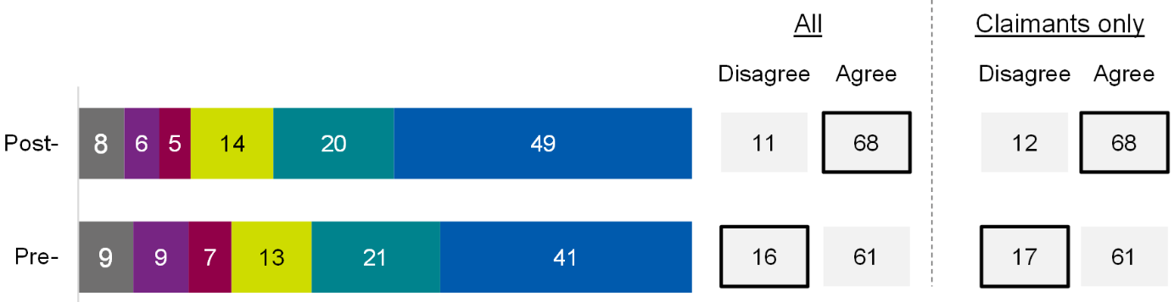



Base: All post-implementation (1,275); All pre-implementation (731). Post-implementation claimants (1,003); Pre-implementation claimants (603)

Table of data for figure 4.8

|  |  |  |
| --- | --- | --- |
| **Response** | **Post-implementation** | **Pre-implementation** |
| Don't know | 8% | 9% |
| Very dissatisfied | 6% | 9% |
| Somewhat dissatisfied | 5% | 7% |
| Neither / nor | 14% | 13% |
| Somewhat satisfied | 20% | 21% |
| Very satisfied | 49% | 41% |
| Disagree (all) | 11% | 16% |
| Agree (all) | 68% | 61% |
| Disagree (claimants only) | 12% | 17% |
| Agree (claimants only) | 68% | 61% |

#### Impact on stress levels

Claimants and claimant representatives were asked to what extent they or the individuals they represented felt worried about their dispute both before and after initial contact with their conciliator. Overall, claimant-side service users in the post-implementation group were more likely than the control group to have reduced worry about their employment dispute following initial contact with their conciliator. Overall, 39% of claimant-side service users in the post-implementation group had reduced worry following initial contact; this compares to 34% in the pre-intervention group. Furthermore, looking at claimants only, those in the post-implementation group were significantly more likely to have reduced worry after initial contact (43% compared to 34% of claimants in the pre-implementation group)

#### Acas staff experience of Workstream 3 changes

##### Perceived efficiency of automated algorithm for allocating cases

Due to the auto-allocation of most cases, conciliators believed that, on average, cases were being allocated more quickly.

Case allocation team members observed that the automated allocation tool worked well when cases were simple and the information was inputted well. They felt it had not worked as well when the case was more complex, when the claim related to a large group case, or when information had been inputted incorrectly into the notification form. In the latter scenario, case allocation team members often ended up reallocating cases.

'We seem to be babysitting [the auto-allocation] with looking at the background to make sure that the cases are going to the right people at the right time. And so that's obviously increased our workload.'  
(Acas staff, case allocation team member)

Another factor that case allocation team members believed was contributing to them having to reallocate cases more frequently than before was shortcomings in the algorithm for allocating cases. For example, allocating to conciliators of the wrong grade. It is important to note that this perspective was not supported by the case management system data findings, and it was also gathered in early in the implementation of auto-allocation.

'Every day we're hit with an issue with the auto-allocation I think.'  
(Acas staff, case allocation team member)

Conciliators identified situations in which the automated allocation tool was appropriately allocating cases in line with their availability. These chimed true with much of the case allocation team member's perspectives. They noted the algorithm wholly respects booked annual leave and does not assign cases during this, works well for full-time employees with regular working hours and works well if given ample (human) input, for example, from a manager.

'The algorithm only works within the parameters that are provided by the people.'  
(Acas staff, Conciliator)

Conciliators identified some areas where they believe the algorithm was not allocating in a way which supported their working patterns, expertise and availability. Firstly, conciliators believed that allocation occurs during weekends which resulted in them returning to numerous cases on a Monday. It should be noted that Acas have stated that weekend allocation did not occur with the tool or otherwise at the time of this evaluation.

Similarly, conciliators noted that cases were automatically allocated overnight, outside of their working hours, creating the illusion that Acas conciliators do not work 9 to 5 hours. When this happened, claimants sometimes phoned a conciliator straight away and expected them to be able to discuss their case. It created an illusion that Acas conciliators do not work 9 to 5 hours. Similarly, a claimant sometimes phoned the conciliator first thing in the morning, expecting the conciliator to have some familiarity with their case due to it having been allocated some hours before. This sometimes resulted in an inefficient and ineffective conversation, which was frustrating both for the claimant and the conciliator.

Acas have flagged that this issue can be addressed by conciliators putting their working hours into Dynamics. Where this has happened, working hours are stated on the allocation notification to the claimant-side service user, going some way in managing expectations.

Conciliators also noted that, for part-time colleagues or those with non-standard working hours, their cases are allocated together at the start of the week, whereas those with regular, full-time working hours received theirs evenly over the working week. This applied similar pressure to that discussed above on those who are not working full-time regular hours.

Lastly, whilst the algorithm does take account for annual leave, conciliators noted that it allocates cases right up until it begins. This can make beginning work on a case difficult, and risks claimants being allocated but having received very little engagement from a conciliator until the leave ends.

'My leave starts on the Monday that I'm getting cases right up until the Friday when I leave and that would be kind of just difficult'  
(Acas staff, Conciliator)

Some conciliators perceived themselves as spending significant time doing new administrative tasks, which previously would have been the remit of colleagues such as early conciliation support officers, before beginning conciliation. These tasks include chasing contact details, such as email addresses, and correcting spelling errors. These tasks include chasing contact details, such as email addresses, and correcting spelling errors.

'It feels like I spend most of my day doing admin rather than I used to get cases and I could get straight into doing conciliation'  
(Acas staff, Conciliator)

##### Allocation relevance to conciliator skills

The case allocation team did not think that the algorithm was assigning cases based on conciliator skills. Where it did attempt to do so, they believed it lacked the nuance to pick up on patterns or trends in the way that a human allocator could.

'It's quite, it's quite crude really in, in how it's sort of decides where case goes.'  
(Acas staff, Case allocation team member)

Case allocation team members and conciliators noted that the algorithm was well adapted to allocating based on skill level if the correct information had been inputted into the notification form. The allocation tool was failing when the claimant or a representative had inaccurately identified their case type, and it was noted that a human allocator may well have picked up on this.

Claimant-side service user claimants, more often than not, felt conciliators had the skills to successfully execute the case.

'I felt confident in him, sounded like he knew what he was doing … his discussion about claims, it was obvious he'd already got the t-shirt and was wearing it. I felt comfortable with him and that he would do a good job.'  
(Service user, Claimant)

However, when speaking to representatives, the perception was that conciliators were knowledgeable across the board. Their ability to navigate their allocated cases reflected a general high standard, as opposed to any matching on the basis of areas of expertise.

'They are generally very good'  
(Service user, Claimant representative)

Where claimant-side service users felt conciliators were not demonstrating the necessary skills, this tended to relate to soft-skills as opposed to factual knowledge, for example, sympathetic listening or communication (so, factors unrelated to the allocation system itself).

##### Case allocation team spending more time on complex and exceptional cases

As intended for Workstream 3, the case allocation team agreed they were spending a larger proportion of their time on complex and exceptional cases. However, they noted that sometimes these cases were getting to them too far down the line. This is due to the algorithm not identifying them as exceptional and assigning them as a standard case. Only when they are flagged do they then arrive with the case allocation team. They noted that prior to auto-allocation, these would be picked up by a human as a non-standard case.

'So, we're picking up some of the complex, more complex cases a bit further down the line when they've been through a few hands. So, it's not ideal in that respect.'  
(Acas staff, Case allocation team member)

##### Scope for further efficiencies in auto-allocation process

Feedback from case allocation team members provides insight into how instances of reallocation could be reduced further. Specifically, the issues the case allocation team identified with the system were: information being stored in multiple places or on multiple 'screens' meaning information is hard to compile and often incomplete; and logging of conciliator availability being populated for the following week - this can't be booked months ahead, which leads to errors.

The case allocation team felt that, ideally, the tool would allow them to view all information in one place, and log availability further ahead. This would hopefully lead to a lower proportion of cases having to be manually reallocated after initial inappropriate allocations.

'There's more kind of screens, there's more little things you have to click in and out of... whereas previously information was condensed into the one space'  
(Acas staff, Case allocation team member)

## 5. Findings for Workstream 4: Large Group Cases

This section explores the impact and user experience of new systems and processes for handling large group cases, developed under Workstream 4 (WS4) of the Smarter Resolutions programme.

Workstream 4 focuses on an optimised service for identifying large groups cases, involving 10 or more individuals belonging to the same workplace dispute, and quickly bringing them to the attention of the dedicated group cases team with the expertise, tools, and resourcing to resolve a case efficiently. These claims account for a relatively small number of cases, but the number of claimants involved in each case means they affect quite a large number of individuals.

Acas identified some key weaknesses in their approach to handling large group cases, impacting on their efficiency. These included: poor levels of information submitted through group notification forms; the manual nature of the process for identifying large group cases (the team try and spot 'same respondent same facts' across individual and group notifications); and inefficiencies in case flags or categorisation in the system (for example, incident type, jurisdiction). Workstream 4 intended to address these weaknesses. All activities under Workstream 4 and included in this evaluation were implemented by October 2022. These were:

* auto-allocation of group cases to the group cases team rather than a manual process
* changes to the group notification form, to enable claimant representatives to add additional information and give permission for conciliators to speak to respondent(s) first
* a respondent allocation report which helps the group cases team spot cases with 'same facts same respondent'

A range of measures were tested using pre-/post-implementation analysis, to understand the impact of Workstream 4. Due to the limited volume of large group cases, and most intended outcomes being internal-facing (they impact Acas staff as opposed to claimant-side service users), findings come from case management system (CMS) data and qualitative interviews (no survey was carried out with claimant-side service users for Workstream 4). A logic model, showing the key outcomes which were measured for Workstream 4 can be found in Appendix A.5.1. Case management system data findings in this section focus on those statistically significant at the 95% confidence level. All findings that did not reach statistical significance at this level can be found in Appendix A.5.4.

### Key findings

Overall, there is some evidence of the new group claims processes improving efficiencies. There were significant differences in cases handled pre- and post-implementation of these changes.

#### Case settlement and reaching outcome

* the proportion of cases reaching a definite outcome in the 6-week early conciliation period increased from 37% to 94% (although the proportion of cases being settled was no different)

#### Efficiency of large group case handling

* Among cases with a definite outcome within 6 weeks, allocation of group cases to the group cases team is much faster in the post-implementation period, by 2.3 days. Pre-implementation, this was 5.3 days, dropping to 3.0 days post-implementation.
* Relatedly, there was a reduced time gap between allocation to contacting the employer-side respondent by 5.6 days (6.5 days pre-implementation to 0.9 post-implementation) and to reaching a definite outcome by 4.5 days (from 11.4 days to 7.0 days).
* One negative finding was that the average allocation count (that is, how many times a case changes hands before it reached its final conciliator) increased from 2.2 to 2.3 post-implementation.

#### Views on the new processes for handling of large group cases

In qualitative interviews, the group cases team identified a few areas impacting efficiencies, which could be addressed:

* Lead cases (usually the first case notified within a group case) being disconnected from linked cases in auto-allocation; and,
* Auto-allocation of individual cases (through Workstream 3) disrupting identification of group cases.

The group cases team felt the new respondent allocation report was reducing some of the manual burden of identifying 'same respondent, same facts' cases.

To the group cases team and claimant representatives, changes to the new group form (permission to contact the respondent, and option to provide additional information) were considered positive, albeit not too impactful in terms of efficiencies.

It was quite rare for claimant representatives to have noticed a change in the efficiency of large group case handling, those that had noticed a difference were positive (one cited a noticeable improvement in the handling of these cases since October 2022).

### Methodology overview

It was not feasible to deliver the evaluation of Workstream 4 as a randomised control trial, namely due to the low volume of large group cases, the variation within these cases, and the timeframes available for the evaluation and programme delivery. The low volume of large group cases, and largely internal-facing impacts of the workstream (meaning changes which affect Acas staff as opposed to service users) meant a survey with claimant-side service users would not be valuable in evaluating this strand.

As such, the impact of Workstream 4 was assessed using a pre and post-implementation comparison. Case management system data was analysed to assess improvements in efficiencies and outcomes.

The pre-implementation period was between 3 January and 29 April 2022 (after the creation of the group cases team in Autumn 2021, but before changes resulting from Smarter Resolutions funding had been introduced); the post-implementation period was between 3 October and 30 December 2022, once the changes within scope for this evaluation had been introduced. The impact of the group cases team being introduced is out of scope for the current evaluation, but the team being in relative infancy is an important context to note for some of the feedback provided.

Table 5.1 presents the number of large group cases in the pre-implementation period (3 January to 29 April 2022) and post-implementation period (3 October to 30 December 2022) for Workstream 4. Appendix A.5.3 provides detail on what was possible to analyse for Workstream 4 using the case management system data.

Table 5.1: Cases in quantitative strands of Workstream 4

|  |  |  |
| --- | --- | --- |
| **Methodology** | **Pre-implementation** | **Post-implementation** |
| Case management system data | 944 | 1,090 |

Analysis of the case management system data was complemented by qualitative fieldwork with the group cases team managers and conciliators, and claimant representatives who have recently had their case handled by the group cases team. Table 5.2 shows the breakdown of these qualitative interviews, and their fieldwork periods.

For claimant representatives, the majority (n=13) had worked with the group cases team on cases both pre and post-implementation, and were therefore able to reflect on any changes noticed. The remaining 7 had only worked on large group cases with Acas in the post-implementation period.

Table 5.2 Participants and interview volumes in qualitative strands of WS4

|  |  |  |  |
| --- | --- | --- | --- |
| **Participants** | **Method** | **Fieldwork period** | **Number of participants** |
| Group cases team managers | In-depth interviews | Feb 2023 | 2 |
| Group cases team | 1 focus group | Mar 2023 | 8 |
| Claimant representatives | In-depth interviews | Feb to Mar 2023 | 20 |

### Research questions for this evaluation

In this evaluation strand, the outcomes for large group cases handled pre-implementation (from 3 January to 29 April 2022) were compared to the outcomes of those handled post-implementation (from 3 October to 30 December 2022). The primary research questions addressed in this strand were:

1. What is the difference in the average number of cases that reached a definite outcome and that settled before and after Workstream 4 changes were implemented?
2. What is the difference in the efficiency of the process for handling large group cases before (pre) and after (post) Workstream 4 changes were implemented?

The secondary research questions explore the changes post-implementation, including:

1. What is the difference in the effectiveness of large group case conciliation?
2. What is the difference in the claimant representative experience of the overall process for large groups cases?
3. What is the difference to the relationships between conciliators and employer representatives?

### Overview of evaluation outcomes

Overall, findings against the evaluation outcomes were mixed. In this report, we have used a 95% confidence level for reporting differences. That is, we are only focusing on differences where there is a 95% chance that a true difference is present. Likelihood of reaching this level of sensitivity in difference is constrained by sample volumes. Mapping of all outcomes against their respective indicators and evaluation data sources can be found in Appendix A.5.2. A full breakdown of findings that did not meet statistical significance can be found in Appendix A.5.4.

To illustrate this broader positive trend in the absence of presenting non-significant findings, however, Table 5.3 below sets out all key indicators measured in Workstream 4 and whether the pre-implementation group statistically differs from the post-implementation group at either a 90% or 95% confidence level. Differences at a 90% level and in a positive direction (normatively) are indicated by 'Positive, 90%', those at the 95% level and in a positive direction are indicated by 'Positive, 95%'. Likewise, those in a negative direction (normatively) are marked by either a 'Negative, 90%' or 'Negative, 95%' to indicate 90% and 95% confidence levels, respectively. 'No sig. difference' indicates that there is no statistically significant difference (at either 90% or 95%) between the pre-implementation and post-implementation groups, in either direction. If data was not available, 'Not available' has been used. All outcomes were measured using case management system (CMS) data.

Table 5.3.1 Overview of WS4 outcomes and findings: case settlement and reaching a definite outcome

|  |  |
| --- | --- |
| **Indicator** | **All** |
| Average number of cases settled in early conciliation window | No sig. difference |
| Average number of cases reaching a definite outcome in early conciliation window | Positive, 95% |

Table 5.3.2 Overview of WS4 outcomes and findings: efficiency of early conciliation

|  |  |
| --- | --- |
| **Indicator** | **All** |
| Reduced time gap from notification to allocation | Positive, 95% |
| Reduced time gap from notification to conciliation | No sig. difference |
| Reduced time gap from allocation to group cases team and contact with employer-side respondent | Positive, 95% |
| Reduced time gap from notification to first contact with conciliator | No sig. difference |
| Average allocation count | Negative, 95% |
| Greater proportion of large cases allocated directly to group cases team | Positive, 90% |
| Reduced time gap to definite outcome | Positive, 95% |

Key to Tables 5.3.1 to 5.3.2: 'Positive, 90%' shows a positive finding at 90% confidence level; 'Positive, 95%' shows a positive finding at 95%; 'Negative, 90%' shows a negative finding at 90%; 'Negative, 95%' shows a negative finding at 95%; 'No sig. difference' shows no significant difference between the intervention and control group. Base: Pre-implementation (944 cases of which 349 reached an outcome in 6-week window); Post-implementation (1090 cases of which 871 with outcomes within the 6-week period).

The following subsection focuses on significant findings from case management system data (at a 95% confidence level) and perceived impacts and experiences as explored in qualitative interviews.

All findings for Workstream 4 that did not reach statistical significance at a 95% confidence level can be found in Appendix A.5.4.

### Findings

Analysis of case management system data allows the effectiveness and efficiencies of Workstream 4 changes to be assessed, through exploration of indicators such as the proportion of cases settled within the 6-week early conciliation period, how many times a case was re-allocated, and time gaps between notification and various conciliation stages (such as allocation, first contact with a conciliator, and outcome being reached).

#### Case settlement and reaching outcome

Analysis of case management system data comparing large group cases pre- and post-implementation shows a link between the new processes and the speed with which cases reach an outcome. For the cases provided, an outcome had been reached within the 6-week period in proportionately more cases from the post-implementation period. Before the intervention, 349 of the 944 cases, or 37%, had reached an outcome within 6 weeks of being notified. In the post-implementation period, this was the case in 871 of the 1,090 cases, or 80%. This difference is significant at a 99% confidence level.

Of interest is the outcome at the end of the case. Figure 5.1 indicates the spread across categories. The issuance of a COT3 is not a common outcome, occurring in less than 2% of all cases that reached an outcome within 6 weeks; this is not significantly different pre- and post-implementation.

Figure 5.1: Outcomes recorded for large group cases (percentages) 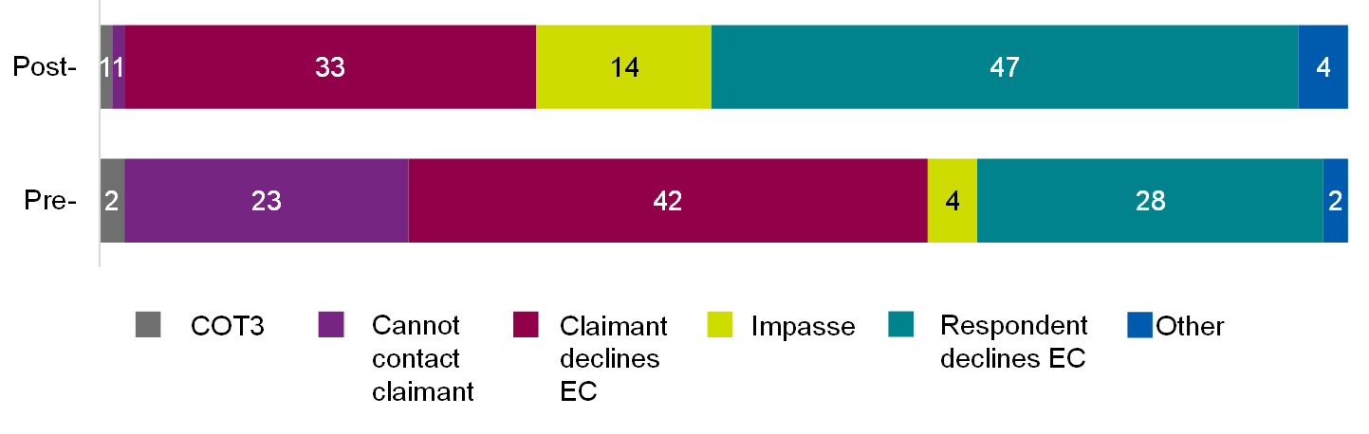

Base: All post-implementation (349); All pre-implementation (871). Source: case management system.

Table of data for figure 5.1

|  |  |  |
| --- | --- | --- |
| **Outcome** | **Post-implementation** | **Pre-implementation** |
| COT3 | 1% | 2% |
| Cannot contact claimant | 1% | 23% |
| Claimant declines EC | 33% | 42% |
| Impasse | 14% | 4% |
| Respondent declines EC | 47% | 28% |
| Other | 4% | 2% |

#### Efficiency of large group case handling

Table 5.4 indicates some further results around the timings for cases. The table presents the time it took cases to reach intermediate outcomes within the statutory 6-week period, among cases where a definite outcome had been reached. The measures are the number of days taken from initial case notification to allocation and outcome and the number of times a case is reallocated. Most marked is that the allocation is much faster in the cases after Workstream 4 implementation, at 3 days. This is significantly different from the 5.3 days taken before Workstream 4 implementation. Time between notification and contacting the employer-side respondent has decreased by 5.6 days, and time to outcome has decreased by 4.5 days; both of these findings are also significant at the 99% confidence level.

Table 5.4.1 Time from case start to intermediate outcomes and number of allocations: difference before and after

|  |  |  |
| --- | --- | --- |
| **Measure** | **Difference** | **Significance** |
| Time to allocation (days) | -2.3 | At 99% |
| Time to contacting employer-side respondent (days) | -5.6 | At 99% |
| Number of allocations | 0.1 | At 95% |
| Time to outcome (days) | -4.5 | At 99% |

Table 5.4.2 Time from case start to intermediate outcomes and number of allocations: average

|  |  |  |
| --- | --- | --- |
| **Measure** | **After** | **Before** |
| Time to allocation (days) | 3.0 | 5.3* (* denotes a figure statistically higher) |
| Time to contacting employer-side respondent (days) | 0.9 | 6.5*(* denotes a figure statistically higher) |
| Number of allocations | 2.3*(* denotes a figure statistically higher) | 2.2 |
| Time to outcome (days) | 7.0 | 11.4*(* denotes a figure statistically higher) |

Base: Post-implementation (871); Pre-implementation (349).

The allocation process involves various allocation steps, with the case being reallocated before reaching a final conciliator. One negative outcome is that the cases take on average 2.3 steps before they reach their conciliator, and this has risen by 0.1 after Workstream 4 compared to the period before.

As the comparison period is 6 months earlier than the post-workstream implementation cases, the estimates can be affected by the pre-implementation case data being more mature.

Steps to mitigate this included focusing only on cases that reached an outcome in 6 weeks and – for the timings of the outcome of cases – this means fewer cases are used in estimating before/after changes. For outcome times, only the 340 that concluded in time of the 871 cases were used in the pre-implementation group and some measures, such as the decreases in time taken to allocate after Workstream 4, become far greater if all cases are included. The approach contrasts with RCT B, where outcomes reached in the period are counted, but all cases are tracked.

There were no significant differences between the pre and post implementation groups for other elements of efficiency. Data for these findings are shown in Appendix A.5.4.

##### Perceived efficiencies of the new group case allocation process

Generally, in the qualitative discussion, the group cases team acknowledged that the auto-allocation of group cases meant that the majority of large group cases were now coming directly to them, reducing the administrative time needed to manually check queues for cases. This has the knock-on effect of claimant representatives being contacted sooner, and the case getting off to a good start.

'The cases are coming straight through to us rather than having to rely on one of us, a couple of times a day, checking the queue[..]I think the claimant reps do really appreciate it because a lot of the time they are quite surprised when we've called them straight away. I think from their view, if we can get hold of them, it does start that process quite quickly rather than in a day or so. Most of the people I've spoken to were pretty pleased that we've contacted them very quickly.'

(Conciliator, Group cases team)

However, the group cases team identified a few, small inefficiencies created by the new processes too. These included:

* changes to how cases are organised
* auto-allocation of individual cases disrupting identification of group cases.

It was quite rare for claimant representatives to have noticed a change in the efficiency of large group case handling, with representatives broadly very pleased with how quickly cases have been picked up both pre- and post-implementation of Workstream 4 changes.

Many described receiving ET1 certificates extremely quickly (within a day or so), and they had noticed this had improved marginally since October 2022 (the point at which all changes under Workstream 4 to be evaluated had been implemented).

Those that had noticed a difference were positive. One claimant representative, who has dealt with many large group cases over the past few years, said that there had been a noticeable improvement in the handling of these cases since October 2022.

'I feel like it has gotten a lot better and Acas has been able to adjust to dealing with a very different type of claim... these are very different to hands on conciliator work...I can understand why it was difficult to begin with and the changes that have come in are really about the data and making sure there are convenient ways to get that data across really.'

(Service user, Claimant representative)

##### Perceived inefficiencies due to changes to how cases are organised

A source of inefficiency, identified by the group cases team, was the way in which cases are organised. One group cases team member outlined a change introduced in early December, whereby information was organised by claim records, as opposed to by individual cases. Although they recognised the benefits of this for the wider service, this presented some issues for the group cases team specifically. They described how this meant 'lead cases' were introduced, and related cases sat beneath this, creating administrative challenges when edits were needed.

'It was quite problematic for the group cases team because we now only have records, if there's any kind of amendment needed or any kind of rejig of which is the lead case. We now have one lead claim and like 20 records within that; in the past it would have been 21 cases. They would have been grouped together and we could work on them and move them around as we want. But since [that amendment] came in, the records don't act or function the same as a case. So, you have limitations and if you did need to make that a case, you've got to go through a rigmarole really to do that so.'

(Conciliator, Group cases team)

Other group cases team conciliators described how, with the new auto-allocation system, lead cases are not always being allocated alongside their linked cases. In some instances, the lead case is coming through to the team, but linked cases are remaining on the early conciliation support officer card. This required some administrative time to resolve, with the group cases team needing to alert the case allocation team that the linked cases should be moved over.

##### Perceived inefficiencies due to impact of Workstream 3 auto-allocation

The above issue has been compounded by the introduction of auto-allocation of individual claims as part of Workstream 3 (introduced mid-January 2023). Although this sits outside of the post-implementation period, and therefore does not impact the case management system data analysis, it is an important consideration for the service moving forward. The group cases team has mentioned that since this auto-allocation has been activated for individual claims, they have not been able to pick up where there are more than 10 individuals submitting a 'same respondent, same facts' claim before their cases are allocated to an individual conciliator. This is impacting efficiencies in the process, as individual conciliation resource is spent on large group cases before they get identified. As such, group cases team resource is spent on liaising with the case allocation team to move the case over, and case allocation team resource is used trying to allocate new individual cases to replace those taken away from conciliators.

'It was causing unnecessary work for conciliators who had possibly even tried to make contact with parties on claims that should have come to us and didn't. For example, we get 30 claims from individual claimants where their representative has said, 'Well, I want you to submit this individually'; 30 people make a claim against XYZ company. Those 30 claims could end up with 30 different conciliators. What we then have to do is ask our central allocations team to take them all off the 30 conciliators and give them to us, but then central allocations have to find 30 more cases to replace that allocation for individual conciliators to make sure that they're getting their proper allocation for the week.'

(Conciliator, Group cases team)

Although group cases team conciliators did not have a solution for this, they felt this highlighted that the service could not move away from manual intervention entirely.

##### Efficiencies created by the respondent allocation report

The introduction of Power BI (a platform for connecting and visualising data) to create the respondent allocation report was identified as a factor improving efficiencies in group cases team case allocation. Previously, team members would need to interrogate case data manually to try and identify 'same respondent, same facts' cases that had not come together or through the same group notification form. The new report allows team members to check for cases that should be allocated to them. The process was felt to be much quicker and, ultimately has resulted in a quicker response to claimant-side service users.

'To me… in general it's just sleeker. You could interrogate the information previously, it's just that with the BI report it's just much easier. Much more user friendly. You could get to the same outcome, it's just an efficiency. It would speed things up, so maybe don't spend as much time on each, so over a day you might find savings there. But I don't think in very general terms it would like, you know almost be that Eureka moment where we've saved a week or 2. It just makes it that we can deal with a higher volume more efficiently. So it has a knock-on effect that does impact and reduce time, so we do get out to people quicker.'

(Conciliator, Group cases team)

##### Efficiencies created by new features of the group notification form

In July 2022, changes were made to the group notification form to try to improve efficiencies in the conciliation process and contribute to an improved service user experience. The new form allowed Acas to contact the employer-side service user (respondent) first and allowed claimant representatives to provide additional information through text boxes. The group cases team and claimant representative reflections on these features and their impact on service efficiencies are explored below.

Very few claimant representatives who had experienced pre- and post-implementation of the group notification form changes mentioned the new features spontaneously or when prompted. This indicates that the changes had a limited impact on service user experience.

#### Permissions to contact employer respondent

The group cases team acknowledged some time savings through the introduction of this feature. Previously, the team needed to email the claimant representative after a notification had been submitted, to seek permission to contact the respondent. This new feature removed a small administrative burden.

'Our team then had to e-mail to ask for permission to contact the respondent. I do see a lot of emails having to go out asking for permission to contact the respondent, which is just a time-wasting thing that we don't necessarily need to be doing. It is a waste of resource sometimes.'

(Conciliator, Group cases team)

The group cases team did not feel this permission added much efficiency to conciliation itself, as it was very rare that they would contact an employer prior to speaking to the claimant representative. They emphasised the importance of establishing all the facts around a large group case, and building some rapport with the claimant representative, before initiating contact with the respondent.

'I don't think we ever [contact the respondent first], even if they say we can. We always make that call to the representative, because there's so many details to confirm within a group case. You don't want to skip out on building that bit of rapport with the individual anyway or you want to still contact them and have a human discussion.'

(Conciliator, Group cases team)

Claimant representatives described how, since the pandemic, it was increasingly common for them to be dealing with insolvency cases. In these cases, the permission to contact the respondent first was somewhat irrelevant.

For cases where there was an opportunity to conciliate with the respondent, claimant representative views on whether they would give this permission were mixed. Some appreciated how giving this permission upfront could improve case handling efficiencies.

'If you can deal with the issue quicker by agreeing that Acas can contact the employer, so you get negotiations and conversations quicker and get a resolution really quickly, that is in everybody's best interest.'

(Service user, Claimant Representative)

Similar to the conciliator perspective, however, one representative said that they would always rather speak to the conciliator in the first instance, before they reach out to the respondent:

'I am always of the view that I want to speak to the conciliator first before they speak to the other side … I don't want the conciliator going off half-cocked with half an understanding of what the case is about.'

(Service user, Claimant Representative)

#### Option to provide additional information

The group cases team felt the availability of additional information in the group notification form only created small efficiencies in the conciliation process, however, when provided, initial conversations with claimant representatives were often better informed.

'It just helps us with the information that they can provide. Not everyone does provide extra information, but when they do, you've got a little bit of background there before you make that initial call, so you kind of understand what the case may be, what kind of questions you might need to ask. So, I think it does help in that respect. We still have to contact them anyway, just to get a lot more information. So, it's not hugely helpful, but it kind of gives us a head start.'

(Conciliator, Group cases team)

Claimant representatives varied in terms of whether they opted to provide additional information. As with the permission to contact the respondent first, some flagged that they would always rather have a conversation with a conciliator in the first instance, to go over details of the case.

'I have no objection to it, but I want to get the process started as quickly as possible and don't want to spend oodles of time [providing additional information]. Also, my experience and preference is to have a conversation with the conciliator to brief them in a quick 10-minute phone call, where I can get over a lot more information and the conciliator can ask me more questions than what I can put in on a form.'

(Service user, Claimant Representative)

Others recognised the value in having this as an option:

'100% that could be useful, because it is always helpful to fill in any messages specific to the claim or any conditions or context we would wish to add to make Acas aware. So, if that has been added that is a positive function.'

(Service user, Claimant Representative)

Some claimant representatives identified the type of information they anticipated using this feature for, to streamline the conciliation process. This included clarifying timeframes in employment and respondent insolvency and flagging when the case is linked to an existing group claim.

'As part of the insolvency process there are different timeframes and milestones attached which may have an impact on that 3-month deadline Acas has. So, if there was additional context we could add around why we were submitting an application at a certain time … There can be a distinction between an individual's last day of work and their effective redundancy date and that could cause confusion in the early conciliation process… if the last date of work is beyond the 3-month period but their employment date was within the 3-month period.'

(Service user, Claimant Representative)

'Potentially the only reason I would use it is if you wanted to link the claims up so you can say we have already notified X, Y, Z, and can these be linked up. Although I think Acas has arranged things up on their side now so claims get automatically linked.'

(Service user, Claimant Representative)

Again, with insolvency cases, this feature was considered somewhat redundant (as no conciliation is needed), although some did state they used this space to alert the group cases team that all they needed was the ET1 certificate.

'We just say no just issue the certificate … because there is no hope of any conciliation anyway so no point in filling it out which means I have to sit there filling it in and Acas has to sit there reading it so a waste of time.'

(Service user, Claimant Representative)

One claimant representative felt that this had had a really positive impact on the efficiency of their case:

'Being able to give additional detail has sped the process up for us, as it gives us the opportunity to say that no conciliation is required, please may you send the early conciliation certificate. Before we had to wait and we would call Acas and request a certificate, whereas now it's issued straightaway. Say I put a form in on Friday, I'd now get everything same day or the next morning, so I'd have all the certificates on Monday to be able to issue the claims that week as well. We can get back to individuals more quickly; it helps us with any kind of backlog.'

(Service user, Claimant Representative)

##### Claimant representative views on the group notification process

Generally, claimant representatives were very positive about the group notification form and its ease of use. They found the functionality of the spreadsheet and website easy to use and straightforward. Very few cited issues with this stage of the process.

'It is simple, and all well laid out and clear what information is required so no issues with the actual completion of the form itself.'

(Service user, Claimant Representative)

A few specific features praised by claimant representatives included the spreadsheet making it easier to upload large amounts of data in one go, and the ability to input addresses:

'I think the main difference is the section where we provide information about claimants and addresses and it's hugely beneficial...I was previously relying on the [employer] website and there was always a possibility of mistakes.'

(Service user, Claimant Representative)

The ability to add multiple respondents to one group case was also valued, as it was felt to save duplication and time:

'You can now put in more than one respondent on a form, so if there is an argument about who employed someone you can put in company A, company B and we always put in the Secretary of State as well. Previously you had to do a separate form for every single respondent you were suing.'

(Service user, Claimant Representative)

One claimant representative mentioned Acas successfully linking separate submissions from 4 different unions.

'I believe they all got linked and that was amazing because that was what we wanted … we all contacted Acas at different times, but somebody there made the link and put them all together and approached the organisation on a collective basis.'

(Service user, Claimant Representative)

##### Claimant representative experience of working with group cases team conciliators

Claimant representatives were generally very positive about the conciliators they had worked with on large group cases. They described conciliators as helpful and knowledgeable, and many appreciated the ease with which they could get hold of the team over the phone to resolve any queries quickly.

However, one finding in contradiction to the aims of Workstream 4 is that some claimant representatives had noticed an increasing lack of consistency with who they are dealing with from Acas. Some highlight that this meant they were frequently repeating facts and having conversations with multiple individuals, although the perceived scale of this issue varied.

'One thing we have noticed, is quite a lot of different people are dealing with your case at any point in time. That's fine, but quite often if you do want to follow-up on something you are then dealing with someone new, and you do have to repeat any issues. So, a bit of inconsistency there but it doesn't cause a major problem.'

(Service user, Claimant Representative)

## 6. Conclusions

### What impact have individual workstreams and the programme overall had on efficiencies within the early conciliation process?

Once a notification has been submitted, Acas has a statutory 6-week period for early conciliation on the case, with the goal of reaching an outcome within this timeframe. Improving efficiencies within the early stages of the early conciliation process should allow more time for conciliators to focus on resolution and reach an outcome within this statutory period. Process changes introduced through the Smarter Resolutions programme had the potential to improve efficiencies at various points in the early conciliation journey including at the point of notification, case allocation, conciliators making contact with claimant-side service users and conciliation itself.

Overall, analysis of Acas's Dynamics case management system (CMS) data points to mostly positive effects of the programme on early conciliation efficiencies across these different journey points.

One of the aims of improving the quality of information provided to claimant-side service users (through the new content strategy and assisted notification form, developed under Workstreams 1 and 2) was to reduce the proportion of incomplete notification forms and resulting triage or amount of input needed from early conciliation support officers prior to allocation. After the introduction of Workstream 1 and Workstream 2 interventions, there was a reduction in the proportion of notification forms having incomplete fields, meaning these changes improved the quality of data coming through. However, this improved quality did not translate to a reduction in the proportion of cases requiring triage (where efficiencies could be made). Cases going through the new processes were more likely to require early conciliation support officer triage than those going through the old processes. There was no evidence of the programme having an impact (positive or negative) on the proportion of invalid cases notified.

The efficiency of case allocation improved, both in terms of how long it took for allocation to the 'final' conciliator (that is, the conciliator that works on the case) to happen, and how many individuals the case is passed through before this point. Speed of allocation was vastly improved by the introduction of auto-allocation under Workstream 3, replacing manual allocation by the case allocation team for the majority of cases. Workstream 4, which focused on early conciliation for large group claims, resulted in a substantial increase in the speed at which group claims were allocated to the group claims team. This was following changes to the group notification form and the introduction of auto-allocation. That said, the number of times a case 'changed hands' prior to final allocation was higher post-implementation.

Improving the speed of allocation does not necessarily translate to more efficient conciliation. First, a conciliator must take advantage of this saved time by starting conciliation sooner. Then, the conciliation itself needs to be efficient.

For Workstream 4, the time taken to reach respondents (employer-side service users) was reduced.

### What impact have individual workstreams and the programme overall had on outcomes of the early conciliation process?

The introduction of Workstream 1, post-notification content (as tested in RCT A) had no impact on the likelihood of a case reaching a definite outcome or settling within the early conciliation period. This is not surprising, however, as this workstream had a greater focus on claimant-side user experience and understanding of the process.

Following the introduction of new pre-notification content and assisted notification changes (as tested in RCT B), it took longer for cases to reach an early conciliation outcome but the proportion of cases reaching a definite outcome within the early conciliation window improved.

For group claims, both the speed at which an outcome was reached, and the proportion reaching a definite outcome within the 6-week period were improved. Overall, this points to conciliation itself being more efficient following the introduction of the Smarter Resolutions programme.

The impact on the proportion of cases that then go onto employment tribunal was difficult to determine within this evaluation, due to the timescales involved and the restrictions of the evaluating window (it can take months for cases to reach employment tribunal). One recommendation would be for Acas to continue to track this within their case management system data.

#### Acas staff experience of the Smarter Resolutions programme

Qualitative data from interviews and focus groups showed that staff generally felt the changes made as part of the Smarter Resolutions programme had either a neutral or positive impact on their experience of performing their job role.

Sometimes, their account and experience of the changes did not reflect the positive impacts shown by the case management system data but this most likely reflects the fact that the impacts were comparatively small. Although these impacts are still important given the scale at which Acas operates, they are probably hard to see in individual workloads over short trial periods.

Conciliators generally felt the tailored material introduced through Workstream 1 (and tested through RCT A) was appropriate and they recognised occasions where it had led to more streamlined conversations during the early stages of contact with claimants. This in turn enabled them to focus more on the process of conciliation.

The Workstream 1 and 2 content tested through RCT B (the pre-notification content and the assisted notification form) led to early conciliation support officers feeling that the form was collecting less irrelevant information than was the case previously which they felt was enabling them to do their job more efficiently.

The key element of Workstream 3 was the development of an algorithm to automatically allocate cases to conciliators, replacing a relatively manual process administered by the case allocation team members. Conciliators agreed that the new process was ensuring that cases reached them faster however they felt that some potential efficiency was being lost as they now had to spent time on administrative tasks such as gaining contact details, clarifying case details, or correcting spelling errors, that used to sit outside of their remit. Some issues that were potentially only teething issues were also reported in the operation of the algorithm. Acas staff sometimes felt that the algorithm was too crude and were frustrated at its inability to pick up on 'obvious' errors within submitted forms.

The case allocation team agreed that the algorithmic allocation was enabling them to spend a larger proportion of their time on complex and exceptional cases (albeit that they felt these cases were getting to them more slowly than under manual allocation).

Changes under Workstream 4 related to large group claims, so only affected the group cases team. Team members perceived small positive changes to the process as a result of the Workstream 4 changes but felt the impact of these was minor. Interestingly, the CMS data shows quite large positive impacts but these did not seem to be apparent to individual staff members. They also felt that the interaction of Workstream 3 and Workstream 4 was limiting their ability to realise efficiencies (because the Workstream 3 algorithm allocated cases too quickly, reducing the ability to scan for group claims before a case is given to a conciliator).

### Claimant-side service user experience of the Smarter Resolutions programme

The programme also showed positive impacts on the experience of claimant-side service usersor claimants only on a number of measures across workstreams:

* Feeling they had the right information at the right time and the information was accurate (Workstream 1)
* Feeling better informed throughout the process and having reduced worry (Workstream 1 and Workstreams 1 to 3 combined)
* Viewing the early conciliation process as fair, getting off to a good start, matching expectations and that it could resolve the dispute before reaching employment tribunal; viewing the conciliator as having the right skills and knowledge; understanding the conciliator's role; and feeling early conciliation helped them understand the strengths and weaknesses of their case (Workstreams 1 to 3 combined)

In terms of the combined impact of Workstreams 1 to 3, claimant representatives tended to be less positive post-implementation with regards to their claimant's satisfaction and about the ease, fairness and informativeness of the process.

The new materials developed were generally viewed positively by claimant-side service users. Some commented that improvements to accessibility and offering alternative modes for conveying the information could potentially improve the experience.

Claimant-side service users exposed to Workstream 3 were impressed with the speed in which they received contact from a conciliator; with one claimant representative noting that this was considerably quicker than previous cases due to the removal of the early conciliation support officer (ECSO) step.

Claimant representatives were also relatively positive about the changes brought in by Workstream 4. This was particularly the case for the group notification process which they felt to be more straightforward than previous approaches.

### Considerations for future evaluation

The evaluation itself presented challenges for the Acas and evaluation teams, which should be considered for future evaluation and programme design.

The timetable of the Smarter Resolutions programme implementation compared to evaluation timeline was a challenge, which particularly impacted the evaluation of Workstream 3. Given there was no clean 'time gap' between the rollout of all Workstream 1 and Workstream 2 service-wide, and the implementation of Workstream 3 changes, the impact of Workstream 3 could not be explored in isolation.

The implementation of auto-allocation under Workstream 3 also occurred very close to the end of the evaluation period. This left a short post-implementation period within the evaluation window. This is bound to mean some teething issues were being experienced in the post-implementation period, meaning the positive impacts of Workstream 3 may be underestimated in this evaluation. Another challenge was the limited availability of cost data, meaning the savings of any efficiencies could not be determined under this trial. Prior to future evaluation, consideration of how this type of analysis could be analysed through case management system data would be beneficial.

Finally, the timeframe for the evaluation meant that the longer-term impacts were not possible. To ensure comparability of outcomes across individuals and evaluation strands, all end of early conciliation surveys were administered at the 6-week point, and all analysis of outcomes from case management system data is at this 6-week point. This was a necessary cut-off point due to the short timeline for the evaluation, however, a high proportion of settlements occur outside of this statutory 6-week period. The findings therefore do not take into consideration impact on the full life-span of a case, where benefits may be seen.

Additionally, the longer-term impact of reducing the proportion of cases that reach employment tribunal was not measurable, as the time it would take to report this with confidence would have meant extending the evaluation timetable by a few months. Ideally this would continue to be monitored by Acas to see if the short-term and medium-term benefits realised under the programme translate into longer term impact.

## Appendix

### A.1.1 Methodology: Data sources

Across the evaluation strands, a range of data collection methods and sources were used. This appendix provides a brief description of each data collection method/source

#### Acas's Case Management System (CMS), Microsoft Dynamics 365

This system holds management information on all cases where a notification has been submitted to Acas. Key management information stored in this system includes case outcomes and time intervals between case events (for example, notification to allocation, notification to first contact with a conciliator, and so on.).

Analysis of Case management system (CMS) data was restricted to outcomes and events achieved within the standard, statutory 6-week period. This was to ensure consistency and comparability in the time elapsed since notification for each case.

#### Google Analytics

A web analytics service, used to record webpage traffic and user behaviour. Data available includes:

* Source data: the origin of traffic to the pages for example, a search engine such as Google, other Acas website page, or an email link
* Events data: user interaction with the tracked pages, such as clicking on links or buttons
* Unique page views: the number of unique users viewing a particular page (that is, if a single user viewed a page multiple times it would count as one unique page view)

#### Claimant-side service user surveys

##### End of early conciliation survey

This survey was administered to claimants and claimant representatives (in both intervention and control groups) 6 weeks after their notification, that is, at the end of the statutory early conciliation window.

Claimant-side service users were first invited to complete the survey online, hosted on IFF Research servers (with one invitation email and up to 3 reminders). If they had not participated following this, IFF interviewers followed-up with the option for claimant-side service users to complete by telephone.

Survey content differed slightly depending on the specific intended outcomes of each workstream, but broadly covered: measures against the intended outcomes, views on the intervention outputs (for example, online content), and satisfaction with the early conciliation service and outcome.

At the end of the survey, participants were asked for permission to re-contact for further, qualitative phases if needed.

##### Pop-up exit surveys

The pop-up surveys were created for this evaluation at 2 points in the journey (see Appendix A.3.2 for a visual of where in RCT B user journey):

* Pre-notification pages pop-up exit survey: An optional pop-up survey appearing at the point of exit on all pre-notification pages for users in both the control and intervention groups
* Notification form submission pop-up exit survey: An optional pop-up survey appearing at the point of notification form submission

These surveys were managed using Hotjar and implemented on the relevant webpages by the Acas Digital Team. The data was securely transferred by Acas to IFF and served 2 purposes:

* Measurement of key outcomes, including confidence claim would be accepted, notification form completion, understanding of early conciliation process and timetable, intention to submit a claim, and the nature of claim
* Permission to re-contact for a further, qualitative phase if needed

#### Qualitative interviews

Qualitative interviews allowed for more in-depth exploration of outcomes and themes emerging in the evaluation. These consisted of in-depth interviews (usually one-to-one, but occasionally paired), mini-group discussions, and focus groups, all conducted via Microsoft Teams or telephone.

Discussions with Acas staff included:

* Individual conciliators, responsible for handling single claims
* The group cases team, responsible for handling large group claims
* The case allocation team (CAT), who are responsible for manually assigning claimant cases to conciliators
* Early conciliation support officers (ECSOs), who finalise and triage cases ahead of them being allocated to a conciliator
* Managers of the group cases team, case allocation team and early conciliation support officer team

Qualitative fieldwork with Acas staff spanned all evaluation strands, with specific audiences for each depending on the relevant workstream aims.

In- depth interviews were conducted with intervention claimant-side service users across all evaluation strands. Where an evaluation strand incorporated a service user survey, permission to contact for qualitative interviews was collected at the end of these surveys.

### A.1.2: Methodology: Overview of evaluation approach

The original intention was for the impact of each workstreams to be evaluated using a randomised control trial (RCT) approach, in which the subjects would be randomly distributed into groups which are either subjected to the service changes (an intervention group) or the legacy service (a control group, used to compare the effects of the intervention with those who do not receive it).

Following the evaluation scoping and setup stages, it was agreed that Workstream 1 outcome would be tested across 2, separate trials:

* Randomised control trial A (RCT A), which included cases notified between 25 July and 30 August 2022. This tested post-notification content elements of Workstream 1
* RCT B, which included cases notified between 24 October and 25 December 2022. This tested pre-notification content elements of Workstream 1, alongside all Workstream 2: assisted notification form elements

Due to constraints in the programme roll-out and evaluation timeline, and case volumes (presented in more detail in the relevant sections of this report), this approach was not feasible for Workstreams 3 (optimised distribution) and Workstream 4 (large group claims). Instead, quasi-experimental pre-/post-implementation analysis was conducted for these workstreams.

Randomised control trial (RCT) A, RCT B and the Workstream 3 post-intervention periods were all sequential.

Table 7.1 summarises the methodologies or data sources used in each evaluation strand.

Table 7.1.1: Overview of methodologies used across evaluation strands

| **Methodology** | **RCT A** | **RCT B** | **WS3** | **WS4** |
| --- | --- | --- | --- | --- |
| Case management system (CMS) | Used | Used | Used | Used |
| End of early conciliation survey | Used | Used | Used | Not used |
| Pop-up exit survey | Not used | Used | Not used | Not used |
| Google analytics | Not used | Used | Not used | Not used |

Table 7.1.2: Overview of methodologies used across evaluation strands in qualitative fieldwork

| **Methodology** | **RCT A** | **RCT B** | **WS3** | **WS4** |
| --- | --- | --- | --- | --- |
| Individual conciliators | Used | Not used | Used | Not used |
| Early conciliation support officers | Not used | Used | Not used | Not used |
| Group cases team managers | Not used | Not used | Not used | Used |
| Group cases team | Not used | Not used | Not used | Used |
| Case allocation team | Not used | Not used | Used | Not used |
| Claimant-side service users | Used | Used | Used | Used |

The following subsections provide details of case, survey, and qualitative fieldwork volumes and timings.

### A.1.3 Data against key indicators

Table 7.2 sets out the indicators for all workstreams, identifies the workstream it aligns with, and flags where significant differences between the intervention group and controls were found in the evaluation.

Table 7.2.1: Indicators mapped against key findings for higher proportion of cases settled at early conciliation

|  |  |  |
| --- | --- | --- |
| **Indicator** | **Workstream(s)** | **Findings** |
| Percentage of cases settled (indicated by COT3 outcome) | WS1 (post-notification) | No significant change |
| Percentage of cases settled (indicated by COT3 outcome) | WS1/WS2 (pre-notification) | Positive change (significant at 95%) |
| Percentage of cases settled (indicated by COT3 outcome) | WS1-3 | Negative change (significant at 95%) |
| Percentage of cases settled (indicated by COT3 outcome) | WS4 | No significant change |
| Percentage of cases go to employment tribunal | All | This could not be determined in the timescales of the evaluation. |
| Percentage of cases require judicial time | All | This could not be determined in the timescales of the evaluation. |

Table 7.2.2: Indicators mapped against key findings for higher proportion of cases reaching a definite outcome at early conciliation

|  |  |  |
| --- | --- | --- |
| **Indicator** | **Workstream(s)** | **Findings** |
| Percentage of cases reaching a definite outcome at early conciliation (EC) | WS1 (post-notification) | No significant change |
| Percentage of cases reaching a definite outcome at early conciliation (EC) | WS1/WS2 (pre-notification) | Positive change (significant at 95%) |
| Percentage of cases reaching a definite outcome at early conciliation (EC) | WS1-3 | Positive change (significant at 95%) |
| Percentage of cases reaching a definite outcome at early conciliation (EC) | WS4 | Positive change (significant at 95%) |

Table 7.2.3: Indicators mapped against key findings for more efficient early conciliation process (programme-level outcome)

|  |  |  |
| --- | --- | --- |
| **Indicator** | **Workstream(s)** | **Findings** |
| Percentage claimants perceiving conciliation to be efficient | WS1 (post-notification) | No significant change |
| Percentage claimants perceiving conciliation to be efficient | WS1-3 | Positive change (significant at 95%) |
| Average time between notification and case outcome | WS1 | Negative change (significant at 95%) |
| Average time between notification and case outcome | WS1/2 | Negative change (significant at 95%) |
| Average time between notification and case outcome | WS1-3 | No significant change |
| Average time between notification and case outcome | WS4 | Positive change (significant at 95%) |
| Percentage agreeing conciliator had the right skills to resolve the dispute | WS1 (post-notification) | Indicative positive change (significant for claimants at 90%) |
| Percentage agreeing conciliator had the right skills to resolve the dispute | WS1-3 | Positive change (significant at 95%) |

Table 7.2.4: Indicators mapped against key findings for more efficient allocation

|  |  |  |
| --- | --- | --- |
| **Indicator** | **Workstream(s)** | **Findings** |
| Average time between notification and allocation | WS1 (post-notification) | Positive change (significant at 95%) |
| Average time between notification and allocation | WS1/WS2 (pre-notification) | Negative change (significant at 95%) |
| Average time between notification and allocation | WS1-3 | Positive change (significant at 95%) |
| Average time between notification and allocation | WS4 | Positive change (significant at 95%) |

Table 7.2.5: Indicators mapped against key findings for reduced reallocation

|  |  |  |
| --- | --- | --- |
| **Indicator** | **Workstream(s)** | **Findings** |
| Reduced allocation count | WS1-3 | Positive change (significant at 95%) |
| Reduced allocation count | WS4 | Negative change (significant at 95%) |

Table 7.2.6: Indicators mapped against key findings for feel less stressed by the conciliation process

|  |  |  |
| --- | --- | --- |
| **Indicator** | **Workstream(s)** | **Findings** |
| Percentage feeling stressed after initial contact with conciliator | WS1 (post-notification) | Positive change (significant for claimants at 95%) |
| Percentage feeling stressed after initial contact with conciliator | WS1/WS2 (pre-notification) | No significant change |
| Percentage feeling stressed after initial contact with conciliator | WS1-3 | Positive change (significant at 95%) |

Table 7.2.7: Indicators mapped against key findings for access right information at the right time

|  |  |  |
| --- | --- | --- |
| **Indicator** | **Workstream(s)** | **Findings** |
| Percentage of claimants agreeing they had access to the right information at the right time | WS1 (post-notification) | Positive change (significant at 95%) |
| Percentage of claimants agreeing they had access to the right information at the right time | WS1/WS2 (pre-notification) | Indicative positive finding (significant for claimant representatives at 90%) |

Table 7.2.8: Indicators mapped against key findings for better informed about the early conciliation process

|  |  |  |
| --- | --- | --- |
| **Indicator** | **Workstream(s)** | **Findings** |
| Percentage of claimants believing service reflected expectations | WS1 (post-notification) | No significant change |
| Percentage of claimants believing service reflected expectations | WS1-3 | Positive change (significant at 95%) |
| Percentage with remaining questions about early conciliation process (and nature of questions) | WS1 (post-notification) | No significant change |
| Percentage with remaining questions about early conciliation process (and nature of questions) | WS1/WS2 (pre-notification) | Negative change (significant for claimant representatives at 95%) |
| Percentage of claimants agree award/outcome matched initial expectations | WS1 (post-notification) | Negative change (significant for claimant representative at 95%) |
| Percentage of claimants agree award/outcome matched initial expectations | WS1-3 | Positive change (significant at 95%) |
| Percentage agreeing they understood conciliator's role | WS1 (post-notification) | No significant change |
| Percentage agreeing they understood conciliator's role | WS1-3 | Positive change (significant at 95%) |

Table 7.2.9: Indicators mapped against key findings for satisfied with early conciliation process

|  |  |  |
| --- | --- | --- |
| **Indicator** | **Workstream(s)** | **Findings** |
| Percentage agreeing early conciliation process was fair | WS1 (post-notification) | No significant change |
| Percentage agreeing early conciliation process was fair | WS1-3 | Positive change (significant at 95%) |
| Percentage satisfied with overall early conciliation process | WS1 (post-notification) | No significant change |
| Percentage satisfied with overall early conciliation process | WS1-3 | Indicative negative change (significant for claimant representative at 90%) |
| Percentage satisfied with early conciliation outcome | WS1 (post-notification) | Indicative negative change (significant for claimant representative at 90%) |
| Percentage satisfied with early conciliation outcome | WS1-3 | Positive change (significant for claimants at 95%) |

Table 7.2.10: Indicators mapped against key findings for satisfied with early conciliation process

|  |  |  |
| --- | --- | --- |
| **Indicator** | **Workstream(s)** | **Findings** |
| Percentage agreeing early conciliation process was fair | WS1 (post-notification) | No significant change |

Table 7.2.11: Indicators mapped against key findings for case efficiency

|  |  |  |  |
| --- | --- | --- | --- |
| **Outcome** | **Indicator** | **Workstream** | **Finding** |
| More efficient conciliation process | Average time notification and outcome/resolution | WS1 (post-notification) | Negative change (significant at 95%) |
| More efficient conciliation process | Percentage agreeing conciliator listened and understood dispute | WS1 (post-notification) | No significant change |
| Notification form information complete and accurate | Percentage of submissions requiring ECSO to triage the cases | WS1/WS2 (pre-notification) | Negative change (significant at 95%) |
| Notification form information complete and accurate | Percentage of incomplete form fields | WS1/WS2 (pre-notification) | Positive change (significant at 95%) |
| Less time between notification and first contract with conciliator | Percentage of notifications going straight to conciliator or not | WS1/WS2 (pre-notification) | Negative change (significant at 95%) |
| Improved data quality to inform early conciliation service design and delivery | Staff perceptions | WS1/WS2 (pre-notification) | No qualitative evidence of this |
| Claim is allocated to most suitable conciliator or team | Current and potential conciliator  resource availability better estimated or aligned with allocations | WS1-3 | No qualitative evidence of this |
| Claim is allocated to most suitable conciliator or team | Perceptions of relevance of case allocation to conciliator's skills | WS1-3 | No qualitative evidence of this |
| Claim is allocated to most suitable conciliator or team | Confidence in ability to deliver EC | WS1-3 | No qualitative evidence of this |
| Reduced reallocation | Reduced percentage of cases that require reallocation | WS1-3 | Positive change (significant at 95%) |
| Case allocation team able to focus on more complex or exceptional cases | Percentage of cases the case allocation team process that are 'complex or exceptional' | WS1-3 | Could not be determined from data |
| Reduced time gap from notification to first contact with conciliator | Average time between initial group notification and first non-automated conciliator contact | WS4 | No significant change |
| Reduced time gap from notification to allocation | Average time between initial group notification and first allocation to GCT | WS4 | Positive change (significant at 95%) |
| Reduced time gap from notification to allocation | Reduced time gap from allocation to group cases team and contact with employer-side respondent | WS4 | Positive change (significant at 95%) |
| Greater proportion of large cases allocated directly to GCT | Percentage of group cases (MU numbers) with 10-250 claimants that are handled by the GCT | WS4 | Positive change (significant at 95%) |

Table 7.2.12: Indicators mapped against key findings for claimant experience

|  |  |  |  |
| --- | --- | --- | --- |
| **Outcome** | **Indicator** | **Workstream** | **Finding** |
| Conciliation off to a good start | Percentage agreeing the process got off to a good start after initial contact with conciliator | WS1 (post-notification) | No significant change |
| Satisfied with notification form process | Percentage of claimants who agreed with the statement ' I found the notification form easy to complete' | WS1/WS2 (pre-notification) | Could not be determined from data. |
| Satisfied with notification form process | Percentage of claimants who experience barriers to notification form completion related to progressive disclosure, channelling and save and return form | WS1/WS2 (pre-notification) | Could not be determined from data. |
| Satisfied with notification form process | Percentage of claimants that returned to complete the notification form later | WS1/WS2 (pre-notification) | Could not be determined from data. |
| Digital take-up | Percentage of digital users of notification form compared with paper | WS1/WS2 (pre-notification) | Could not be determined from data. |
| Improved user experience (claimants, respondents and representatives) | Perceptions of relevance of conciliator's skills to case needs | WS1-3 | Positive change (significant at 95%) |
| Improved user experience (claimants, respondents and representatives) | Ease of communication with conciliator | WS1-3 | No significant change |
| Improved user experience (claimants, respondents and representatives) | Satisfaction with case results | WS1-3 | Mixed findings - positive change for claimants (significant at 95%), negative change for claimant representatives (significant at 95%) |
| Allocations perceived as 'fairer' by conciliators | Qualitative insights | WS1-3 | No evidence of this |
| Stronger relationships between conciliators and employer reps | Conciliators report stronger relationships | WS4 | No evidence of this |
| Representatives provide early warning of upcoming large cases | Conciliators alerted to cases prior to notifications received | WS4 | No evidence of this |
| Improved user experience | Claimant representatives find group notification form easier or has improved | WS4 | Positive qualitative evidence of this |
| Improved user experience | Claimants and representatives satisfied with handling of case | WS4 | Positive qualitative evidence of this |
| Improved user experience | Claimants and representatives finding process 'easy' | WS4 | Positive qualitative evidence of this |
| Improved user experience | Claimants and representatives feeling they were given accurate information during their case | WS4 | No evidence of this |

Table 7.2.13: Indicators mapped against key findings for understanding of early conciliation process

|  |  |  |  |
| --- | --- | --- | --- |
| **Outcome** | **Indicator** | **Workstream** | **Finding** |
| Better informed about the early conciliation process | Percentage claimants understanding case | WS1 (post-notification) | No significant change |
| Better informed about the early conciliation process | Percentage agreeing information given was accurate | WS1 (post-notification) | Positive change (significant at 95Percentage) |
| Better informed about the early conciliation process | Percentage agreeing that the conciliator gave useful information, relevant to dispute | WS1 (post-notification) | Indicative positive change (significant at 90Percentage) |
| Better informed about the early conciliation process | Percentage agreeing that the process helped them decide whether to take case to employment tribunal | WS1 (post-notification) | Indicative positive change (significant for claimants at 90Percentage) |
| Understand early conciliation time limits | Percentage of claimants feel confident they understand Early conciliation time limits | WS1/WS2 (pre-notification) | No significant change |
| Understand if claim is (in)valid | Percentage of claimants exiting Early conciliation process before starting notification form b/c recognise claim is invalid | WS1/WS2 (pre-notification) | Could not be determined from data. |
| Understand if claim is (in)valid | Percentage of who feel confident their claim will progress to Early conciliation | WS1/WS2 (pre-notification) | No significant change |
| Fewer invalid claims | Percentage of invalid claims | WS1/WS2 (pre-notification) | No significant change |
| Exhausted internal appeal processes | Percentage of claimants who have completed their organisations D&G progress | WS1/WS2 (pre-notification) | No significant change |

### A.2.1 Workstream 1: Pre- and post-notification content

#### Notify Acas about making a claim to an employment tribunal

[Weblink to notify Acas about making a claim](https://www.acas.org.uk/notify/start)

This webpage begins the new assisted notification form journey.

#### New assisted notification form

The new assisted notification form had the following features:

* Progressive disclosure feature: where the user is taken to a new page containing the question and associated help text, instead of seeing long single pages asking for multiple inputs of information.
* Save and return, and the channelling feature: where the user is only shown notification form questions or sections that are relevant, based on their responses to previous questions or sections.
* Embedded content: webpages with videos and content to help service users with understanding of early conciliation and related (content listed in detail below).

#### Early conciliation process video: What Happens During Acas early conciliation

[Weblink to YouTube early conciliation process video](https://www.youtube.com/watch?v=rxdnu6C-2rQ)

The video explains the purpose of Acas, the role of the conciliator and what happens during the Acas early conciliation process. It also explains what the claimant needs to do before early conciliation, including gathering information relevant to their claim, reflecting on a settlement they would be happy with and potentially seeking independent legal advice. It explains the possible results of early conciliation – either a legally binding agreement between both parties or proceeding to an employment tribunal. It clarifies that the early conciliation process is completely confidential and explains that a conciliator will be in touch.

#### Wages video

[Weblink to wages video](https://www.youtube.com/watch?v=N9_TFwt6gyI)

This video explains the difference between wages and other payments an employee might receive from an employer. It also explains when an employer can legally deduct money from wages, for example, if the employee signs a contract that says they can do so or if it is a statutory deduction such as tax or national insurance payments. The video clarifies what happens if there is a strike or if an employee is accidentally overpaid by an employer. It ends by describing the time limits on claiming back deductions.

#### Early conciliation certificate video

[Weblink to early conciliation certificate video](https://www.youtube.com/watch?v=f2nzSiFF0iU)

This video explains what the Conciliation Certificate is, what information it contains and the options available once it is received. It explains that conciliation can continue until an employment tribunal takes place and describes why this is a good option, for example, because conciliation is less costly, more informal and could resolve the dispute more quickly. The video ends by explaining the deadline for submitting a claim to an employment tribunal once the Conciliation Certificate is issued.

#### Time limits page

[Weblink to time limits page](https://www.acas.org.uk/employment-tribunal-time-limits)

This information page explains how long someone has to make a claim to an employment tribunal.

#### Emotional support page

[Weblink to emotional support page](https://www.acas.org.uk/getting-emotional-support)

This information page explains that disputes can affect someone's mental health and makes recommendations for accessing support.

**Automated 'You've Notified' email**

This email is sent automatically after someone has submitted a notification form. This confirmed:

* The conciliators name
* That they would be called as soon as possible to discuss the dispute, and what to expect from that call (some questions about what the claimant wants to get out of conciliation, and that it would take 30 minutes).
* Expectations of the claimant-side service user
* Sign-posting to the content outlined above
* What to do if the claimant wants a representative

### A.2.2 Randomised control trial A (RCT A): user journey

Figure 7.1 describes the user journey for claimant-side service users participating in RCT A, as follows:

1. Employee/representative enters tell.acas.org landing page
2. Pre-notification: link back to early conciliation pages on Acas main page, helpline numbers, start a claim page
   1. At this stage, the person may exist the process if they decide not to make an early conciliation claim
3. Notification: the person starts their claim through the pre-notification form and submits it
4. Post-notification: the person receives confirmation of submission and is sorted into the control group (assigned to a legacy conciliator) or intervention group (assigned to a conciliator with discretionary content)
5. At the end of RCT A, the case is either settled in early conciliation or proceeds to ET

Figure 7.1: User journey for claimant-side service users participating in RCT A

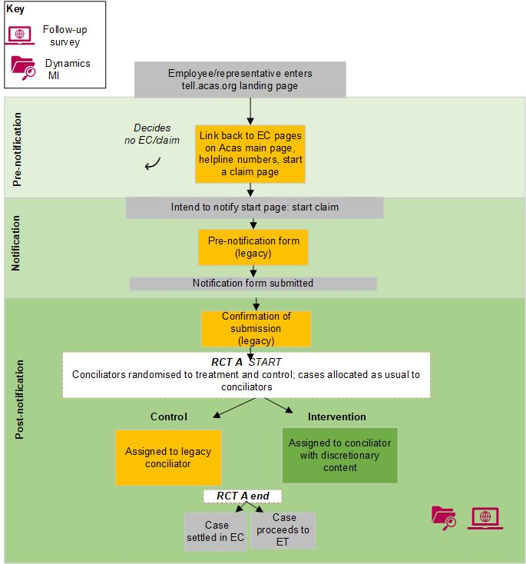

### A.2.3 Randomised control trial A (RCT A): logic model

#### Rationale and assumptions

* RCT A only tests the post notification content developed during workstream 1 (provided after the notification form is complete and the user has confirmed they want to progress to early conciliation)
* Wider workstream content, including pre-notification content, will be assessed during RCT B
* Assumptions underpinning programme logic model:
  + many of the outcomes will also be applicable to other workstream 1 content
  + owing to the nature of the conciliator teams, the intervention and legacy teams may not be equal in size, but they will include a random mix by experience, training and region
  + conciliators in the intervention group will have training and will take a consistent approach in using the new post notification content
  + most users have the capacity to grasp basic principles of employment law, the best way to resolve their dispute and have clear expectations of where Acas can help
  + most users have the capabilities to engage with the new post-notification digital content

Figure 7.2 shows the logic model for post-notification content, broken down as follows:

1. Input:
   * Workstream 1 and 2 teams (service)
   1. Contractors – content strategist, user designer/service designer (service)
2. Activities:
   1. Identify 4 user journeys, starting at tell.acas.org (service) (from input 1.a)
   2. Disabled users testing. Disability access certificate (service) (from input 1.b)
   3. Conciliator training and briefing on new content (service) (from input 1.a)
3. Outputs:
   1. Automated email (employee/rep) (from activities 2.a) (covered in RCT B)
   2. On tell.acas.org 'Supporting welfare and Understanding timescales' (employee/rep) (from activities 2.a and 2.b) (covered in RCT B)
   3. Simple explanation and signposting to relevant resources (mechanisms) (from activities 2.a) (covered in RCT B)
   4. Post notification discretionary content (mechanisms) (from activities 2.a and 2.c)
4. Short-term outcomes (immediate):
   * Understand if claim is valid (employee/rep) (from outputs 3.a to3.c) (covered in RCT B)
   1. Exhausted internal appeal process (employee/rep) (from output 3.c) (covered in RCT B)
   2. Understand EC timetable (employee/rep) (from outputs 3.d)
   3. Can access right information at the right time (employee/rep) (from outputs 3.d)
   4. Feel less stressed by EC process (employee/rep) (from outputs 3.d)
   5. Conciliation off to a good start (employee/rep) (from outputs 3.d)
5. Mid-term outcomes (6 weeks):
   * More efficient conciliation process (service) (from short-term outcomes 4.a to 4.d)
   * Better informed about EC process (employee/rep) (from short-term outcomes 4.a to 4.d)
   1. Satisfied with the EC process (employee/rep) (from short-term outcomes 4.e)
6. Impacts (6+ weeks)
   1. More cases settled in early conciliation window (service) (from mid-term outcomes 5.a)
   * Improved application experience (employee/rep) (from mid-term outcomes 5.b to 5.c)

Figure 7.2: Logic model for post-notification content, as tested in RCT A

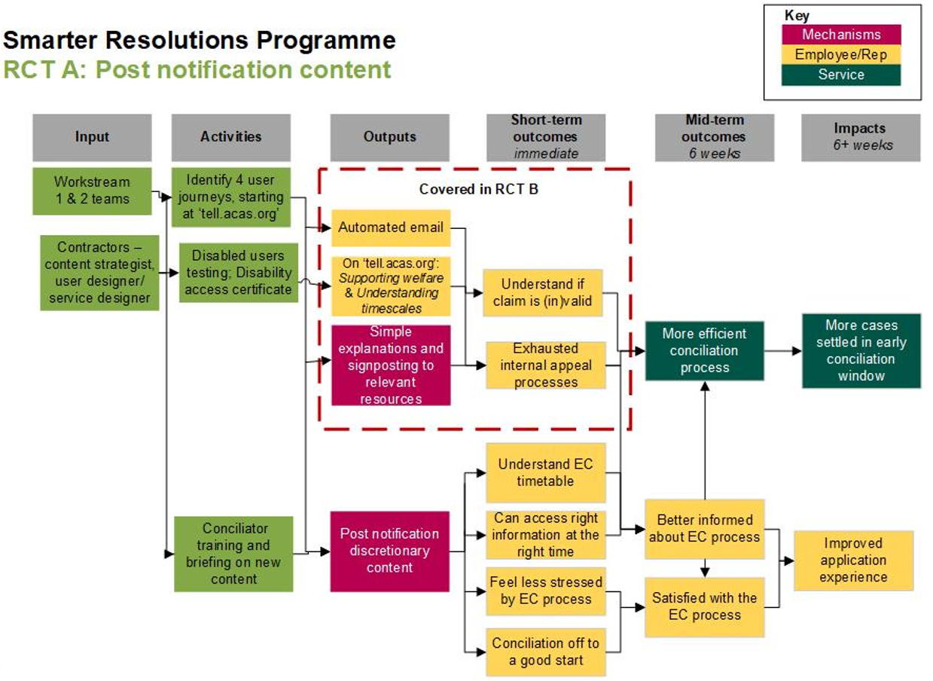

### A.2.4 Randomised control trial A (RCT A): Indicators

The table below presents the key outcomes and related indicators for the intended Workstream 1 post-notification content (tested in RCT trial A) outcomes in a table, and the data sources for evidence against each.

Table 7.3: Outcomes and indicators relating to post-notification content, included in RCT A

|  |  |  |  |  |
| --- | --- | --- | --- | --- |
| **Audience** | **Outcome** | **Indicator** | **Source** | **Timings** |
| Claimant-side service users | Understand early conciliation timetable | Percentage of claimants understanding what the timetable is after initial contact with conciliator | End of early conciliation survey | 6 weeks post-notification |
| Claimant-side service users | Access right information at the right time | Percentage agreeing they had access to the right information at the right time | End of early conciliation survey | 6 weeks post-notification |
| Claimant-side service users | Feel less stressed by the early conciliation process | Percentage feeling stressed after initial contact with conciliator | End of early conciliation survey | 6 weeks post-notification |
| Claimant-side service users | Conciliation off to a good start | Percentage agreeing the process got off to a good start after initial contact with conciliator | End of early conciliation survey | 6 weeks post-notification |
| Claimant-side service users | Better informed about the early conciliation process | Percentage of claimants believing service reflected expectations | End of early conciliation survey | 6 weeks post-notification |
| Claimant-side service users | Better informed about the early conciliation process | Percentage with remaining questions about early conciliation process (and nature of questions) | End of early conciliation survey | 6 weeks post-notification |
| Claimant-side service users | Better informed about the early conciliation process | Percentage of claimants agree award/outcome matched initial expectations | End of early conciliation survey | 6 weeks post-notification |
| Claimant-side service users | Better informed about the early conciliation process | Percentage claimants understanding case | End of early conciliation survey | 6 weeks post-notification |
| Claimant-side service users | Better informed about the early conciliation process | Percentage agreeing information given was accurate | End of early conciliation survey | 6 weeks post-notification |
| Claimant-side service users | Better informed about the early conciliation process | Percentage agreeing they understood conciliator's role | End of early conciliation survey | 6 weeks post-notification |
| Claimant-side service users | Better informed about the early conciliation process | Percentage agreeing that the conciliator gave useful information, relevant to dispute | End of early conciliation survey | 6 weeks post-notification |
| Claimant-side service users | Better informed about the early conciliation process | Percentage agreeing that the process helped them decide whether to take case to employment tribunal | End of early conciliation survey | 6 weeks post-notification |
| Claimant-side service users | Satisfied with early conciliation process | Percentage satisfied with overall early conciliation process | End of early conciliation survey | 6 weeks post-notification |
| Claimant-side service users | Satisfied with early conciliation process | Percentage satisfied with early conciliation outcome | End of early conciliation survey | 6 weeks post-notification |
| Claimant-side service users | Satisfied with early conciliation process | Percentage agreeing early conciliation process was fair | End of early conciliation survey | 6 weeks post-notification |
| Service | More efficient allocation | Average time between notification and allocation | End of early conciliation survey | 6 weeks post-notification |
| Service | More efficient conciliation process | Average time notification and outcome/resolution | Case management system (CMS) | 6 weeks post-notification |
| Service | More efficient conciliation process | Average time between notification and respondent contacted | Case management system (CMS) | 6 weeks post-notification |
| Service | More efficient conciliation process | Percentage claimants perceiving conciliation to be efficient | Case management system (CMS) | 6 weeks post-notification |
| Service | More efficient conciliation process | Percentage agreeing conciliator listened and understood dispute | Case management system (CMS) | 6 weeks post-notification |
| Service | More efficient conciliation process | Percentage agreeing conciliator had the right skills to resolve the dispute | Case management system (CMS) | 6 weeks post-notification |
| Service | More claims reach definite outcome in EC | Percentage of cases reaching definite outcome in EC | Case management system (CMS) | 6 weeks post-notification |
| Service | More claims are settled at EC | Percentage of cases settled at early conciliation stage | Case management system (CMS) | 6 weeks post-notification |

### A.2.5 Randomised control trial A (RCT A): Background on Case management system (CMS) analysis and Acas case level data

Acas manages cases through an information system that tracks cases from their submission to Acas to various stages, allowing Acas administrators, conciliators and other staff to record the progress, events and communications associated with each case. This data can be analysed for the cases in both arms of RCT A that is used to evaluate Workstream 1, content strategy.

In this workstream, post-notification content is tested with half of cases that entered into Acas systems between 25 July and 19 September 2022. These cases were randomly allocated to conciliators sending out new content while, the other half of cases were randomly allocated to conciliators using the old content.

The dataset contains case specific information (such as the notification form), or information about individuals involved in an employment dispute (such as contact details of claimants, respondents, and so on.), or information about transactions (such as events that occur as a case progresses), or characteristics of the case (such as its jurisdictions both during conciliation and as heard in the Tribunal).

There are several identifiers in the database. The key one is the case identifier, which is present in any data that is about a case. It allows linking of the data together, collating details of the case with events in the conciliation process. Typical events include the submission date, the allocation of the case, through to the outcome.

The identifiers for the cases that were allotted to each arm of the randomised control trial were added. This included whether the claimants participated in the end of early conciliation survey and – during the survey – whether they answered yes or no to their survey responses being linked to the Dynamics data. There were 5,097 cases that could be linked of which 2,631 were in the intervention group (Workstream 1, Group 1) and 2,466 were in the control (Workstream 1, Group 2). The early conciliation outcome was within 6 weeks of start in 1,439 cases for the intervention group and 1,429 in the control. 1,487 were then surveyed of which 756 were in the intervention group and 731 in the control.

The data can be linked to non-Acas data. The respondent in the case is usually an organisation and – where this can be matched to a Companies House number – the employer's industry, employment, and other accounting data can be found using the BvD FAME database. This is a database with comprehensive information on both public and private companies across the UK and Ireland. It can be used to research a company in detail or find companies that match a specific criteria. For organisations not registered at Companies House, many could be categorised, for example, NHS trusts, universities, schools, using keywords in their names.

Figure 7.3: Classifying respondents to sectors

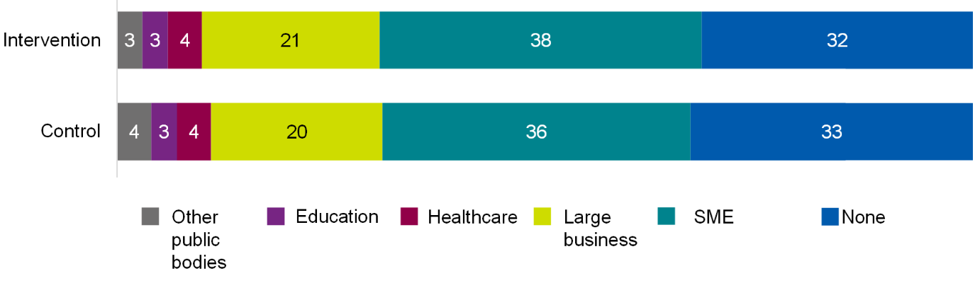

Base: All intervention (1,351); All controls (1,357). Source: case management system.

Table of data for figure 7.3

|  |  |  |
| --- | --- | --- |
| **Sector** | **Intervention** | **Control** |
| Other public bodies | 3% | 4% |
| Education | 3% | 3% |
| Healthcare | 4% | 4% |
| Large business | 21% | 20% |
| SME | 38% | 36% |
| None | 32% | 33% |

Figure 7.3 indicates the proportion of cases where this was possible and the broad categories to which the respondent organisation could be placed. Cases where the organisation could not be categorised are not included. The category 'None' covers where the organisation is blank, such as because the employer is not an organisation.

Most cases involved incorporated entities, around 20% were large businesses, having at least 250 employees, and 37% were small and medium sized enterprises (SMEs). The other 3 categories covered public sector and other unincorporated entities and the coding flags ones with a health or social care focus (hospitals, care homes, and so on) and education.

A split primarily using keywords in the organisation name has measurement issues, but to some extent these measurement issues were less of a concern for the purpose of the evaluation. Organisation is not used in outcome measurement. Rather, it has been used to check that the cases that benefitted from Smarter Resolutions outputs are similar to the counterfactuals. The measurement issues in categorisation are likely to affect both treated and comparator equally, and so results can still be used to indicate that the randomisation leads to a balance between the intervention and control groups, with around the same proportion of respondents in the 6 groupings. For Randomised control trial A (RCT A), the balance is good, suggesting randomisation has worked well.

### A.2.6 Randomised control trial A (RCT A): Non-significant findings

#### Impact on cases reaching definite outcome and settlement

In Acas's case management system, Dynamics 365, each case can be tracked to completion. There were 5,097 cases in Dynamics 365 for the RCT A period. Of these, 4,708 had an outcome recorded in the data. Focusing on the 2,868 that had an outcome within 6 weeks, the figure indicates outcomes and that 'case reaching an impasse' has the largest share (apart from the 'other' category). Figure 7.4 details the outcomes recorded for all cases in RCT A. Settlement (indicated by the issuance of a COT3) occurs in 13% of all cases. The figure also indicates that the share of this outcome across the intervention and control is statistically the same and so the intervention has not affected the level of agreed settlement.

Figure 7.4: Outcomes recorded for RCT A cases within 6 weeks (percentages)

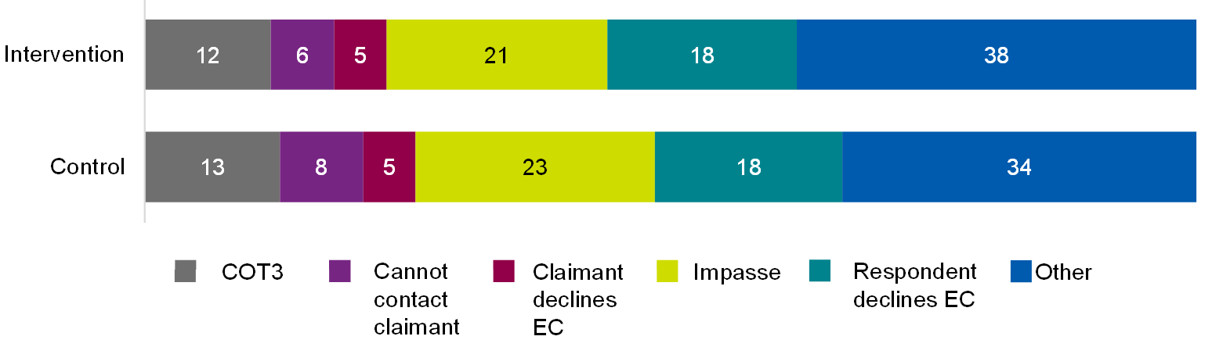

Base: All intervention (1,439); All control (1,429). Source: case management system.

Table of data for figure 7.4

|  |  |  |
| --- | --- | --- |
| **Outcome** | **Intervention** | **Control** |
| COT3 | 12% | 13% |
| Cannot contact claimant | 6% | 8% |
| Claimant declines EC | 5% | 5% |
| Impasse | 21% | 23% |
| Respondent declines EC | 18% | 18% |
| Other | 38% | 34% |

#### Impact on case efficiency

As shown in Figure 7.5 there was no significant difference in perceptions of efficiency between the intervention and control group for these claimant-side service users.

Figure 7.5: Service user views on the efficiency of the early conciliation process

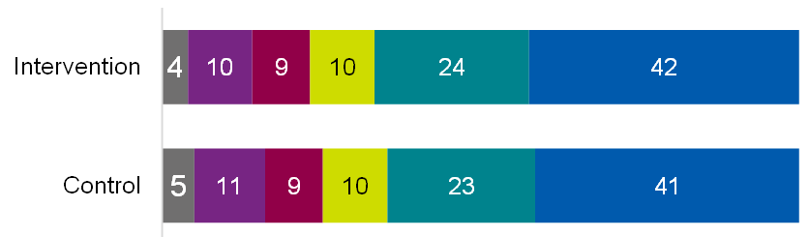



Base: All intervention (756); All control (731)or Intervention claimants (619); Control claimants (603)

Table of data for figure 7.5

|  |  |  |
| --- | --- | --- |
| **Response** | **Intervention** | **Control** |
| Don't know | 4% | 5% |
| Strongly disagree | 10% | 11% |
| Tend to disagree | 9% | 9% |
| Neither / nor | 10% | 10% |
| Tend to agree | 24% | 23% |
| Strongly agree | 42% | 41% |

#### Impact on claimant-side service user experience

As shown in Figures 7.6 to 7.8 below, there were no significant differences between service user experience between those in the intervention and control groups in relation to: whether the process helped them understand case strengths and weaknesses (Figure 7.7); satisfaction for both the early conciliation outcome and the service (Figure 7.7); whether the outcome and service compared to their expectations (Figure 7.8); and, whether the early conciliation process felt fair (Figure 7.9).

Figure 7.6.1: Service user levels of satisfaction of the early conciliation outcome

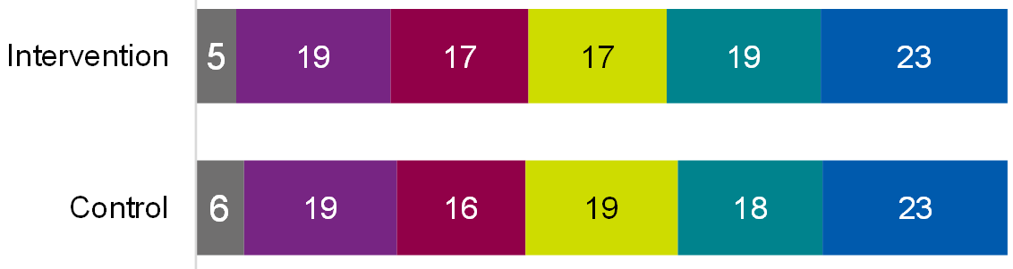



Table of data for figure 7.6.1

|  |  |  |
| --- | --- | --- |
| **Response** | **Intervention** | **Control** |
| Don't know | 5% | 6% |
| Strongly disagree | 19% | 19% |
| Tend to disagree | 17% | 16% |
| Neither / nor | 17% | 19% |
| Tend to agree | 19% | 18% |
| Strongly agree | 23% | 23% |

Figure 7.6.2: Service user levels of satisfaction of the early conciliation service

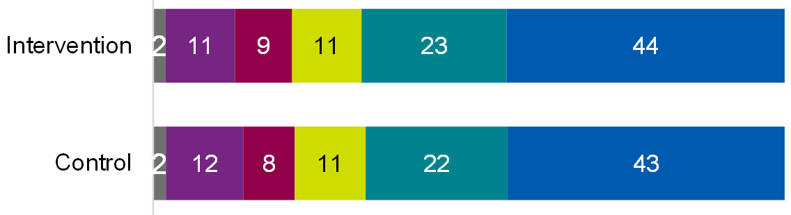



Table of data for figure 7.6.2

|  |  |  |
| --- | --- | --- |
| **Response** | **Intervention** | **Control** |
| Don't know | 5% | 6% |
| Strongly disagree | 19% | 19% |
| Tend to disagree | 17% | 16% |
| Neither / nor | 17% | 19% |
| Tend to agree | 19% | 18% |
| Strongly agree | 23% | 23% |

Base: All intervention (756); All control (731)or Intervention claimants (619); Control claimants (603)

Figure 7.7.1: Service user expectations of the early conciliation process: helped to understand strengths and weaknesses of case

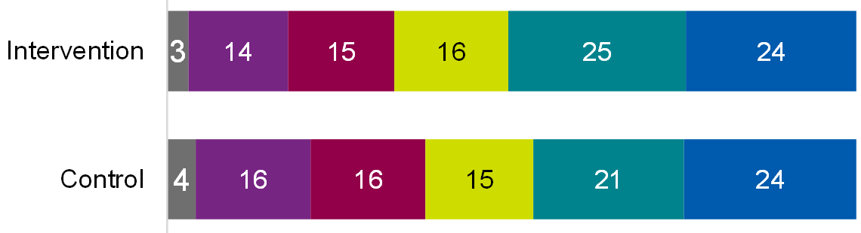



Table of data for figure 7.7.1

|  |  |  |
| --- | --- | --- |
| **Response** | **Intervention** | **Control** |
| Don't know | 3% | 4% |
| Strongly disagree | 14% | 16% |
| Tend to disagree | 15% | 16% |
| Neither / nor | 16% | 15% |
| Tend to agree | 25% | 21% |
| Strongly agree | 24% | 24% |

Figure 7.7.2: Service user expectations of the early conciliation process: outcome met expectations

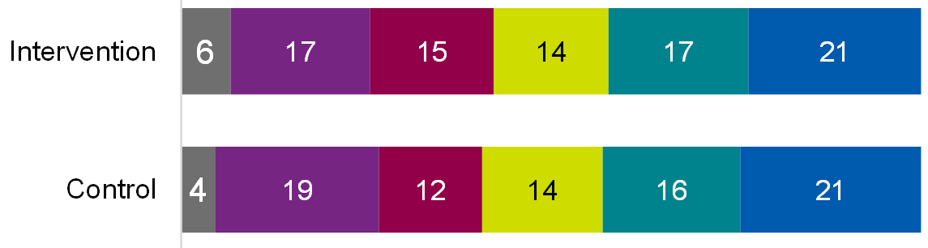



Table of data for figure 7.7.2

|  |  |  |
| --- | --- | --- |
| **Response** | **Intervention** | **Control** |
| Don't know | 6% | 4% |
| Strongly disagree | 17% | 19% |
| Tend to disagree | 15% | 12% |
| Neither / nor | 14% | 14% |
| Tend to agree | 17% | 16% |
| Strongly agree | 21% | 21% |

Figure 7.7.3: Service user expectations of the early conciliation process: overall met expectations

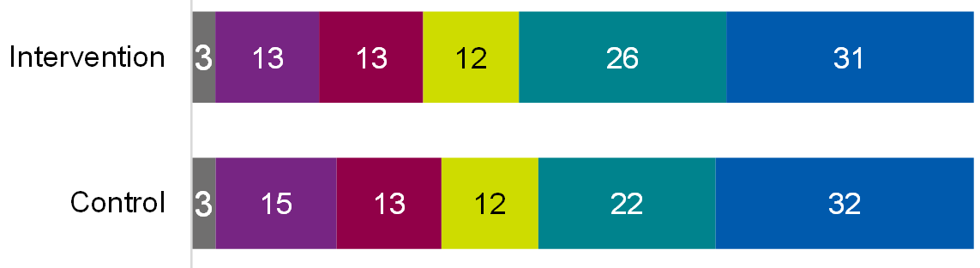



Table of data for figure 7.7.3

|  |  |  |
| --- | --- | --- |
| **Response** | **Intervention** | **Control** |
| Don't know | 3% | 3% |
| Strongly disagree | 13% | 15% |
| Tend to disagree | 13% | 13% |
| Neither / nor | 12% | 12% |
| Tend to agree | 26% | 22% |
| Strongly agree | 31% | 32% |

Base: All intervention (759); All control (731) or Intervention claimants (619); Control claimants (603)

Figure 7.8: Service user views on the fairness of the early conciliation process

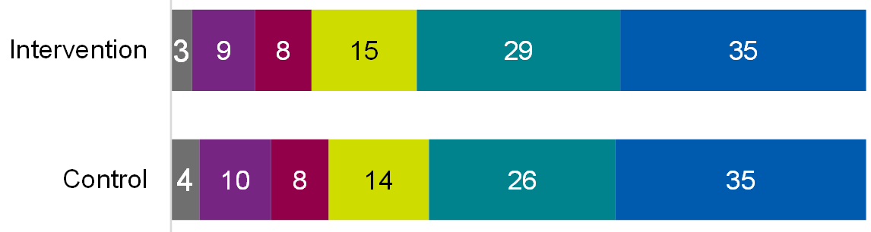



Base: All intervention (759); All control (731) or Intervention claimants (619); Control claimants (603)

Table of data for figure 7.8

|  |  |  |
| --- | --- | --- |
| **Response** | **Intervention** | **Control** |
| Don't know | 3% | 4% |
| Strongly disagree | 9% | 10% |
| Tend to disagree | 8% | 8% |
| Neither / nor | 15% | 14% |
| Tend to agree | 29% | 26% |
| Strongly agree | 35% | 35% |

In addition to being asked about the early conciliation process, claimant-side service users were also asked about their experiences with their conciliators specifically. Questions covered their understanding of the role of the conciliator, their experiences and the information provided by their conciliator. As shown in Figures 7.9 and 7.10, no significant differences were seen between the intervention and control groups in terms of: understanding the role of a conciliator and the early conciliation process (Figure 7.9); and, views on the understanding and skills of conciliators (Figure 7.10);

Figure 7.9.1: Service user views on the initial contact with their conciliator: understanding the conciliator role

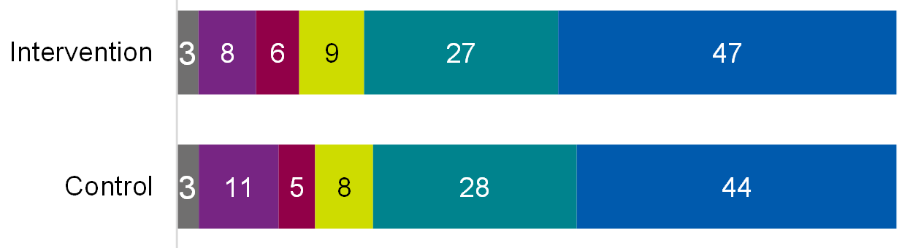



Table of data for figure 7.9.1

|  |  |  |
| --- | --- | --- |
| **Response** | **Intervention** | **Control** |
| Don't know | 3% | 3% |
| Strongly disagree | 8% | 11% |
| Tend to disagree | 6% | 5% |
| Neither / nor | 9% | 8% |
| Tend to agree | 27% | 28% |
| Strongly agree | 47% | 44% |

Figure 7.9.2: Service user views on the initial contact with their conciliator: helped the process get off to a good start

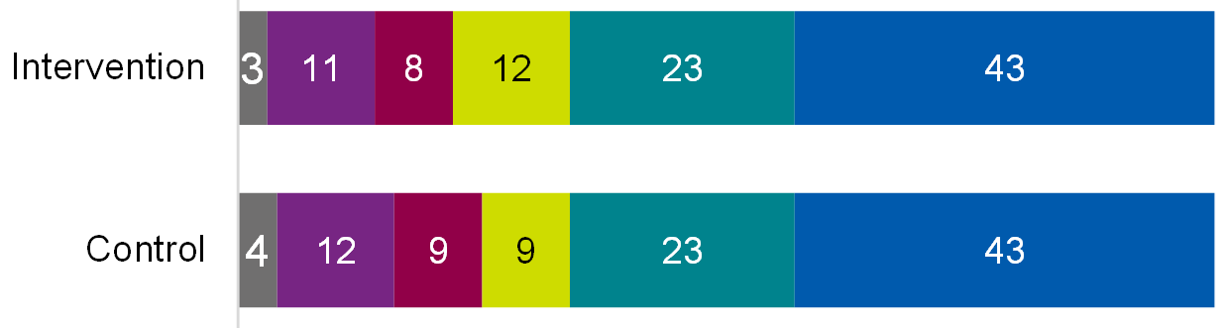



Table of data for figure 7.9.2

|  |  |  |
| --- | --- | --- |
| **Response** | **Intervention** | **Control** |
| Don't know | 3% | 4% |
| Strongly disagree | 11% | 12% |
| Tend to disagree | 8% | 9% |
| Neither / nor | 12% | 9% |
| Tend to agree | 23% | 23% |
| Strongly agree | 43% | 43% |

Base: All intervention (756); All control (731) or Intervention claimants (619); Control claimants (603)

Figure 7.10.1: Service user views on their conciliator: listened and understood

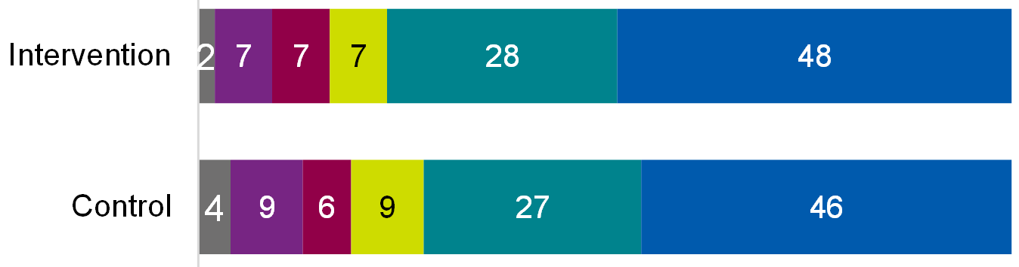



Table of data for figure 7.10.1

|  |  |  |
| --- | --- | --- |
| **Response** | **Intervention** | **Control** |
| Don't know | 2% | 4% |
| Strongly disagree | 7% | 9% |
| Tend to disagree | 7% | 6% |
| Neither / nor | 7% | 9% |
| Tend to agree | 28% | 27% |
| Strongly agree | 48% | 46% |

Figure 7.10.2: Service user views on their conciliator: had the right skills and knowledge

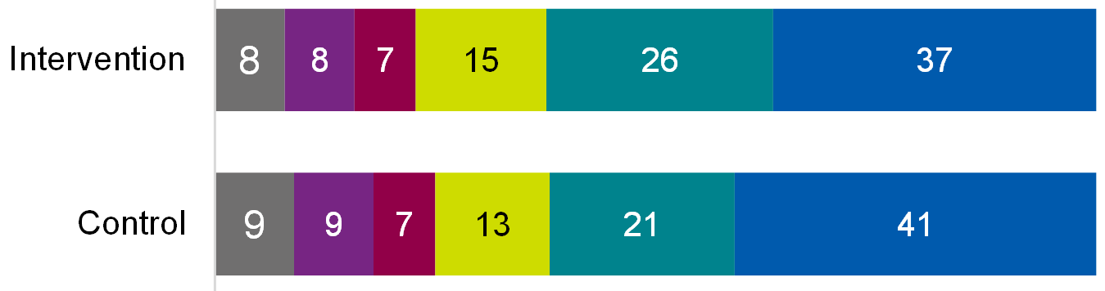



Table of data for figure 7.10.2

|  |  |  |
| --- | --- | --- |
| **Response** | **Intervention** | **Control** |
| Don't know | 8% | 9% |
| Strongly disagree | 8% | 9% |
| Tend to disagree | 7% | 7% |
| Neither / nor | 15% | 13% |
| Tend to agree | 26% | 21% |
| Strongly agree | 37% | 41% |

Figure 7.10.3: Service user views on their conciliator: gave useful information

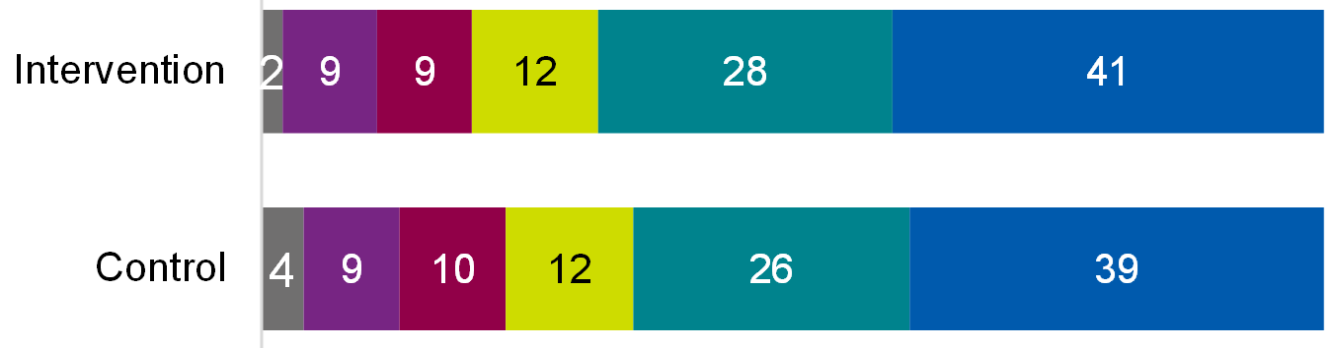



Table of data for figure 7.10.3

|  |  |  |
| --- | --- | --- |
| **Response** | **Intervention** | **Control** |
| Don't know | 2% | 4% |
| Strongly disagree | 9% | 9% |
| Tend to disagree | 9% | 10% |
| Neither / nor | 12% | 12% |
| Tend to agree | 28% | 26% |
| Strongly agree | 41% | 39% |

Base: All intervention (756); All control (731) or Intervention claimants (619); Control claimants (603)

Perceived understanding of early conciliation process

Claimant-side service users were asked about their understanding of the early conciliation process after their initial contact with a conciliator: the 6-week time limit, post-early conciliation options, and the purpose of early conciliation being to resolve a dispute and avoid going to an employment tribunal. As shown in Figure 7.11, no significant differences were seen between the intervention and control groups in this regard.

Figure 7.11.1: Service user views on informativeness of their conciliator: understood the 6-week time limit

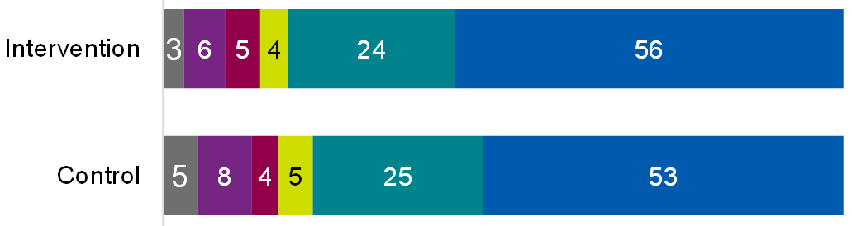



Table of data for figure 7.11.1

|  |  |  |
| --- | --- | --- |
| **Response** | **Intervention** | **Control** |
| Don't know | 3% | 5% |
| Strongly disagree | 6% | 8% |
| Tend to disagree | 5% | 4% |
| Neither / nor | 4% | 5% |
| Tend to agree | 24% | 25% |
| Strongly agree | 56% | 53% |

Figure 7.11.2: Service user views on informativeness of their conciliator: understood the options after early conciliation

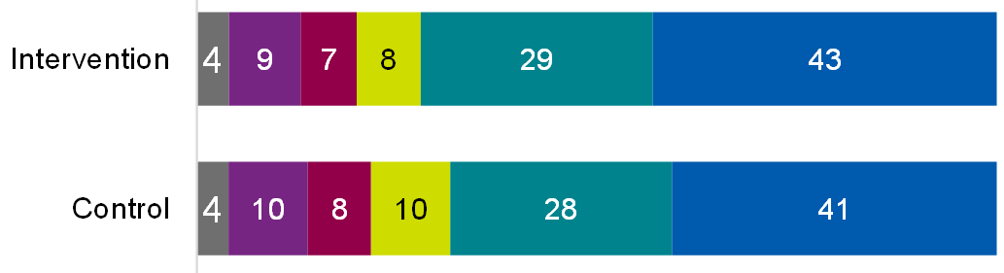



Table of data for figure 7.11.2

|  |  |  |
| --- | --- | --- |
| **Response** | **Intervention** | **Control** |
| Don't know | 4% | 4% |
| Strongly disagree | 9% | 10% |
| Tend to disagree | 7% | 8% |
| Neither / nor | 8% | 10% |
| Tend to agree | 29% | 28% |
| Strongly agree | 43% | 41% |

Figure 7.11.3: Service user views on informativeness of their conciliator: understood that taking part in early conciliation could help resolve the dispute without going to an employment tribunal

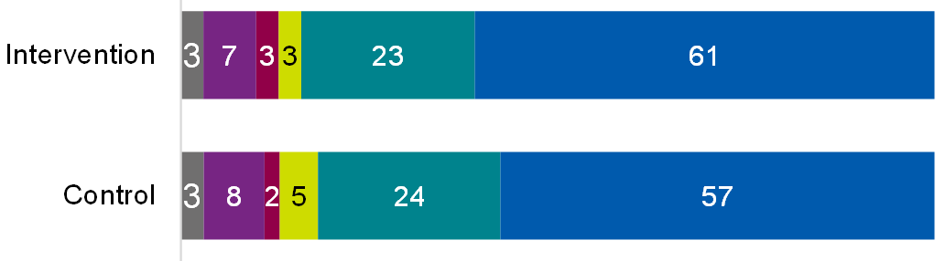



Table of data for figure 7.11.3

|  |  |  |
| --- | --- | --- |
| **Response** | **Intervention** | **Control** |
| Don't know | 3% | 3% |
| Strongly disagree | 7% | 8% |
| Tend to disagree | 3% | 2% |
| Neither / nor | 3% | 5% |
| Tend to agree | 23% | 24% |
| Strongly agree | 61% | 57% |

Base: All intervention (756); All control (731) or Intervention claimants (619); Control claimants (603)

The results show that generally, claimant-side service users understood the process and purpose of early conciliation, and access to the post-notification content did little to increase levels of this understanding. This finding is further supported by the evidence around whether claimant-side service users felt there were any questions not answered. Again, there was little difference between the 2 groups (Figure 7.12).

Figure 7.12: Service user questions about the early conciliation process

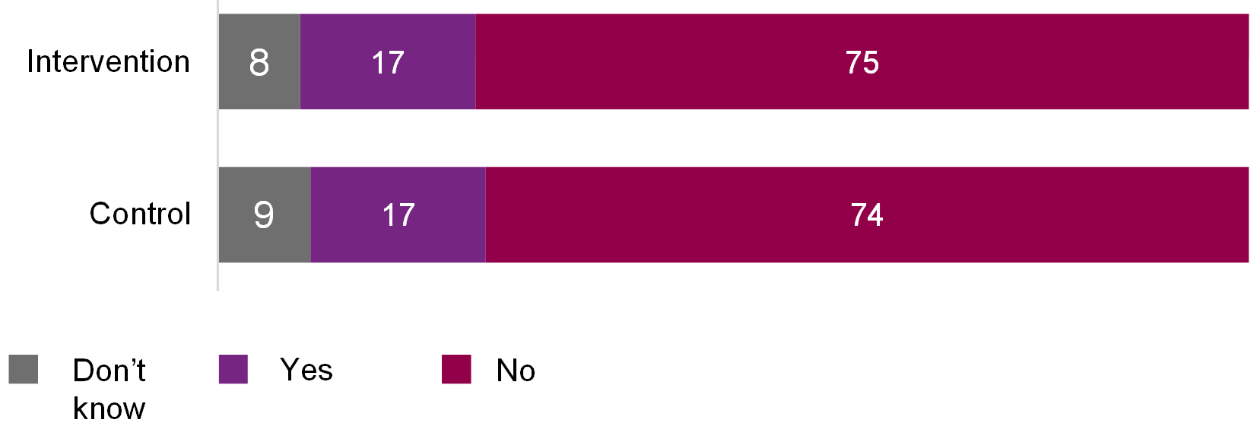

Base: All intervention (756); All control (731) or Intervention claimants (619); Control claimants (603)

Table of data for figure 7.12

|  |  |  |
| --- | --- | --- |
| **Response** | **Intervention** | **Control** |
| Don't know | 8% | 9% |
| Yes | 17% | 17% |
| No | 75% | 74% |

### A.2.7 RCT A: Findings on new content usefulness (non-significant)

There were no significant differences in perceived usefulness of the new content. Proportions stating the content they had seen was useful is shown in Table 7.4.

Table 7.4: Perceived usefulness of new content among services that report engagement (% useful)

|  |  |  |
| --- | --- | --- |
| **Content** | **Intervention** | **Control** |
| Early conciliation process video | 61% | 61% |
| Time limits page | 71% | 75% |
| Emotional support page | 59% | 65% |
| Wages video | 67% | 60% |
| Early conciliation certificate video | 66% | 73% |

Base (Intervention/Control): All reporting engagement with each material – early conciliation process video (276/205); Time limits page (472/434); Emotional support page (142/130); Wages video (52/57); early conciliation certificate video (124/94).

### A.3.1 Overview of new assisted notification content

Table 7.5: Overview of pre-notification content and new assisted notification form features

| **Content** | **Where delivered** | **What the content covers** |
| --- | --- | --- |
| 'Start to find help' content | Across Acas website | This includes the: 1) emotional support page, 2) time limits page, and 3) wages video to aid users when they are at the early information-gathering phase of their dispute journey. |
| 'Intend to notify start page' content | embedded in the <http://www.acas.org.uk/tell> webpage | This includes information embedded in the new assisted notification form. |
| 'Complete the form' content | Embedded throughout the notification form itself and content sent to users after their notification has been received | This includes information embedded throughout the notification form itself and content sent to users after their notification has been received, outlining what to expect next. |

### A.3.2 RCT B Content and Notification Form Logic Model

Figure 7.13 illustrates the logic model for pre-notification content introduced under Workstreams 1 and 2 (RCT B). The rationale and assumptions are:

* Workstreams 1 and 2 believe if employees and their representatives:
  + Received information about the early conciliation process earlier, and relevant to their circumstance, they are more likely to submit a valid claims and be more satisfied with the notification process
  + Are digitally supported through the notification form they will submit complete and accurate information, and valid cases will require less input from Early Conciliation Support Officers (ECSOs) to triage
* Assumptions underpinning the programme logic model:
  + Most users start their EC journey at tell.acas.org
  + Notification form changes do not introduce new issues to form acceptance/conciliation
  + Most users have the capacity to grasp basic principles of employment law, the best way to resolve their dispute and have clear expectations of where Acas can help
  + Most users have the capabilities to engage with the digitally-hosted information and notification form
  + Most claims close by six weeks after notification submitted

The logic models flows as described below:

1. 'Input' contains the following 5 elements:
   1. Workstream 1 and 2 teams
   2. Contractors – content strategist user designer/service designer
   3. Workstream 2 team and conciliators
   4. Contractors – Deloitte, user/service designers
   5. Acas digital team
2. 'Activities' contains the following 5 elements:
   1. Identify 4 user journeys, starting at 'tell.acas.org' (from Input 1.a-b)
   2. Disabled users testing: Disability access or certificate (from Input 1.a-b)
   3. Identify if more claim information required (from Input 1.c-d)
   4. Identify claim issues preventing form acceptance/conciliation (from Input 1.c-d)
   5. Design data infrastructure for case allocation processing (from Input 1.e)
3. 'Outputs' contains the following 7 elements:
   1. Automated email: 'You've notified' and 'Intro to EC' video (claimants/reps) (from Activities 2.a)
   2. Pages on tell.acas.org: 'emotional support' and 'time limits@ (claimants/reps) (from Activities 2.a-b)
   3. Simple explanations and signposting to relevant resources (mechanisms) (from Activities 2.c)
   4. Progressive disclosure and channelling (mechanisms) (from Activities 2c)
   5. Ability to save and return to form (mechanisms) (from Activities 2.c to d)
   6. More space for more detailed case information (mechanisms) (from Activities 2.c)
   7. Form data infrastructure for case allocation processing (service) (from Activities 2.e)
4. 'Short-term outcomes: immediate' contains the following 8 elements:
   1. Understand EC timetable (claimants/reps) (from Outputs 3.a to c)
   2. Understand if claim is valid (claimants/reps) (from Outputs 3.a to c)
   3. Exhausted internal appeal processes (claimants/reps) (from Outputs 3.a to c)
   4. Feel less stressed by EC process (claimants/reps) (from Outputs 3.a to c)
   5. Can access right information at the right time (claimants/reps) (from Outputs 3.c to e)
   6. Digital take-up (service) (from Outputs 3.c to e)
   7. Notification form information complete and accurate (service) (from Outputs 3.c-f, Short-term outcomes 4.f)
   8. Less time from ECSO to triage cases (service) (from Outputs 3.g, Short-term outcomes 4.g)
5. 'Mid-term outcomes: within 6 weeks' contains the following 4 elements:
   1. Better informed about EC process (claimants/reps) (from Short-term outcomes 4.a to c)
   2. Fewer invalid claims (claimants/reps) (from Short-term outcomes 4.a to c)
   3. Satisfied with notification form process (claimants/reps) (from Short-term outcomes 4.a to e)
   4. Less time between notification and first contact with conciliator (service) (from Short-term outcomes 4.g to h)
6. 'Impacts: by 6 weeks) contains the following 3 elements:
   1. Improved application experience (claimants/reps) (from Mid-term outcomes 5.a to c)
   2. More cases settled in early conciliation window (service) (from Mid-term outcomes 5.d)
   3. Improved data quality to inform EC service design and delivery (service) (from Short-term outcomes 4.g)

Figure 7.13: Logic model for pre-notification content introduced under Workstreams 1 and 2 (RCT B)

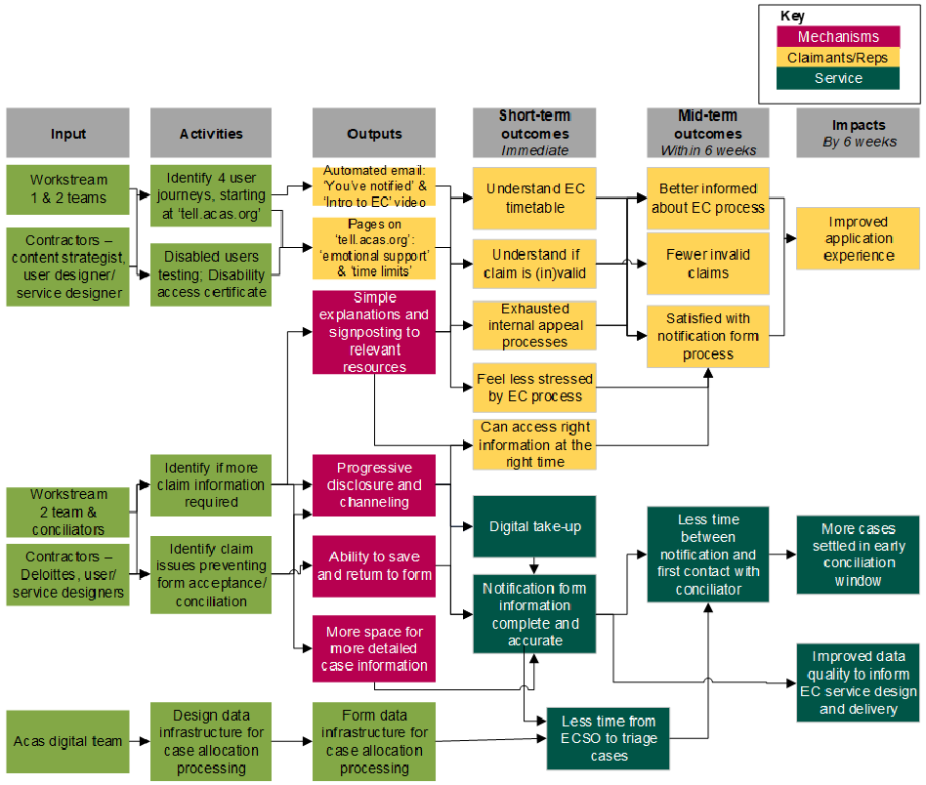

### A.3.3 RCT B user journey

Figure 7.14 shows the user journey for claimant-side services users involved in the RCT B trial. Both groups start with entering the acas.org.uk/tell webpage and clicking 'make individual claim'.

The control group then went through 3 webpage steps to reach the 'intend to notify start page' to start their claim, which was done through Legacy form 1 or Legacy forms 1+2.

The intervention group went through 3 webpages including 'emotional support' and 'time limit' pages, to complete the assisted form.

RCT B ended once the notification form was completed. For both groups, there were 4 potential post-notification journeys:

* Certificate issues (to ET)
* Case closed (invalid)
* ESCO triage (information missing)
* Allocated to conciliator to deliver EC

Figure 7.14: Claimant-side user journey of service users involved in the RCT B trial

A flow diagram illustrating the claimant-side customer journey, described in the text prior to the chart.

## 

### A.3.4 RCT B: Indicators

The table below presents the key indicators for the intended RCT B outcomes in a table, and the data sources for evidence against each.

Table 7.6: RCT B Outcomes and indicators

|  |  |  |  |  |
| --- | --- | --- | --- | --- |
| **Audience** | **Outcome** | **Indicator** | **Source** | **Timings** |
| Claimant-side service users | Understand early conciliation time limits | percentage of claimants feel confident they understand Early conciliation time limits | End of early conciliation survey | 6-week follow-up |
| Claimant-side service users | Understand early conciliation time limits | percentage of claimants feel confident they understand Early conciliation time limits | Pop-up surveys | After leaving 'intend to submit' pages and after submitting notification form |
| Claimant-side service users | Understand if claim is (in)valid | percentage of claimants exiting Early conciliation process before starting notification form b/c recognise claim is invalid | Pop-up survey | After leaving 'intend to submit' pages |
| Claimant-side service users | Understand if claim is (in)valid | percentage of who feel confident their claim will progress to Early conciliation | Pop-up survey | After submitting notification form |
| Claimant-side service users | Exhausted internal appeal processes | percentage of claimants who have completed their organisations D&G progress | Pop-up survey | After leaving 'intend to submit' pages |
| Claimant-side service users | Feel less stressed by Early conciliation process | percentage of claimants who feel process up to and including notification form completion was not exceptionally stressful | End of early conciliation survey | 6-week follow-up |
| Claimant-side service users | Feel less stressed by Early conciliation process | percentage of claimants landing on ''Emotional Support' page compared with views on stressfulness of the notification form completion | Webstats compared with end of early conciliation survey | After 6 weeks |
| Claimant-side service users | Access right information at the right time | percentage of claimants agreeing they had access to the right information at the right time | End of early conciliation survey | 6-week follow-up |
| Claimant-side service users | Better informed about early conciliation process | percentage of claimants believing service reflected their expectations | End of early conciliation survey | 6-week follow-up |
| Claimant-side service users | Better informed about early conciliation process | percentage of claimants believing service reflected their expectations | Pop-up surveys | after leaving 'intend to submit' pages and after submitting notification form |
| Claimant-side service users | Better informed about early conciliation process | percentage of claimants with remaining questions about early conciliation process | End of early conciliation survey | 6-week follow-up |
| Claimant-side service users | Better informed about early conciliation process | percentage of claimants with remaining questions about early conciliation process | Pop-up surveys | after leaving 'intend to submit' pages and after submitting notification form |
| Service | Fewer invalid claims | percentage of invalid claims | Case management system (CMS) | After 6 weeks |
| Claimant-side service users | Satisfied with notification form process | percentage of claimants who agreed with the statement ' I found the notification form easy to complete' | End of early conciliation survey | 6-week follow-up |
| Claimant-side service users | Satisfied with notification form process | percentage of claimants who experience barriers to notification form completion related to progressive disclosure, channelling and save and return form | End of early conciliation survey | 6-week follow-up |
| Claimant-side service users | Satisfied with notification form process | percentage of claimants that returned to complete the notification form later | Case management system (CMS) | 6-week follow-up |
| Claimant-side service users | Improved application experience | percentage of claimants who are satisfied with overall application experience | End of early conciliation survey | 6-week follow-up |
| Service | Digital take-up | percentage of digital users of notification form compared with paper | Case management system (CMS) | After 6 weeks |
| Service | Notification form information complete and accurate | percentage of submissions requiring ECSO to triage the cases | Case management system (CMS) | After 6 weeks |
| Service | Notification form information complete and accurate | percentage of incomplete form fields | Case management system (CMS) | After 6 weeks |
| Service | Less time between notification and first contract with conciliator | percentage of notifications going straight to conciliator or not | Case management system (CMS) | After 6 weeks |
| Service | More cases settled in early conciliation window (6 weeks post-notification) | percentage of cases settled at early conciliation stage | Case management system (CMS) | After 6 weeks |
| Service | More cases settled in early conciliation window (6 weeks post-notification) | percentage of cases go to employment tribunal | Case management system (CMS) | After 6 weeks |
| Service | Improved data quality to inform early conciliation service design and delivery | Staff perceptions | Qualitative research | After 6 weeks |

### A.3.5 RCT B: Background on case management system (CMS) analysis and Acas case level data

Similar to randomised control trial A (RCT A), an extract of the case management system (CMS) data was provided for cases notified to Acas between 24 October and 24 December 2022, with the data taken in early March so that all cases had progressed for at least 6 weeks. There are 22,283 cases in this extract. Of these, analysis focuses on all cases considering their status of the case at the 6-week point.

The dataset contains 14 separate tables, with each of the cases being recorded in some or all of these. As with RCT A, data processing links the data together by case ID and then collates events. For an event, as well as the date, textual or categorical data is included. So, an event such as the notification will be associated with the type of case (for example, standard versus fast). Compilation then constructs a dataset with a row for each case and a series of variables drawing from the event data. Typical events include the submission date, the allocation of the case, through to the outcome.

The outcome of the conciliation process is described in three indicator variables. A first is whether the claim proves invalid, measured using data in incident tables that indicate where a claim is deemed out of scope. A further outcome indicator is whether a case has a definite outcome, which has categories of 'informal resolution', 'COT3', 'Respondent declines EC', 'Cannot contact respondent' and so on.

There are dates associated with events: whether the initial case notification or the drawing up of the certificate (creation variable). These variables are available for all cases that have completed early conciliation. For the indicator used – the reaching of Tribunal - data is incomplete even where the claimant or respondent have declined early conciliation or not reached a settlement. At the time the data was extracted, many cases would not have established the timing of a tribunal.

For RCT B, as well as a data extract soon after the completion of the trial, a further data extraction took place a further 2 months afterwards focusing on the latest records of whether a case went to Tribunal. Some specific analysis on this is presented here, as later extraction of data was not possible for all workstreams.

Table 7.7: Outcome indicators measured using Case management system (CMS)

|  |  |  |
| --- | --- | --- |
| **Outcome** | **Indicator** | **Derived from** |
| Allocation | Key indicator: % of notifications going straight to conciliator or not | Allocation history, looking at cases allocated to final conciliator allocator in one step (ignoring initial allocation to admin team) |
| Outcome | Key indicator: % of cases settled at early conciliation stage | Incident data, focusing on the Acas outcomes COT3, private settlement, informal resolution and out of scope |
| Allocation | % of submissions requiring ECSO to triage the cases | Allocation history, looking at cases returned to early conciliation support officers (ignoring initial allocation to team) |
| Notification | % of incomplete form fields | Notification form data and flag that information is missing |
| Outcome | Key indicator: % of invalid claims | Incident data, focusing on the Acas outcome out of scope |

Many of the Smarter Resolutions interventions assist in the correct allocation of a case, based on an improved understanding in claimants (Workstream 1), clearer claims being made initially (Workstream 2) and automated allocation (Workstream 3). A Dynamics table called Allocation History records the timings of the start of allocation and then each subsequent allocation through to a final conciliator. This sometimes takes only one step and this is a case being placed immediately with a conciliator but, where a case is initially allocated to a conciliator that cannot progress the case, the number of steps to a final allocation can be both counted and characterised.

Allocation can be to a conciliator, identified by the name of an individual. Also, an individual allocation can be to a team, often also a conciliator team, but usually the teams at Acas that do the allocation of cases. When the early conciliation Support team takes part in the pathway of a case to a conciliator can indicate both triage by the team or manually over-riding an automatic allocation and this, combined with other variables can be used to create variables about how a case has been allocated.

There are 2 particular combinations that have been used:

* Straight to conciliator – This is where the first entry on the history is the final allocation, and is a named conciliator or conciliation team. There are some teams that allocate cases and straight to conciliator includes ones where the cases are allocated in a second step
* Case triaged – Where the allocation pathway involves early conciliation support, this marks a case as being triaged. Where the first step is early conciliation Support and the allocation is automatic (recorded in the Dynamics data with a flag), this indicates early conciliation triage also, as the auto allocation algorithm determines the team's input to allocate the case is needed

The pathways did also indicate case reallocations between conciliators, and the approach to measure this was to count the number of steps to reallocation. This was preferred over tagging cases where the conciliator changes as it gave more information about the pathways' length. However, as noted in the second bullet, a case pathway involving allocation after initial phase to early conciliation support, and subsequent reallocation, is used to also indicate the case has been triaged.

There are 2 allocation outcomes measured, one looking at direct allocations to the conciliator (called 'Goes straight to conciliator' in results below) and a second marking the cases where there is evidence of early conciliation Support team triage, called ('Requires ECSO triage').

#### Analysing effects of Workstream 2: Results from RCT B

The identifiers for the cases – each case has a unique identifier – that were associated with the cases in each arm of the RCT B were added into extracts of data from Acas's Dynamics case management system. There were 22,283 cases that could be linked of which 8,747 were in the intervention group and 13,536 were in the control. There were 8,668 and 12,821 in each arm after first extraction, removing duplicates, or where a key variable was missing. The early conciliation outcome was within 6 weeks of start in 4,298 cases for the intervention group and 8,337 in the control group.

It was expected that the proportion of cases in each arm would be approximately equal, however, this was not the case. Investigations by Acas showed that a number of cases had bypassed randomisation, resulting in larger numbers entering the control group. This predominantly happened in cases involving a large number of claims submitted by representatives. In these circumstances, the representatives had automated systems that submitted claims through saved links that led directly to the old notification form. This resulted in these cases bypassing randomisation, and there was evidence that these cases did differ from the average so had the potential to bias results.

Figure 7.16 highlights one of the effects of this, with an imbalance between the types of organisations in the control and intervention groups. This categorisation was achieved using the same processes as described for RCT A. The automation was known to be occurring in public bodies, and the cases involving public bodies was therefore higher in the control as a result.

Figure 7.16: Proportion of respondents by sector for RCT B

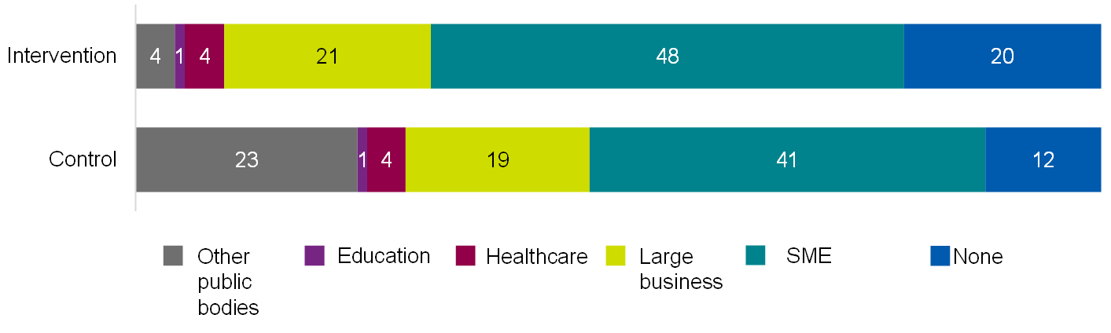

Base: All intervention (4,531); All control (4,773). Source: case management system.

Table of data for figure 7.16

|  |  |  |
| --- | --- | --- |
| **Sector** | **Intervention** | **Control** |
| Other public bodies | 4% | 23% |
| Education | 1% | 1% |
| Healthcare | 4% | 4% |
| Large business | 21% | 19% |
| SME | 48% | 41% |
| None | 20% | 12% |

To control for this effect, different options were considered, primarily removing the affected cases from the control group or using statistical matching to rebalance the control group. In consultation with the evaluation working group (which governs the Smarter Resolutions evaluation), the decision was made to conduct further analysis removing the affected cases.

Table 7.8 compares the RCT B results with the affected cases included, alongside the results when these batches of cases are removed. Removing batches was primarily undertaken by removing the cases identical in terms of the employer, jurisdiction and whether a representative was used. The approach removed, as expected, significantly more cases from the control than the intervention group.

Table 7.8.1: Indicators for cases in RCT B with affected cases (percentage difference between intervention and control)

|  |  |  |
| --- | --- | --- |
| **Days taken to…** | **Difference** | **Significance** |
| Allocate case | 0.9 | At 99% |
| Early conciliation outcome | 1.7 | At 99% |

Table 7.8.2: Indicators for cases in RCT B without affected cases (percentage difference between intervention and control)

|  |  |  |
| --- | --- | --- |
| **Days taken to…** | **Difference** | **Significance** |
| Allocate case | 2.4 | At 99% |
| Early conciliation outcome | 5.8 | At 99% |

Base for Tables 7.8.1-7.8.2: All intervention (8,668); All control (12,821) reduced to All intervention (8,411); All control (10,291) when batches removed.

The effect on the days taken to stages of the conciliation does change but remains significant and with the same sign. This means that the results presented earlier using only RCT B are not overly sensitive to bypassing randomisation.

Table 7.9.1: Indicators for cases in RCT B with affected cases (percentage difference between intervention and control)

|  |  |  |
| --- | --- | --- |
| **Case** | **Difference** | **Significance** |
| Goes straight to conciliator | -3.9% | At 99% |
| Reaching a definite outcome | -0.5% | None |
| Requires ECSO triage | -0.6% | None |
| Incomplete forms | -0.6% | None |
| Is invalid | -0.1% | None |

Table 7.9.2: Indicators for cases in RCT B without affected cases (percentage difference between intervention and control)

|  |  |  |
| --- | --- | --- |
| **Case** | **Difference** | **Significance** |
| Goes straight to conciliator | -2.2% | At 99% |
| Reaching a definite outcome | 1.7% | At 99% |
| Requires ECSO triage | 4.1% | At 99% |
| Incomplete forms | -0.7% | At 99% |
| Is invalid | -0.1% | None |

Base for Tables 7.9.1-7.9.2: All intervention (8,668); All control (12,821); reduced to All intervention (8,411); All control (10,291) when batches removed.

Table 7.9 indicates that the removing the affected cases change the results on a number of outcomes. Given these large number of cases have essentially the same characteristics, it is unsurprising that this has biased the results towards the batched cases. The table indicates that these cases are different and so had an impact on the effects of Workstream 2. Excluding these cases also impacts the validity of the trial and so results should be treated with some caution.

While RCT B showed positive and negative impacts on the service, the majority of these become insignificant when the affected cases are removed. This suggests the RCT B results, unadjusted for batches of cases, are probably due to what occurred in the batch cases.

Overall, there are effects from the bypassing, but they appear to be modest on the timing related outcomes and more mixed for the effects on what happens to cases.

### A.3.6 RCT B: Non-significant findings

#### Satisfaction with Early Conciliation service

When asked whether claimant-side service users were satisfied with the early conciliation service, there was no significant difference between the control and the intervention groups.

Figure 7.17: Service users' level of satisfaction during the early conciliation service

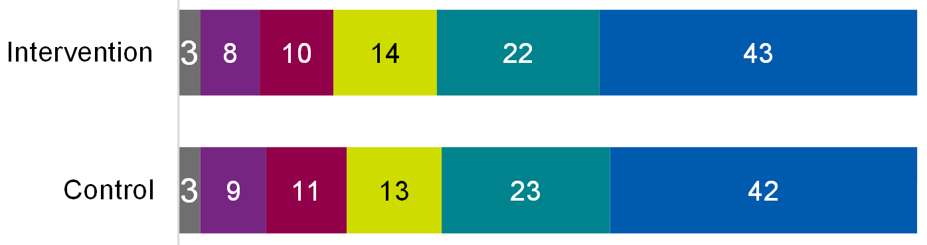



Base: All intervention (1,011); All control (1,266) or Intervention claimants (815); Control claimants (1056).

Table of data for figure 7.17

|  |  |  |
| --- | --- | --- |
| **Satisfaction level** | **Intervention** | **Control** |
| Don't know | 3% | 3% |
| Very dissatisfied | 8% | 9% |
| Somewhat dissatisfied | 10% | 11% |
| Neither / nor | 14% | 13% |
| Somewhat satisfied | 22% | 23% |
| Very satisfied | 43% | 42% |

Claimant-side service users were asked whether they felt satisfied with when they received information in the early conciliation process. There was no significant difference between the intervention and control groups.

Figure 7.18: Service users' views on getting the right information at the right time

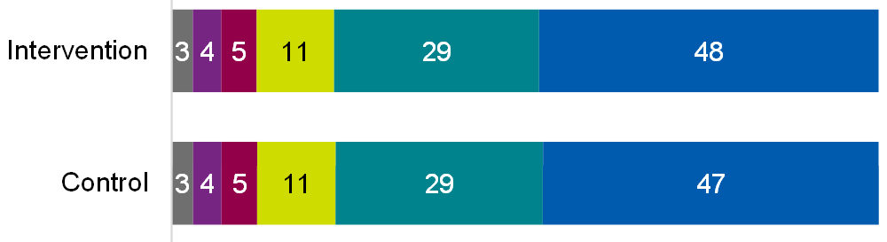



Base: All intervention (1,011); All control (1,266) or Intervention claimants (815); Control claimants (1,056).

Table of data for figure 7.18

|  |  |  |
| --- | --- | --- |
| **Response** | **Intervention** | **Control** |
| Don't know | 3% | 3% |
| Strongly disagree | 4% | 4% |
| Tend to disagree | 5% | 5% |
| Neither / nor | 11% | 11% |
| Tend to agree | 29% | 29% |
| Strongly agree | 48% | 47% |

Claimant-side service users were asked how easy they found the notification form to complete. There were no significant differences between the control and intervention groups.

Figure 7.19: Service users' views on the ease of completing the notification form

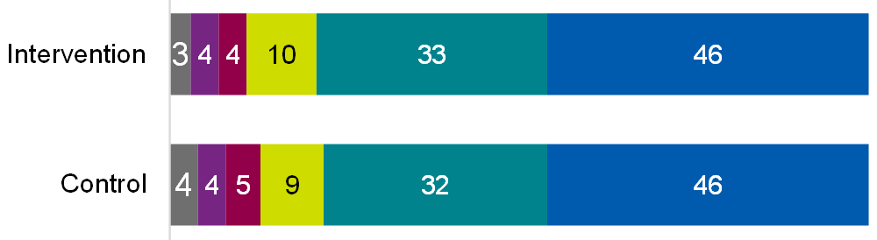



Base: All intervention (1,011); All control (1,266) or Intervention claimants (815); Control claimants (1056).

Table of data for figure 7.19

|  |  |  |
| --- | --- | --- |
| **Response** | **Intervention** | **Control** |
| Don't know | 3% | 4% |
| Strongly disagree | 4% | 4% |
| Tend to disagree | 4% | 5% |
| Neither / nor | 10% | 9% |
| Tend to agree | 33% | 32% |
| Strongly agree | 46% | 46% |

#### Impact on stress levels

Claimants and claimant representatives were asked to what extent they or the individuals they represented felt worried about their dispute both before and after notification. Claimant-side service users in the intervention group were no more likely than the control group to have reduced worry about their employment dispute after submitting their notification (that is, they did not have a lower level in the 5-point score after notifying, compared to before). In both the intervention and control groups, 29% of claimant-side service users had reduced worry following notification. For claimants only, 32% of the intervention group had reduced worry, compared to 31% of the control group.

#### Perceived understanding of early conciliation process

There was no significant difference between the intervention and the control groups in how far they understood what was involved in the early conciliation service at the time of submitting their claim notification form.

Figure 7.20: Claimant-side service users understanding of what the early conciliation service involved

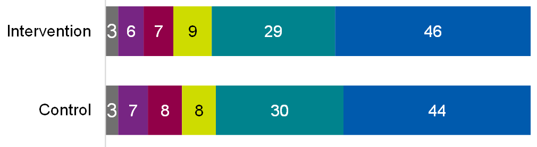



Base: All intervention (1,011); All control (1,266) or Intervention claimants (815); Control claimants (1056)

Table of data for figure 7.20

|  |  |  |
| --- | --- | --- |
| **Response** | **Intervention** | **Control** |
| Don't know | 3% | 3% |
| Strongly disagree | 6% | 7% |
| Tend to disagree | 7% | 8% |
| Neither / nor | 9% | 8% |
| Tend to agree | 29% | 30% |
| Strongly agree | 46% | 44% |

There was no significant difference between the intervention and the control groups in terms of whether they had questions about the early conciliation process, either before or after submitting the notification form.

Figure 7.21.1: Claimant-side service users having further questions about the early conciliation process before starting the notification form

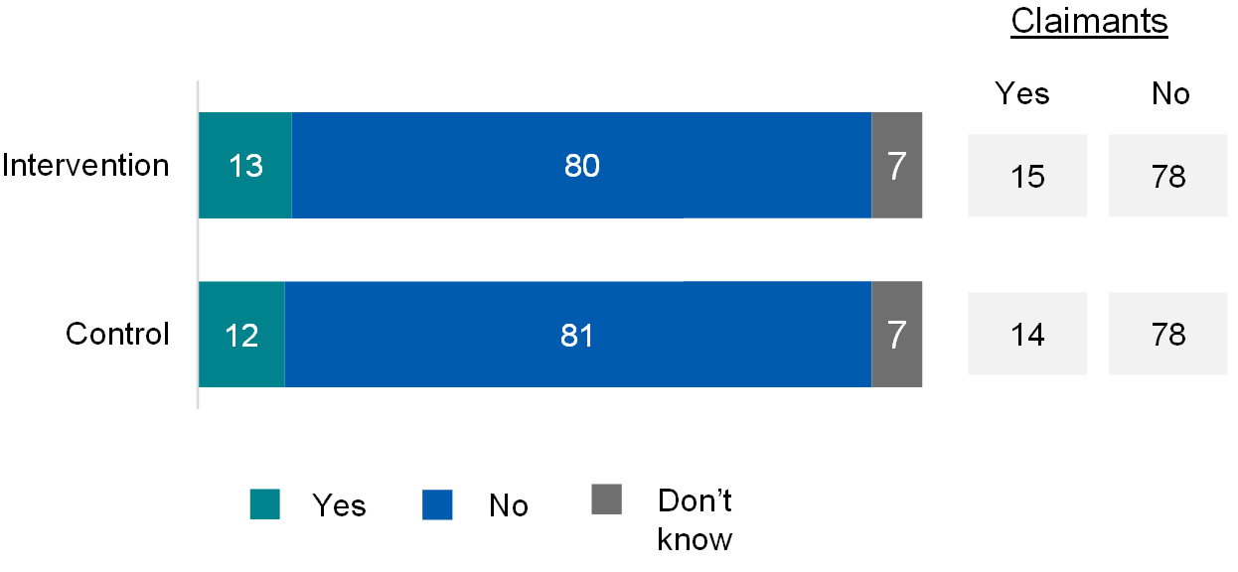

Table of data for figure 7.21.1

|  |  |  |
| --- | --- | --- |
| **Response** | **Intervention** | **Control** |
| Yes (all) | 13% | 12% |
| No (all) | 80% | 81% |
| Don't know (all) | 7% | 7% |
| Yes (claimants) | 15% | 14% |
| No (claimants) | 78% | 78% |

Figure 7.21.2: Claimant-side service users having further questions about the early conciliation process before submitting the notification form

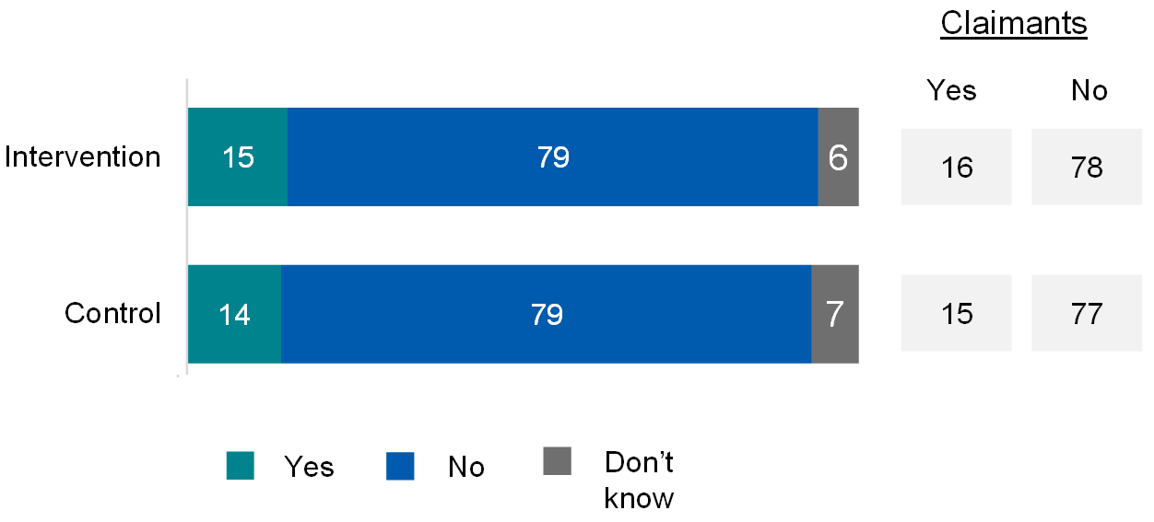

Table of data for figure 7.21.2

|  |  |  |
| --- | --- | --- |
| **Response** | **Intervention** | **Control** |
| Yes (al) | 15% | 14% |
| No (all) | 79% | 79% |
| Don't know (all) | 6% | 7% |
| Yes (claimants) | 16% | 15% |
| No (claimants) | 78% | 77% |

Base: All intervention (1,011); All control (1,266) or Intervention claimants (815); Control claimants (1056)

#### Understanding time limits

There was no significant difference between the intervention and the control groups in terms of whether they understood the 6-week time limit for early conciliation.

Figure 7.22: Claimant-side service users understanding of the 6-week time limit for early conciliation

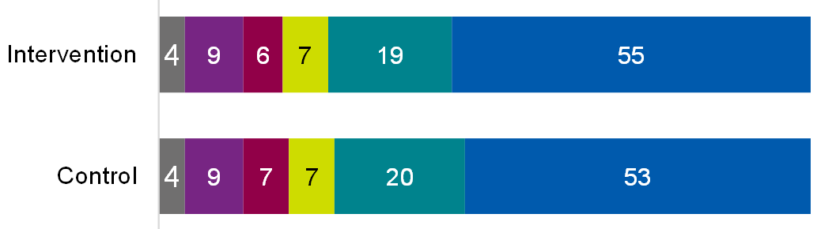



Base: All intervention (1,011); All control (1,266) or Intervention claimants (815); Control claimants (1056)

Table of data for figure 7.22

|  |  |  |
| --- | --- | --- |
| **Response** | **Intervention** | **Control** |
| Don't know | 4% | 4% |
| Strongly disagree | 9% | 9% |
| Tend to disagree | 6% | 7% |
| Neither / nor | 7% | 7% |
| Tend to agree | 19% | 20% |
| Strongly agree | 55% | 53% |

Of all claimant-side service users, those significantly more likely to agree they understood the 6-week early conciliation time limit also found the notification form easy to complete (82%), compared to those who found it difficult (42%).

#### Understanding the validity of a claim

Case management system data analysis showed there was no significant difference in the validity of claims between the intervention and control groups. There was a low proportion of users in the intervention group (2%) and control group (2%) who submitted an invalid claim.

There was no significant difference between the control and intervention groups in terms of whether they felt confident that their claim would be accepted for early conciliation.

Figure 7.23: Whether claimant-side service users felt confident their claim will progress to early conciliation

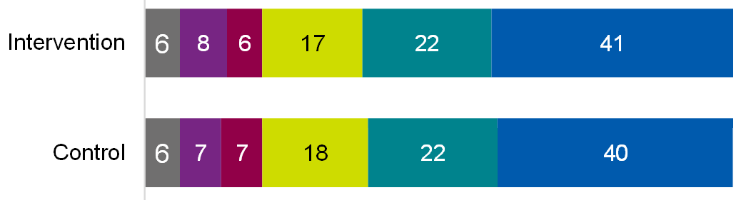



Base: All intervention (1,011); All control (1,266) or Intervention claimants (815); Control claimants (1056)

Table of data for figure 7.23

|  |  |  |
| --- | --- | --- |
| **Response** | **Intervention** | **Control** |
| Don't know | 6% | 6% |
| Strongly disagree | 8% | 7% |
| Tend to disagree | 6% | 7% |
| Neither / nor | 17% | 18% |
| Tend to agree | 22% | 22% |
| Strongly agree | 41% | 40% |

Claimant-side service users were significantly more likely to feel confident that their claim would progress if they: knew what to expect from the early conciliation process, had seen the emotional support page, felt they got right information at right time, found the form easy to complete.

#### Completing the disciplinary and grievances procedure

Claimant-side service users in the intervention group were just as likely to have completed their organisation's disciplinary and grievances (D&G) procedure as those in the control group. Figure 7.24 shows there was no significant difference between the intervention and control groups.

Figure 7.24.1: Whether claimant-side service users engaged in company's disciplinary and grievance procedure

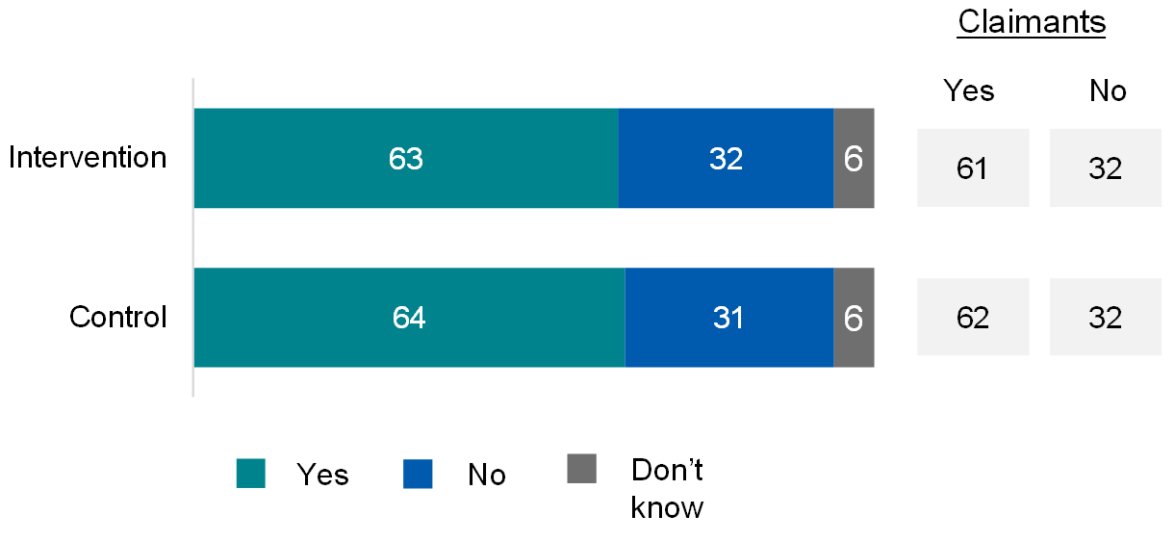

Table of data for figure 7.24.1

|  |  |  |
| --- | --- | --- |
| **Response** | **Intervention** | **Control** |
| Yes (all) | 63% | 64% |
| No (all) | 32% | 31% |
| Don't know (all) | 6% | 6% |
| Yes (claimants) | 61% | 62% |
| No (claimants) | 32% | 32% |

Of those claimant-side service users who had engaged in their organisation's disciplinary and grievances procedure, half (51%) had completed the process. Figure 7.24.2 shows there was no significant difference between the intervention and control groups.

Figure 7.24.2: Whether claimant-side service users completed company's disciplinary and grievance procedure (if engaged in it)

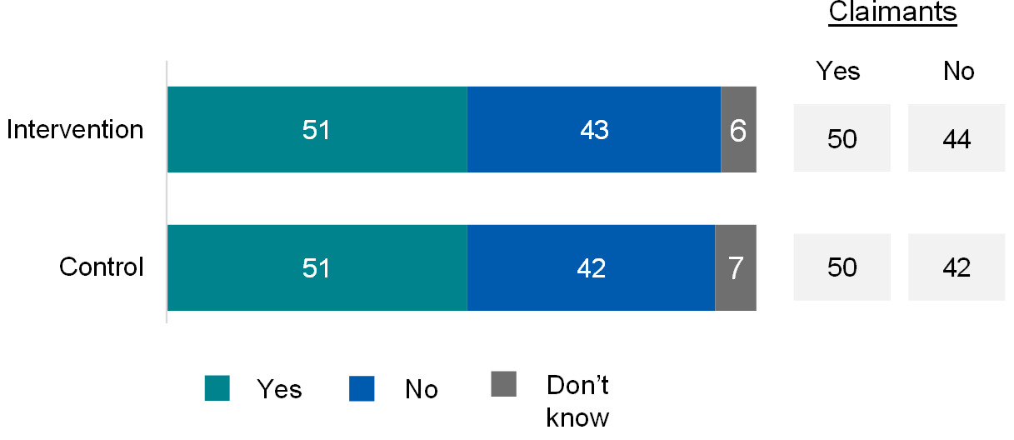

Table of data for figure 7.24.2

|  |  |  |
| --- | --- | --- |
| **Response** | **Intervention** | **Control** |
| Yes (all) | 51% | 51% |
| No (all) | 43% | 42% |
| Don't know (all) | 6% | 7% |
| Yes (claimants) | 50% | 50% |
| No (claimants) | 44% | 42% |

Base: All intervention (1,011); All control (1,266); Intervention claimants (815); Control claimants (1056). All intervention who have engaged in company's disciplinary and grievance process (632); All control who have engaged in company's disciplinary and grievance process (807); Intervention claimants who have engaged in company's disciplinary and grievance process (496); Control claimants who have engaged in company's disciplinary and grievance process (652)

### A.3.7 RCT B findings on new content usefulness (non-significant)

#### Time Limits page

There were no significant differences in perceived usefulness of the new content.

Figure 7.25: Service user views on usefulness of Time Limits page

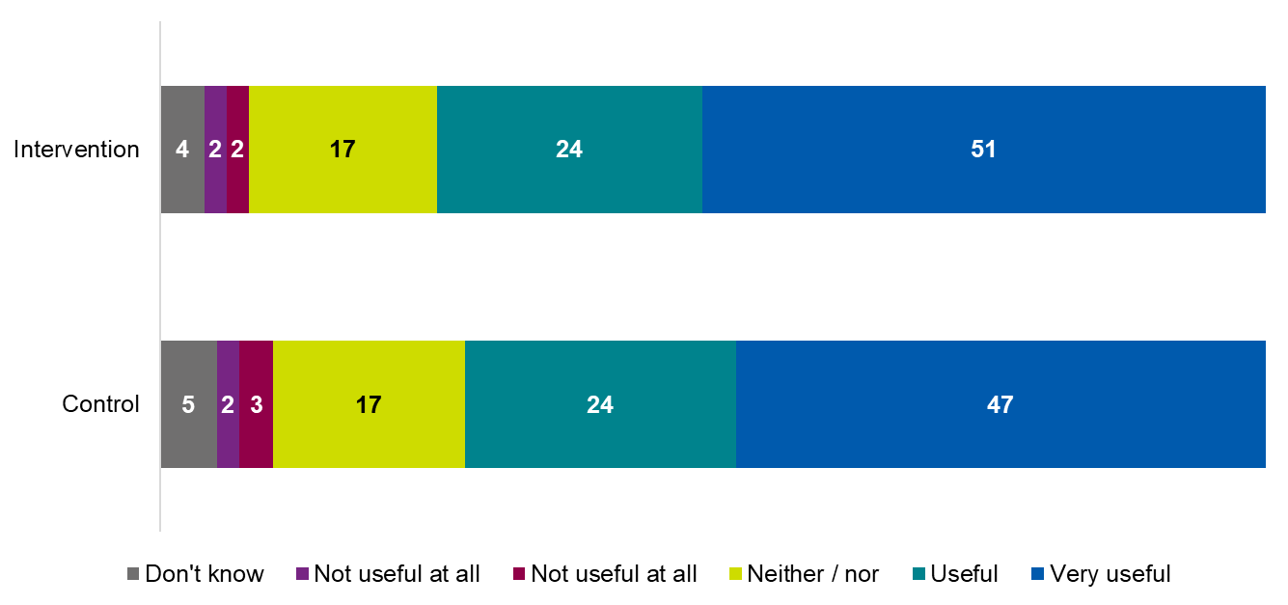

Base: All seen Time Limits page (1478); Control seen page (805) or Intervention seen page (673); Control claimants seen page (702) or Intervention claimants seen page (568)

Table of data for figure 7.25

|  |  |  |
| --- | --- | --- |
| **Response** | **Intervention** | **Control** |
| Don't know | 4% | 5% |
| Not useful at all | 2% | 2% |
| Not useful | 2% | 3% |
| Neither / nor | 17% | 17% |
| Useful | 24% | 24% |
| Very useful | 51% | 47% |

#### Emotional support page

There were no significant differences in perceived usefulness of the new emotional support page.

### A.4.1 Workstream 3: User journey map

Figure 7.26 below outlines the claimant-side service user journey following the submission of an individual claim, both pre and post-implementation of Workstream 3 changes. Under the current system, it takes 2 weeks to allocate to individual conciliators, going through the following steps:

1. Claimant notifies
2. ECSO check and prepare the case
3. Route to CAT Queue
4. Allocation
5. Conciliator email sent
6. Conciliator contacts

The new system and processes should reduce this to 2 minutes, going through the following steps:

1. Claimant notifies
2. Automation checks and allocates – introductory email sent
3. Conciliator contacts

Figure 7.26: Changes to user journey following Workstream 3 implementation

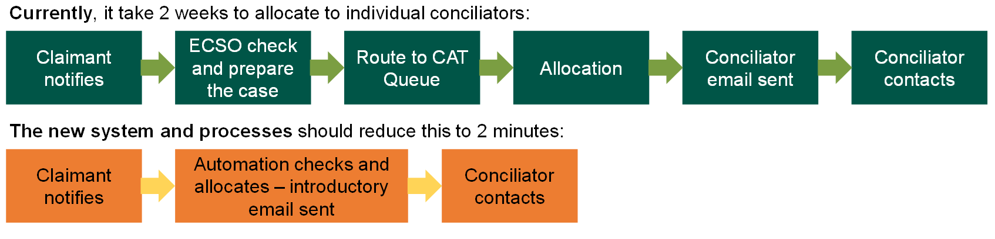

The model captures our understanding of the workstream, including our assumptions of how the programme will operate and how claimants and representatives will experience it (Figure 7.27). It illustrates the mechanisms for change and how activities are translated into impacts.

The rationale for Workstream 3 is that if:

* the systems for capturing information about conciliators work profiles (location, expertise, preference, reasonable adjustment), current caseloads and availability, are integrated, Acas will be able to monitor conciliator resource effectively and accurately; and,
* an automated algorithm for categorising cases, which also considers conciliator resource, is created, most cases can be automatically allocated and go directly from notification to the most suitable conciliator, requiring less administrative input from case allocation team members.

The assumptions underpinning the Workstream 3 logic model are:

* the new notification form and information coming through it will provide data accurate and complete enough for automatic allocation of most cases
* the algorithm will work effectively with all information available to assign to the most suitable conciliator
* information on conciliator work profiles, caseloads and availability are 'live' (that is, up to date with all relevant information)
* conciliators will respond to their allocations at (at least) the same speed as usual (that is, the time saved from notification to allocation is not lost with lags in first contact)
* most claims close within 6 weeks after notification is submitted

To ensure the 'jurisdiction- to-track-to-conciliator' allocation works effectively, Acas need correct, up-to-date information on all conciliators. As such, the first activity undertaken in Workstream 3 was a mapping exercise, creating work and case profiles for all conciliators. Other activities included:

* developing or enhancing processes and tools for capturing conciliator availability and work profiles (resulting mechanism: an effective system for monitoring conciliator resource, availability, and work profile);
* development of an algorithm to increase automation of allocations; and, bringing these together (resulting mechanism: cases organised optimally via an improved engine),
* development of an improved automated allocation system (resulting mechanism: claim is automatically allocated to the most suitable conciliator or team).

The key resulting mechanism underpinning Workstream 3 is that a claim is automatically allocated to the most suitable conciliator (available, correct grade, location and so on.) or team. Note: The mechanisms refer to mechanisms of change. These are the point of connection between specific activities and outcomes that Acas believe will bring about the outcomes. The hypothesis is that these will bring about specific outcomes and the absence of them, or different mechanisms, will not bring about the intended outcomes.

The above outputs are expected to lead to short-term outcomes, at the point of case allocation. These short-term outcomes are:

* most cases go direct from notification to conciliator or team
* reduced time gap from notification to conciliator
* reduction in the volume of cases distributed through case allocation team
* reduced reallocation

Acas hypothesise that if these short-term outcomes are achieved, claimants and representatives will benefit in other ways, within 6 weeks of submitting a claim. These mid-term outcomes are:

* a reduced time gap between notification and conciliator contacting service user
* claims resolved more quickly and efficiently
* a higher proportion of cases settled at early conciliation, as there is more time within the early conciliation window to focus on resolution as opposed to administration
* improved user experience for claimants, respondents and representatives
* allocations perceived as 'fairer' by conciliators
* case allocation team able to focus on more complex or exceptional cases

Ultimately, the efficiencies introduced through Workstream 3 should result in a reduction in administration costs (of case allocation team), an improved early conciliation settlement or resolution rate, and resulting employment tribunal return rate and related time and costs of cases in employment tribunal.

Figure 7.27: Workstream 3 (optimised distribution) logic modelThis is the Workstream 3 logic model, described in the text prior to the image.

### A.4.3 Workstream 3 Indicators

Table 7.10 Workstream 3 outcomes and indicators

|  |  |  |  |  |
| --- | --- | --- | --- | --- |
| **Audience** | **Outcome** | **Indicator** | **Source** | **Timings** |
| Conciliators or Claimants and Claimant Representatives | Claim is allocated to most suitable conciliator or team | Current and potential conciliator  resource availability better estimated or aligned with allocations | Qual | 6-week follow-up |
| Conciliators or Claimants and Claimant Representatives | Claim is allocated to most suitable conciliator or team | Perceptions of relevance of case allocation to conciliator's skills | Qual | 6-week follow-up |
| Conciliators or Claimants and Claimant Representatives | Claim is allocated to most suitable conciliator or team | Confidence in ability to deliver EC | Qual | 6-week follow-up |
| Service | Reduced time gap from notification to being assigned to a conciliator | Average time between notification and being assigned to a conciliator | Case management system (CMS) | After 6 weeks |
| Service | Reduced reallocation | Reduced percentage of cases that require reallocation | Case management system (CMS) | After 6 weeks |
| Service or case allocation team members | Case allocation team able to focus on more complex or exceptional cases | Percentage of cases the case allocation team process that are 'complex or exceptional' | Qual | 6-week follow-up |
| Service | Claims resolved more quickly and efficiently | Perception of improved efficiencies | Qual | A few weeks implementation |
| Service | Claims resolved more quickly and efficiently | Conciliation characterised by more informed, better-quality conversations | Qual | A few weeks implementation |
| Service | Claims resolved more quickly and efficiently | Average time between notification and case outcome | Case management system (CMS) | After 6 weeks |
| Claimants and Representatives | Improved user experience (claimants, respondents and representatives) | Expectations compared to experience of EC | Survey | 6-week follow-up |
| Claimants and Representatives | Improved user experience (claimants, respondents and representatives) | Perceptions of relevance of conciliator's skills to case needs | Survey | 6-week follow-up |
| Claimants and Representatives | Improved user experience (claimants, respondents and representatives) | Ease of communication with conciliator | Survey | 6-week follow-up |
| Claimants and Representatives | Improved user experience (claimants, respondents and representatives) | Satisfaction with case results | Survey | 6-week follow-up |
| Claimants and Representatives | Improved user experience (claimants, respondents and representatives) | Overall satisfaction with conciliator performance/experience | Survey | 6-week follow-up |
| Conciliators | Allocations perceived as 'fairer' by conciliators |  | Qual | A few weeks implementation |
| Service | Higher proportion of cases reaching a definite outcome at early conciliation | Percentage of cases reaching a definite outcome at EC | Case management system (CMS) | After 6 weeks |
| Service | Early conciliation settlement/ resolution rate increases | Percentage reaching definite outcome within EC | Case management system (CMS) | After 6 weeks |
| Service | Early conciliation settlement/ resolution rate increases | Percentage of early conciliation cases settled | Case management system (CMS) | After 6 weeks |

### A.4.4 Workstream 3: Background on Case management system (CMS) analysis and Acas case level data

Workstream 3 was delivered in late 2022 and case allocation was automated in Acas systems from the start of 2023. For the analysis of Workstream 3, the post-implementation sample of cases are those that notified from 27 February to 17 March 2023, with the data extract drawn 28 April. There were 7,366 cases accessed of which 4,844 cases reached an outcome in the statutory 6-week period.

The evaluation of Workstream 3 compared outcomes for cases before changes were made (pre-implementation) and after (post-implementation).

For the pre-implementation period, a dataset of 15,452 cases was provided, of which 8,555 were cases that reached an outcome within 6 weeks. The period for this comparator dataset was January 2022 to May 2022, which was before any of the workstreams would have affected how cases were handled. Also, the period was after the Covid-affected months, when the Acas service would have differed from business-as-usual.

The 2 datasets contain case specific information (such as the notification form), or information about actors (such as contact details of claimants, respondents, and so on), or information about transactions (such as events that occur as a case progresses), or characteristics of the case (such as its jurisdictions both during conciliation and as heard in the Tribunal).

However, it does appear that the manner in which cases are recorded does vary. A Tribunal date is entered for 80% of the cases, far higher than in other extracts of data. Also, the older dataset is extracted with outcomes updated, meaning that comparing outcomes with an extract about more recent cases is problematic where data is derived from the most up-to-date status of an old case, as this will not be comparable to the post-implementation extract.

There are several identifiers in the database. The key one is the case identifier, which is present in any data that is about a case. It allows linking the data together collating details of the case with events in the conciliation process. Typical events include the submission date, the allocation of the case, through to the outcome.

The Smarter Resolutions evaluation assesses impacts using administrative data. This section focuses on the use of Acas's case level data and using it to assess outcomes of Workstream 3 of the programme, which focused on automating the distribution of claims. The workstream directs cases to the most appropriate and available conciliator, using an automated algorithm.

#### Estimating outcomes and the underlying Dynamics data

Table 7.11 maps out the outcomes measured under Workstream 3 and the case level Dynamics indicators used to measure them.

Many of the Smarter Resolution interventions assist in the correct allocation of a case, based on an improved understanding in claimants, clearer claims being made initially and automated allocation. A Dynamics table called Allocation History records the timings of the steps in allocation to a conciliator. This sometimes takes only one step. The time taken for this can be determined in the data, and this case would then be allocated directly to a conciliator. The data is also used to track more complex paths to a conciliator, such as where a case is initially allocated to a conciliator that cannot progress the case. The number of steps to a final allocation can be both counted and timed. Also, whether the case requires reallocation after an initial allocation can be identified by the Officer handling the case and then a further allocation to a conciliator. This underpins measures of the time taken and the parties involved in the allocation of a case.

The outcome of the conciliation process[1] is described in a single indicator variable, which has categories of 'informal resolution', 'COT3', 'Respondent declines EC', 'Cannot contact respondent' and so on. In Table 8.4, this is the table (indicated with a T) 'Incident' and the variable (V) in that table is Acas outcome.

There are dates associated with this: the drawing up of the certificate (creation variable) and then the date of the outcome (usually on the day of the certificate creation but not always). These variables are available for all cases that have completed the early conciliation. It is used to define which cases can and cannot be analysed in the evaluation when a data extract is drawn.

Table 7.11: Outcomes measured using case management system (CMS)

| **Outcome** | **Indicator** | **Table-Variable** |
| --- | --- | --- |
| Reduced time gap from notification to being assigned to a conciliator | Average time between notification and being assigned to a conciliator | T: acas_allocationhistory  V: acas_allocationhistorycount |
| Reduction in the volume of cases distributed through case allocation team (CAT) | Percentage of cases distributed through case allocation team (CAT) | T: acas_allocationhistory  V: acas_allocationdate  T: acas_allocationhistory |
| Reduced reallocation | Reduced percentage of cases that require reallocation | T: acas_allocationhistory  V: acas_allocationdate  T: acas_allocationhistory |
| Reduced time gap between notification and first conciliator conversation | Average time between notification and first conciliator conversation | T: acas_relationships  V: acas_typename and createdon |
| Claims resolved more quickly and efficiently | Average time between notification and case closure | T: Incident  V: acas_ecoutcomedate |
| Higher proportion of cases informally at EC | Percentage of cases informally resolved at EC | T: Incident  V: acas_outcome |

Note: T stands for Dynamics table name; V is the variable name within the table.

The table highlights one of the evaluation outcomes that can be derived from these variables, 'Percentage of cases settled at early conciliation stage'. The evaluation outcomes are the variables that are compared to the cases that benefit from Smarter Evaluation workstreams against those that don't to understand additional effects. Settling more cases at early conciliation stage would be a benefit, hopefully reducing the costs of going to Tribunal.

An additional dimension to this is a second outcome that can be measured using the Dynamics data: the time between case start and the outcome. Dates are recorded in Dynamics for the submission and receipt of the claimant's ET1 and then the respondent's ET3 and the start date of the Tribunal. These indicators can be used to identify the claims that go to Tribunal and the time since Acas was informed about the dispute.

#### Identifying the comparators using statistical matching

The earlier workstreams used a randomised control trial to identify cases that acted as the control. In the Workstream 3 impact evaluation, propensity score matching was used to match the post-implementation cases to a set of cases that were as comparable as possible.

The propensity score is the probability of a case being assigned to a particular intervention group, given their observed characteristics or covariates. It is estimated using a probit regression model, where the pre- and post-implementation assignment is the modelled variable, and the covariates are the predictors. The propensity score summarises the covariates into a single value that represents the probability of intervention assignment, making it easier to compare individuals with similar probabilities of intervention.

Propensity score matching involves matching treated individuals (those who experienced the intervention) with control individuals (those who did not experience the intervention) based on their propensity scores. The goal is to create matched pairs or groups of individuals that have similar propensity scores, thereby balancing the covariates between the post-implementation and pre-implementation groups. This matching process reduces the impact of confounding factors and allows for a more accurate estimation of the intervention effect.

The matching aligned the pre-implementation cases to the post- implementation cases in terms of the jurisdiction of the case, the type of respondent, whether the case was linked to a group case and the categorisation of the case as standard (as opposed to fast). Figure 7.28 shows that the share of jurisdictions was very similar before matching, so matching did not need to reweight the pre-implementation cases a great deal. This was also the case for the other variables. The rest of the analysis does however focus on this balanced sample after matching.

Figure 7.28: Jurisdictions cited in post-implementation and pre-implementation cases

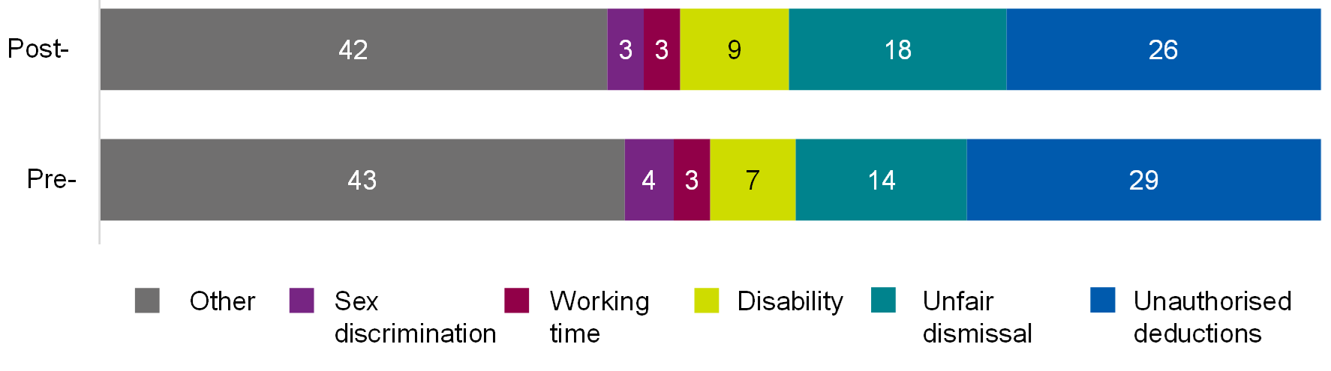

Base: Pre-implementation cases (4,836), post-implementation cases (4,844). Source: case management system (CMS)

Table of data for figure 7.28

|  |  |  |
| --- | --- | --- |
| **Jurisdiction** | **Post-implementation** | **Pre-implementation** |
| Other | 42% | 43% |
| Sex discrimination | 3% | 4% |
| Working time | 3% | 3% |
| Disability | 9% | 7% |
| Unfair dismissal | 18% | 14% |
| Unauthorised deductions | 26% | 29% |

### A.4.5 Workstream 3: Non-significant findings

#### Satisfaction with early conciliation process and ease of early conciliation process

As shown in Figure 7.29, there were no significant differences in response between post-implementation and pre-implementation claimant-side service users in regard to how satisfied claimant-side service users were with the early conciliation service (regardless of case outcome), or how easy they found the process of early conciliation.

Figure 7.29.1: Satisfaction with early conciliation service

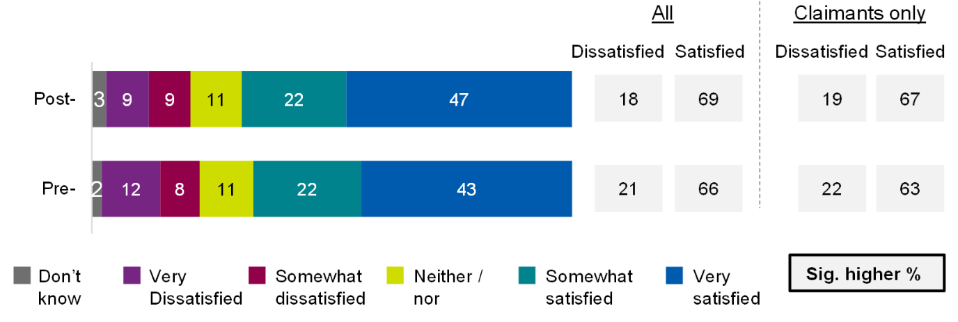

Table of data for figure 7.29.1

|  |  |  |
| --- | --- | --- |
| **Response** | **Post-implementation** | **Pre-implementation** |
| Don't know | 3% | 2% |
| Very dissatisfied | 9% | 12% |
| Somewhat dissatisfied | 9% | 8% |
| Neither / nor | 11% | 11% |
| Somewhat satisfied | 22% | 22% |
| Very satisfied | 47% | 43% |
| Dissatisfied (all) | 18% | 21% |
| Satisfied (all) | 69% | 66% |
| Dissatisfied (claimants) | 19% | 22% |
| Satisfied (claimants) | 67% | 63% |

Figure 7.29.2: Satisfaction with ease of early conciliation process

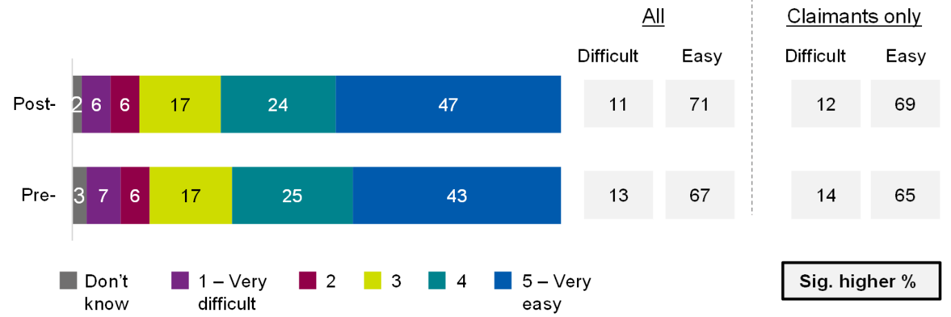

Table of data for figure 7.29.2

|  |  |  |
| --- | --- | --- |
| **Response** | **Post-implementation** | **Pre-implementation** |
| Don't know | 2% | 3% |
| 1 – very difficult | 6% | 7% |
| 2 | 6% | 6% |
| 3 | 17% | 17% |
| 4 | 24% | 25% |
| 5 – very easy | 47% | 43% |
| Difficult (all) | 11% | 13% |
| Easy (all) | 71% | 67% |
| Difficult (claimants) | 12% | 14% |
| East (claimants) | 69% | 65% |

Base: All post-implementation (1,275); All pre-implementation (731). Post-implementation claimants (1,003); Pre-implementation claimants (603)

### A.5.1 Workstream 4: Logic Model

Figure 7.30 below is the Workstream 4 logic model. The model captures our understanding of the workstream, including our assumptions of how the programme will operate and how claimants and representatives will experience it. It illustrates the mechanisms for change and how activities are translated into impacts.

The rationale for Workstream 4 is that if greater automation and quality of data coming through notification is occurring, this will reduce costs of early conciliation and increase time available for resolution.

The assumptions underpinning the Workstream 4 logic model are:

* The new notification form and information coming through it will provide data accurate and complete enough for automatic allocation to the group claims team
* The new system will sufficiently link individual claims together
* Rapport with employer representatives can build when communication from conciliators can happen sooner in the process
* Most claims close by 6 weeks after notification submitted

The key mechanisms developed through the service design work are:

* An effective system for auto-allocating large cases to the group cases team
* A new notification form which allows additional information (open text boxes where claimants can explain the details of their case) and permission to speak to respondent(s) first. The development of this form took place in 2 phases, the second version of the new form was not rolled out until January 2023 and hence sits outside of this evaluation
* A respondent allocations report to help the group cases team spot 'same facts same respondent' cases
* An effective system for auto-allocating large cases to the group cases team

The above outputs are expected to lead to short-term outcomes:

* Claimant representatives have an improved experience of completing a group notification form
* There is a reduced time gap from notification to group cases team contacting employer representatives, resulting in improved relationships between conciliators and this group
* Less work done by other conciliators before large group cases are transferred to the group cases team
* Greater proportion of large group claims are allocated directly to the group cases team
* A reduced time gap from notification to allocation to the group cases team, and resulting reduced time gap from notification to first contact with a conciliator

Acas hypothesise that if these short-term outcomes are achieved, the service, claimants and representatives will subsequently benefit in other ways. These mid-term outcomes are:

* Stronger relationships between conciliators and representatives which will lead to early warning about potential upcoming large group claims which might in turn lead to earlier warning of potential collective disputes (where a group of employees bring a case against an employer as opposed to several employees bringing individual linked cases).
* Collective disputes can include legal action, but also many other workplace disputes such as annual pay reviews, other pay issues, contract terms and conditions, changes in working practices, discipline and dismissal, if an employee representative or a group of people are involved, redundancy consultation and redundancy selection, trade union recognition. These are very important due to their potential impact on workplaces and wider society.
* Improved user experience for claimants, respondents and representatives.

Ultimately, the efficiencies introduced through Workstream 4 should result in more effective conciliation for large cases and more large cases settled in conciliation.

Figure 7.30: Workstream 4 Large Group Claims Logic Model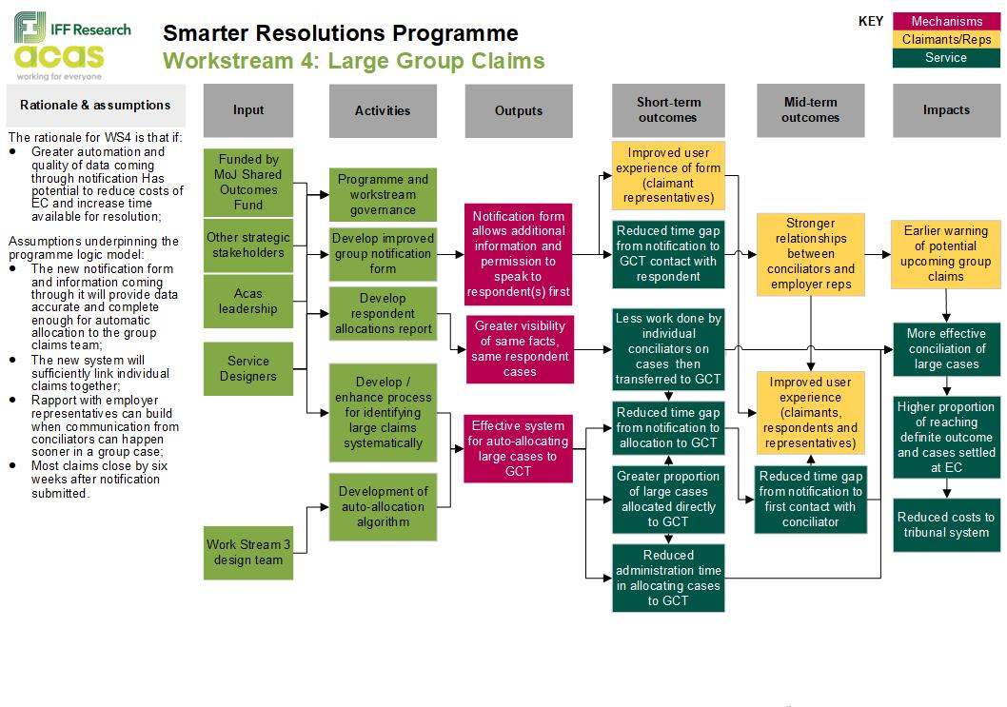

### A.5.2 Workstream 4: Indicators

This will introduce the key indicators for Workstream4 outcomes in a table, and the data sources for evidence against each.

These outcomes and impacts for WS4, and the associated indicators for measuring them are summarised in the evaluation framework below.

We will be able to compare pre and post-implementation cases in the Case management system (CMS), supported by insight from qualitative interviews.

Table 7.12: Indicators attributed to each outcome under Workstream 4

|  |  |  |  |  |
| --- | --- | --- | --- | --- |
| **Audience** | **Outcome** | **Indicator** | **Source** | **Timings** |
| Service | Reduced time gap from notification to GCT contact with respondent | Not applicable | Qualitative interviews | After 6 weeks |
| Claimants or Representatives | Reduced time gap from notification to conciliation | Average time between initial notification and first conciliator conversation | Case management system (CMS) | After 6 weeks |
| Service | Reduced time gap from notification to first contact with conciliator | Average time between initial group notification and first non-automated conciliator contact | Case management system (CMS)  Qualitative interviews | After 6 weeks |
| Service | Reduced time gap from notification to allocation | Average time between initial group notification and first allocation to GCT  Average allocation count (how many times did the group case change hands in its life) | Case management system (CMS) | After 6 weeks |
| Conciliators | Less work done by other conciliators on cases that are then transferred to GCT | Average allocation count (how many times did the group case change hands in its life) | Case management system (CMS) | After 6 weeks |
| Service | Greater proportion of large cases allocated directly to GCT | percentage of group cases (MU numbers) with 10-250 claimants that are handled by the GCT | Case management system (CMS) | After 6 weeks |
| Conciliators and Employer representatives | Stronger relationships between conciliators and employer reps | Conciliators report stronger relationships | Qualitative interviews | After 6 weeks |
| Conciliators andr Employer representatives | Representatives provide early warning of upcoming large cases | Conciliators alerted to cases prior to notifications received | Qualitative interviews (May not be possible to observe in timeframes available) | After 6 weeks |
| Claimants and Representatives | Improved user experience | Claimant representatives find group notification form easier or has improved  Claimants and representatives satisfied with handling of case  Claimants and representatives feeling they were given accurate information during their case  Claimants and representatives finding process 'easy' | Qualitative interviews | After 6 weeks |
| Service | Higher proportion of cases settled at early conciliation | Percentage of cases settled (as indicated by COT3 outcome) | Case management system (CMS) | After 6 weeks |

## 

### A.5.3 Workstream 4: Background on Case management system (CMS) analysis and Acas case level data

This section focuses on the use of Acas's case level data to assess outcomes of Workstream 4. Workstream 4 focuses on an optimised service for identifying users who belong to the same workplace dispute and quickly bringing them to the attention of the dedicated 'large group claims' team with the expertise, tools and resourcing to resolve a case efficiently. These claims account for a relatively small number of cases, but the number of claimants involved in each case means they affect quite a large number of individuals.

#### Conciliation outcomes

Acas manages cases through an information system that tracks cases from their submission to Acas to various stages, allowing Acas administrators, conciliators and other staff to record the progress, events and communications associated with each case. This data can be analysed for the large group cases before and after Workstream 4. The compiled data tracks cases from their submission to Acas using the Dynamics management information systems. This section describes the outcome variables that can be derived as the cases are tracked in the management data.

#### Estimating outcomes and the underlying Dynamics data

Table 7.13 maps out the outcomes and the case level Dynamics indicators used to measure the outcome. The outcome of the conciliation process is described in a single indicator variable, which has categories of 'informal resolution', 'COT3', 'Respondent declines EC', 'Cannot contact respondent' and so on. In Table 7.13, this is the T:Incident' and V:acasoutcome.

There are dates associated with this: the drawing up of the certificate (creation variable) and then the date of the outcome (usually on the day of the certificate creation but not always). These variables are available for all cases that have completed early conciliation. It is used to define which cases can and cannot be analysed in the evaluation when a data extract is drawn.

Table 7.13: Outcomes measured using Case management system (CMS)

| **Outcome** | **Indicator** | **Table-Variable** |
| --- | --- | --- |
| Conciliation outcome | Date of submission and start of case | T: acas_notification  V: acas_dateandtimeofsubmission |
| Conciliation outcome | Whether a COT3, informal resolution etc. is the outcome of early conciliation | T: Incident  V: acas_outcome |
| Conciliation outcome | Time to reach outcome | T: Incident  V: acas_ecoutcomedate |
| Claims settled | % of cases settled at early conciliation stage | Not applicable |
| Efficient conciliation | Average time between initial conciliator conversation and outcome/ resolution | Not applicable |
| Tribunal stage | Date of ET1 submission for cases to Tribunal | T: Incident  V: et1_tribunal |
| Tribunal stage | Date of ET1 submission for cases to Tribunal | T: Incident  V: acas_et1submissiondate |
| Tribunal stage | Date of ET1 receipt for cases to Tribunal | T: Incident  V: acas_et1receiptdate |
| Tribunal stage | Date of ET3 submission for cases to Tribunal | T: Incident  V; et3_tribunal |
| Tribunal stage | Date of Tribunal | T: Incident  V: tribunal_start |
| Allocation performance | Count of allocations and re-allocations | T: acas_allocationhistory  V: acas_allocationhistorycount |
| Allocation performance | Date of individual allocation | T: acas_allocationhistory  V: acas_allocationdate |
| Allocation performance | Whether allocation was automated | T: acas_allocationhistory  V: acas_isautomaticallyallocated |
| Efficient allocation | % of notifications going straight to conciliator or not | Not applicable |

Note: T stands for Dynamics table name; V is the variable name within the table.

The table highlights one of the evaluation outcomes that can be derived from these variables, 'Percentage of cases settled at early conciliation stage'. This is created at case level coding to one the cases that reached one of the outcomes considered as a concluding a case, a COT3, an informal resolution, out-of-scope and private settlement. For Workstream 4, while settling more cases at early conciliation stage would be a benefit reducing the costs of going to Tribunal, it is less a feature of the large claims. This outcome is less likely as the likelihood of avoiding a Tribunal is probably lower for these claims given their scale and complexity.

An additional dimension to this is a second outcome that can be measured using the Dynamics data: the time between case start and the outcome. The outcomes for large claims after the early conciliation process often relate to the case progressing to Tribunal. Dates are recorded in Dynamics for the submission and receipt of the claimant's ET1 and then the respondent's ET3 and the start date of the Tribunal. These indicators can be used to identify the claims that go to Tribunal and the time since Acas was informed about the dispute.

Many of the Smarter Resolutions interventions assist in the correct allocation of a case, based on an improved understanding in claimants, clearer claims being made initially and automated allocation. A Dynamics table called AllocationHistory records the timings of the start of allocation and then each subsequent steps in allocation to a conciliator. This sometimes takes only one step. The time taken for this can be determined in the data, and this case would then be allocated directly to a conciliator, The data is also used to track more complex paths to a conciliator, such as, where a case is initially allocated to a conciliator that cannot progress the case. T, the number of steps to a final allocation can be both counted and timed. Also, whether the case requires triage by the early conciliation support officers or its allocation to the Group Claims Team can be identified, characterising cases as such. This underpins measures of the time taken and parties involved in the allocation of a case.

#### Acas case level data

Large claims are relatively rare, in comparison to the wider Acas case data. So, an extract of all large claims notified within a 4-month period before the intervention, January - March to June - April 2022, was used as the before intervention sample. This is compared with a sample drawn for all large claims starting notified in the October to December period of 2022.

This led to 944 cases in the pre-intervention period and 1,090 in the post-intervention period. Before the intervention, 349 of the 944 cases, or 37%, had reached an outcome within the 6-week period. In the later period, after Workstream 4 had been implemented, this was the case in 891 (94%) cases out of 1,090. This difference is significant at 1% confidence.

The dataset contains case specific information (such as the notification form), or information about claimant-side service users (such as contact details of claimants, respondents, and so on), or information about transactions (such as events that occur as a case progresses), or characteristics of the case (such as its jurisdictions both during conciliation and as heard in the Tribunal).

There are several identifiers in the database. The key one is the case identifier, which is present in any data that is about a case. Large claims are identified because their early conciliation reference identifiers mark them out. It allows linking the data together collating details of the case with events in the conciliation process. Typical events include the submission date, the allocation of the case, through to the outcome.

The identifier also marks a claim as being large, which was used to extract cases for the analysis both for the before and after Workstream 4 periods. Key findings are in the body of the report.

### A.5.4 Workstream 4: Non-significant findings

Table 7.14.1: Indicators for large claim cases after 6-week period before and after Workstream 4

|  |  |  |
| --- | --- | --- |
| **Large claim…** | **Difference before or after** | **Significance** |
| Requires ECSO triage | -0.8% | None |
| Is invalid | 0.0% | None |
| Is settled | 0.0% | None |
| Went straight to conciliator | -0.4% | None |
| Went straight to GCT | 4.1% | None |

Table 7.14.2: Indicators for large claim cases after 6-week period before and after Workstream 4 (share of cases)

|  |  |  |
| --- | --- | --- |
| **Large claim…** | **After** | **Before** |
| Requires ECSO triage | 3.1% | 3.9% |
| Is invalid | 0.2% | 0.2% |
| Is settled | 1.1% | 1.1% |
| Went straight to conciliator | 55.3% | 55.6% |
| Went straight to GCT | 53.4% | 49.3% |

Base for Tables 7.14.1 and 7.14.2: All intervention (1,090); All control (944) No means not significant.

The early stages of the conciliation processes are relatively similar before and after the implementation of Workstream 4. Around 4% of cases required some Early Conciliation Support Officer input in the pre-implementation cases. While this falls to around 3% in the post-implementation sample, the difference is not significant. The validity of the cases is very high, with this flag being present in relatively few cases.

The allocation process – as already noted – is quick, with over half the cases being allocated to the group case team in the first allocation. This reduces slightly following the intervention. However, this change is insignificant.

1.