

**Research**

Evaluation of Acas Individual Conciliation 2019:

Evaluations of Early Conciliation and conciliation in Employment Tribunal applications

Keiran Pedley, Michael Clemence, Rebecca Writer-Davies, Dylan Spielman

**Ipsos MORI**

September 2020

**Disclaimer**

The views in this Research Paper are the authors' own and do not necessarily reflect those of Acas or the Acas Council. Any errors or inaccuracies are the responsibility of the authors alone.

For any further information on this study, or other aspects of the Acas research programme email [**research@acas.org.uk**](mailto:research@acas.org.uk)

Acas research publications can be found at

[**www.acas.org.uk/researchpapers**](http://www.acas.org.uk/researchpapers)

Published by Acas

© Acas

**Acas Research Paper**

**Evaluation of Acas Individual Conciliation 2019:**

|  |  |  |
| --- | --- | --- |
| **Evaluations** | **of** | **Early Conciliation and** |
| **conciliation** | **in** | **Employment Tribunal** |
| **applications** |  |  |

**September 2020**

**Keiran Pedley, Michael Clemence, Rebecca Writer-Davies, Dylan Spielman (Ipsos MORI)**

## DISCLAIMER

This is an independent, evidence-based research paper produced by Keiran Pedley, Michael Clemence, Rebecca Writer-Davies and Dylan Spielman of [Ipsos MORI](https://www.ipsos.com/ipsos-mori/en-uk)

The views in this research paper are the authors’ own and do not necessarily reflect those of Acas or the Acas Council. Any errors or inaccuracies are the responsibility of the authors alone.

## CONTENTS

1. PREFACE 5
2. GLOSSARY 6
3. KEY FINDINGS & TRENDS AT-A-GLANCE 7
4. EXECUTIVE SUMMARY 10
5. INTRODUCTION AND CONTEXT 19
6. INTRODUCTION TO THE EVALUATION OF EARLY CONCILIATION 27
7. PROFILE OF PARTIES AT EC AND THEIR DISPUTES 28
   1. Profile of claimants 29
   2. Profile of employers 30
   3. Profile of claimant and employer representatives 31
   4. The workplace dispute 32
   5. End of employment 33
   6. Written policies and procedures 33
8. UPTAKE OF EARLY CONCILIATION 34
   1. Submission of the EC notification form and interaction with the ECSO 34
   2. Employer-initiated EC 38
   3. Claimant decision-making around participating in EC 38
   4. Employer decision-making around taking part in EC 40
   5. Previous knowledge and experience of EC 41
9. THE EARLY CONCILIATION EXPERIENCE 45
   1. Contact with the conciliator 45
   2. Perceptions of the conciliator 48
   3. Time spent on the case / workplace problem 53
   4. Receipt of EC certificate 54
10. SATISFACTION WITH EARLY CONCILIATION AND DRIVERS OF OUTCOME 55
    1. EC outcomes 55
    2. Drivers of successful case outcome 56
    3. Settlement details 59
    4. Reasons for not reaching a settlement 60
    5. Importance of Acas in resolving the dispute 60
    6. Satisfaction with the outcome of EC 62
    7. Satisfaction with the service received from Acas 63
    8. Perceived benefits of EC 69
    9. Non-financial benefits to the employer 70
    10. Future use of Acas 70
11. EMPLOYMENT TRIBUNAL CLAIM DECISION-MAKING 72
    1. Submission (and intention of submission) of an Employment Tribunal claim 72
    2. Decision-making around the submission of Employment Tribunal claims 73
    3. Decision-making around the non-submission of Employment Tribunal claims 74
    4. Likely action in absence of EC 75
    5. Feelings around the decision not to take part in EC 76
12. INTRODUCTION TO THE EVALUATION OF CONCILIATION IN EMPLOYMENT TRIBUNAL APPLICATIONS (‘POST-ET1 CONCILIATION’) 77
13. PROFILE OF PARTIES AT POST-ET1 CONCILIATION 78
    1. Profile of participants 79
    2. Employer characteristics 81
    3. Profile of representatives 82
    4. Case characteristics 85
    5. Comparison of profiles at ET stage and EC stage 86
14. ACAS INVOLVEMENT FOLLOWING ET APPLICATION 88
    1. Initial contact with Acas 88
    2. Uptake of post-ET1 conciliation 91
    3. Reasons for not participating in post-ET1 conciliation 92
    4. Determinants of taking part in post-ET1 conciliation 92
15. THE POST-ET1 CONCILIATION EXPERIENCE 95
    1. Contact with the conciliator 95
    2. Perceptions of the conciliator 98
    3. Overall satisfaction with the service received from Acas 102
16. DETAILS OF ET CASE OUTCOMES 104
    1. Case outcomes 105
    2. Drivers of successful case outcome 105
    3. Settlement details 108
    4. Settlement details 109
    5. Role of Acas in resolving the case 109
    6. Reasons for case withdrawals 111
    7. Determining the ‘Acas effect’ in non-progression to an ET hearing 112
    8. ET hearings 113
    9. Satisfaction with case outcome 114
17. IMPACT OF EC ON THE ET PROCESS 115
    1. Role of EC in uptake of post-ET1 conciliation 116
    2. Perceptions of the conciliator 116
    3. Parties’ own perceptions of the role of EC on the post-ET1 process 118
    4. The use of EC and ET1 conciliation outcomes 120
    5. Prior use of EC and satisfaction with the post-ET1 conciliation service 120
18. CONSEQUENCES OF POST-ET1 CONCILIATION AND FUTURE ACAS USAGE 122
    1. Provision of information by the conciliator 122
    2. Implementation of new procedures 123
    3. Future use of Acas conciliation services 123
19. ACAS INDIVIDUAL CONCILIATION 2019 – CONCLUSIONS ACROSS BOTH EVALUATIONS 126
20. ENDNOTES 132

## PREFACE

This report details the outcomes of two evaluations, covering the services Acas offers users of its Individual Conciliation service – Early Conciliation (EC) and post- ET1 Conciliation. The surveys are the second wave of service evaluations, with the first wave of the EC survey conducted in 2015 and the first wave of post-ET1 survey carried out during 2016.

Both surveys cover user views of the services, including experience of the service, views of the conciliators, satisfaction with the service received, the outcome of the case and likelihood to use the service again in the future. Fieldwork for both surveys was carried out in 2019 and data in both cases is weighted to reflect the overall population of cases recorded in Acas’ management information. Full details for fieldwork and weighting can be found in the technical report.

Throughout the report reference is made to ‘claimant-side’ and ‘employer-side’ participants. This should be interpreted as the total sample of claimants and their representatives, or employers and their representatives, combined unless otherwise stated.

Typically, results are reported only where they are ‘statistically significant’ – that is, the difference between the two figures is large enough that it is possible to say that this difference is also highly likely to exist in the wider population. This is noted in the text by the explicit use of the word ‘significant’ in the commentary and highlighted in tables and charts. Some other, non-significant differences are highlighted where they are pertinent to the discussion – either because they reinforce important findings from a previous study or another question in the survey or because they indicate a notable directional trend that suggests a relationship worth exploring.

Where percentages do not sum to 100, this may be due to rounding of percentages, the exclusion of “don’t know” categories, or multiple answers. Throughout the volume, an asterisk (*) denotes any value of less than half a per cent.

## GLOSSARY

**Individual Conciliation (IC):** An umbrella term that takes in both Early Conciliation and Post-ET1 Conciliation as what are effectively one conciliation service delivered at different time points. The word ‘Individual’ is used to distinguish the service from Collective Conciliation (Acas’ longstanding service for resolving collective employment disputes).

**Early Conciliation (EC):** Acas service introduced April 2014, since when claimants have been required to notify Acas of their intention to lodge an employment tribunal claim and will be offered the opportunity to engage the services of an Acas conciliator, who will seek to resolve the dispute without going to court.

**Post-ET1 conciliation:** Acas’ longstanding service for settling individual disputes after a claim has been submitted to an Employment Tribunal.

**ET1:** The form used to make a claim to an Employment Tribunal

**Employment Tribunal (ET) Fees:** Employment Tribunal fees were introduced in July 2013 and declared unlawful by the UK Supreme Court in July 2017. During the intervening period, fees were required to be paid when a claim form was presented to an ET and prior to the hearing of the claim.

ET fees were payable when EC and Post-ET1 conciliation were last evaluated (in 2015 and 2016, respectively).

**Track:** Acas classification of cases that broadly reflects the old system of ‘three period categories’ whereby ET cases were allocated jurisdictional ‘tracks’:

* ‘Fast track’ cases involving straightforward questions of fact that can be quickly resolved should the case reach a hearing (e.g. non-payment of wages)
* ‘Standard track’ cases involving somewhat more difficult issues and requiring a greater degree of case management (e.g. unfair dismissal)
* ‘Open track’ cases involving the most legally complex issues and generally requiring the most amount of resource to resolve (e.g. discrimination).

**Statistically significant differences:** Where the difference between figures is large enough that it is possible to say that this is also highly likely to exist in the wider population – noted throughout this report by the explicit use of the word ‘significant’.

**Binary logistic regression analysis:** A statistical technique used throughout this study to examine the relationships between a ‘dependent’ variable with multiple ‘independent’ variables (factors which might influence the dependent variable) to identify the most influential measures of association in the data. More detail is available in the technical note.

## KEY FINDINGS & TRENDS AT-A-GLANCE

### Early Conciliation

* Claimant and employer profiles are very similar to that seen in 2015 – with claimants more likely to be represented in 2019 than they were in 2015.
* Employer representatives are more experienced than claimant representatives in dealing with disputes.
* Seventy-five per cent of claimant-side participants said that the information provided by Acas at the point they completed the EC notification form helped them to understand how the Early Conciliation process worked.
* Eighty-two per cent of claimants rated the ECSO support officer as ‘good’ at explaining the EC service but this score has fallen seven points from 2015.
* Awareness of EC is growing. However, some audiences (younger claimants, smaller employers and first-time reps) are less aware of the service than the overall average and may need more support when dealing with cases.
* Around eight in ten survey participants who were in contact with a conciliator were in contact with just one. Seventy-seven per cent of claimant-side and 81 per cent of employer-side EC participants were satisfied with the amount of contact received.
* However, 20 per cent and 15 per cent respectively would prefer more contact – rising to 30 per cent for both audiences among those in contact with more than one conciliator (i.e. users whose cases were handled by teams providing cover for conciliator absence or that changed hands between conciliators; this survey pre-dates subsequent pilots of team-based service delivery).
* Conciliators are rated very positively across a range of professional competencies and behaviour traits but the proportion of both claimant-side and employer-side EC participants rating conciliators as ‘good’ at outlining the employment law as it applied to their case has fallen sharply (15 points and 16 points respectively).
* Satisfaction with the service provided by Acas among EC participants remains very high, with eight in ten satisfied on both the claimant and employer-side.
* Employer-side satisfaction with the Acas service has fallen six points since 2015, likely linked to falling satisfaction with EC outcome (down 11 points) and fewer COT3 settlements recorded in the survey with this audience (those reaching a settlement typically give better satisfaction scores).
* However, regression analysis shows several internal Acas factors can influence the likelihood of a settlement taking place, such as the quality of information given at the notification stage or the frequency and nature of contact with the conciliator(s) during the EC process.
* EC participants on the employer-side who were in contact with more than one conciliator (i.e. their cases were handled by teams providing cover for conciliator absence) tend to be less satisfied with the service provided overall than those in contact with just one. This is not the case for claimant- side participants, although both audiences were less satisfied with the *timeliness of contact* with conciliators where more than one conciliator was used.
* Speed and avoiding a tribunal are seen as key benefits of using EC and the overwhelming majority of survey participants would be prepared to use the service in future if they encountered a similar situation again.
* More than eight in ten of those settling reported a financial settlement and almost all had received their payment by the time of the survey (94 per cent).
* Amongst those submitting an ET claim, practical considerations such as EC not resolving the case or the employer not being willing to engage are cited as key reasons for doing so, along with holding the employer to account or recovering money owed. Two in three of this group say Acas could not have done more.
* Amongst those claimant-side participants deciding *not* to go to tribunal, two-thirds say that Acas was a factor in their decision not to proceed to at least some extent.

### Conciliation in Employment Tribunal applications (‘Post-ET1 Conciliation’)

* Claimant- and employer-side profiles were very similar to the last wave of the survey, with the proportion of employers from larger organisations lower at the ET stage compared with the earlier EC stage – as seen in 2016.
* The proportion of smaller organisations involved in post-ET1 conciliation is larger than it was at the 2016 post-ET1 survey.
* Overall, representation levels for claimants and employers at post-ET1 conciliation have decreased since 2016, although they remain higher than for EC – this may be linked to an increase in the proportion of fast track cases involved in the ET phase for this wave.
* The level of reported service uptake was lower at the post-ET1 stage than it was for EC. Just over half of claimant-side and employer-side participants who had been in contact with Acas since the submission of their ET claim confirmed taking part in conciliation at this point. In EC the comparable figure was 68 per cent, although sampling differences mean comparisons should be made with care and it is possible that reported uptake of post- ET1 conciliation is underestimated due to participant recall1.
* Previous participation in EC (for the same dispute) was identified as an important predictor of participation in post-ET1 conciliation, although this factor had no impact on reported satisfaction with Acas’ services. Recalling receiving an introduction letter from an Acas conciliator was another driver of participation for both audiences.
* Most claimant- and employer-side participants had contact with just one Acas conciliator during post-ET1. Telephone remains the most common method of contact with conciliators overall but employer reps are more likely to use email. Email is growing in importance as a method of communication for both audiences.
* A majority of claimants, employers and their respective representatives were happy with the amount of contact they had with the Acas conciliator.
* Ratings of Acas conciliators remained strongly positive. Conciliators were rated highest for ‘relaying proposals and offers to and from employer / claimant’ (73 per cent among claimant-side participants and 78 per cent among employer-side participants).
* As in 2016, large majorities of both groups taking part in conciliation (8 in 10) reported satisfaction with the service provided by Acas, including clear majorities of service users who did not settle their case through conciliation.
* Around 8 in 10 of those who settled their dispute said that the settlement included a financial payment to the claimant and almost all reported that the claimant had received their payment by the time of the survey (97 per cent of all participants).
* Six in ten claimant-side participants and seven in ten employer-side participants reported that they were satisfied with the outcome of their case, regardless of their views of the service they received from Acas.
* Overall, a majority agreed that Acas’ involvement had been important in moving the parties closer to resolving the dispute, with clear majorities of those who reached a settlement agreeing this was the case. Around half of those who settled agreed that Acas’ involvement had been a factor in resolving the case (3 in 10 disagreed).
* As in 2016, strong majorities of all participants – two-thirds of claimants, employers and both sets of representatives – said that they would make use of Acas conciliation again if they became engaged in another dispute in the future.

## EXECUTIVE SUMMARY

Acas has a longstanding statutory duty to promote the resolution of claims to the Employment Tribunal (ET) in order to avoid recourse to a full tribunal hearing. Under current arrangements this duty is provided in two parts – Early Conciliation (EC) and conciliation in Employment Tribunal applications, which occurs after an ET1 claim form is submitted (‘post-ET1 conciliation’). This report details the outcomes of two 2019 survey evaluations, covering both elements.

In considering the results for these surveys, it important to be mindful of various changes since the prior evaluations in 2015 (EC) and 2016 (post-ET1 conciliation). First, the ET fees regime that had been introduced in July 2013 – 9 months before the introduction of EC – was abolished following the [July 2017 UK](https://eur02.safelinks.protection.outlook.com/?url=https%3A%2F%2Fwww.supremecourt.uk%2Fcases%2Fuksc-2015-0233.html&data=02%7C01%7CASUTHERLAND%40acas.org.uk%7Cc1123b9f83664ed0764908d837b90279%7C06b1a98db4a64e8696c2258ae458ab3b%7C0%7C0%7C637320615044442531&sdata=vDbf9HyX01o1xxPzwh9vwxYKYF4LSIhJn6Bj2fp6OxA%3D&reserved=0) [Supreme Court judgement](https://eur02.safelinks.protection.outlook.com/?url=https%3A%2F%2Fwww.supremecourt.uk%2Fcases%2Fuksc-2015-0233.html&data=02%7C01%7CASUTHERLAND%40acas.org.uk%7Cc1123b9f83664ed0764908d837b90279%7C06b1a98db4a64e8696c2258ae458ab3b%7C0%7C0%7C637320615044442531&sdata=vDbf9HyX01o1xxPzwh9vwxYKYF4LSIhJn6Bj2fp6OxA%3D&reserved=0) branding these fees unlawful. As a result, there has been a substantial increase in Acas conciliation caseloads since the last evaluations. During the intervening period, Acas has also (re)introduced a dedicated fast-track conciliator role. Results for 2019 should therefore be considered against this context of change. Conversely, after these surveys were undertaken in 2019, Acas introduced a new online notification form and case management system and has also piloted alternative models of conciliation delivery. None of these subsequent features were captured in the 2019 surveys, which provide an evaluation of the Individual Conciliation service as it stood in early 2019.

### EARLY CONCILIATION

This is the second evaluation of EC – the first since the abolition of ET fees – and is based on a representative (telephone) survey of claimants, employers and representatives whose EC cases concluded in March and April 2019; 932 claimant- side interviews and 773 employer-side interviews were undertaken. Fieldwork took place between May and August 2019.

### Profile of parties at EC and the dispute

The profiles of claimants, employers and their representatives closely match those from 2015, with the main difference observed being that a greater proportion of claimants used representation this time.

The majority of claimants surveyed were men, working full-time in private sector organisations, and from a white ethnic background. Claimants were also likely to speak English as a first language and be aged between 25 and 55 years old. Around one in five had worked for their organisation more than ten years and a similar proportion were members of a trade union at the time of the dispute. Three in ten reported having a long-term illness or disability.

The profile of employers surveyed was also similar to 2015, a large majority operated in the private sector and more than half in more than one workplace. Seven in ten had an internal HR department and one in four an internal legal department. One in three were members of an employers or staff association and just over two in five operated in large organisations of more than 250 employees.

The most notable difference in the profile of survey participants in 2019 when compared to 2015 was the level of representation among claimants. 38 per cent of claimants used some form of representation in their case, compared with 24 per cent in 2015. Among employers this figure also rose slightly (from 29 to 33 per cent).

Turning to representatives themselves, representatives of both claimants and employers were most likely to be legal professionals. However, while claimant-side reps without a legal background tended to be a friend or family member or a trade union rep, on the employer side non-legal representatives tended to be HR specialists. These differences in profile between audiences may explain why employer-side reps are more experienced with claims than those on the claimant side – with three in four employer reps having dealt with claims for more than 5 years compared to half of claimant reps.

A consistent picture also emerged when comparing the nature of disputes between 2015 and 2019. Three in four (75 per cent) said that the claimant’s employment had come to an end because of the dispute. The most common reasons that a claimant’s employment had come to an end were dismissal (37 per cent) or resignation (27 per cent). Meanwhile, a disconnect is observed between claimant and employer-side survey participants about whether written policies and procedures were in place for cases like those experienced and whether they were followed. Employer-side participants were much more likely than claimant-side participants to say that policies were in place and that they were followed fully during the dispute.

### Uptake of Early Conciliation

The most common reason given by claimant-side participants for submitting an EC notification form continues to be because the claimant ‘had to in order to submit an Employment Tribunal claim…but keen to see if a settlement could be reached beforehand’ (54 per cent). Just 18 per cent did so because they had to in order to submit a tribunal claim without any intention of reaching a negotiated settlement – suggesting most claimants enter the process open to a settlement.

The service provided by the ECSO – the support officer who contacts potential claimants after notification to confirm details and provide information about the service and hence is an important driver in the uptake of EC – was viewed positively. Seventy-five per cent of claimant-side participants agreed that the information provided by Acas at the point they completed the EC notification form helped them to understand how the Early Conciliation process worked, with 82 per cent of claimants rating the Acas support officer as ‘good’ at explaining the Early Conciliation offer. Although the proportion rating the support officer as good is somewhat down on the 89 per cent that said the same in 2015, and the proportion that say ‘very good’ is also down from 71 per cent to 59 per cent, such trends should be viewed in the context that more than eight in ten rate this first stage favourably overall.

The top three reasons that claimant-side participants gave for taking part in EC were ‘to reach a resolution’ (41 per cent), ‘because we / I had to’ (28 per cent) and ‘to avoid an employment tribunal’ (18 per cent). These findings largely follow those witnessed in 2015, although reaching a resolution is now the most commonly cited reason rather than ‘because we / I had to’. On the employer-side, the most

commonly cited reasons for taking part were ‘to reach a resolution’ (37 per cent) and ‘to avoid an employment tribunal’ (18 per cent), with a range of other reasons given beyond these. In terms of why Early Conciliation was *not* accepted, there was no standout reason given by claimant-side participants, while employer-side participants mainly ‘felt there was no case to answer’ (64 per cent).

Although the data does not show an increase in the proportion of claimants and employers choosing to participate in EC, it is encouraging that awareness of the service appears to have grown since 2015. More than half (52 per cent) of claimant- side participants had heard of Acas Early Conciliation prior to their claim (up ten points). Claimant representatives (83 per cent) were more likely than claimants themselves (38 per cent) to recall awareness but the proportion of claimants who are aware is up slightly from 2015 (34 per cent). Meanwhile, knowledge of EC continues to be very high on the employer-side (88 per cent).

Despite the positive trend above, the survey data does identify some audiences where awareness could improve. For example, younger claimants, employers operating in smaller companies and those claimant representatives dealing with a dispute for the first time all exhibit less awareness of Acas Early Conciliation than others. These audiences may require greater levels of support during disputes from Acas in future, as they navigate the conciliation and tribunal process.

### The Early Conciliation experience

A large majority of claimant-side (79 per cent) and employer-side (84 per cent) participants that were in contact with a conciliator dealt with only one. The main method of contact for both audiences tended to be telephone but a significant increase in the proportion using email as the main method of contact is observed for both sides – with reps more likely than claimants or employers to communicate with the conciliator by email. The average number of contacts with a conciliator for both sides was five. For those where EC took place, 77 per cent of claimant-side and 81 per cent of employer-side EC participants were happy with the level of contact experienced. However, one in five claimant-side and 15 per cent of employer-side participants would have preferred more contact (a significant increase from 2015 on the employer-side when this was 8 per cent).

Notably, those in touch with more than one conciliator tended to want more contact – 30 per cent on both the claimant and employer-side, with this group more likely than average to say that they had to initiate contact with Acas too. Furthermore, those dealing with multiple conciliators were also less likely to say the conciliator was ‘always’ available when needed. Where users dealt with multiple conciliators, their case will have been handled by teams providing cover for conciliator absence; this survey pre-dates subsequent pilots of team-based service delivery.

EC participants in both audiences were asked to rate the conciliator across a range of competencies and behaviour traits. On competencies, conciliators were rated highest for ‘explaining the conciliation process’ and lowest for ‘helping you to understand the strengths and weaknesses of this potential claim’. On behaviour traits, both audiences rated the conciliator very highly on ‘listening to what you had to say’ and being ‘trustworthy’ but weakest on ‘helped you decide on whether or not to settle you case without any undue influence’ (as was also the case in 2015). Overall conciliators were rated positively across a range of attributes for both audiences but there has been a statistically significant fall on both the claimant and

employer-side in the proportion of EC participants rating the conciliator as ‘good’ at ‘outlining the employment law as it applied to your problem’, which has declined by 15 and 16 percentage point decreases respectively. These declining scores suggest that this could be an area for improvement among conciliators moving forward.

Nevertheless, it should be emphasised that the Early Conciliation experience is overwhelmingly seen as positive one, perhaps emphasised by the fact that 76 per cent of claimant-side and 84 per cent of employer-side participants viewed the conciliator as ‘even-handed’ in the dispute, consistent with 2015.

### Satisfaction with Early Conciliation and drivers of outcome

Of those taking part in EC, 28 per cent of claimant-side and 26 per cent of employer-side participants reached a COT3 settlement. This compares to 29 and 35 per cent in 2015 respectively. More than eight in ten of those settling on both sides reported a financial settlement, with a mean settlement value slightly in excess of £4,000 for each audience; around £500 more on average than those recorded in 2015. Ninety-four per cent of survey participants overall (94 per cent of claimant-side participants and 95 per cent of employer-side participants) said that the money had been paid by the time of the survey. Where a settlement had not taken place, financial or otherwise, claimant-side participants reported a lack of employer interest in discussing a settlement and employer-side participants felt there was no case to answer. These reasons closely match those given in 2015.

Overall satisfaction with the service provided by Acas among EC participants continues to be very high. Eighty-two per cent of claimant-side participants were satisfied, as were 80 per cent of employer-side participants. These satisfaction levels are virtually the same as those achieved in 2015 on the claimant-side (79 per cent) but are significantly lower for the employer side (86 per cent). These trends are likely linked to similar trends observed for satisfaction with the *outcome* of conciliation itself. Here, 49 per cent of claimant-side participants were satisfied (+1 point from 2015) as were 54 per cent on the employer-side (down 11 points). So as satisfaction with the outcome of conciliation falls on the employer-side, so too does satisfaction with the service provided.

The relationship between satisfaction and outcome is complex. Given that we know there is a close link between whether a case was settled or not and satisfaction scores given (those achieving a settlement give better scores), the fall in the number of COT3 settlements observed for employers could be linked to declining satisfaction scores. However, this is not a one-way relationship. Survey findings show that 88 per cent of claimant-side and 72 per cent of employer-side participants that settled agreed that Acas was an important factor in the decision to resolve the case, ranging from 92 per cent among claimants to 59 per cent of employer representatives. Indeed, regression analysis shows that internal Acas factors, such as the quality of information provided at the EC form submission stage or the frequency and quality of contact with a conciliator, also impacts the likelihood of a settlement taking place. Therefore, Acas is not a passive actor in the relationship between satisfaction with the outcome and satisfaction with the quality of service as the latter can impact the former. Furthermore, those employer-side participants that were explicitly dissatisfied with the service were most likely to cite poor communication as the reason, suggesting EC outcome alone cannot explain scores for satisfaction with the Acas EC service. Or, at least, to the extent that it

does, the service provided by Acas plays an important role in whether a settlement takes place too.

Finally, all survey participants were asked if they would make use of the Acas Early Conciliation service in the future if they were involved in a similar situation. Overall 90 per cent of claimants-side and 87 per cent of employer-side participants said they either ‘definitely’ or ‘probably would’. 68 per cent of claimants said that they ‘definitely would’ (an increase from the 62 per cent that said the same in 2015) compared to 83 per cent of claimant reps (up six points), 51 per cent of employers (down four points) and 71 per cent of employer reps (up seven points). The main benefits of EC across both audiences were seen as resolving the issue more quickly and avoiding a tribunal. Claimant-side participants also mentioned reducing stress whilst employer-side participants thought it would be cheaper (primarily due to legal / associated time costs).

### Employment Tribunal claim decision-making

Sixty-one per cent of claimant-side participants who had not reached a COT3 settlement according to Acas records (regardless of whether EC had taken place) said that they had either submitted, or planned to submit, an ET claim. This figure has increased sharply from 46 per cent in 2015. Of those who had not reached a COT3 settlement, nor submitted an ET claim, 78 per cent said that they had made a final decision (same as 2015) and 81 per cent of this group said that they would *not* be submitting a claim. Just nine per cent said they would submit an ET claim, and a further one in ten said it was too late to do so. Figures here align closely with 2015.

Aside from practical considerations, such as EC not resolving the issue (24 per cent) or the employer not engaging in EC (20 per cent), the primary reasons given for submitting a claim included wanting to recover money owed (20 per cent) and wanting to hold the employer accountable (16 per cent). Among those submitting an ET claim (or intending to do so), 66 per cent said there was nothing more Acas could have done to stop this compared to 70 per cent in 2015. Encouragingly, two- thirds (66 per cent) of those that had decided *against* submitting an ET claim said Acas was a factor in helping them reach this conclusion at least to some extent.

Among those deciding not to submit an ET claim (and not reaching a COT3 settlement) the main reason for not doing so was that the issue had already been resolved by this point (47 per cent) along with a feeling that the claimant would not win the case (26 per cent). In 2015, tribunal fees were reported to be a key driver of non-submission, mentioned by one quarter (26 per cent) of those who had decided against submitting a claim.

It is possible to estimate the proportion of claimants who participated in EC but did not go on to submit an ET claim, for whom Acas’ intervention was a contributing factor to this outcome. This includes those who reached a settlement through EC as well as those who did not settle their case but reported that Acas was a factor in their decision not to submit an ET claim. The proportion of claimants who fall into this group – who experienced an ‘Acas effect’ – was 44 per cent, a score that is not significantly different to the 48 per cent who said so in 2015.

### CONCILIATION IN EMPLOYMENT TRIBUNAL APPLICATIONS (‘POST-ET1 CONCILIATION’)

This is the second evaluation of post-ET1 conciliation since the introduction of EC – the first since the abolition of ET fees – and is based on a representative (telephone) survey of claimants, employers and representatives whose corresponding EC notification windows had closed between March and May 2018; 481 claimant-side interviews and 464 employer-side interviews were undertaken. Fieldwork took place between June and August 2019.

### Profile of parties at post-ET1 conciliation

The profile of participants in 2019 matched that of 2016 very closely, including the demographics of claimants and the ‘firmographic’ information about employers who used the service.

Claimants in the survey were likely to be male, aged over 45, working full-time in the private sector and from a White ethnic background. Two thirds (66 per cent) had worked for their employer for at least one year and one fifth (20 per cent) reported being a member of a Trade Union or staff association. Nine in ten had no previous experience of making an Employment Tribunal claim at any workplace.

Employers were most likely to be based in the private sector (80 per cent) and from organisations with more than one workplace in the UK (52 per cent). Half (50 per cent) were from small organisations (between one and 49 employees) and a similar proportion (52 per cent) reported having a formal HR department.

The proportion of smaller organisations involved in ET claims has grown since 2016, while the proportion of larger organisations involved in claims has fallen compared with the EC survey results. Overall, representation levels for claimants and employers have decreased substantially since 2016. Half (56 per cent) of claimants reported using a representative and three-quarters (74 per cent) of employers said the same, a drop of 22 points and 10 points respectively since 2016. Despite this fall, which may reflect a change in the service user base, claimants and employer were still much more likely to be represented in post-ET1 conciliation than EC, consistent with findings from 2016.

As was the case in the EC evaluation, representatives at post-ET1 were most likely to be legal professionals, followed by family members and trade union representatives. The proportion of claimants and employers using legal professionals at post-ET1 has fallen slightly – but not significantly – since 2016 (72 per cent, down from 76 per cent). Compared with representatives used in EC, those involved at this latter stage were more experienced, with three quarters (75 per cent) having more than 5 years of experience dealing with employment claims. At the EC stage this figure was six in ten (61 per cent).

### Acas involvement following the ET application

Claimants (and their representatives) were slightly more likely to report that they had made initial contact with Acas after the submission of the ET1 form. Removing those who could not recall who had made first contact, 50 per cent on the claimant- side said they had made the first contact, while 46 per cent said that Acas had initiated contact. The comparable figures from 2016 were 61 per cent and 31 per cent respectively. Where Acas made the first contact, 15 per cent of claimant-side participants said this took place within two working days of them receiving the

notification letter and four in ten (39 per cent) reported that this contact happened between two working days and a week of them receiving the letter. Just under half (48 per cent) of employers did not recall when contact was first made by Acas, perhaps reflecting their more passive role in this stage of the process.

Just over half (55 per cent) of claimant-side participants who had been in contact with Acas since the submission of their ET claim confirmed taking part in conciliation at this point. This proportion was similar among employer-side participants (58 per cent). This level of service uptake for post-ET1 was lower than the uptake of EC, which was 68 per cent across both audiences.

Driver analysis for both employer- and claimant-side participants found that recalling receiving a letter from the Acas conciliator saying they would be in contact to try and settle the case and participation in EC in the same dispute were both associated with an increased likelihood of participating in post-ET1 conciliation. Additionally, for claimants, being from a white ethnic background was associated with a lower likelihood of participating in post-ET1.

### The post-ET1 conciliation experience

A large majority of claimant and employer-side participants who were in contact with a conciliator dealt with only one (both 71 per cent). Overall, telephone remains the main method of contact for service users, although employer-side participants were equally likely to use email or telephone. Use of email has risen significantly since 2016 and is higher still among employer representatives, for whom it is the most-used method of contact. For those where post-ET1 took place, 70 per cent of claimant-side and 81 per cent of employer-side participants were happy with the amount of contact they received from Acas during the dispute. Regardless of whether conciliation took place, both audiences agreed that the conciliator was available when needed (69 per cent of claimant-side participants and 65 per cent of employer-side participants respectively).

Ratings of the Acas conciliator remained positive across claimant and employer- side participants in conciliation. Conciliators were rated highest for ‘relaying proposals and offers to and from employer / claimant’ (73 per cent among claimant- side participants and 78 per cent among employer-side participants) and lowest for ‘helping you understand the strengths and weaknesses of this potential claim’ (55 per cent and 34 per cent respectively). However, for the latter, only 13 and 11 per cent respectively rated the conciliator as explicitly ‘poor’ in this area – suggesting this was not always seen as necessary by those participating in conciliation.

Related to this, claimants and employers tended to be more positive about conciliators than their representatives. However, rather than being more negative about conciliators’ performance and attributes, representatives were instead more likely to report that the conciliator ‘did not do this’, potentially reflecting this group’s greater experience in employment disputes and correspondingly lower requirements for support.

Overall, there have been a number of significant, positive, shifts in conciliator ratings since 2016 – particularly among claimants – and large majorities of those taking part in post-ET1 conciliation reported satisfaction with the service provided by Acas. 79 per cent of claimant-side participants and 81 per cent of employer- side participants said they were satisfied with the Acas service provided after the tribunal claim was submitted.

### Details of ET case outcomes

Half (52 per cent) of those surveyed who took part in post-ET1 conciliation reached a settlement through COT3, while a fifth (20 per cent) progressed to a full Employment Tribunal hearing, the remainder being withdrawn, struck out, a default judgement or settled privately. Among those who settled their case, most reported a financial payment being part of the agreement. Among claimant-side participants, the average value of payments was £9,298, while employer-side users gave an average settlement value of £8,005. The claimant-side figure is a decrease of £769 compared with 2016, while the employer-side figure is an increase of £925. Nearly all who mentioned a financial settlement said that the money had been paid by the time of the interview (98 per cent of claimant-side participants and 97 per cent of employer-side participants).

The most important driver increasing the likelihood of a settlement for claimants was viewing Acas’ ability in moving the two sides together as important. This was also true for employer-side participants, although the availability of the Acas conciliator and how quickly the conciliator contacted the employer after the submission of the ET claim were also important factors for this audience.

Regardless of the outcome of their case, most participants (60 per cent claimant- side and 52 per cent employer-side) agreed that Acas’ involvement had been important in helping to move parties closer to resolving the dispute. A similar proportion agreed that Acas’ involvement had been a factor in resolving the case (55 per cent of claimant-side and 49 per cent of employer-side participants). These scores have not changed significantly since 2016, despite a small improvement among employer-side participants.

When a case progressed to a formal hearing, most (67 per cent) claimant-side participants said it was because the employer had not been willing to negotiate. Employer-side participants tended to report that the case had gone to hearing because they had done nothing wrong (29 per cent), the claimant had been unwilling to negotiate or an offer was made to the claimant that was not accepted (both 16 per cent).

Among all survey participants, putting aside the service received from Acas, two- thirds of claimant-side participants (62 per cent) and seven in ten employer-side participants (73 per cent) reported that they were satisfied with the outcome of their case.

By combining separate outcome groups, it is possible to derive an estimate of the overall proportion of claimants (and representatives) who submitted an ET claim but did not go on to tribunal and for whom Acas was a factor in helping them to reach this conclusion – otherwise termed the ‘Acas effect’. In 2019 this analysis suggests that 61 per cent of cases experienced the ‘Acas effect’, the same level experienced in 2016.

### Impact of EC on the ET process

There was a positive relationship between EC and post-ET1 – participation in EC makes participants more likely to accept an offer of post-ET1 conciliation. While half (55 per cent) of all claimant-side participants in the survey reported taking part in post-ET1, this proportion rose to two-thirds (68 per cent) among those who had already taken part in EC as part of their dispute.

Those who had already taken part in EC were more likely to report that Acas’ involvement in post-ET1 conciliation had been important in helping to move parties closer towards resolving the case (63 per cent of all participants who took part in EC compared to 51 per cent among those who did not). Further, those who recalled taking part in EC earlier in their dispute were more likely to indicate they had settled than those who did not. Among this group, 57 per cent of claimant-side and 56 per cent of employer-side participants said that their case was settled, compared with

47 per cent and 49 per cent who said they did not take part in EC. This is a statistically significant difference on the claimant side but not on the employer side.

However, there was no difference in conciliator ratings between those who did and did not take part in EC previously – perhaps related to the fact that the majority of those who took part in both EC and post-ET1 used the same conciliator for both. Both groups that took part in post ET1 conciliation were very likely to say that the conciliator had been even-handed (79 per cent of all participants who took part in EC compared to 80 per cent of those who did not), and that the conciliator was generally available when needed.

Those who used the same conciliator as at the EC stage were more likely to say that the conciliator had been even-handed compared to those that did not (79 per cent compared to 68 per cent). They were also significantly more likely to say their conciliator was always or usually available when needed (75 per cent compared to 61 per cent).

In a difference from 2016, prior use of EC did not have an impact on satisfaction with the post-ET1 conciliation service received: the proportion satisfied with the service received was similar between those who had used EC earlier in their dispute and those that had not.

### Consequences of post-ET1 conciliation and future Acas usage

As in 2016, large majorities said they would make use of Acas conciliation services again if required regardless of whether or not they had taken part in post ET1 conciliation on this occasion (86 per cent of claimant-side participants and 88 per cent of employer-side participants). Sixty-nine per cent of claimant-side participants said they would ‘definitely’ make use of the service again, rising to 77 per cent among those taking part in post-ET1 conciliation. Among employer-side participants these numbers were 63 per cent and 73 per cent respectively.

There is scope for Acas to do more to embed change among employers, as four- fifths of unrepresented employers who took part in post-ET1 conciliation said they did not receive any information or advice from their Acas conciliator to help prevent them from encountering another similar case in the future (79 per cent). While it should also be acknowledged that 31 per cent of this group said they introduced new policies, procedures or practices as a consequence of guidance received from the conciliator, this suggests that more work can be done actively to ensure employers update their procedures to avoid future disputes.

## INTRODUCTION AND CONTEXT

The Advisory, Conciliation, and Arbitration Service (Acas) commissioned Ipsos MORI to undertake evaluations of its Individual Conciliation services – Early Conciliation and Post-ET1 Conciliation. This report outlines the findings from this research.

### Background

Acas has a longstanding statutory duty to promote the resolution of claims to the Employment Tribunal (ET) in order to avoid recourse to a full tribunal hearing. Under current arrangements this duty is provided in two parts – Early Conciliation (EC) and conciliation in Employment Tribunal applications, which occurs after an ET1 claim form is submitted (‘post-ET1 conciliation’).

In the majority of cases, prospective ET claimants are now required to contact Acas *before* a claim can be submitted to the ET, which gives Acas the opportunity to talk to claimants about the benefits of conciliation (although it is not mandatory to take up this offer). Early Conciliation is the service offered at this point, with the conciliation offered after a claim has been submitted to the ET known as ‘post-ET1 conciliation’. Both these forms of ‘Individual Conciliation’ involve the same Acas staff performing a very similar role; the difference is the point in time at which the conciliation occurs in the claimant’s dispute resolution journey.

There have been recent shifts in the context that Acas’ Individual Conciliation services operate in:

* **Abolition of ET fees**: [A decision by the UK Supreme Court in July 2017 to](https://www.supremecourt.uk/cases/uksc-2015-0233.html) [abolish fees for ET claims](https://www.supremecourt.uk/cases/uksc-2015-0233.html) (introduced in 2013) has seen volumes of EC notifications increase, although not yet to the levels recorded prior to the introduction of fees. Recent service volume increases can be seen in the figures below.
* **Changes to the Acas staffing model**: Acas’ approach to EC has evolved: in 2016 a new dedicated “fast track conciliator” role was created. These staff members deal exclusively with fast track cases.

### Figure 1. Growth Volume of EC Notifications, 2014 - 2019

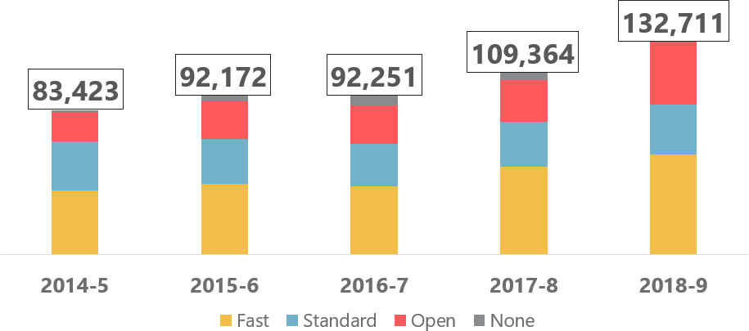

**Figure 2. Growth volume of ET cases received, 2014-2019**

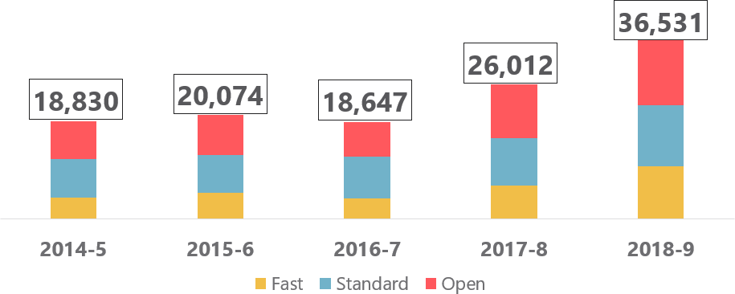

In considering the results for these surveys, especially the trends and changes since the prior evaluations in 2015 (EC) and 2016 (post-ET1 conciliation), it is important to be mindful of this context of change. The abolition of ET fees, the increase in EC and ET caseloads and – perhaps to a lesser extent – the introduction by Acas of a dedicated fast-track conciliator role might all be expected to have some bearing on results, although it is not possible to go beyond the data and attribute specific causal impacts of these changes. Key trends between 2015 (EC), 2016 (post-ET1 conciliation) and 2019 are given throughout the report, but these should not be taken as a signal of a *direct* comparison insofar as the context that EC operates in has shifted.

Since this evaluation was undertaken in 2019, Acas has made other developments in service provision: a new online notification form for claimants; a new case management system for conciliators, and; pilots of alternative team-based models of conciliation delivery. None of these subsequent features were captured in the 2019 surveys, which provide as an evaluation of the EC service as it stood in March- April 2019 and the ET conciliation service as it stood between summer 2018 and spring 2019 (full sampling frame details for both are provided below).

### Conciliation in the Individual Dispute Resolution journey

#### *EC notification*

The submission of a notification form by the claimant2 is the first part of the IC process. This notification contains only a very limited amount of prescribed information and in more than 90 per cent of cases is submitted to Acas via an online form.

#### *The roles of the ECSO and conciliator*

Following submission of the notification, an Acas Early Conciliation Support Officer (ECSO) contacts the potential claimant to confirm contact details, gather basic information and provide information about EC. Unless the case is clearly invalid or the claimant explicitly declares an unwillingness to pursue EC, the case is allocated to an Acas conciliator, who then aims to make follow-up contact and gain the claimant’s permission to contact the respondent (their employer/former employer), in order to commence EC (which by definition requires both parties’ explicit agreement).

Provided the respondent agrees, Acas then offers the EC service. Because notification is mandatory this gives Acas the opportunity to explain the benefits of EC to potential claimants who may not otherwise considered or known about it.

Where parties do not engage in EC (either because the claimant or the employer refuse or are uncontactable), Acas issues a formal Certificate to the claimant entitling them to make a tribunal claim (the certificate includes a unique reference number which the claimant must provide if they go on to submit a claim to the ET). Where a claim is submitted, the parties will be offered post-ET1 conciliation, irrespective of whether they engaged in EC.

Where the claimant and respondent agree to engage in EC, an Acas conciliator will explore how the potential claim might be resolved, talking through the issues with the employer and the employee. Mostly this takes place over the telephone. The conciliator will also, where appropriate:

* explain the Early Conciliation process
* encourage the use of internal procedures such as disciplinary and grievance procedures if available
* explain the way tribunals set about making their decision and what things they take into account
* discuss the options available
* help parties to understand how the other side views the issues
* discuss any proposals either party has for a resolution.

#### *Representation*

There is no obligation for potential claimants to have a representative in EC, but if they do appoint a representative to act for them Acas will conciliate through that representative and indeed the representative may agree a settlement on the claimant’s behalf. Respondents will similarly choose whether or not to appoint a representative. A representative can be appointed at any point in the case – from day one to midway or even towards the end of the case.

#### *Settlements*

If a settlement is agreed through EC, the conciliator will usually record what has been agreed on an Acas form (known as a COT3) which both parties will sign, as a formal record of the agreement.

The COT3 is a legally binding contract that means the claimant will not be able to make a tribunal claim in that matter. Conversely, if the parties cannot settle their differences the conciliator will bring EC to an end and a formal Certificate confirming that an EC notification has been made will be issued, after which point the claimant is free to make a claim to an ET.

#### *Timings*

There is a time limit for an employee to bring an ET claim following the event about which they are claiming – typically three or six calendar months depending on the jurisdiction of the claim; this is called the ‘limitation period’. The claimant must notify Acas within this period and can then use EC for a period of up to one month (with the possibility of a further two weeks in certain circumstances). If the matter is still not resolved at the end of EC, the conciliator will issue a Certificate and the claimant will be free to make a tribunal claim. Once EC has ended, all claimants will always have up to four weeks in which to present their claim.

#### *The ET1 form*

Employment Tribunal proceedings are begun when a claimant submits an ‘ET1’ form against their employer to the Employment Tribunal. After the form is submitted and copied to Acas, an Acas conciliator contacts the parties to offer them the opportunity to resolve their dispute through conciliation, avoiding the need to go to a full tribunal.

#### *The role of conciliator*

The post-ET1 conciliation service is the same as that provided at the earlier EC stage: an Acas conciliator will explore how the potential claim might be resolved, talking through the issues with the employer and the employee.

#### *Representation*

As with EC, there is no obligation for claimants to have a representative in conciliation, but if they do appoint a representative to act for them Acas will conciliate through that representative.

#### *Settlements*

As with EC, if a settlement is agreed, the conciliator will usually record what has been agreed on an Acas COT3 form, which both parties will sign, as a formal record of the agreement. The COT3 is a legally binding contract that means the claimant will not be able to continue with the tribunal claim in that matter.

If the parties cannot settle their differences through conciliation, the conciliator will bring the process to an end and full tribunal proceedings begin.

**Figure 3. Early Conciliation process flow**

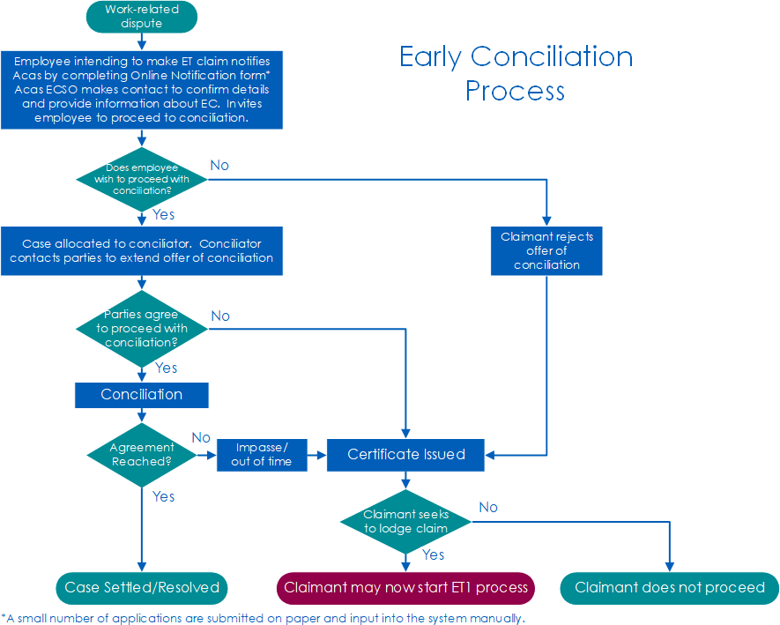

**Figure 4. Post-ET1 Conciliation process flow**

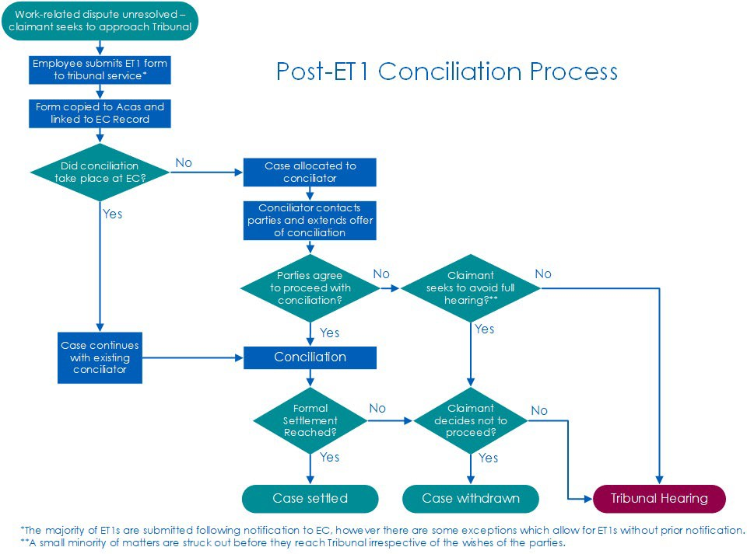

**Project aims and objectives**

The aim of these evaluations was to evaluate the effectiveness and impact of Acas’ individual conciliation services for claimants, employers and their representatives at the EC and post-ET1 stages. Within that, the research aimed to establish:

* A reliable picture of the views of users of all party types who participated in Acas conciliation; claimants (employees), claimant representatives, respondents (employers) and respondent representatives including a picture of their aims, expectations and comprehension throughout the process.
* Performance indicators including satisfaction with the Acas EC and post-ET services.
* Data examining the barriers and facilitators to settlement at both conciliation stages.
* Ratings of Acas conciliators and Early Conciliation Support Officers (ECSOs).
* The impact of Acas conciliation on the dispute outcome, including the role played by EC on outcomes at the post-ET stage.
* The costs and benefits of EC and post-ET conciliation
* A comparison of differences in case outcomes and satisfaction between cases in different categories and with different representation status and party type (claimants, respondents and representatives of both) and other standard demographics.

### Research design

Each evaluation consisted of two telephone surveys; topline details are provided below. The full details of the survey design can be found in the Technical Appendix.

#### *Early Conciliation evaluation*

The two surveys were:

1. A telephone survey of claimants (and their representatives) who had submitted an EC notification.
2. A telephone survey of employers (and their representatives) who had been contacted by Acas about an EC notification that had been received about them, and who were offered EC.

The sampling frame for both surveys was drawn from Acas records of EC notifications where EC had concluded and *either* a COT3 *or* Certificate had been issued between 25 March and 3 May 2019. The sampling approach was as follows:

* + For the survey of claimants, a random stratified sample of claimants was drawn from all cases within the sample frame. For selected cases which were selected where a representative was listed as dealing with the case on the claimant’s behalf (according to Acas’ MI records), the claimant’s representatives was approached for the survey. In all cases where there was no representative, the claimant was approached directly for the survey.
  + For the survey of employers, a random stratified sample of employers was drawn from all cases in which an employer would have been aware than an EC notification had been submitted about them. Again, where recorded (on Acas’ MI records), the representative was approached. An overview of these cases is shown in Table 1 below.

### Table 1. Overview of EC case outcomes eligible for each survey

|  |  |  |
| --- | --- | --- |
| **EC Outcome** | **Potentially**  **sampled for the claimant survey** | **Potentially**  **sampled for the employer survey** |
| **Claimant would not engage with EC – certificate issues by**  **ECSO no contact with respondent)** | Yes | No |
| **Claimant could not be contacted by conciliator – certificate issued by**  **conciliator (no contact with respondent)** | Yes | No |
| **Claimant would not engage**  **with EC – certificate issued by conciliator** | Yes | No |
| **Respondent could not be contacted/would not engage**  **with EC – certificate issued by conciliator** | Yes | Yes |
| **EC complete – no settlement (certificate issued by**  **conciliator)** | Yes | Yes |
| **EC complete – resolved COT3** | Yes | Yes |

The sample for both surveys was issued in two main batches, timed to be approximately six to eight weeks after the conclusion of EC (marked by either the issuing of the EC certificate or the signing of a COT3 agreement). The rationale for this timing was based on aiming to contact service users ideally when:

* + Their limitation period had ended (or was nearing its end), and they had made their final decision about whether or not to submit an ET claim;
  + Or, if an ET claim had already been submitted, when the ET case would most likely be in an early stage and post-ET1 conciliation was unlikely to have already commenced.

#### *Post-ET1 conciliation evaluation*

Here again the research design consisted of two telephone surveys:

1. A telephone survey of claimants (and their representatives) who had submitted an Employment Tribunal claim.
2. A telephone survey of employers (and their representatives) who had been contacted by Acas about an Employment Tribunal claim taken against them.

The sampling frame for both surveys was drawn from Acas records of all claimant- and employer-side contacts whose corresponding EC notification window had closed between 2 March and 30 May 2018.

### The questionnaires

In addition to demographic information, the questionnaires collected information and views on the full dispute journey:

* + Employment details
  + EC: Dispute details
  + EC: The initial stages of the dispute (EC notification form, experience with an ECSO
  + EC: The experience and outcome of EC (including satisfaction with both)
  + EC: Submission of an ET claim
  + ET: Acas involvement in, and user experience of, post-ET1 conciliation
  + ET: the outcome of the Tribunal (satisfaction)
  + EC: The role played by prior EC in resolving post-ET1 cases The full questionnaires can be found in the technical appendix.

### Fieldwork

For the EC surveys, fieldwork took place from the 23 May and 23 August 2019. In total, 932 interviews were achieved in the claimant survey (76% with claimants and 24% with their representatives) and 773 interviews were achieved in the employer survey (70% with employers and 30% with their representatives). Details on response rate can be reviewed in the technical appendix.

For the post-ET1 conciliation surveys, fieldwork took place between 12 June and 23 August 2019. In total, 481 interviews were achieved in the claimant survey (81% with claimants and 19% with their representatives) and 464 interviews were achieved in the employer survey (47% with employers and 53% with their representatives).

Further details about fieldwork management and response to both surveys are included in the Technical Appendix

### Weighting

For both EC surveys, the final data were weighted to be representative to all claimants, employers and representatives who submitted an EC notification, whose cases closed within the sampling period. The two surveys (claimant-side and employer-side) were weighted separately.

A similar approach was taken in the ET survey: data from both surveys were weighted to be representative to all claimants, employers and representatives who submitted an EC notification, whose cases closed within the sampling period, with separate weighting schemes for the employer- and claimant-side surveys

Full details of the weighting strategy is included in the Technical Appendix.

# INTRODUCTION TO THE EVALUATION OF EARLY CONCILIATION

The Advisory, Conciliation, and Arbitration Service (Acas) commissioned Ipsos MORI to undertake the second wave of its evaluation of the Early Conciliation (EC) service. This part of the report outlines the findings from this research, with comparisons to [a similar study undertaken in 2015](https://archive.acas.org.uk/media/4335/Evaluation-of-Acas-Early-Conciliation-2015/pdf/Evaluation-of-Acas-Early-Conciliation-2015.pdf).

The survey covers user experiences of the service provided from the submission of an EC notification form up to the resolution of the dispute through a settlement or preparation for a full tribunal claim, or another outcome. User experiences of conciliation after the submission of the ET1 form are covered under the second survey in this report.

Fieldwork took place from the 23 May and 23 August 2019. In total, 932 interviews were achieved in the claimant survey (76% with claimants and 24% with their representatives) and 773 interviews were achieved in the employer survey (70% with employers and 30% with their representatives). Details on response rate can be reviewed in the technical appendix.

In considering the results for this survey, especially the trends and changes since the previous evaluation in 2015, it is important to be mindful of the context of change: the abolition of ET fees, the increase in EC caseloads, and – perhaps to a lesser extent – the introduction by Acas of a dedicated fast-track conciliator role might all be expected to have some bearing on results, although it is not possible to go beyond the data and attribute specific causal impacts of these changes.

Key trends between 2015 and 2019 are given throughout this part of the report, but these should not be taken as a signal of a *direct* comparison insofar as the context that EC operates in has shifted.

Finally, it should be noted that since this evaluation was undertaken in 2019, Acas has made other developments in service provision: a new online notification form for claimants; a new case management system for conciliators, and; pilots of alternative team-based models of conciliation delivery. None of these subsequent features were captured in the 2019 survey, which provides as an evaluation of the service as it stood in March – April 2019.

## PROFILE OF PARTIES AT EC AND THEIR DISPUTES

### Synopsis:

This chapter outlines the profiles of the four types of participants who took part in the survey:

* Claimants
* Employers
* Claimant representatives
* Employer representatives

The chapter also presents findings about the workplace dispute as reported by the claimant (or their representative). It includes details of the nature of the dispute, reasons for leaving employment and the use of written policies and procedures at the workplace.

As detailed in Chapter 5, the survey of claimants consisted of all claimant-side participants who submitted an EC notification. The survey of employer-side participants consisted of all employers who had been contacted about an ET notification which had been received about them, and who were offered EC.

**Key trends at-a-glance**

* The profile of participants in 2019 was very similar to the profile of participants in 2015.
* Overall representation of claimants and employers has increased since 2015.
* Most claimants worked full-time and within the private sector.
* The majority of employers worked in the private sector and were responsible for dealing with employment disputes in their organisations.
* Representatives were most likely to be solicitors, barristers or another type of lawyer. Beyond this, there are differences in representatives profile observed between claimants and employers, with representatives of the latter being more experienced in dealing with cases.
* The key trends relating to the workplace dispute in 2019 were very similar to those in 2015.
* In nearly all cases the claimant had been employed by the same organisation that they were in dispute with, but their employment had ceased by the time the survey took place.
* The majority of claimants indicated that their employment ended due to the dispute, with dismissal and resignation the most common reasons given.
* There is a perception gap between claimants and employers about whether employers have written policies and procedures for cases and if they were used in the case in question.

### Profile of claimants

All claimant participants were asked a range of questions about their personal and employment characteristics.

#### *Employment characteristics*

The employment characteristics of claimant-side participants in 2019 were very similar to those in 2015.

* + - * Just under two thirds (62 per cent) did not have management or supervisory responsibilities.
      * Just over three quarters (78 per cent) worked full-time (i.e. more than 30 hours a week) with 15 per cent working part time and five per cent on zero- hour contracts. In 2015, these figures were 77 per cent, 17 per cent and five per cent respectively.
      * Length of employment varied, from 31 per cent who had employed for less than a year at the time of contacting Acas, to 20 per cent who had been employed for ten or more years.
      * At the time of initiating EC, one fifth (19 per cent) were a member of a trade union or staff association.
      * Seven in ten (74 per cent) worked in the private sector, with 16 per cent in the public sector, and four per cent in the non-profit/voluntary sector. In 2015, these figures were 71 per cent, 19 per cent and five per cent respectively.
      * At the time of the survey, over six in ten (62 per cent) of all claimant participants interviewed were in paid employment.

#### *Personal characteristics*

The personal characteristics of the claimant participants in 2019 were also very similar to those in 2015.

* + - * Claimants tended to be between the ages of 25 and 55; 44 per cent were women.
      * Three quarters (75 per cent) described their ethnic group as White. One in ten (eight per cent) indicated they were Asian, while nine per cent indicated they were Black, four per cent from a mixed ethnic group, and two per cent from other ethnic groups.
      * Over two-fifths (44 per cent) described their religion as Christian (compared with 54 per cent in 2015) and a similar proportion (41 per cent) indicated that they were of no religion. Six per cent were Muslim and three per cent from another religious background.
      * Eight in ten (85 per cent) confirmed English as their first language.
      * Just over one quarter (31 per cent) indicated that they had a long-term illness, health problem or disability.
      * The majority (91 per cent) described themselves as heterosexual or straight.
      * Four in ten (44 per cent) had an income greater than £30,000 per year, a significant rise from just over a third (36 per cent) in 2015.
      * Few had previous experience of making Employment Tribunal claims; just seven per cent had raised one before at any workplace, while 92 per cent had not.

#### *Overall level of claimant representation*

Where Acas’ records listed representative details, then the representative (rather than the claimant) was approached for interview. Although most cases of representation were recorded in Acas’ management information, this is not the case for all participants.3

To understand the full extent of claimant representation, a check question was asked of claimant participants to see if they involved a representative later on in their case. Combining this with the sample information, it can be determined that a representative was used by 38 per cent of claimant participants. This is significantly higher than the overall level of representation in 2015, when 24 per cent of claimant participants were represented.

### Profile of employers

The characteristics of unrepresented employer participants in the 2019 survey were very similar to those in 2015.

* Three quarters (77 per cent) were based in the private sector (compared with 74 per cent in 2015) with 15 per cent in the public sector and seven per cent in the non-profit/voluntary sector.
* The majority (57 per cent) had more than one workplace in the UK. In 2015, this figure was 60 per cent.
* Participants were split between smaller and larger organisations: one third (36 per cent) worked in a small organisation with between one and 49 employees and close to a fifth (18 per cent) were from medium-sized organisations with 50-249 employees. Two-fifths (44 per cent) were in a large organisation with 250 or more employees, slightly lower than the 49 per cent recorded in 2015.
* Most employers were based in smaller workplaces however, with six in ten (57 per cent) located in a small workplace with between one and 49 employees, while one in five (18 per cent) in a medium-sized workplace with between 50 and 249 employees. Just under one in five (16 per cent) reported working at larger workplaces with 250 or more employees, close to the 2015 figure of 15 per cent.
* Seven in ten employer participants (71 per cent) reported working for an organisation that had an internal Human Resources (HR) or Personnel Department that dealt with personnel issues. Additionally, one quarter (23 per cent) had an internal legal department that dealt with personnel or employment issues.
* For a third of employer participants (31 per cent) there were trade unions or staff associations active at the workplace, and three in ten (33 per cent) were members of an employer’s or trade association.
* The vast majority (92 per cent) reported that they were the person who dealt with employment disputes in their own organisation.
* Sixty-seven per cent had previous experience of using Acas services in the past year, compared with 65 per cent in 2015. For this group, the most commonly-used Acas services were the website (70 per cent) and conciliation in a different employment dispute (60 per cent).
* Half said that they had previously had an employment tribunal claim raised against them prior to this specific dispute (51 per cent).

#### *7.2.1 Overall level of employer representation*

Although most cases of representation were recorded in Acas’ management information, a check question was included in the survey to capture any cases where this information was missing.

Combining both data sources (Acas MI records and the results of the check question) it can be determined that a representative was used by 33 per cent of employers. Unlike claimant representation, this is not significantly different to 2015, when 29 per cent of employers were represented.

### Profile of claimant and employer representatives

In cases where a claimant or employer were selected to participate in the survey, but a representative was listed on Acas’ MI records as dealing with the case on their behalf, the representative was approached for an interview.

All representatives who were interviewed were also asked a number of profiling questions. Overall, there were some significant differences between claimant representatives in 2015 and 2019 but none for employer representatives between the two waves.

Claimant representatives were:

* Most likely to be solicitors, barristers or another type of lawyer (33 per cent). This is significantly lower than the proportion of this type of representative in 2015, when 46 per cent had a legal background. However, consistent with 2015, 24 per cent were a friend, neighbour, spouse or partner in 2019, 18 per cent were from a trade union or worker representative, and five per cent were personnel or human resources specialist.
* Highly varied in their level of experience: nearly half said they had dealt with ET claims for more than five years (49 per cent) but one quarter (25 per cent) had never dealt with them before. The proportion with more than five years’ experience was significantly lower than in 2015, when it was 59 per cent. See Table 2.
* Most likely to represent claimants (44 per cent) in employment disputes. This was significantly lower than in 2015, when 57 per cent of claimant representatives said they usually represented claimants. A substantial minority of claimant representatives had not represented anyone previously (28 per cent).

Employer representatives were:

* Most likely to be solicitors, barristers or another type of lawyer (48 per cent), while 33 per cent were personnel or human resources specialist.
* Substantially more experienced with ET claims than claimant representatives. Nearly three quarters (75 per cent) had dealt with ET claims for more than five years, significantly higher than the half (49 per cent) of claimant representatives with the same level of experience. Just five per cent reported having less than one year’s ET claim handling experience, the same number as in 2015 and significantly lower than the figure for claimant representatives. See Table 2.
* More specialised than claimant representatives: they were much more likely to say they usually represented employers (79 per cent). Just one per cent reported that they usually represented the claimant, and 17 per cent reported that they usually represented either party.

### Table 2. Length of time dealing with ET claims as reported by all representatives

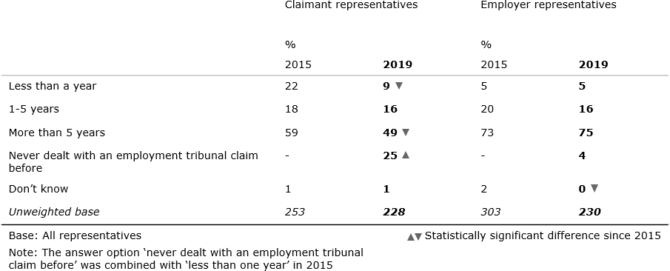

### The workplace dispute

#### *7.4.1 The dispute*

Just under half of claimant-side participants were party to a fast track case (45 per cent) compared with 27 per cent involved in open track and standard track cases. This breakdown differs slightly from 2015 where a similar proportion of fast track case (45 per cent) but there were slightly more standard track cases (34 per cent) and fewer open track cases (21 per cent).4 These differences in sample composition should be taken into account when comparing results between the two waves of research – particularly the greater proportion in 2019 of more legally complex, open track cases – although in practice they result in small differences overall.

There were no significant differences in track by ethnicity among claimants. Similar proportions of BAME and White claimants were party to a fast track case (54 per cent and 51 per cent), although BAME claimants were slightly less likely to have standard track cases compared with those from a White ethnic background (17 per cent compared with 26 per cent) and slightly more likely to have an open track case (30 per cent compared to 23 per cent).5

In nearly all cases, the claimant had been employed by the same organisation they were in dispute with (97 per cent). In these cases, where the claimant worked for the employer, 82 per cent were no longer employed by the organisation in question by the time of the survey. This is significantly lower than 2015, when 88 per cent said the same. However, the overwhelming pattern remained consistent with 2015 – claimants tended not to be employed by the employer they were in dispute with by the time of the survey (see Table 3).

### Table 3. Whether claimant still works for the same employer, as reported by claimants, employers and their representatives

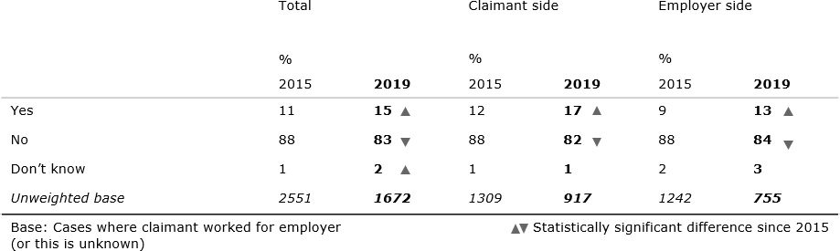

Almost three quarters of claimant-side participants who no longer worked for the employer reported that the claimants’ employment had ended *before* the EC notification was submitted to Acas (73 per cent). However, just under a quarter (24 per cent) said they were still employed at the time of submitting the EC notification.

Across all the tracks, at the time of the survey the majority of claimants reported not being employed by the employer they had been in a dispute with.

However, claimants who were involved in open track and fast track disputes were, at the time of the survey, the most likely to still be employed by the organisation they had been in dispute with (24 per cent and 20 per cent respectively), compared to those in standard track (five per cent) disputes. This followed a similar pattern to the differences by track in 2015.

### End of employment

Among claimant-side participants, the most commonly cited reason for the ending of the claimant’s employment was that they had been dismissed (37 per cent). The next most common reason was that the claimant had resigned (27 per cent). In 2015, the top two reasons were the same, when 41 per cent reported being dismissed and 23 per cent reported resigning.

Three quarters (75 per cent) of claimant-side participants reported that the claimants’ employment had ended because of the dispute. This left 22 per cent for whom the dispute had no relation to the termination of their employment with the organisation involved. These findings are consistent with those from the 2015 survey.

### Written policies and procedures

Half of all claimant-side participants reported that their employer had written policies and procedures for dealing with employment disputes (49 per cent). Of this group, two in ten said that these had been followed fully (23 per cent); three in ten (29 per cent) felt they had been partially followed and four in ten (42 per cent) said they had not been followed at all. These findings are consistent with those from the 2015 survey.

Nearly nine in ten (85 per cent) employer-side participants said that written policies and procedures for dealing with employment disputes had been in place. Of this group, seven in ten (72 per cent) said that policies and procedures had been followed fully.

## UPTAKE OF EARLY CONCILIATION

### Synopsis:

This chapter explores uptake of Early Conciliation (EC), including the process of notification and interactions with Early Conciliation Support Officers, the reasons for deciding to take part (or not) and previous knowledge or experience of the EC service.

**Key trends at-a-glance**

* Overall, the timings and reasons for submitting an EC notification have remained similar to 2015: nine in ten claimants made an EC notification to Acas within three months of their dispute occurring and just over half of claimant-side participants entered EC because they had to submit an ET claim, but also because they wanted to reach a settlement.
* Six in ten claimant-side participants were contacted by an ECSO within two working days, close to the 2015 level of response. The proportion contacted within one working day has risen significantly, from five to 16 per cent.
* One third of claimant-side participants understand Employment Tribunal time limits to present their case in time, while one quarter are unaware of these time limits.
* Driver analysis revealed that a claimant’s motivations for submitting the EC notification form, whether the claimant remained working with the employer against whom they submitted the claim and the information provided by Acas at the form submission stage were the three biggest drivers associated with the likelihood of ultimately accepting the EC service.
* Among those who do not use the EC service, three quarters decided against EC at the ECSO stage of the process; an increase from half who decided at this point in 2015 (though sample size is small here).
* Prior awareness of the EC service has increased among claimants and employers since 2015 when it was a new service, while it has remained at the same high level for representatives of all types. Previous usage of EC has increased among all groups.

### Submission of the EC notification form and interaction with the ECSO

#### *The process of submitting the EC notification form*

Before an Employment Tribunal claim has been lodged, claimants (or their representatives) should inform Acas about the workplace dispute so that they can try to settle the dispute through Early Conciliation to avoid a tribunal claim. Claimants (or their representatives) can start this process by submitting an EC notification form, which provides Acas with the contact details of the claimant, and the person or organisation they wish to make a claim against.6

When asked how soon Acas had been notified after the workplace dispute, 24 per cent of claimant-side participants said that it was within one week, 37 per cent said that it was within one month and 28 per cent that it was within three months. This means 89 per cent said that Acas had been notified within three months, compared with 92 per cent in the 2015 survey.

There were noticeable differences when looking at this question by track, with those in open track disputes taking the longest to notify Acas after the workplace dispute – 62 per cent of claimant-side participants in fast track disputes and 67 per cent in standard track disputes had notified Acas within one month, significantly higher than the equivalent 52 per cent in open track disputes.

This is consistent with the findings from 2015, when those in fast and standard track disputes were even more likely to contact Acas less than a month after the dispute (67 and 63 per cent respectively, compared with 51 per cent of those in open track disputes).

Claimant representatives were more likely than claimants to take longer to make initial contact with Acas. One in four (27 per cent) claimants made contact with Acas within one week, compared with one sixth (16 per cent) of claimant representatives. Again, this trend is consistent with the findings from 2015.

Among all claimant-side participants, three quarters (76 per cent) reported that the notification form had been submitted by the claimant themselves (compared with 82 per cent in 2015). Those with fast track cases were more likely than average to have submitted the form themselves (82 per cent), while those with standard track cases were less likely than average to have done so (70 per cent). Twenty-two per cent said that somebody else had submitted it on the claimant’s behalf (18 per cent said the representative had submitted it and four per cent said that it was someone else).

Looking at claimant representatives only, 53 per cent reported that they had submitted the EC notification form on behalf of the claimant, close to the 47 per cent of claimant representatives who said the same in 2015.

#### *The reason for submission*

EC notification forms can be submitted for a number of reasons: some claimants may see it as a necessary procedural step on the way to taking an employer to a full Employment Tribunal, while others will be keen to enter conciliation with their employer at this early point, to seek a negotiated solution. Claimant-side participants were asked a closed question to understand their broad motivation for making an EC notification:

* + - * 18 per cent said they ‘had to, in order to submit an Employment Tribunal claim’;
      * 54 per cent said they ‘had to, in order to submit a tribunal claim, but were also keen to see if a settlement could be reached’;
      * A quarter (24 per cent) said they ‘just wanted to see if a settlement could be reached and did not have a desire to submit an Employment Tribunal claim’.

These figures do not represent any significant changes from 2015.

Representatives were more likely than claimants to report being open to settlement options. This could suggest that claimants who appoint a representative are more interested in reaching a settlement, or more open-minded about the outcome of the process. It might also reflect a representative’s greater experience of conciliation and employment law increasing the likelihood of reaching a settlement. Representatives were also more likely to seek opportunities for a conciliated settlement than unrepresented claimants:

* + - * Two thirds of representatives (64%) reported submitting the notification because they ‘had to, in order to submit a tribunal claim, but were also keen to see if a settlement could be reached’ compared with 49 per cent of claimants. These figures were similar in 2015.
      * One quarter (26%) of claimants described their reason for making an EC notification as being that they ‘just wanted to see if a settlement could be reached and did not have a desire to submit an Employment Tribunal claim’, compared with 19 per cent of representatives. In 2015, only nine per cent of representatives selected this reason as an answer to the question.

There are also noticeable differences between tracks (see Figure 5).

* + - * Claimant-side participants involved in fast track and standard track disputes were more likely to have engaged in EC with no intention of going to Tribunal if a settlement could not be reached (29 per cent and 24 per cent respectively compared with 16 per cent for open track disputes);
      * Claimants in open track disputes were more likely to have submitted their EC notification form as part of the path to tribunal but remained willing to see if a settlement could be reached (62 per cent compared with 47 per cent of fast track disputes and 56 per cent of those in standard track disputes). This is consistent with the findings from 2015. See Figure 5.

### Figure 5. Claimant-side participant reasons for submitting an EC form by track

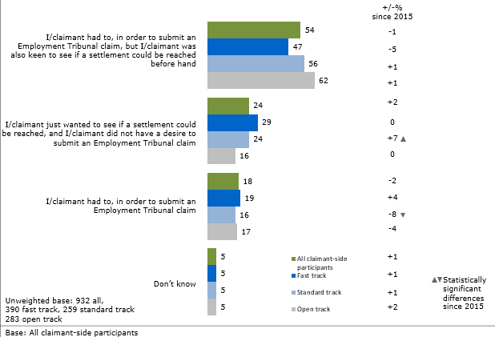`

#### *The role of the form in explaining Early Conciliation*

Claimant-side participants were asked whether the information provided by Acas at the point they completed the EC notification form helped them to understand how the Early Conciliation process worked.7

Overall responses were positive, with claimants more so than representatives:

* + - * Three in four claimant-side participants (75 per cent) agreed that the information provided was helpful.
      * This rose to eight in ten (79 per cent) among claimants only, with just over half (54 per cent) strongly agreeing
      * Two thirds (66 per cent) of claimant representatives agreed that the information provided was helpful and just over one third (36 per cent) strongly agreed

As detailed in the regression analysis in Chapter 10, this question was found to have a significant impact on the likelihood of unrepresented claimants settling their case successfully. Those who agreed that that the information provided was helpful were associated with a higher likelihood of a settlement than those who did not. Regression analysis also shows that the helpfulness of information at the EC notification form stage also has a positive impact on the likelihood of claimants to take up EC in the first place (see *8.3.2 Factors determining the acceptance of the offer of EC* for more*).*

#### *Contact by an Early Support Conciliation Support Officer*

Claimants were asked how quickly they were contacted by an Early Conciliation Support Officer (ECSO) after they submitted an EC notification form. Fifty-eight per cent reported being contacted by an ECSO within two working days, close to the 2015 figure of 62 per cent. The proportion of claimants being contacted on the same day they submitted the EC notification form has risen significantly since 2015, from five per cent to 16 per cent.

They were also asked to rate how well the ECSO had explained the EC service to them. Overall, claimants were very positive, with 82 per cent rating this element of the service as good (59 per cent said ‘very good’ and 23 per cent said ‘fairly good’). Whilst this overall figure has dropped significantly from 2015, when it was 89 per cent, it remains the case that a very small proportion (7 per cent) rated the ECSO as poor here (five per cent said ‘fairly poor’ and two per cent said ‘very poor’). While there were no differences across case tracks in the overall proportion who rated this aspect of the service as good, those in open track disputes were significantly less likely to rate the explanation as ‘very good’ compared with those in fast track disputes (52 per cent versus 61 per cent).

#### *Claimant perception of the suitability of EC to their case*

Claimants were asked how suitable EC had sounded to their case when they discussed the service with the ECSO: 79 per cent said they thought that it sounded suitable (49 per cent said ‘very suitable’ and 30 per cent ‘fairly suitable’) and just eight per cent felt it did not sound suitable. These findings are consistent with those from the 2015 survey, when 82 per cent thought EC sounded suitable and eight per cent thought it did not sound suitable.

#### *Understanding of time limits*

There are strict time limits within which a tribunal claim must be presented. In most claims, the deadline is three months less one day from the date of workplace dispute at issue.8

When claimants were asked what they understood the time limits for presenting a tribunal claim to be there were a range of responses, ranging up to six months, and including a large proportion of ‘don’t knows’. Twelve per cent were correct, giving the answer of ‘three months less one day’, an increase from 2015 when five per cent gave this answer.

Others gave answers shorter than the official period; 11 per cent of claimants gave the answer ‘one month’, four per cent said ‘28 days’ and two per cent said ‘two months’. While these are not the correct answer, those working to this deadline would submit their forms within the official time limit.

The largest proportion of claimants – 37 per cent – said ‘three months’. While this is very close to the correct answer, it is incorrect as a claimant presenting their ET claim three months after submitting the form would have missed their deadline. This figure has decreased slightly since 2015, when 43 per cent gave this answer.

In total 28 per cent gave an answer which would allow them to submit a tribunal claim within the deadline, although a further 37 per cent were very close to giving a correct response. Most notably, a substantial minority – one quarter (25%) – do not know the time limits at all.

### Employer-initiated EC

Although it occurs much less often, employers may initiate EC if they believe that an employee will lodge an employment tribunal claim against them.9 All employer- side participants were asked whether they or the claimant originally notified Acas about the workplace dispute. Just three per cent of employer-side participants confirmed that they had made the notification, the same proportion as in 2015 (2 per cent) and matching the service figures reported in [Acas’ 2018-19 annual report](https://www.acas.org.uk/media/6267/Acas-Annual-Report-2018---2019/pdf/CCS001_CCS04199488).

### Claimant decision-making around participating in EC

#### *Accepting or declining the offer of EC*

Based on questions around the events that had happened after notifying Acas, it is possible to make a simple binary distinction in the data between those claimant- side participants who agreed to take part in EC and those who did not:

* + - * Eight in ten (77%) agreed to take part in EC. In 2015, this figure was 81 per cent.10
      * Seventeen per cent refused. This was the same in 2015.
      * For five per cent it could not be established whether they agreed to take part or not. In 2015, this figure was two per cent.

After refusals to participate in EC from employers were taken into account, the proportion of claimant-side participants who took part in EC stood at 58 per cent, a significant decline from the 2015, when 64 per cent went on to participate in EC.

#### *Factors determining the acceptance of the offer of EC*

Throughout this report a series of regression analyses have been conducted to understand the factors associated with certain aspects of how service users engage with EC. This first model examines the factors ‘driving’ whether claimants accepted the offer to participate in EC (Please note: representatives were not included in the model).

A binary logistic regression analysis was used: this is a technique which examines the relationships between a ‘dependent’ variable (in this case, whether someone accepts the offer to participate in EC) with multiple ‘independent’ variables (factors which might influence the dependent variable, such as the track of a claimant’s dispute) to identify the most influential factors. It is important to note that regression analysis such as this measures association between variables rather than causation, meaning it is not possible to infer a causal relationship between linked variables. Further detail is available in the technical appendices.

The independent variables which were found to be determinants of whether claimants accepted the offer to engage in EC are listed below in order of predictive strength:

* + - * *Motivation for the EC form submission*: Those who did *not* say that they submitted an EC form simply to take their employer to a tribunal were more likely to accept the offer of EC.
      * *Information provided about the EC process by the notification form*: Claimants who agreed that the EC form provided information which was helpful in understanding the process were more likely to accept the offer.
      * *Whether the claimant is still working for the employer*: Claimants who are still working for the employer against whom they raised an EC claim were significantly less likely to accept the offer.

### Figure 6. Logistic regression results of factors determining claimant acceptance of EC

***Claimant more likely to accept***

Does not say they had to accept the offer of EC solely to take their employer to an Employment Tribunal

Agrees that the information provided by Acas at the EC Form submission stage was helpful in explaining the

process

Still works with the employer against whom they

made the EC notification

***Claimant less likely to accept***

#### *Timeline for claimants deciding not to take part in EC*

For claimant-side participants who chose not to take part in EC – 17 per cent of all claimant-side participants – there were three stages in the process at which this could occur:

1. Three quarters (76 per cent) of those who decided not to take part said they made this decision known during their initial conversation with the ECSO. In 2015, 52 per cent of claimants who decided not to take part in EC decided that at this stage.
2. For seven per cent of those who did not want to take part, no further contact was established after speaking to an ECSO. In 2015, 25 per cent of claimants who decided not to take part in EC fell into this category.
3. One in six (16 per cent) of those who did want to take part made this known when they were subsequently speaking to the conciliator. In 2015, 23 per cent of claimants who decided not to take part in EC decided that at this stage.

Among those who decided not to take part in EC, claimants from all tracks were most likely to decide not to take part when initially speaking to the ECSO (87 per cent of those involved in fast track disputes, 56 per cent involved in standard track disputes and 55 per cent involved in open track disputes). In 2015, those involved in open track disputes were most likely to decide not to take part in EC when speaking to the conciliator, rather than when having preliminary conversations with the ECSO (44 per cent).

It is important to note that differences between the findings in 2019 and 2015 outlined in this chapter are unlikely to be significant given the small base sizes. It

is unlikely that all participants distinguish between ECSOs and Conciliators, which may make recall difficult. Therefore, these comparisons should be interpreted with caution.

#### *Reasons for EC not taking place*

Claimant-side participants who decided not to use EC were asked why they made this decision – this question revealed a wide variety of reasons, with no single pre- eminent rationale.

As in 2015, this year, a range of reasons were offered to participants, with the top five being cited by between 10 and 20 per cent of claimant-side participants. In 2019, the most commonly cited reason was ‘I/claimant felt that conciliation would not resolve the issues / would be a waste of time’ (19 per cent). Other reasons included knowing that the employer would not be willing to engage (18 per cent), deciding not to proceed after speaking to Acas (14 per cent) and the issue already having been resolved or time running out (both 13 per cent). As we can see from these numbers, there was no single stand out factor explaining the decision not to proceed here, as was the case in 2015. In 2015, the most commonly cited reason was ‘the issue was resolved by the time Acas assistance was offered’ (14 per cent).

Where claimant-side participants reported that EC did not take place as a result of the employer being unwilling to take part (in their view), they were asked why they felt this was the case and a similar pattern emerged to that seen in 2015:

* + - * The most common answer given was ‘don’t know’ (28 per cent). In 2015, this was the second most common answer (17 per cent).
      * The next most common answer was that the employer was ‘not willing to negotiate’ (27 per cent). In 2015, this was the most common answer (32 per cent).
      * This was followed by ‘the employer felt they had no case to answer to’ (22 per cent). In 2015, this was also the third most common answer (16 per cent).

#### *Decision-making around taking part in EC*

The top three reasons cited by claimant-side participants for deciding to accept the offer of EC were ‘to reach a resolution’ (41 per cent), ‘because we had to’ (28 per cent) and ‘to avoid an employment tribunal’ (18 per cent). These trends largely follow the findings from the 2015 survey.

There were no significant differences between claimant-side participants from different dispute tracks. However, there were some differences between the reasons cited by claimants and their representatives for agreeing to participate in EC:

* + - * Claimants were significantly less likely than representatives to cite the reason ‘because we/I had to’ (25 per cent compared with 34 per cent of representatives);
      * Claimants were significantly more likely than representatives to cite the reason ‘it was the best approach’ (15 per cent of claimants compared with eight per cent of representatives).

### Employer decision-making around taking part in EC

#### *Whether employers engaged with EC*

The level of participation in EC by employer-side participants was high with 78 per cent of those interviewed saying that they had taken part, and no significant

differences by case track. This is consistent with the findings from the 2015 survey when 82 per cent of employer-side participants said they had taken part. This also reflects the sampling approach for the study: employers were only surveyed if they had been party to a case where the claimant had agreed to conciliation.

#### *Profile of employers who took part in EC*

The profiles of employers who took part in EC and those who did not were largely aligned, as in 2015. Employers with more than a single workplace in the UK were significantly more likely to take part in EC, but there were no differences by organisation size or whether they had an HR or legal department.

#### *Reasons for not taking part*

Those employer-side participants who decided not to take part in EC were asked why they made this decision.

Six in ten (64 per cent) stated it was because the organisation ‘felt (it) had no case to answer to’. This was followed by ‘was not willing to negotiate’ (17 per cent) and ‘felt that conciliation would not resolve the issue/ would be a waste of time’ (13 per cent). These findings are consistent with those in 2015, when the top three reasons cited were the same. Employer-side participants from open track cases were more likely than others to say they had no case to answer, as were employers more likely to say this than their representatives.

#### *Decision making around taking part*

The top two reasons cited by employers for agreeing to participate in EC were ‘to reach a resolution’ (37 per cent) and ‘to avoid an employment tribunal’ (18 per cent). The third most popular reasons were ‘because we/I had to’, ‘it was the best approach’ and ‘to help understand better’ (all 12 per cent). There were no notable differences between the reasons stated by employer-side participants. These trends largely follow the findings from the 2015 survey.

There were also no significant differences between employer-side participants from different dispute tracks. However, employers were significantly more likely than their representatives to cite being ‘contacted by Acas’ as a reason for agreeing to participate in EC. However, this reason was not a top mention for either audience.

### Previous knowledge and experience of EC

#### *Among claimants*

Overall, 52 per cent of claimant-side participants had heard of EC before their case, a significant increase from the 42 per cent who said the same in 2015.

Claimant representatives were more likely than claimants to have previous knowledge of EC – 83 per cent reported prior knowledge compared with 38 per cent of claimants. Among representatives, there has been no change in percentage of those with prior knowledge. Among claimants, there has been a slight increase since 2015, when only 34 per cent of claimants had previously heard of EC, potentially reflecting the fact that the service is now five years old. See Table 4.

### Table 4. Previous knowledge of EC among claimants and their representatives

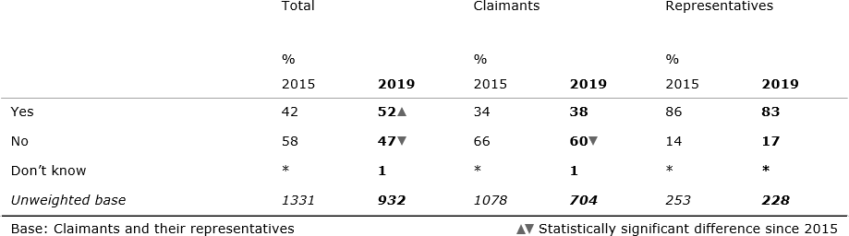

Claimant-side participants involved in open track disputes were more likely to have heard of EC prior to their current dispute compared with those in standard or fast track disputes (63 per cent compared with 54 per cent and 45 per cent respectively).

There were also some notable differences by age, with older claimants being more likely to have heard of EC prior to their current claim than the younger cohort. For example, 41 per cent of those aged between 55 and 64 had heard of EC before compared with 29 per cent of those aged between 35 and 44. In 2015, there was also a general upward trend in awareness in line with age.

In addition to an increase in awareness of the service, there has been an increase in prior use of EC. Forty-six per cent of claimant-side participants with existing awareness of EC reported having used it before, compared with 28 per cent in 2015. Claimant representatives were more likely than claimants to have used the service before – 77 per cent of claimant representatives aware of the service had previously used it, in comparison to just 16 per cent of claimants. These findings are consistent with those from the 2015 survey. See Table 5.

### Table 5. Previous use of EC among claimants and their representatives

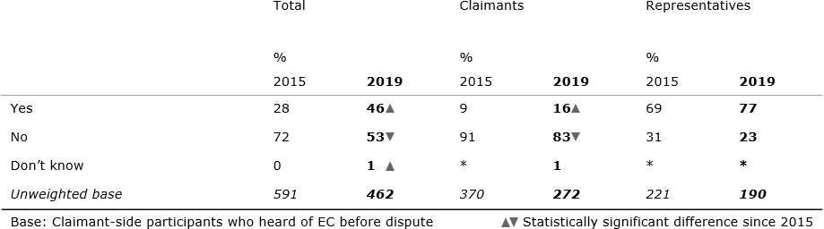

Claimant-side participants were also asked how they had originally heard of EC. The most commonly reported source was ‘a friend or colleague’, with 22 per cent of claimant-side participants citing this option. This was followed by ‘professional body/ membership organisation specific to my industry’ (15 per cent) and ‘Trade Union’ (10 per cent). By comparison, in 2015 the second most commonly reported source was ‘Citizen’s Advice Bureau’ (14 per cent) and the third most commonly reported source was ‘Acas website’ (12 per cent). In 2019, seven per cent of those that had heard of EC cited the Acas website as a source of information.

#### *Among employers*

Previous knowledge of the EC service was much higher among employer-side participants than among claimant-side participants – 88 per cent of employer-side participants had heard of EC before their current dispute, compared with 52 per

cent on the claimant side (see Table 6). This is consistent with the findings from 2015 when 84 per cent on the employer side had heard of EC before their current dispute in comparison to 42 per cent on the claimant side.

Echoing the claimant-side pattern, employer representatives were much more likely than employers to have previous knowledge – nearly all (98 per cent) employer representatives reported having previous knowledge of the service. Previous knowledge of the service among employers was also high, with 85 per cent saying they were aware of it: a significantly higher score than in 2015 (79 per cent).

### Table 6. Previous knowledge of EC among employers and their representatives

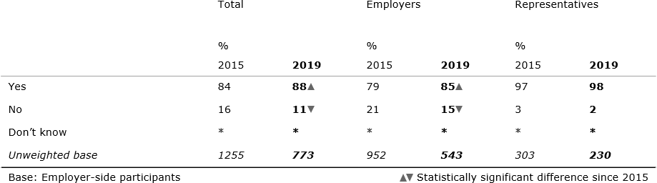

Of those who had previously heard of the EC service, representatives were more likely than employers to have used it before – 85 per cent of representatives compared with 55 per cent of employers. Both employers and representatives were more likely to have previously used the service in 2019 than in 2015, when the service had only been offered for one year and 68 per cent of representatives and 33 per cent of employers who had heard of the service had used it (see Table 7).

### Table 7. Previous use of EC among employers and their representatives

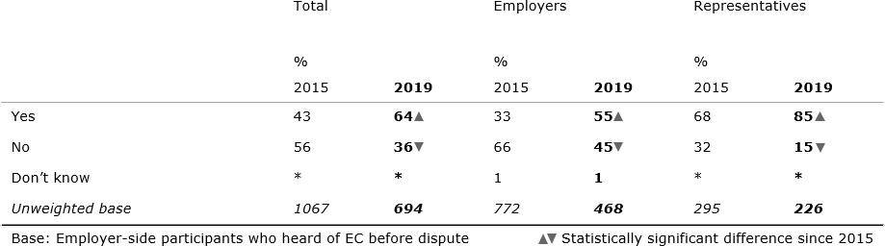

Other key demographic factors associated with previous awareness and usage of EC among employers are:

* Those involved in open and standard track disputes were more likely to have heard of EC prior to their current dispute compared with those in fast track disputes (94 per cent and 92 per cent compared with 80 per cent respectively).
* Those who worked at larger organisations were significantly more likely to have heard of EC before their dispute and to have previously used the service compared with smaller businesses:
  + Organisations with fifty employees or more were more likely to have heard of EC: nine in ten of those organisations with fifty or more employees said they were aware of the service previously, compared with around seven in ten for smaller organisations.
  + Experience of previous use of the service was significantly higher among the largest businesses only; 78 per cent of those with 500 or more employees reported having used the service before, compared with the overall level of 64 per cent.

It is also worth noting that among *both* sets of representatives, those who had never dealt with an employment tribunal claim before were much less likely to have heard of Early Conciliation (41 per cent). Although the sample size of those who have never dealt with an ET claim before is small – 64 respondents in the survey – the scale of the difference between these audiences suggests that this is a real trend. Eighty-seven per cent of this small group are claimant-side representatives, who may well be family members, partners or carers of the claimant rather than a professional representative – this group may require more support from Acas as they navigate the Early Conciliation process.

Employer-side participants were also asked how they had originally heard of EC. The most commonly reported source was ‘Professional body/membership organisation specific to my industry’, with 15 per cent of claimant-side participants citing this option. This was followed by ‘My own organisation/ HR department’ (12 per cent) and ‘Had taken part in it / been offered it previously by Acas (in a different employment dispute)’ (11 per cent). In 2015, ‘Acas contact about this case’ was the most commonly reported source (17 per cent).

## THE EARLY CONCILIATION EXPERIENCE

### Synopsis:

This chapter explores users’ experience of Early Conciliation (EC), including contact with, and perceptions of, the Acas conciliator, as well as receipt of the EC certificate.

### Key trends at a glance

* Telephone remains participants’ primary method of communication with Acas conciliators, although email use has risen significantly since 2015.
* The amount of contact with conciliators witnessed in 2019 is consistent with 2015 (an average of five contacts per dispute).
* Most participants that took part in EC agreed that the level of contact they had experienced had been about right, with around one in five expressing a preference for more (increasing to three in ten among those in contact with more than one conciliator).
* Those who had multiple conciliators were less likely to agree that their conciliators were always available: on the claimant-side four in ten single- conciliator participants reported that the conciliator was always available, compared to a third for those with multiple conciliators. On the employer side, these figures were 28 and 17 per cent. At the time of the survey, multiple conciliators were a feature of cases handled by teams providing cover for conciliator absence; fieldwork pre-dated subsequent pilots of team-based service delivery.
* Ratings of the Acas conciliator remained largely positive across claimant and employer side participants that had taken part in EC. Both audiences agreed the conciliator had provided a clear explanation of the conciliation process and listened to what they had to say.
* However, ratings of how the conciliators communicated employment law as it applied to the case have dropped since 2015 among both audiences.
* Participants’ ratings of conciliators were influenced by their case outcome, with participants who reached a settlement through EC more likely to rate conciliator availability positively.
* Satisfaction with the level of contact provided by Acas conciliators during EC fell among employer-side participants this year, although around four-fifths of this group were still satisfied.
* Claimant and employer-side participants spent similar amounts of time on the dispute this year. For employer-side participants this represents an increase in time spent since 2015.
* A majority of claimant side participants were aware of the certificate issued when EC ended in an impasse and recalled receipt. Similarly, a majority of employers understood the purpose of the certificate.

### Contact with the conciliator

All those involved in a dispute which progressed to the conciliator stage were asked about their contact with the conciliator or conciliators who dealt with their case. By this point service users would have contacted both ECSOs and conciliators; those surveyed were asked to answer these questions considering conciliators only. Here it is important to note that not all cases where contact with a conciliator was established ended up with Early Conciliation taking place.

Most participants confirmed having a single conciliator on their case (79 per cent of claimant-side participants and 84 per cent of employer-side participants). Other participants reported dealing with multiple conciliators (i.e. their cases would have been handled by teams providing cover for conciliator absence): one in ten (13 per cent and 11 per cent respectively) had dealt with two, while just a handful (four per cent and two per cent) reported speaking with three or more conciliators.11 There has been little change since 2015, when a majority (80 per cent and 87 per cent) reported one point of contact, one in ten (14 per cent and eight per cent) reported two, and a minority (four per cent and three per cent) reported three or more12. Unlike in 2015, these results did not differ significantly between claimants, employers and their representatives.

Telephone and email were the main ways in which claimants, employers and their respective representatives liaised with the Acas conciliator (see Table 8). Telephone remains the primary method of communication used across audiences, although email use increased significantly from 2015 (up seven points among claimants and their representatives and 16 points among employers and their representatives).13 Among employer representatives specifically, email is now the main way in which they communicate with conciliators. Letters were used by a minority of either group, while just a handful reported face-to-face communication.

### Table 8. Modes of contact with the Acas conciliator

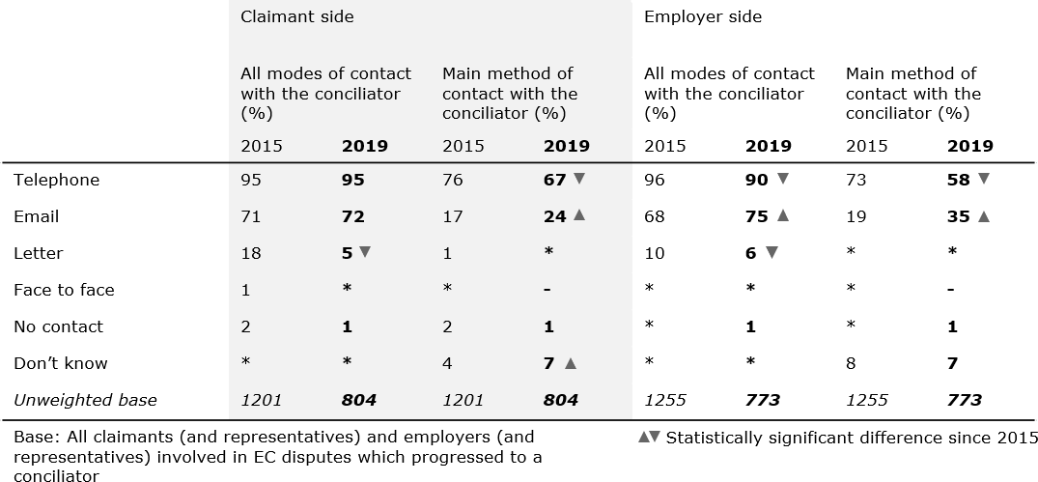

Mirroring 2015, those who reached a settlement through EC were more likely to report having written communication (email or letter) with the Acas conciliator.14

There were also differences by claimant type and case track. Employer representatives were significantly more likely than employers to report having communicated with Acas conciliators by email (87 per cent versus 70 per cent); email usage was also found to be predictive of a successful conciliation outcome in the regression analysis for employers in section 10.2. Claimant-side participants involved in open track disputes were also significantly more likely to have communicated by email than those involved with standard or fast track disputes (78 per cent, 68 per cent and 70 per cent respectively).

On average, survey participants reported five contacts with the Acas conciliator. For claimant-side participants, this means there has been no change in the average (mean) level of reported contact since 2015. Among employer-side participants, the amount of contact has risen from an average of four.

Those who reached a settlement through EC reported more contact than those who did not, as did those involved in open track disputes. Employer representatives also reported significantly higher levels of contact than employers.

In disputes where EC took place, there was significant variation in contact initiation between audiences. Half (47 per cent) of claimant-side participants reported that Acas had contacted them most of the time, while a third (36 per cent) of employer- side participants reported this to have been the case. Employer-side participants were instead more likely to report that this had been shared equally between themselves and Acas (51 per cent). A minority of both groups said they had initiated contact with Acas most of the time (14 per cent and 12 per cent respectively). Scores have been stable since 2015.

There was significant variation in contact initiation by both case track and outcome. Claimant and employer-side participants who reached a settlement through EC were more likely to report that the initiation of contact had been shared equally between themselves and Acas, while those involved in fast track disputes tended to report that Acas had initiated contact with them most of the time.

Those who had contact with multiple Acas conciliators were more likely to report that they had initiated contact with Acas most of the time than those in touch with a single conciliator. Among claimant-side participants using multiple conciliators, a quarter (24 per cent) reported that they had contacted Acas most of the time, while 21 per cent of employer-side participants said the same. This compares with 13 per cent of claimant-side participants and 11 per cent of employer-side participants who reported a single point of contact at Acas. Due to the base sizes involved, it is not possible to break this down further by case track.

A majority (77 per cent of claimant-side participants and 81 per cent of employer- side participants) of those who took part in EC were satisfied with the amount of contact they had with the Acas conciliator. A fifth (20 per cent) of claimant-side participants requested more contact, while a sixth (15 per cent) of employer-side participants said the same. Just a handful of each group requested less (one per cent and two per cent respectively).

Comparing the overall scores to 2015, the proportion of claimant-side participants that were satisfied with the amount of contact is stable but there has been a fall in the proportion of employer-side participants that are satisfied (see Table 9).

### Table 9. Contact preferences

Employer-side participants Claimant-side participants

|  |  |  |  |  |
| --- | --- | --- | --- | --- |
|  | % |  | % |  |
| 2015 | **2019** | 2015 | **2019** |
| Would have preferred more | 8 | **15** | 24 | **20** |
| Would have preferred the same | 88 | **81** | 74 | **77** |
| Would have preferred less | 2 | **2** | 1 | **1** |
| Don’t know | 1 | **2** | 1 | **2** |
| *Unweighted base* | *1050* | ***649*** | *914* | ***545*** |
| Base: All participants who participated in EC  Statistically significant difference since 2015 | | | | |

A quarter (24 per cent) of claimant-side participants involved in open track disputes expressed a preference for more contact, significantly above those involved in fast track cases (15 per cent). However, seven in ten (71 per cent) of the former group felt the level of contact had been about right. Participants who used multiple conciliators were also more likely to say they would have liked more contact (30 per cent among both claimant and employer sides). However, as with open track cases, most claimant and employer side participants who use multiple conciliators (64 per cent and 66 per cent) said the amount of contact received was about right.

Claimants were significantly more likely to want more contact than claimant representatives, employers, or employer representatives (24 per cent, compared with 12 per cent, 16 percent and 13 per cent respectively). Among both claimant- and employer-side participants, those who reached a settlement were more satisfied with the level of contact than those who did not.

### Perceptions of the conciliator

Claimants, employers and their representatives who took part in EC were asked to rate the quality of their conciliator across a range of performance attributes. As seen in Figure 7 below, ratings were largely positive, with most claimant-side participants rating Acas as good across all metrics. On the employer-side less than half of participants rated their conciliators’ performance as good for some traits. However, for all attributes participants were more likely to rate the conciliator as good than poor.

### Table showing ratings of the conciliator Figure 7. Ratings of the conciliator

Across all audiences, conciliators were most highly rated for their explanation of the conciliation process and joint-lowest for helping participants to understand the strengths and weaknesses of the potential claim and outlining employment law as it applied to their problem. The biggest change since 2015 has been a fall in ratings of the conciliator on the latter, with the proportion rating the conciliator as good down 15 points among claimant-side participants and 16 points among employer- side participants. However, there has not been a significant increase in the proportion rating conciliators as ‘poor’ in this area, suggesting that recent changes in employment law around this area may be a cause. In terms of the audiences driving these scores, both claimant and employer reps and those involved in open track cases tend to give less positive scores in this area, as do employer-side participants in smaller organisations.

As noted above, employer-side participants were less likely to rate the conciliator as ‘good’ than claimant-side participants for all but one attribute. This is comparable with 2015 and largely driven by a greater proportion of this group reporting that the conciliator ‘did not do this’ for individual attributes rather than indicating that the conciliator performance was ‘poor’.

For both claimant- and employer-side audiences, representatives tended to be less likely than unrepresented claimants and employers to rate their conciliator as ‘good’.15 There was one notable exception to this rule. For both audiences, representatives were more likely to rate the conciliator as ‘good’ than claimants or employers for ‘relaying proposals / offers to and from employer / claimant’; 76 per cent of claimant reps and 74 per cent of employer reps rated the conciliator as ‘good’ on this measure, compared with 58 per cent and 64 per cent of claimants and employers respectively.

Ratings of the conciliator were significantly lower than average among two groups for both claimant-side and employer-side audiences, following patterns observed in 2015:

* Those in open track disputes were less likely to rate the conciliator as ‘good’ than those in fast track disputes. Exceptions to this were witnessed on the employer-side, where there was no variation in scores by track for ‘explaining the conciliation process’ and ‘relaying proposals and offers to and from employer / claimant’.
* Those who did not reach a settlement through EC were less likely to rate the conciliator as ‘good’ than those who did. Again, for employer-side participants, there was no variation by outcome for ‘explaining the conciliation process’ but there was for other attributes.

However, in both circumstances, claimant and employer-side participants remained more likely to rate their conciliator as ‘good’ than ‘poor’.

The number of conciliators involved in a case did not have a significant impact on conciliator ratings for either claimant or employer-side users – although a directional pattern is noted for some attributes on the employer-side.

### Table 10. Conciliator performance by number of conciliators

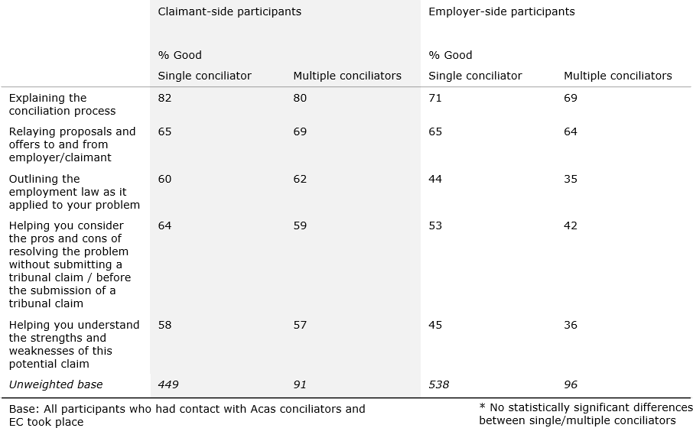

Impressions of conciliators’ personal attributes were strongly positive overall, with a majority of both claimant and employer-side participants agreeing with all bar one of the statements presented to them. Conciliators were rated best for ‘listening to what [participants] had to say’ and being ‘trustworthy’, and least well for helping participants decide whether to settle their case without undue influence. This final measure was the one on which the proportion of employer-side participants agreeing with the statement fell below half – although still significantly more employer-side participants agreed with this statement than disagreed.

### Figure 8. Ratings of the conciliator

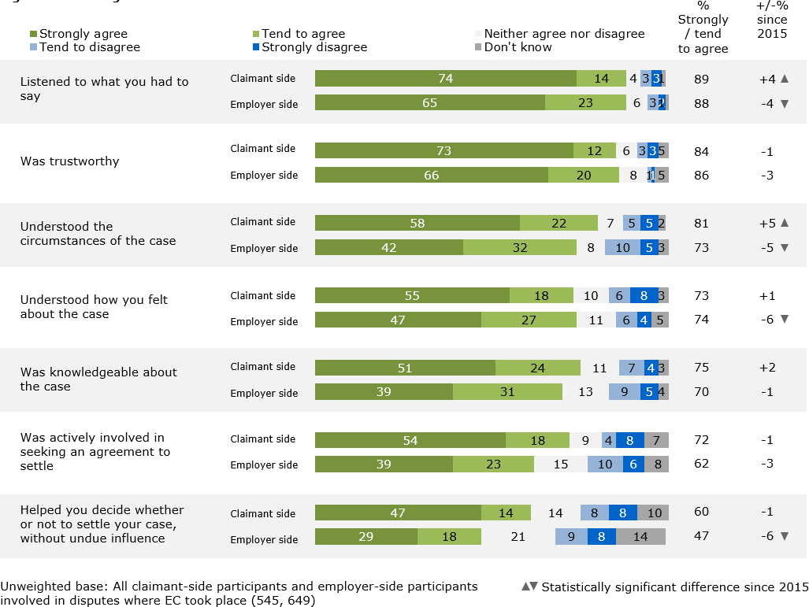

In comparison with the last wave of the survey, on the claimant-side, scores have improved for ‘listened to what you had to say’ (up four points since 2015) and ‘understood the circumstances of the case’ (up five points). By contrast, scores have fallen among employer-side participants across the following statements: ‘listened to what you had to say’ (down four points), ‘understood the circumstances of the case’ (also down five points), ‘understood how you felt about the case’ (down six points) and ‘helped you decide whether or not to settle your case without undue influence’ (also down six points).

Conciliator ratings for personal characteristics were largely consistent across claimant and employer-side participants, with some exceptions:

* Claimant representatives were more likely to agree that the conciliator had ‘listened to what [they] had to say’ (94 per cent) and was ‘trustworthy’ (90 per cent) than claimants (86 per cent and 81 per cent), although ratings are strong for both groups.
* Employer representatives were more likely to perceive the conciliator as ‘trustworthy’ (92 per cent) than employers themselves (84 per cent). Again, these scores remain high for both audiences.

There were also some differences observed by case track:

* Claimant-side participants in open track disputes were generally less likely to agree with each statement than those involved in fast track disputes (and often in standard cases too).
* Employer-side participants in open track disputes were less likely to agree that the conciliator was ‘actively involved in seeking an agreement to settle’ than those involved in fast track cases. There were otherwise no significant differences by case track for this audience other than those in open track

cases being significantly less likely to agree the conciliator ‘understood the circumstances of the case’ than those in standard and fast track cases.

As well as differences depending on the number of conciliators used:

* Among employer-side participants, those in contact with more than one conciliator were significantly less likely to agree with the statements than those in contact with one apart from the statements ‘was trustworthy’ and ‘Helped you to decide whether or not to settle your case, without undue influence’.
* No significant differences were observed among claimant-side participants based on the number of conciliators used.

Case outcome was also an important indicator of participant agreement with these statements, with participants for whom EC ended in a settlement more likely to agree with each statement.

As in 2015, a large majority of claimant and employer-side participants felt that the conciliator had been even-handed in how they dealt with the dispute (76 per cent and 84 per cent respectively). A tenth (ten per cent) of claimant-side participants felt that the conciliator had been more on their side, while just one per cent of employer-side participants felt the same. One in ten (11 per cent) employer- side participants felt that the conciliator had been more on the side of the claimant, while a similar proportion (nine per cent) on the claimant-side thought the reverse was true. Across both audiences, representatives remained more likely to feel that the conciliator had been even-handed than those they represented. Whilst on the claimant-side, it is notable that those reaching a settlement through EC were more likely to think the conciliator had been on their side (15 per cent) than those who had not (seven per cent).

In terms of conciliator availability, more than six in ten claimant and employer-side participants reported that the Acas conciliator was always or usually available when they needed them (67 per cent and 62 per cent respectively), numbers that are in line with those seen in 2015 (67 per cent and 64 per cent). Fewer than one in ten (across both audiences) felt that the conciliator had been rarely or never available (both seven per cent).

There were a handful of significant differences across subgroups of interest:

* Those who had multiple conciliators were less likely to agree that the conciliators were always available.16 On the claimant-side, 39 per cent of those in contact with one conciliator said they were always available compared with 33 per cent of those in contact with more than one. On the employer-side the figures were 28 and 17 per cent respectively.
* Claimants were more likely to report that the conciliator was always available (40 per cent) than their representatives (30 per cent).
* Employer representatives were more likely to agree that the conciliator had always or usually been available when needed (70 per cent) than employers (59 per cent).
* Claimants, employers and their respective representatives who reached a settlement through EC were more likely to feel that the conciliator had been ‘always’ or ‘usually’ available than those who did not.

### Time spent on the case / workplace problem

The amount of time reported to have been spent on the dispute varied significantly by audience. Employers reported spending the most time on the dispute with an average (mean) of 26 hours in total. This represents a significant increase from 2015 when an average of 15 hours was spent per dispute.

Claimants reported spending an average of 25 hours, while claimant representatives reported an average of 18 hours, and employer representatives an average of 11 hours.

When considering the averages, it should be noted that there was considerable variation in the amount of time spent on each case as the median number of hours spent by audience was eight, seven, five and four respectively. A full breakdown is shown in Table 11.17

### Table 11. Time spent on the case / workplace problem

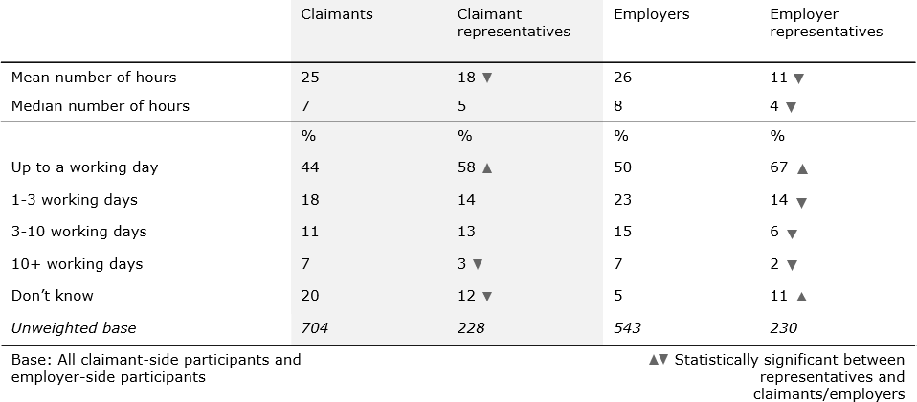

There was no significant variation in time taken by case outcome, but there was by track. Claimant-side participants involved in open track cases reported spending an average of 29 hours on the case, with a median of eight, while those involved in standard or fast track cases reported spending an average of 19 and 21 hours respectively, with a median of five. Among employer-side participants a similar pattern can be observed, with an average of 38 hours reported in open track cases, compared to 28 and 16 hours among standard and fast track cases specifically.

Employers were also asked to report how many people at their organisation spent time on the dispute.

The average number of people involved in each dispute among employers was three. Half (51 per cent) of employers reported that one or two members of staff had spent time on the case (down from 61 per cent in 2015), while a similar proportion (47 per cent) said that three or more had been involved.

Those involved in open track cases reported the highest number of people involved (a mean of four), while those involved in fast track cases reported the lowest (a mean of two).

### Receipt of EC certificate

#### *Receipt by claimants*

All claimant-side participants who failed to reach a settlement would have been issued with a certificate from Acas to confirm that an EC notification had been made but an agreement was not reached (or attempted). Claimant-side participants were asked whether they recalled receiving that certificate. Nine in ten (89 per cent) did, up significantly on 2015 (82 per cent). Representatives were more likely to recall the certificate (95 per cent) than claimants (86 per cent). Claimant-side participants involved in open track disputes were also more likely to recall receipt of the certificate (93 per cent) than those in fast or standard track disputes (both 87 per cent).

All those who recalled receiving the certificate were asked an open-ended question to understand if they knew what this meant for their dispute. Close to two-thirds (62 per cent) of claimant-side participants said receipt of the certificate meant their case could now proceed to tribunal. A quarter (27 per cent) understood that the certificate acted as a formal acknowledgement that EC had ended, and a sixth (14 per cent) that the certificate was proof conciliation had taken place. Just six per cent said they understood there was now a time limit to submit a tribunal claim, while two per cent did not understand what the certificate meant.

Claimant representatives were more likely to report that the certificate acted as a formal acknowledgement that EC had ended (38 per cent), and that there was a time limit to submit a tribunal claim (11 per cent). Similarly, those involved in open track disputes were more likely to say receipt of the certificate meant there was now a time limit to submit a tribunal claim (12 per cent) than those in other tracks.

Since receipt of the certificate, a sixth (16 per cent) of claimant-side participants said they remained in contact with the Acas conciliator assigned to their case. Among those who remained in contact, half (56 per cent) said this was after they submitted their ET claim, while almost a fifth (18 per cent) said it was before they submitted their ET claim. A sixth (16 per cent) said they were in contact both before and after they submitted their ET claim. These findings are consistent with 2015 where 19 per cent of claimant-side participants reported continued contact with the conciliator post-conciliation and 62 per cent of this audience said this contact took place after the tribunal claim was submitted.

#### *Awareness of certificate among employers*

Eight in ten (79 per cent) employer-side participants were aware that when EC concluded without a COT3 settlement, claimants were issued with a certificate confirming that they had complied with the requirement to contact Acas and permitting them to submit an Employment Tribunal claim. A fifth (16 per cent) of employers were unaware. In 2015, 84 per cent were aware that a certificate would be issued.

Employer representatives were more likely to be aware of this requirement (87 per cent) than were employers themselves (76 per cent).

In contrast to 2015, there was no significant difference by case outcome or track.

## SATISFACTION WITH EARLY CONCILIATION AND DRIVERS OF OUTCOME

**Synopsis:** This chapter looks at the determinants of case outcome, including the importance of Acas in resolving disputes and likelihood to recommend Acas services to others.

### Key trends at a glance

* Around a quarter of those taking part in EC reached a settlement, while seven in ten were unable to achieve a resolution within the EC period.
* The majority of settlements involved a financial payment. The average (mean) value of any payment rose significantly since 2015, now reported as £4,246 by claimant-side participants and £4,019 by employer-side participants. Almost all claimants who received a monetary settlement had been paid by the time of the survey.
* Where a settlement had taken place, both sides agreed that Acas’ involvement had been important in resolving their dispute, although claimant-side participants tended to place greater weight on Acas’ input when making a decision than the employer side.
* Around half of EC participants were satisfied with the outcome of EC, although satisfaction varied significantly by outcome and track.
* Setting aside case outcome, around eight in ten EC participants were satisfied with the service provided by Acas. Satisfaction with the Acas service has fallen slightly among employer-side participants, from 86 per cent to 80 per cent.
* Key drivers for satisfaction with the service provided by Acas among claimants included the quality of information provided at the EC notification stage, Acas’ role in moving the sides closer together and claimants’ motivation for entering EC (whether they were interested in reaching a settlement or just wanted to go to a Tribunal).
* For employers, important determinants of satisfaction included the role Acas played in bringing the sides closer, the availability and method of contact with the conciliator, as well as the size of the organisation.
* A majority of both claimant-side participants and employer-side participants said they would use Acas again, were they to find themselves in a similar position.

### EC outcomes

Although case outcome is recorded in the Acas Management Information system from which the surveys were sampled, it was also re-confirmed by both parties during the interview. This reported outcome of EC was used for the analysis conducted throughout this chapter. Given the nature of the sampling design – described at Chapter 5 – findings cannot be combined from both sides to be representative of ‘EC cases’ as a whole and Acas MI, rather than survey data, remains the definitive source for the quantification of case outcome at the overall level.18

The proportion of claimant-side participants in the survey reporting that conciliation had taken place represented over half of all cases (58 per cent). Among those who took part in EC, a quarter (28 per cent) reached a COT3 settlement, while two per cent reported a private settlement. Seven in ten (70 per cent) said they were unable to reach either form of settlement19. As for employer-side participants who,

it should be borne in mind, are not surveyed in cases where the claimant refused EC – eight in ten (78 per cent) reported having taken part in EC. Results for this group aligned closely with claimants: a quarter (26 per cent) reported reaching a COT3 settlement, two per cent reached a settlement privately and three-quarters (72 per cent) said they were unable to reach either form of agreement.

### Drivers of successful case outcome

Throughout this report a series of regression analyses have been conducted to understand the factors associated with the likelihood of service users using different parts of the EC service. These models examine the factors ‘driving’ whether claimants and employers came to a settlement in their case (representatives were not included in either model).20 Note that these models are used to measure associations between variables, not causation.

To provide understanding on the impact of ‘internal’ factors (those within Acas’ control such as conciliator performance) and ‘external’ ones (e.g. claimant or employer characteristics) separate models have been established for both.

#### *Among claimants – internal factors*

The independent internal variables which were found to be determinants of whether claimants successfully settled their EC case are listed below, in order of predictive strength (See Figure 9):

* *Importance of Acas in brokering a resolution*: Agreeing that Acas was important in helping move the two parties closer towards resolving the case was associated with a significantly higher likelihood of a successful case resolution.
* *Information provided at the EC notification form submission stage*: Another strong predictor was agreeing that the information provided by Acas at the EC form submission stage helped them understand how the EC process worked (note that those surveyed used the old version of the notification form, which has since been redesigned).

### Figure 9. Logistic regression results of internal factors determining claimant settlement

***Claimant more likely to have reached a settlement***

Acas involvement was important in helping move parties closer towards resolving the case

Information provided by Acas at the EC Form submission stage was helpful in explaining the

process

#### *Among claimants – external factors*

The independent external variables which were found to be determinants of whether claimants successfully settled their EC case are listed below in order of predictive strength (See Figure 10):

* *Claimant gender:* Men were associated with a significantly lower likelihood of successfully resolving their EC case, compared with women and those who withheld this information.
* *Long-term illness:* Having with a long-term illness, health problem or disability was also associated with a lower likelihood of a successful settlement of their case at the EC stage (claimants with a long-term illness

or disability were also significantly more likely to have more complex open track cases – 44% compared with 30% overall – which may play a role in this correlation)

* *Current employment:* If a claimant is currently working for the employer with whom they have a dispute, this is correlated with a lower likelihood of a successful resolution to the case

### Figure 10. Logistic regression results of external factors determining claimant settlement

***Claimant less likely to have reached a***

***settlement***

I think of myself as male

I have a long-term illness, health problem, or disability

I work for them [the employer] now

#### *Among employers – internal factors*

The independent internal variables which were found to be determinants of whether employers successfully settled their EC case are listed below in order of predictive strength (See Figure 11):

* *Importance of Acas in brokering a resolution*: Agreeing that Acas was important in helping move the two parties closer towards resolving the case was powerfully associated with a significantly higher likelihood of a successful case resolution.
* *Availability of the Acas conciliator*: There is a positive correlation between the likelihood of a successful settlement with employers feeling that the conciliator was always or usually available when needed
* *Method of contact with the conciliators:* Employers whose main method of contact with their conciliator was by email were also more likely to resolve their case successfully. Email use is also associated with other factors such as larger company size so this relationship is unlikely to be directly causal, instead related to a number of additional factors that are outside of this model. The comparative strength of this factor is also less than the importance of Acas in brokering a resolution and the amount of contact with the conciliator.
* *Amount of contact with the conciliator*: A lower rate of contact with the conciliator was negatively associated with a successful outcome – those who reported 1-3 contacts were less likely to resolve their case through EC

### Figure 11. Logistic regression results of internal factors determining employer settlement

***Employer more likely to have reached a settlement***

Acas involvement was important in helping move parties closer towards resolving the case

Acas conciliator/s were always/usually available

when needed

Main/only method of contact with Acas conciliator/s

was email

Had contact 1-3 times with Acas conciliator/s

***Employer less likely to have reached a***

***settlement***

#### *Among employers – external factors*

The independent external variables which were found to be determinants of whether employers successfully settled their EC case are listed below in order of predictive strength (See Figure 12):

* *Personal involvement in the case:* Where the employer who dealt with the dispute also had responsibility for dealing with employment disputes in their organisation more generally, this was associated with a significantly higher likelihood of a successful case outcome.
* *Presence of an HR or personnel department*: If employers have a specialised HR or personnel function there is a small negative correlation: it is associated with a lower likelihood of the case being resolved successfully.

### Figure 12. Logistic regression results of external factors determining employer settlement

***Employer more likely to have reached a settlement***

I am responsible for dealing with employment

disputes in this organisation

The organisation has an internal Human Resources or Personnel Department that deals with personnel issues

***Employer less likely to have reached a***

***settlement***

The four models here identify various key factors associated with a higher likelihood of a successful resolution.

For claimants the key internal factors are the overall impact Acas had in brokering a resolution and the information provided in the notification form at the very start of the EC process, while external factors are demographic, including gender, disability status and employment. This differs from 2015, where standard service

metrics such as the number of contacts by the conciliator and the conciliator’s ability to relay proposals was more important.

For employers these service metrics were more important, with conciliator availability, the amount of contact and the method of contact all being important internal factors, in addition to Acas’ overall ability to broker a resolution. External factors appear to relate to having the ‘right’ person deal with the dispute; if the employer who handled the case was the person within the organisation with responsibility for dealing with employment disputes more generally, this was associated with a higher likelihood of a successful outcome. The presence of an HR or Personnel department was found to have a small negative association with the likelihood of settling a case – possibly related to the fact HR departments are more common in the largest businesses.

### Settlement details

Most participants who reached a settlement via EC reported that financial compensation for the claimant was a part of the agreement (reported by 87 per cent of claimant-side participants and 82 per cent of employer-side participants respectively). A quarter (27 per cent and 22 per cent) received a reference, while a minority (five per cent and three per cent) received a letter of explanation or an apology (three per cent and two per cent).

The average value of the financial settlements reported was £4,246 among claimant-side participants and £4,019 among employer-side participants. This is an increase of £562 among claimant-side participants and £575 among employer-side participants since 2015, although there is wide variation beneath this mean: the median values reported by claimants was £1,600 while it was £849 for employers.

The value of financial settlements differed significantly across case track (see Table 12). Those in open track disputes reported the highest settlement value, while those in fast track disputes reported the lowest.

### Table 12. Value of financial settlements received

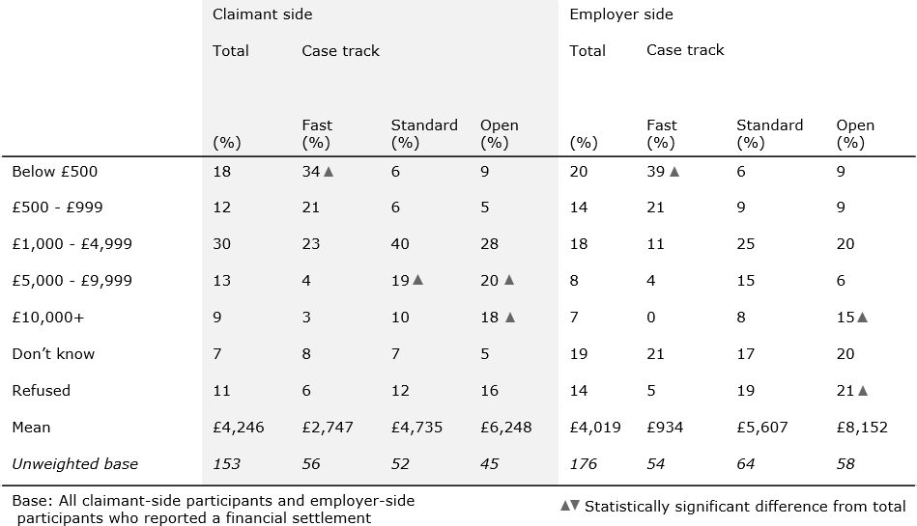

As in 2015, almost all who reported reaching a financial settlement confirmed that the settlement had been paid to them by the time of the survey (94 per cent and 95 per cent for claimant-side and employer-side participants respectively).

### Reasons for not reaching a settlement

#### *Among claimant-side participants*

Among claimant-side participants who failed to reach a resolution via EC, the most common reason reported for the impasse was that ‘the employer did not want to take part in the conciliation / was not interested in talking’ (30 per cent). A sixth (18 per cent) reported that the employer felt they had no case to answer to, while one in ten (12 per cent) said the employer had not been willing to talk further.

As in 2015, claimant-side participants in fast track disputes were more likely to report that EC had failed because ‘I / claimant wanted money and the employer was not willing to pay’ (13 per cent) than those in open or standard track disputes (five per cent and nine per cent respectively).

#### *Among employer-side participants*

Among employer-side participants who engaged in EC, but failed to reach a settlement, the most common reason for the impasse was that the employer felt they ‘had no case to answer to’ (37 per cent). A sixth (18 per cent) reported that the claimant had wanted more money than they were willing to give, and a similar proportion (16 per cent) said that they offered a settlement, but that the claimant was not willing to accept it.

In contrast to 2015, there was no significant difference in outcome by case track.

### Importance of Acas in resolving the dispute

Survey participants were asked to judge the importance of Acas’ involvement in their dispute in three ways:

* Helping them decide how to proceed with the dispute;
* Moving the parties closer to resolving the dispute; and
* Helping them decide whether or not to settle the dispute.

Claimant-side participants were generally more likely than employer-side participants to view Acas’ involvement as important across these measures. However, aggregate measures hide significant differences in opinion between claimants, employers and their respective representatives.

Claimants were most likely to view Acas’ involvement in their dispute as important across measures. A majority said Acas’ involvement had been very or quite important (see Figures 13, 14 and 15).

**Figure 13. Importance of Acas in helping decide how to proceed with the dispute**

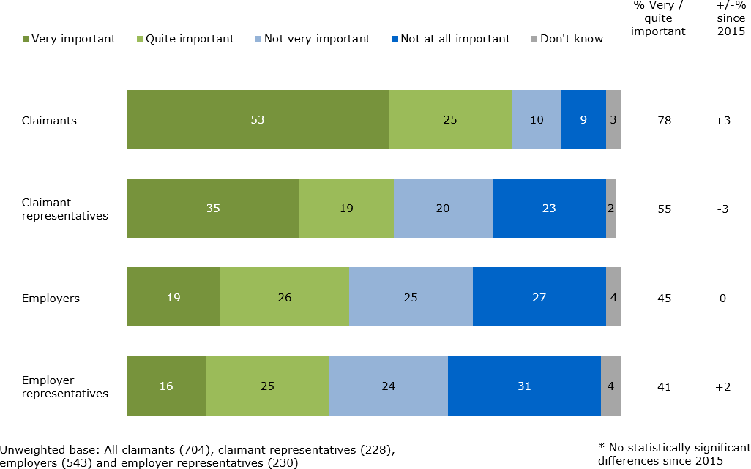

**Figure 14. Importance of Acas in moving parties closer together**

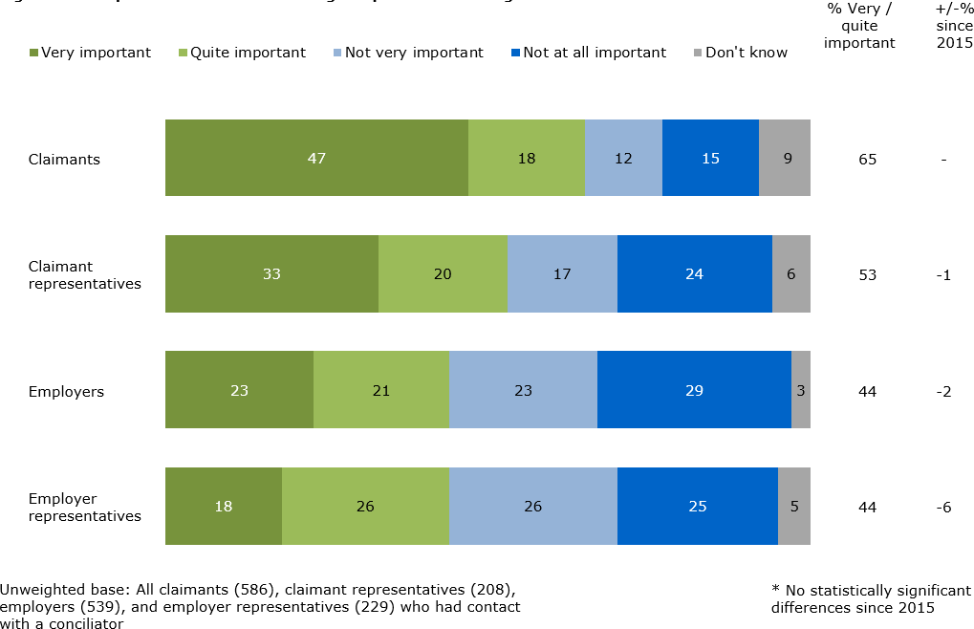

**Figure 15. Importance of Acas in the decision to settle**

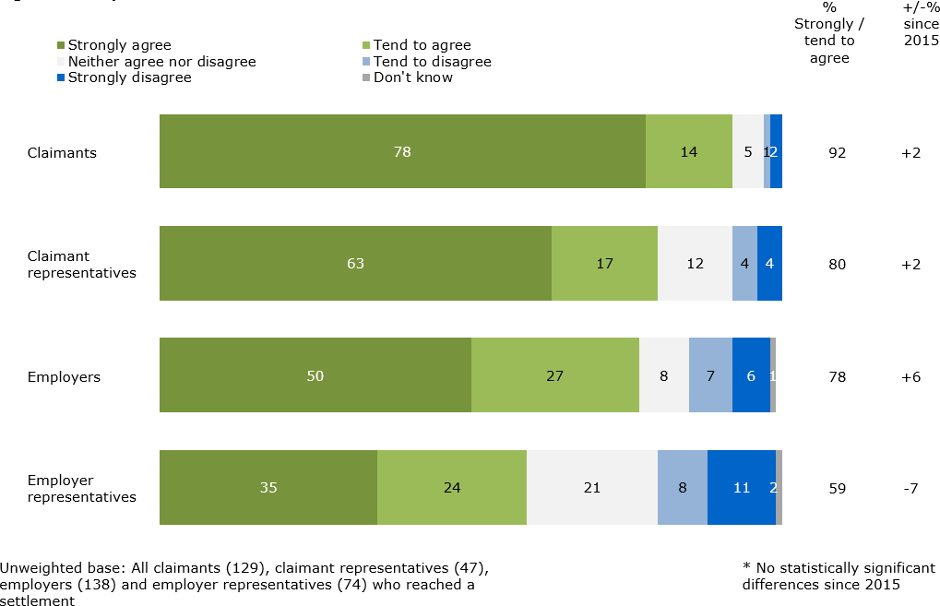

In contrast, employer representatives were the group least likely to rate Acas’ involvement in their dispute as important. However, a majority still agreed that Acas’ involvement had been an important factor in the decision to resolve the case.

Among claimant-side participants, those involved in fast track disputes were more likely to attribute importance to Acas across all aspects than those involved in standard or open track disputes. Similarly, those who reached a settlement via EC were more likely than those who did not settle to feel that Acas had been important in moving the parties closer together and resolving the dispute. This trend was mirrored among employer-side participants.

### Satisfaction with the outcome of EC

Survey participants who took part in EC remained largely satisfied with the outcome of their case. Half (49 per cent) of claimant-side participants reported that they were satisfied, while just over half (54 per cent) of employer-side participants said the same.

### Figure 16. Satisfaction with the outcome of EC

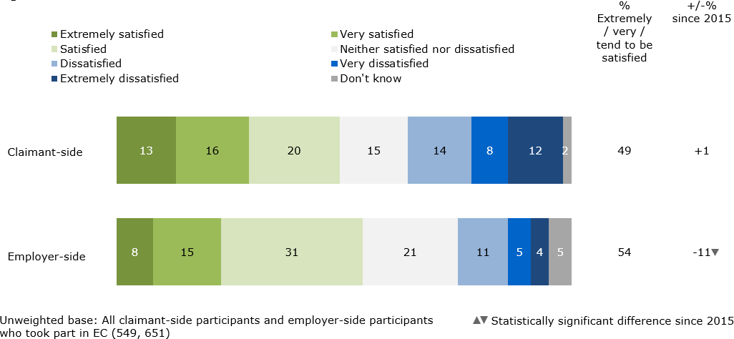

As in 2015, claimants were more likely to report dissatisfaction with the outcome of EC than employer-side participants (49 per cent said they were satisfied while 34 per cent said they were dissatisfied, compared to 48 per cent satisfied and 36 per cent dissatisfied in 2015). There was no difference in satisfaction levels between those in contact with one or multiple conciliators.

Satisfaction with the *outcome* of EC among employer-side participants has dropped significantly since 2015, although this is in a context where the proportion of employers surveyed who reported reaching a settlement through EC has also decreased,21 reflecting a fall in the overall COT3 settlement rate since 2015. Both factors will have been affected by the substantial change in the nature and volume of cases since 2015 as a result of the abolition of Tribunal fees.

When data is analysed by case outcome, employer-side participants who reached a settlement through EC continue to report high satisfaction: 82 per cent of employer-side participants who reached a settlement reported that they were satisfied with the outcome of EC compared to 44 per cent of those who did not. This trend is also found among claimants-side participants: 83 per cent of those who reached a settlement reported satisfaction with conciliation compared to 34 per cent of those who did not settle.

Elsewhere, those involved in open track disputes tended to report lower satisfaction with the outcome of EC than those involved in standard or fast track disputes. Among claimant-side participants, a third (38 per cent) of those involved in open track disputes reported that they were satisfied, while around half (51 per cent and 56 per cent) of those involved in standard or fast track cases said they were satisfied with the outcome. A similar pattern can be observed among employer- side participants, with 49 per cent of those involved in open track disputes satisfied, compared with 55 per cent and 59 per cent of those involved in standard or fast track disputes.

### Satisfaction with the service received from Acas

In addition to asking about views on the outcome of the conciliation, those who took part in EC were also asked for their views of the service provided by Acas overall – independent of the outcome of their case. Acas scored highly on these measures among all service users:

* More than eight in ten reported satisfaction with the timeliness of Acas’ contact (85 per cent of claimant-side participants and 82 per cent of employer-side participants reported this to have been the case). Just seven and nine per cent were dissatisfied respectively.
* A majority reported that they were satisfied with the service provided by Acas as a whole (82 per cent and 80 per cent of claimant and employer-side participants respectively). See Figure 17.
* Among all participants (including those who did not take part in conciliation), the level of satisfaction with Acas’ service was similar, at 77 per cent for claimant-side participants and 79 per cent among those on the employer side

### Figure 17. Satisfaction with the service received from Acas

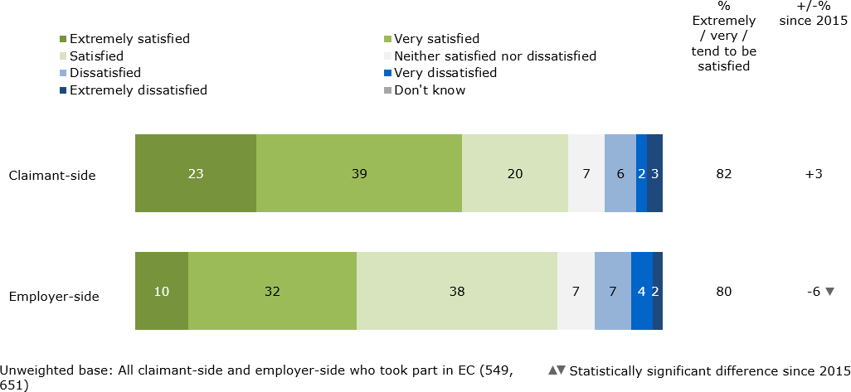

While it remains high, overall satisfaction among employer-side participants is significantly lower than 2015, when 86 per cent reported satisfaction with the service provided. Dissatisfaction has also increased, from six per cent in 2015 to 12 per cent in 2019.

This fall in satisfaction on the employer-side reflects a complicated relationship between satisfaction with the Acas service, satisfaction with outcome and the outcome achieved, discussed elsewhere in this report.

A drop in the number of COT3 settlements may be one factor, especially as satisfaction with the Acas service is greater amongst participants who settled: 94 per cent for employers and 93 per cent for claimants, compared with 74 per cent and 77 per cent respectively among those who did not – as is satisfaction with the outcome achieved (82 per cent versus 44 per cent for employers). Another factor will be the changed nature of cases coming to Acas due to legislative changes around fees.

However, such a conclusion assumes a one-way relationship between outcome and settlement. The quality of service provided by Acas is another factor which can facilitate a positive outcome. For example, 78 per cent of employers reaching a settlement agreed that Acas was important in the decision to settle; and the regression analysis also outlines how internal Acas factors related to the service can also affect the outcome of a case. Therefore, whilst the relationship between outcome and satisfaction is clear, we should not assume that the only factor in whether customers are satisfied is the outcome achieved, nor that Acas is a passive actor in that process.

Meanwhile, satisfaction with the service provided by Acas varied significantly across subgroups:

* Those who reached a settlement through EC were more likely to report satisfaction with the service received than those who did not (93 per cent of claimant-side participants and 94 per cent of employer-side participants respectively).
* Claimant-side participants involved in fast track disputes were more likely to be satisfied (90 per cent) than those in standard (82 per cent) or open track (73 per cent) disputes. In contrast, among employers (and their representatives) there was no variation by case track.
* Satisfaction with Acas was ten points lower among claimant-side participants who went on to submit an ET1 form, although still more than seven in ten of this user group said they were satisfied with the service received (73 per cent).
* Employer-side participants who had contact with more than one Acas conciliator during their dispute (i.e. cases handled by teams covering conciliator absence) were less likely to report satisfaction with the service provided by Acas than those with a single point of contact (71 per cent and 82 per cent respectively). This relationship was not observed among claimants.
* However, across both claimant and employer-side participants, those with a single point of contact at Acas reported higher satisfaction with the *timeliness* of Acas’ contact than those who experienced multiple conciliators (i.e. cases handled by teams covering conciliator absence). Among claimant-side participants, 87 per cent of those with a single conciliator reported that they were satisfied with the timeliness of Acas’ contact compared with 78 per cent of those who experienced multiple conciliators. Among employer-side participants, the comparative figures were 85 per cent and 67 per cent.
* Unlike 2015, there was no significant difference in satisfaction between claimants and representatives.

Those who said they were dissatisfied with the service provided by Acas, regardless of whether EC had taken place, were asked why. Across both claimant and employer-side participants the most common reason for dissatisfaction was that the service or communication provided by Acas was deemed poor (see Table 13). Other reasons included: Acas did not do enough for the participant (mentioned by

33 per cent and 18 per cent of claimant and employer-side participants respectively), Acas did not offer any advice (mentioned by 23 per cent and 16 per cent of claimant and employer-side participants), and that time limits caused issues (mentioned by 15 per cent of claimant and employer-side participants respectively).

### Table 13. Reasons for dissatisfaction with the service provided by Acas

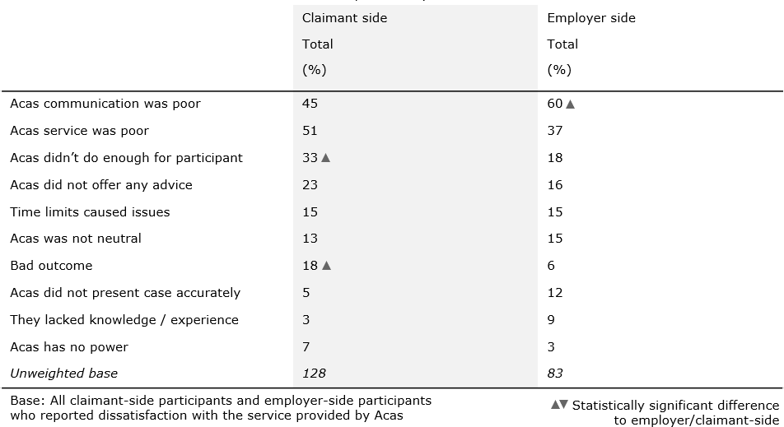

#### *Drivers of satisfaction among claimants*

Throughout this report a series of regression analyses have been conducted to understand the factors associated with the likelihood of service users using different parts of the EC service. These models examine the factors ‘driving’ claimant satisfaction with the overall service received from Acas (representatives were not included).22 Note that these models are used to measure associations between variables, not causation.

To provide understanding on the impact of ‘internal’ factors (those within Acas’ control such as conciliator performance) and ‘external’ ones (e.g. claimant or employer characteristics) separate models have been established for both.

#### *Among claimants – internal factors*

The independent internal variables which were found to be determinants of whether claimants were satisfied with the overall service they received from Acas are listed below in order of predictive strength (See Figure 18):

* + - * *Information provided at the EC form submission stage*: The strongest indicator of satisfaction with the overall service was agreement that the information provided by Acas at the EC form submission stage helped claimants understand how the EC process worked.
      * *Importance of Acas in moving the two sides together*: Another powerful indicator of satisfaction was agreement that Acas was important in moving the two parties closer towards resolving the case.
      * *Suitability of Early Conciliation to the case*: Claimants who agreed that EC sounded suitable to their case when they discussed it with the ECSO were also associated with a significantly higher likelihood of being satisfied with the service provided by Acas.
      * *Importance of Acas advice in deciding how to proceed*: Claimants who agreed that Acas involvement was important in helping them decide on how to proceed with the dispute were also more likely to be satisfied with the overall Acas service provided
      * *Delay in initial contact from Acas*: Those who had to wait more than two working days to be contacted by Acas after submitting their EC notification form were less likely to report overall satisfaction with the service.

### Figure 18. Logistic regression results of internal factors determining claimant satisfaction

***Claimant more likely to have been satisfied with the overall service from Acas***

Information provided by Acas at the EC Form submission stage was helpful in explaining the

process

Acas involvement was important in helping move parties closer towards resolving the case

When the Acas support officer discussed the EC service with me, it sounded suitable

Acas involvement was important in helping me to decide on how to proceed with this dispute

***Claimant less likely to have been satisfied with the overall service from Acas***

After the notification was submitted, established contact with someone at Acas after more than 2 working days

#### *Among claimants – external factors*

The independent external variables which were found to be determinants of whether claimants were satisfied with the overall service they received from Acas are listed below in order of predictive strength (See Figure 19):

* + - * *Motivation for entering EC:* The strongest positive correlation with satisfaction in this model was found among those claimants who described their reason for entering EC as ‘Had to, in order to submit an ET claim, but I was also keen to see if a settlement could be reached beforehand’. Those who entered EC with the sole aim of reaching a settlement (rather than taking their employer to a Tribunal) were also more likely to be satisfied, although this was the third-strongest factor in the model.
      * *Sector of employment:* Being employed in the private sector was positively associated with an increased likelihood of being satisfied with the service.
      * *Time spent on the dispute:* Shorter cases and disputes were also a driver of increased satisfaction. Those who spent three working days or less on the dispute were more likely to be satisfied with the overall service provided by Acas.

### Figure 19. Logistic regression results of external factors determining claimant satisfaction

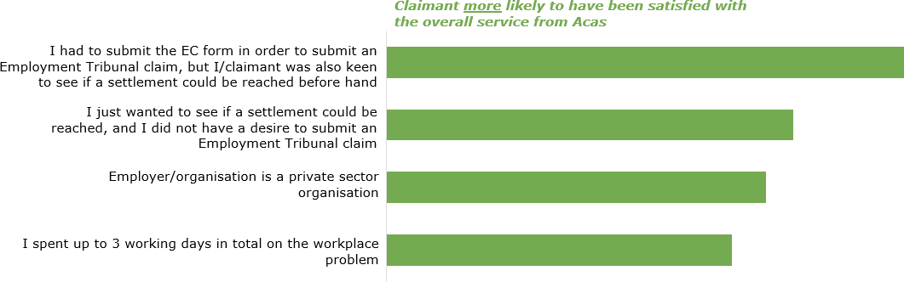

In summary, the regression analyses highlight two key areas for both internal and external factors.

Important internal factors tend to be related either to information provided at an early stage – especially the information provided at the EC form submission stage and the speed with which claimants received a response, but also how suitable the service felt to the claimant’s circumstances – or to the level of service provided by Acas, including skill in moving the two sides together and the quality of advice given. This differs from the 2015 model, which found conciliator attributes (pro- activity in seeking an agreement, trustworthiness, knowledge about and understanding of the case) to be important.

The key external factors also split into two main categories. The first speaks to the claimants’ motivation for entering EC while the second was more demographic, focussed on employment sector and the time spent on the dispute. This also differs from 2015 when only demographic factors – the track of the case and trade union membership – were found to be significant.

#### *Drivers of satisfaction among employer-side participants*

The same regression analysis was applied to employer-side participants to understand the impact of internal and external factors on satisfaction with the service.

#### *Among employers – internal factors*

The independent internal variables which were found to be determinants of whether employers were satisfied with the overall service they received from Acas are listed below in order of predictive strength (See Figure 20):

* + - * *Importance of Acas in brokering a resolution*: The strongest internal driver of employer satisfaction was found to be agreeing that Acas was important in helping move the two parties closer towards resolving the case.
      * *Availability of the Acas conciliator*: There is a positive correlation between the likelihood of employer satisfaction with the service and agreeing that that the conciliator was ‘always’ or ‘usually’ available when needed
      * *Method of contact with the conciliators:* Employers whose main method of contact with their conciliator was telephone were more likely to express satisfaction with the overall service provided.

### Figure 20. Logistic regression results of internal factors determining employer satisfaction

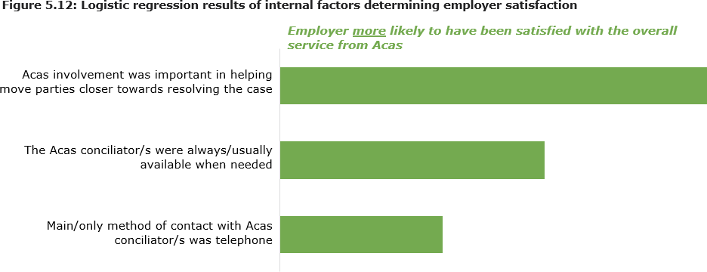

#### *Among employers – external factors*

The independent external variables which were found to be determinants of whether employers successfully settled their EC case are listed below in order of predictive strength (See Figure 21):

* + - * *Number of UK workplaces:* Larger organisations – those with more than one workplace in the UK – were correlated with an increased likelihood of being satisfied with the service provided by Acas.
      * *Whether the claimant works with them now:* A lower likelihood of satisfaction was correlated with cases where the claimant no longer worked with the employer in the dispute. It should be noted that the significance of this relationship does not quite meet the 95% probability threshold and so should be considered more carefully.

### Figure 21. Logistic regression results of external factors determining employer satisfaction

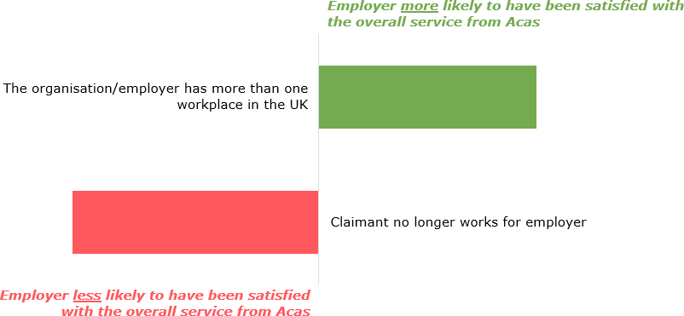

Internal factors associated with higher satisfaction among employers were related to two concepts – the first was the ability of Acas to broker a resolution between the two sides while the second relates to the service provided by the conciliator, in particular the availability of the conciliator and the main method of contact. This is similar to the 2015, which found a series of conciliator skills (proactivity, even- handedness, understanding and knowledge) to be important, alongside Acas’ role in bringing the sides closer together.

The final factor in this year’s model – method of contact – highlights competing employer demands on the service; while phone contact is associated with higher satisfaction in the model, when asked directly employers want more email communication from conciliators.

Only one external factor was found to have a bearing on the likelihood of employer satisfaction – whether the organisation had more than one workplace in the country. This differs from 2015, when the only relevant factor was whether the employer was part of an Employers or Trade federation.

### Perceived benefits of EC

All claimant and employer-side participants were asked to say what they thought the main benefits of taking part in EC were, compared to submitting an Employment Tribunal claim. The responses given are listed in Table 14 below.

### Table showing perceived benefits of EC Table 14. Perceived benefits of EC

The primary benefit of EC referenced by both audiences was that it could save time – both by resolving the issue more quickly (35 per cent and 37 per cent of claimant and employer side participants respectively) and preventing the case from going to tribunal (28 per cent and 31 per cent respectively). Employer-side participants were more likely to say the process was cheaper (28 per cent) while claimant-side participants reported that it was less stressful or traumatic than tribunal (24 per cent). Those employer-side participants who thought EC would make the process cheaper tended to cite legal and time associated costs as a reason, but a minority still mentioned tribunal fees as a barrier.

### Non-financial benefits to the employer

In response to a separate, but related question, a sixth (17 per cent) of employers reported that the Acas conciliator had provided them with information or advice that would help them avoid having to deal with a similar case in the future. This compares to 14 per cent in 2015.

Those who reported this were asked whether they had made any changes in the organisation following the dispute as a result of advice or information provided by the Acas conciliator. As in 2015, this group was most likely to report that they would ensure procedures already in place were followed in the future (71 per cent). Half (52 per cent) said they were reviewing or improving the training provided to managers, and a third that they planned to introduce or review current disciplinary or grievance processes (36 per cent). There was no significant variation by case track or outcome.

### Future use of Acas

Survey participants were asked whether they would use Acas again if they found themselves in a similar situation. Agreement was high across almost all user and outcome groups, as was the case in 2015.

Nine in ten claimant-side and employer-side participants said they would use Acas again (90% and 87% respectively), with a majority saying that they ‘definitely’ would use Acas again (73 per cent and 56 per cent). Few participants from either group said that they would not use Acas again (nine per cent and ten per cent respectively).

Openness to repeat usage of Acas was highest among claimant-side participants who reached a settlement via EC: 97 per cent would do so, compared with 86 per cent of those who did not reach settlement. This trend was also found among employer-side participants: 93 per cent of those who reached a settlement via EC reported that they would use Acas again, as would 86 per cent of those who did not reach a settlement.

Although re-use scores were high across all case track types, claimant-side participants involved in fast track disputes reported were more likely to be open to using Acas again (92 per cent) than those involved in open track cases (86 per cent). Among employer-side participants this trend was reversed: those involved in open (89 per cent) or standard (92 per cent) track disputes were more likely to report they would be open to using Acas again than those involved in fast track disputes (81 per cent).

## EMPLOYMENT TRIBUNAL CLAIM DECISION- MAKING

**Synopsis:** This chapter explores the decision-making process for the submission of an ET claim, both among those whose EC cases did not culminate in a formal settlement, as well as those who did not take part in EC at all. It also examines the causes of non-submission, and the extent to which Acas affected this decision.

### Key trends at-a-glance

* Almost six in ten of those claimant-side participants who did not reach an agreement through EC (or other means) reported submitting or planning to submit an ET claim this year. This compares to nearly half in 2015.
* Two-thirds felt there was nothing more Acas could have done to resolve the situation prior to submission.
* Among those claimant-side participants who submitted a claim, the recovery of money owed was a key factor in their decision, as was holding their employer to account.
* Financial cost was less often a factor in the decision not to proceed with an ET claim submission than in 2015. It was instead more likely that the issue had been resolved outside of conciliation, and therefore ET was now unnecessary.
* Two-thirds of those who decided against an ET claim said Acas was a factor in this decision.
* Claimant and employer-side participants differed significantly in what they assumed would have happened to their claim had EC not existed. Claimant- side participants tended to report that they would have tried to find another resolution prior to submitting an ET claim, whereas employer-side participants tended to assume claimants would have proceeded to a Tribunal straight away.
* Among those employer-side participants who chose not to take part in EC, a large majority reported that they were happy with their decision. Claimant- side participants held a mix of opinions – while a little over half were happy with their decision not to take part, a quarter were unsure if this was the right choice.

### Submission (and intention of submission) of an Employment Tribunal claim

Almost six in ten (57 per cent) claimant-side participants who Acas records show had not reached a COT3 settlement reported that they had already submitted an ET1 claim and a further three per cent said they were planning to – a total of 61 per cent.23 This figure is a significant increase on 2015, when just under half (46 per cent) reported the same; although this rise may reflect the different operational context for EC now that fees have been abolished.

Among claimants who did not settle at EC, some groups were more likely than others to report having proceeded to submit an ET claim:

* Sixty-six per cent of those involved in open track disputes reported submitting an ET claim. Six in ten (57 per cent) of those in standard track disputes said they had done so, while half (53 per cent) of those in fast track disputes said this had been the case.
* Mirroring 2015, six in ten (58 per cent) of those who had opted-in to EC, but whose employer had not, had since submitted an ET claim.

Among claimant-side participants who had not submitted an ET claim, nor achieved a COT3 resolution, eight in ten (78 per cent) said they had made a final decision about how to proceed with their case. Among this group, eight in ten (81 per cent) said they did not plan to submit an ET claim, while nine per cent said they did (a further one in ten said it was too late). These figures match closely with 2015, when eight in ten (78 per cent) of this group said they did *not* intend to submit a claim, six per cent had said that they did and 15 per cent had said it was too late.

### Decision-making around the submission of Employment Tribunal claims

Claimant-side participants who reported submitting an ET claim, or intended to do so, were asked for their reason(s) for taking this course of action. Participants were not prompted, but interviewers coded their responses against a list of possible answers. The most popular response options are shown below (Table 15).

### Table 15. Claimant-side participant reasons for submitting / planning to submit an ET claim

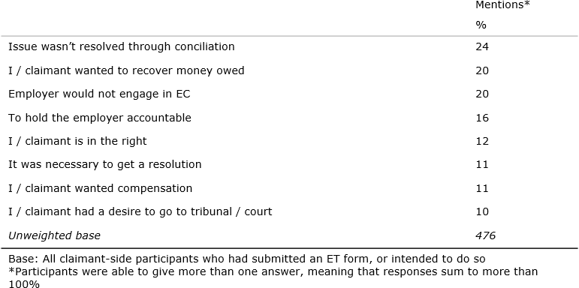

A key shift in rationale has been a fall in the proportion who say they submitted (or intended to submit) an ET claim in order to hold their employer accountable – this was 34 per cent in 2015 and 16 per cent in 2019. By contrast, the proportion who said that one of their reasons was that the issue was not resolved through conciliation has doubled, from 11 per cent to 24 per cent.

Those in fast track disputes were more likely to report that the recovery of money lost was a key driver of their ET claim (35 per cent), compared with standard or open track disputes (12 per cent and three per cent respectively).

Claimant-side participants who had submitted an ET claim (or planned to do so) were asked whether there was anything more Acas could have done to resolve the matter. Mirroring 2015, two-thirds (66 per cent) said no, while a quarter (26 per cent) said yes. Among those who felt Acas could have done more, the most common request was for ‘more communication’ (42 per cent), while others said Acas could have given ‘better support’ (31 per cent) or ‘been more involved’ (25 per cent) in their case or explained the process better (22 per cent).

### Decision-making around the non-submission of Employment Tribunal claims

#### *Reasons for not submitting an ET claim*

Those claimant-side participants who had not reached a COT3 settlement but had decided against submitting an ET claim were asked for their reason(s) for taking this course of action. Respondents gave their reasons in their own words, but responses were coded into a list detailed below.

Half (47 per cent) reported that the issue had since been resolved, rendering an ET claim redundant (this had been the second most cited reason in 2015, at 20 per cent). A quarter (26 per cent) said they did not think they would win the case (see Table 16).

### Table 16. Claimant-side participant reasons for not submitting / planning not to submit an ET claim

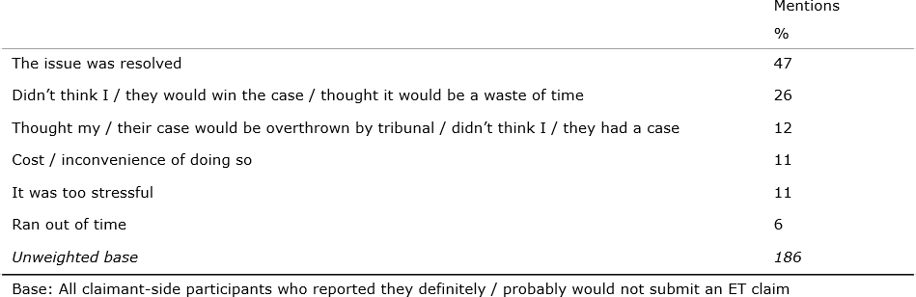

In 2015, tribunal fees were the most reported reason for non-submission, mentioned by one quarter (26 per cent) of those who had decided against submitting a claim. With these fees now abolished the proportion mentioning financial considerations is much lower, at 11 per cent – and typically this was combined with discussion about the inconvenience of the process.

#### *Non-submission of ET claims in unsettled cases: determining the* ‘Acas effect’

Two-thirds (66 per cent) of claimant-side participants who had decided against submitting an ET claim and had not reached a COT3 settlement said Acas was a factor in helping them reach this conclusion, while three in ten (31 per cent) said Acas was not a factor. This result is not significantly different to 2015, when six in ten (61 per cent) reported that Acas was a factor in their decision not to proceed to ET.

### Figure 22. Importance of Acas in decision not to proceed to ET (claimant- side participants)

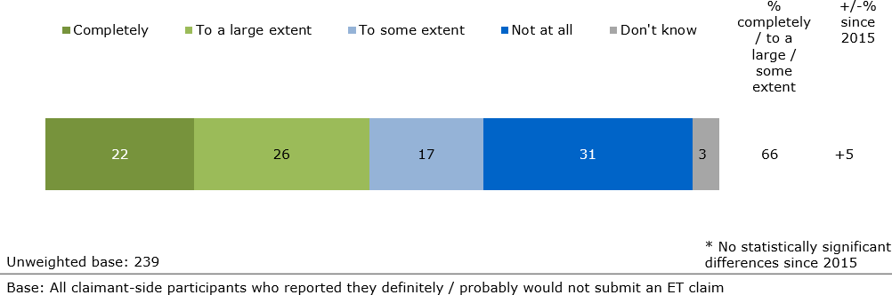

As in 2015, those involved in fast track disputes were more likely to say Acas had been a factor in their decision (73 per cent) compared with claimants in open track cases (56 per cent).

One way to quantify the importance of Acas on ET decision making is to calculate the proportion of claimant-side participants who decided not to take their employer to an Employment Tribunal *owing to their participation in EC*. This rate is calculated by summing the following groups and dividing by the overall number of claimants who took part in EC:

* + - * Those who took part in EC and reached a COT3 settlement or a private settlement
      * Those who took part in EC and did not reach a settlement but decided against submitting an ET claim *and* reported that Acas was a factor in helping them to reach this conclusion.

The overall ‘Acas effect’ based on this data stands at a rate of 44 per cent, a level not significantly different to the 2015 score of 48 per cent.

### Likely action in absence of EC

Both claimant and employer-side participants who had taken part in EC were asked to imagine what would have happened had there been no EC service.

Echoing the 2015 results, views differed significantly between claimants and employers (see Table 17).

### Table 17. Likely action in absence of EC

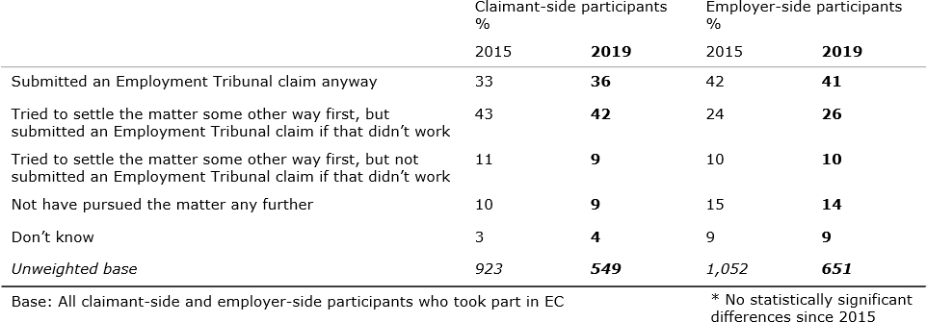

Employer-side participants were most likely to report that the claimant would have submitted an ET claim anyway (41 per cent), while the most likely response from the claimant-side was that they would have tried to settle the matter another way first, before submitting an ET claim if that did not work (42 per cent) – although a similar proportion said they simply would have submitted their claim anyway (36 per cent).

Results differed significantly by track among employer-side participants – those involved in open or standard track disputes were more likely than average to say that the claimant would have submitted an ET claim against them anyway (45 per cent and 49 per cent respectively). There were no significant differences by case track among claimants and their representatives, although claimant reps were more likely to say they would have tried to find a settlement than claimants themselves.

### Feelings around the decision not to take part in EC

All participants who decided not to take part in EC were asked how they felt about the decision in hindsight. As in 2015, there were significant differences in opinion between groups. A large majority of employer-side participants reported that they were happy with their decision not to use EC (84 per cent). Just two per cent said they regretted not having used EC.

By contrast, the views of claimant-side participants were mixed. While half (52 per cent) said they were happy with their decision, a quarter (24 per cent) said they were in two minds about their decision, and one in ten (10 per cent) said they actively regretted their decision not to use EC (see Figure 23).

**Figure 23. Happiness with the decision not to use EC**

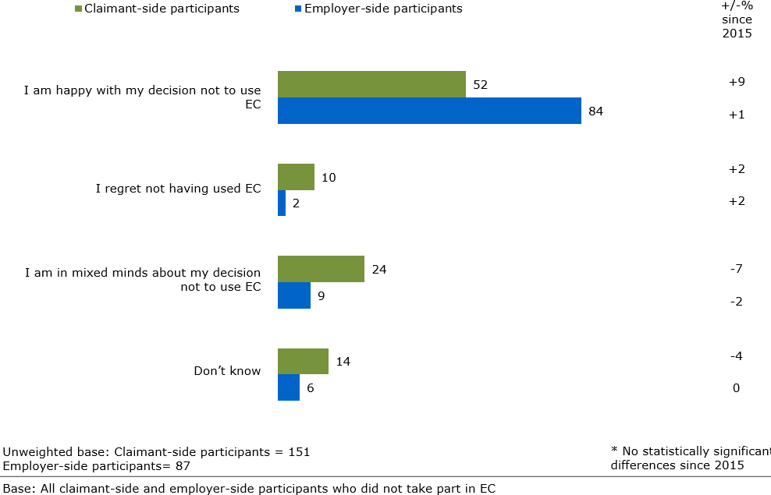

## INTRODUCTION TO THE EVALUATION OF CONCILIATION IN EMPLOYMENT TRIBUNAL APPLICATIONS (‘POST-ET1 CONCILIATION’)

The Advisory, Conciliation, and Arbitration Service (Acas) commissioned Ipsos MORI to undertake an evaluation of its post-ET1 conciliation service i.e. conciliation in Employment Tribunal applications. This is the second wave of this evaluation since the introduction of Early Conciliation. This part of the report outlines the findings from this research, with comparisons to [a similar study undertaken in](https://archive.acas.org.uk/media/4591/Evaluation-of-Acas-conciliation-in-Employment-Tribunal-applications-2016/pdf/Evaluation-of-Acas-conciliation-in-Employment-Tribunal-applications-2016.pdf) [2016](https://archive.acas.org.uk/media/4591/Evaluation-of-Acas-conciliation-in-Employment-Tribunal-applications-2016/pdf/Evaluation-of-Acas-conciliation-in-Employment-Tribunal-applications-2016.pdf).

The survey covers user experiences of the conciliation service provided by Acas for employment disputes between the submission of an ET claim and the conclusion of the dispute through a settlement, withdrawal or continuation to full tribunal. User experiences of conciliation prior to the submission of an ET claim (i.e. Early Conciliation) are covered under the first survey in this report.

Fieldwork took place between 12 June and 23 August 2019. In total, 481 interviews were achieved in the claimant survey (81 per cent with claimants and 19 per cent with their representatives) and 464 interviews were achieved in the employer survey (47 per cent with employers and 53 per cent with their representatives). Details on response rate can be reviewed in the technical appendix.

In considering the results for this survey, especially the trends and changes since the prior evaluation in 2016, it is important to be mindful of the context of change: the abolition of ET fees, the increase in conciliation caseloads and – perhaps to a lesser extent – the introduction by Acas of a dedicated fast-track conciliator role might all be expected to have some bearing on results, although it is not possible to go beyond the data and attribute specific causal impacts of these changes. Key trends between 2016 and 2019 are given throughout this part of the report, but these comparisons should be treated with caution because of the changes in the context that post-ET1 conciliation operates in.

Finally, it should be noted that since this evaluation was undertaken in 2019, Acas has made other developments in service provision including a new case management system for conciliators and pilots of alternative team-based models of conciliation delivery. As the ET survey sample deals primarily with cases from summer 2018 and spring 2019, the impact of these features will not be reflected in the data (full sampling frame details are provided in the technical appendix).

## PROFILE OF PARTIES AT POST-ET1 CONCILIATION

**Synopsis:** This chapter outlines the profiles of the four types of participants who took part in the survey:

* Claimants
* Employers
* Claimant representatives
* Employer representatives

### Key trends at-a-glance

* The profile of participants in 2019 was very similar to the 2016 profile and is also broadly in line with the profile of participants at the EC stage.
* Claimants’ personal characteristics remained consistent with the 2016 survey and closely matched the profile of participants at the EC stage on characteristics including income, age and gender.
* Claimants’ employment characteristics were also largely consistent with the 2016 survey: the majority worked full-time in the private sector and had no previous ET experience. However, among those who had been job applicants or else no longer worked for the employer against whom they brought a case, claimants were significantly more likely to be in full-time employment at the time of the interview compared with 2016.
* Employers’ characteristics were similarly largely consistent with 2016: most are smaller private sector organisations with one site in the UK. Compared with EC, employers involved in post-ET1 conciliation are less likely to be from larger organisations and are also less likely to have internal legal or HR departments.
* Overall representation levels for claimants and employers have decreased since 2016, a pattern which may be correlated with an increase in fast track cases compared with the last wave of the survey. Nevertheless, claimants and employers remain much more likely to be represented in post-ET1 conciliation than EC, consistent with findings from the previous wave.
* Matching the picture from 2016, the most commonly-used representatives for both claimants and employers were solicitors, barristers or lawyers – although the proportion of parties using legal professionals at this stage has fallen. Both sides nevertheless remain more likely to use legal professionals as representatives at the post-ET stage compared with the EC stage.
* Representatives used in post-ET1 conciliation also tended to have more years of experience than those used at the EC stage – again echoing findings from 2016.

### Profile of participants

This section outlines the profile of the claimants and employers who participated in the survey. Comparisons are made with data from the first wave of the post-ET1 conciliation survey (from 2016) as well as the two waves of the EC survey (conducted in 2019 and 2015), to show how profiles vary both over time and between the two conciliation stages.

#### *Claimant characteristics*

A large majority (82 per cent) of claimants worked full-time (more than 30 hours a week), while 14 per cent worked part-time. Four per cent of claimants said their employment depended on work being available, or on being contacted by their employer. This profile matches other surveys:

* + - * In the 2019 EC survey 78 per cent of claimants worked full-time, 15 per cent worked part-time and five per cent had employment contingent on the availability of work or employer demand.
      * In the 2016 post-ET1 conciliation survey the figures were 79 per cent, 15 per cent and five per cent

Two thirds (66 per cent) of claimants had worked for their employer for at least one year at the time of contacting Acas about the workplace problem.

* + - * This is in line with the general profile of claimants who submitted EC notifications – the 2019 EC survey reports that 68 per cent of claimants notifying had worked for their employer for at least one year.
      * However, it is a lower figure than the previous ET survey data. In 2016, 79 per cent of ET claimants had worked for their employer for at least one year. This drop is likely related to the increase in fast track cases as a proportion of the overall caseload since 2016: the data from the 2019 survey shows that among claimant-side participants more generally, three in ten (29 per cent) fast track claimant-side participants had worked with the employer for less than 6 months, compared with eight per cent for open track cases and seven per cent for standard track cases.

One in five (20 per cent) claimants reported being a member of a Trade Union or staff association – close to the level recorded in the 2019 EC survey (19 per cent) and the 2016 ET survey (also 19 per cent).

Claimants were also asked about their employment situation at the time of the interview. Among claimants who were job applicants or no longer worked for the employer against whom they raised the case, nearly eight in ten (77 per cent) were in full-time employment. This is significantly higher than the level recorded in the previous wave of this survey (59 per cent).

Among those who were not in paid employment at the time of the interview, one third (35 per cent) confirmed having had paid work at some point since leaving their employer. This is significantly higher than those at the EC stage, when only 15 per cent reported having paid work since leaving their employer – a factor which may be explained by the longer time lag between the dispute and the interview in the post-ET1 survey. It is also an increase on the level recorded in the 2016 post- ET1 conciliation survey, when one fifth (21 per cent) said they had had paid work since leaving their employer.

Eighty-nine per cent of claimants had not previously made an Employment Tribunal claim at any workplace. This matches claimants at the EC notification stage, where 92 per cent of claimants reported never having made an Employment Tribunal claim previously. It is also a similar level to that recorded in the 2016 post-ET1 conciliation survey, when 86 per cent had not made a previous claim.

Claimants were also asked a series of questions about their personal characteristics.

* + - * Six in ten (60 per cent) claimants were male. This is broadly in line with the 2019 EC survey (55 per cent) and the previous wave of the ET survey. See Table 18.
      * Also matching the 2016 ET and 2019 EC results, more than nine in ten (93 per cent) claimants identified as heterosexual.
      * Just over half of ET claimants (54 per cent) were aged over 45, close to the 59 per cent figure recorded in 2016. In the EC survey, just under half of claimants (47 per cent) were aged over 45. See table 19.
      * Nearly eight in ten (78 per cent) claimants described their ethnic group as White. Seven per cent identified as Black, six per cent as Asian, three per cent as mixed ethnic background and two per cent from another ethnic group.
      * Half of all claimants (48 per cent) described their religion as Christian. Six per cent described themselves as Muslim. Thirty-nine per cent reported that they were of no religion. This broadly reflects the profile of claimants at the EC notification stage and the 2016 survey.
      * Almost nine in ten (88 per cent) claimants spoke English as their first language. There was a similar proportion at the EC stage (85 per cent) and in 2016 (89 per cent).
      * As in 2016, a third (28 per cent) of claimants reported having a long-term illness, health problem or disability. This is also in line with claimants at the EC notification stage, where 31 per cent reported the same.
      * Four in ten (40 per cent) claimants confirmed having an income greater than

£30,000 per year. This is in line with claimants at the EC notification stage, where 44 per cent reported the same and also the 2016 survey (38 per cent), suggesting that the income levels of claimants have not noticeably shifted since the removal of Employment Tribunal fees.

**Table 18. Gender of claimants**

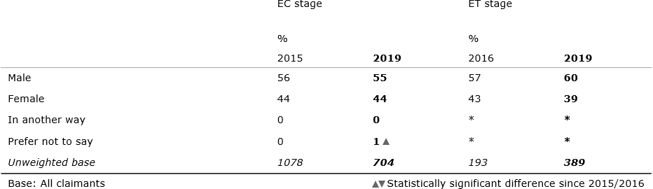

**Table 19. Age of claimants**

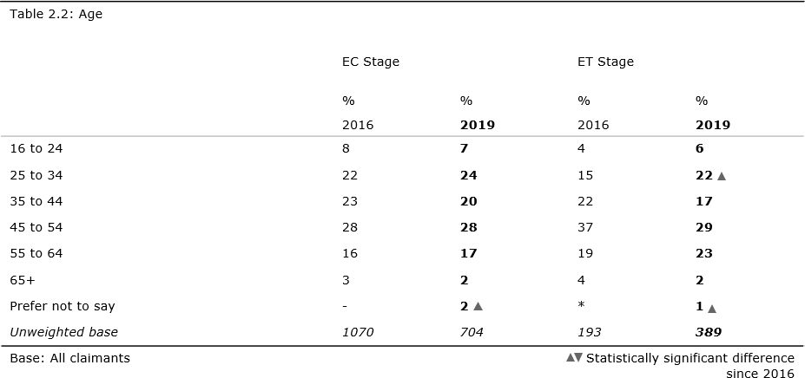

### Employer characteristics

The profile of employers this year broadly reflects the profile of employers both in 2016 and at the EC notification stage. However, following the increase in the proportion of fast track ET claims within our sample in 2019, the proportion of smaller organisations involved in ET claims has grown since 2016, while the proportion of larger organisations involved in claims appears to have fallen compared with the EC survey results. Please note that comparisons should be interpreted with care due to the low base size in 2016.24

Overall, eight in ten (80 per cent) employers worked in private sector organisations. Twelve per cent worked in public sector organisations, and seven per cent worked in non-profit/voluntary organisations. These figures are consistent with profile of employers at the EC stage and with the 2016 ET survey.

Looking at workplace size, seven in ten (70 per cent) employers were from a small workplace (between 1 and 49 employees), two in ten (19 per cent) were from a medium-size workplace (between 50 and 249 employees) and one in ten (9 per cent) were from large workplaces (250 or more employees). This represents a modest rebalancing of the profile compared with 2016, when 62 per cent of workplaces were small and 14 per cent were large.

Around half (52 per cent) of employers involved in ET claims in 2019 worked for organisations with more than one workplace in the UK. This is close to the 57 per cent figure recorded at the EC notification stage and also matches the 2016 ET survey (59 per cent).

In terms of overall organisation size, half (50 per cent) of employers were from small organisations (between 1 and 49 employees), two in ten (20 per cent) were from medium-size organisations (between 50 and 249 employees) and three in ten (29 per cent) were from large organisations (250 or more employees). Reflecting the trend in workplace size there has been a small shift towards smaller organisations since 2016 when 39 per cent had been from small organisations and 37 per cent from large ones. This shift should be interpreted with caution however, as the 2016 base size was just 99 employers.

This change is likely related to the increase in fast track ET claims compared with 2016: among employer-side participants one in five (19 per cent) employers

involved in fast track claims are from large organisations with more than 500 employees, compared with to 39 per cent and 34 per cent for open and standard track cases respectively.

Compared with the 2019 EC survey, organisations involved in ET claims tend to be smaller than those at EC. Forty-four per cent of employers in the EC survey were from large organisations of 250 or more employees, compared with 29 per cent at the ET stage. This relationship can also be observed between the previous waves of the EC and ET surveys: in the 2016 post-ET1 conciliation survey, 37 per cent of employers were from large organisations and in the 2015 EC report the equivalent number was 49 per cent.

Half (52 per cent) of employer organisations had an internal Human Resources (HR) or Personnel department that deals with personnel issues, compared with 67 per cent in 2016. One quarter (23 per cent) had an internal legal department that deals with personnel or employment issues, while three in ten (28 per cent) were members of an Employer’s or Trade Association. Around one in six (17 per cent) had active trade unions or staff associations in the workplace.

Employers in the ET survey were much less likely to have a formal HR department than those in the EC survey (52 per cent compared with 71 per cent), likely a reflection of some of the differences in organisation size when comparing the two samples we have noted above.

Nearly all (95 per cent) employers reported that, within their own organisation, they were the individuals who normally deal with employment disputes – this is consistent with the 2016 survey, when the figure was 89 per cent.

### Profile of representatives

In cases where a claimant or employer were selected for the survey, but a representative was listed on Acas’ MI records as dealing with the case on their behalf, the representative was approached for an interview rather than the claimant or employer.

All representatives were asked a series of profiling questions, the findings from which are outlined in the following sub-sections.

#### *Claimant representatives*

Half of claimant representatives were solicitors, barristers or another type of legal professional (53 per cent). Just under one fifth (16 per cent) were friends, neighbours, spouses or partners, while less than a tenth (7 per cent) were a Trade Union or worker representative.25

This differs from the profile of claimant representatives in the 2019 EC survey, with a higher level of official legal representation: while legal professionals were also the largest single group in the EC survey, they constituted one third of all representatives (33 per cent) at that earlier stage. Compared with the ET sample, representatives at EC were more likely to be informal representatives such as friends of family (24 per cent) or Trade Union workers (18 per cent).

This difference between EC and ET is more pronounced than in the previous wave of the surveys, although the proportion of representatives who are legal professionals has declined in both EC and ET since then. We should also note that the sample size of representatives at the ET stage in 2019 was 92, compared with 319 in 2016 so care should be taken in making comparisons across waves. See table 20 for a full breakdown.

### Table 20. Type of claimant representative

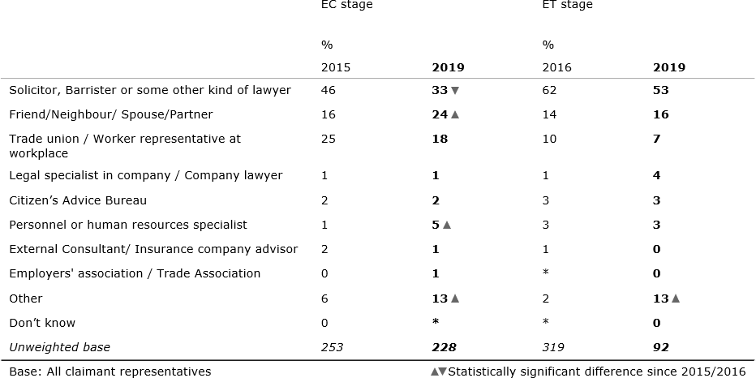

Six in ten claimant representatives (60 per cent) had more than five years’ experience dealing with ET claims, while 19 per cent had between 1-5 years’ experience. One in ten (10 per cent) had worked with ET claims for less than a year, and a similar proportion (12 per cent) had never dealt with an ET claim before. This broadly reflects the profile of claimant representatives in 2016.

Four in ten (41 per cent) claimant representatives reported that they usually represent claimants in ET proceedings. A similar proportion (39 per cent) said that they usually represent either a claimant or an employer. One in ten (13 per cent) reported that they have never represented either party before, and a slightly smaller proportion (7 per cent) reported that they usually represent an employer.

Claimant representatives at the post ET conciliation stage were more experienced than those at the EC notification stage. At the EC stage, there were more claimant representatives who had never dealt with an ET claim before (28 per cent). Additionally, representatives at the EC stage were significantly more likely to have had no previous experience in representing either a claimant or an employer (28 per cent compared to 13 per cent at the ET stage). See table 21 for a full breakdown.

### Table 21. Length of time claimant representatives had dealt with ET claims

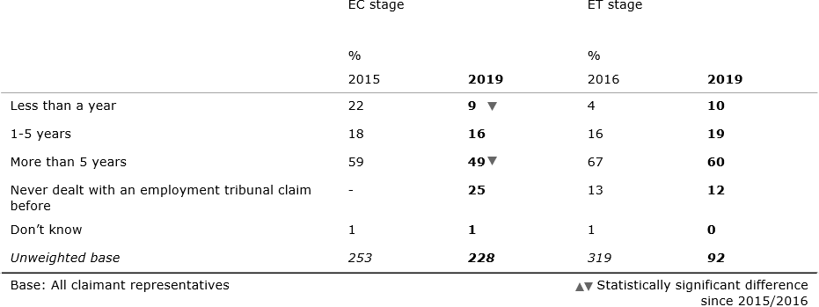

More than eight in ten (84 per cent) claimant representatives were appointed before the ET claim was submitted. Nine per cent were appointed after the ET claim had already been submitted and five per cent were appointed at the point the ET claim was submitted.

#### *Employer representatives*

More than eight in ten employer representatives were solicitors, barristers or other legal professionals (84 per cent). Repeating a pattern observed in the first wave of the surveys, employer representatives were almost twice as likely to be solicitors, barristers or other kind of lawyers at the ET stage compared with the EC stage (48 per cent). See table 22 for a full breakdown.

### Table 22. Type of employer representative

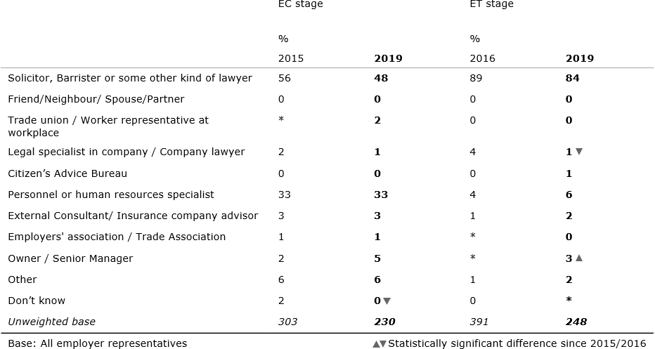

Employer representatives were typically very experienced: more than eight in ten (85 per cent) had worked with ET claims for more than five years, slightly above the level recorded in 2016 (82 per cent). Almost all others (12 per cent) had worked with ET claims for between one and five years. Following the pattern observed among claimant representatives, employer representatives at the post ET conciliation stage were more experienced than those at the EC notification stage, when 75 per cent of employer representatives had worked with ET claims for more than five years. See table 23 for a full breakdown.

### Table 23. Length of time employer representatives had dealt with ET claims

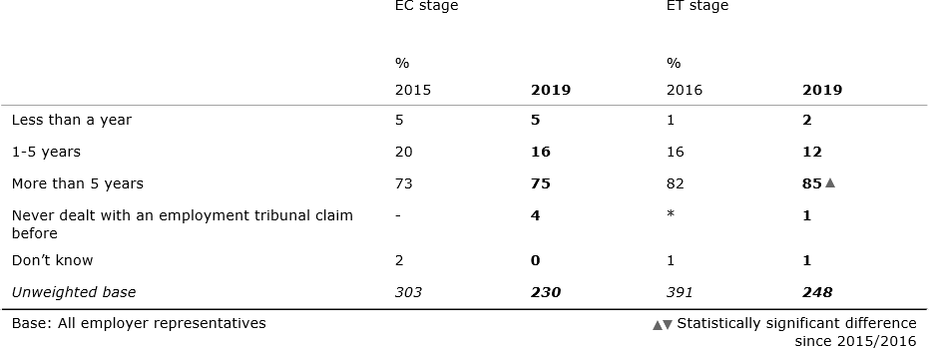

Almost all employer representatives had previously represented either an employer or claimant. As in 2016, three quarters (73 per cent) of employer representatives tended to specialise in representing employers. A quarter (25 per cent) reported that they usually represent either party and one per cent reported that they normally represent the claimant.

Half (51 per cent) of employer representatives were appointed before the ET claim was submitted while four in ten (43 per cent) were appointed more reactively, at the point of the ET3 response. This is a significant increase from 2016, when a third (33 per cent) appointed a representative at this reactive stage. Just five per cent were appointed after the employer had already made an ET3 response.

### Case characteristics

While representation is typically well-recorded in Acas’ records, a checking question was included in claimant and employer interviews to confirm whether they had used a representative to deal with Acas during the ET process.

#### *Claimant-side*

Combining both Acas MI records and the results of the check question it can be determined that a representative was used by 56 per cent of claimants. This a significant fall from 2016, when representatives were used by 78 per cent of post- ET1 conciliation claimants. It remains significantly higher than the proportion of claimants who used a representative at EC stage in 2019 (38 per cent), echoing the results of the first wave of the surveys (78 per cent at ET 2016 and 24 per cent at EC 2015).

Claimants involved in open and standard track disputes were significantly more likely than those in fast track disputes to use a representative (67 per cent, 63 per cent and 33 per cent respectively). This is reflective of the pattern at EC and of the findings from the 2016 ET survey; and the increased proportion of fast track cases in 2019 may be a factor behind the fall in representation observed in this wave.

There were some differences in track by ethnicity, but small base sizes mean that these should be interpreted with caution.26 Claimants from White ethnic backgrounds were significantly more likely to be party to a fast track case than BAME claimants (42 per cent compared to 29 per cent) while BAME claimants were more likely to be party to an open track case (43 per cent compared to 24 per cent).

Half (50 per cent) of claimant-side participants reported having taken part in EC before their Employment Tribunal claim had been submitted. This is significantly lower than in 2016 (66 per cent) and may have an impact on outcomes as driver analysis in this report highlights prior participation in EC as a significant factor in the likelihood of accepting the offer of conciliation at the post-ET1 stage for both claimants and employers.

More than eight in ten (84 per cent) claimant representatives were appointed before the ET claim was submitted. As reported in the EC survey, a third (38 per cent) of claimants had representation at the EC stage. This means that it is likely that a large proportion of claimant representatives were appointed between the issuing of the Acas EC certificate and the submission of an Employment Tribunal claim. One in ten (9 per cent) representatives took on their role after the ET1 was already submitted, while five per cent took on their role at the point the ET1 form was submitted.

These findings are consistent with the 2016 survey, when 83 per cent of claimant representatives took on their representative role before the ET claim was submitted.

#### *Employer-side*

Combining Acas MI records and the results of the check question it can be determined that a representative was used by 74 per cent of employers. As with the claimant-side, this is a significant decrease in the overall level of employer representation at the post-ET1 stage: in 2016, 84 per cent had used a representative. As in 2016, and matching the claimant-side pattern, employer representation at the ET stage remains higher than at the EC stage. One third of employers used representation in the 2019 EC survey (33 per cent).

Matching another claimant-side trend, employers involved in open and standard track disputes were significantly more likely than those in fast track disputes to use a representative (87 per cent, 79 per cent and 55 per cent respectively). This also matches the employer-side pattern in the 2019 EC survey as well as the 2016 ET survey.

Just over a third (35 per cent) of employer-side participants reported having taken part in EC before the Employment Tribunal claim had been submitted. This compares to 46 per cent in 2016.

There has been a slight change in the balance of previous Employment Tribunal experience: in this wave of the survey 41 per cent of employer organisations had previously had an ET claim made against them, slightly below the 52 per cent recorded in 2016. Fifty-five per cent had no prior experience of an ET claim having been made against them, a small increased from 44 per cent in 2016.

### Comparison of profiles at ET stage and EC stage

As described in the previous sections, the profile of claimants and employers who submit ET applications (as recorded by this survey) is very similar to the profile of claimants who submit EC notifications (as recorded in the EC survey). However, there are some notable differences.

#### *Claimant-side*

* + - * Overall representation at the ET stage is significantly higher than at the EC stage.
      * The most commonly used representatives at both stages were solicitors, barristers or lawyers, but the use of such representatives was much higher at the post-ET1 conciliation stage than the EC notification stage.
      * Claimant representatives involved in post-ET1 conciliation were also more likely to have greater experience than those used in EC.
      * Claimants not in paid employment at the time of the ET interview were significantly more likely to report having had paid work at some point since leaving their employer than claimants not in paid employment at the time of the EC interview, likely attributable to the longer period of time between the workplace incident and the survey in the former.

#### *Employer-side*

* + - * Matching trends in the claimant-side survey, overall representation at the ET stage among employers is significantly higher than at the EC stage.
      * As with claimants, the most commonly used employer representatives at both stages were solicitors, barristers or lawyers, but the use of such representatives was much higher at the post-ET1 application stage than the EC notification stage, and they also tended to be more experienced at this later point.
      * In line with claimant representatives, employer representatives at the post- ET1 conciliation stage were more experienced than those at the EC notification stage.
      * Employers involved in post-ET1 conciliation were more likely to be from smaller organisations than those at the EC stage. They were also less likely to be based in organisations that had internal legal or HR departments.

## ACAS INVOLVEMENT FOLLOWING ET APPLICATION

**Synopsis:** This chapter explores the initial interactions between the parties and Acas following an ET application and examines the key determinants of uptake of Acas conciliation at this point.

**Key trends at-a-glance**

* Participants on both sides were more likely to report that they had made initial contact with Acas (rather than Acas making first contact with them) after the submission of the ET1 form. This is a difference from 2016, when Acas was more likely to make the first contact.
* Where Acas made the initial contact, claimant-side participants involved in open track disputes were most likely to report that this contact had been established a week or more after receiving the letter. This suggests that for those involved in open track disputes, establishing contact with Acas takes longer than for those in fast and standard track disputes.
* As in 2016, nearly half of employer-side participants said they did not know when contact was made with Acas.
* As in 2016, the level of service uptake for post-ET1 conciliation was lower than the uptake of EC. However, participants who took part in EC were more likely to take part in ET conciliation than those that did not.
* Regression analysis of the key drivers behind claimant participation in post-ET1 conciliation found recalling receiving an introduction letter from an Acas conciliator and participation in EC earlier in the dispute were associated with a higher likelihood of acceptance, while being from a White ethnic background was associated with a lower likelihood of acceptance
* For employers, taking part in EC earlier on and receiving a letter from the conciliator were correlated with an increased likelihood of participation in post- ET1 conciliation.

### Initial contact with Acas

All participants were asked whether they received a letter from Acas explaining that they would be contacted in order to try and settle their employment dispute through conciliation.

More than eight in ten (85 per cent) claimant-side participants reported receiving this letter, close to the 2016 proportion of 88 per cent. Seven in ten (71 per cent) employer-side participants reported having received this letter, a significant decrease from 2016 (83 per cent).

Claimant-side participants were asked whether they or Acas had initiated contact.27 A slightly larger proportion of participants claimed that they had made the first contact with Acas after submitting an ET1 form, rather than Acas making the first contact with them – a change from 2016. Four in ten (44 per cent) claimant-side participants reported that they made the first contact with Acas after the ET claim was submitted. A similar proportion (40 per cent) of claimant-side participants

reported that the Acas conciliator made the first contact. One in ten (13 per cent) could not recall who made the initial contact and just three per cent said contact was never made. In 2016, a greater proportion of claimant-side participants reported that Acas had made the first contact (61 per cent) and a smaller proportion reported that they had made the first contact (31 per cent).

Given the large proportion of ‘don’t know’ responses to this question, excluding these from the results is likely to give a more accurate picture, whereby Acas reportedly made initial contact in 46 per cent of cases, with 50 per cent saying that they had made first contact, and no contact being established for just three per cent. With ‘don’t know’ responses removed, claimants themselves were more likely than claimant representatives to report having made first contact (55 per cent and 43 per cent respectively), echoing the pattern observed in 2016. However, it is important to note that small base sizes mean the difference is not statistically significant.28

### Figure 24. Who made first contact between claimant-side participants and Acas

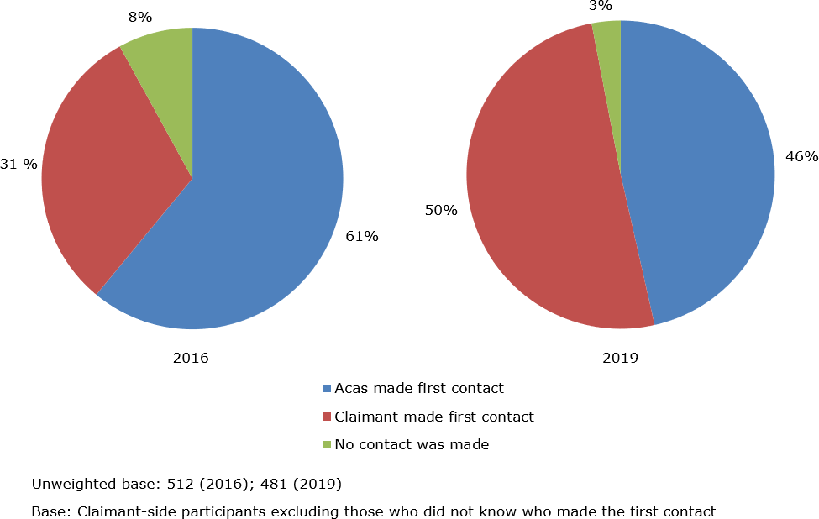

Nearly half (47 per cent) of employer-side participants reported that the Acas conciliator made the first contact. Almost three in ten (28 per cent) reported that they made the first contact with Acas after the ET claim was submitted. Two in ten (20 per cent) could not recall who made the initial contact and just three per cent said contact was never made. As with claimants, in 2016 a greater proportion of employer-side participants reported that Acas had made the first contact (66 per cent) and a smaller proportion reported that they had made the first contact (25 per cent).

As was the case with claimants, employer-side participants who accepted the Acas offer of post-ET1 conciliation were more likely to report having made the first contact with Acas. Thirty-five per cent of this group initiated contact, compared with 19 per cent of those who did not take part in conciliation, suggesting that this group is more actively engaged with the service.

As with claimant-side participants, there was a large proportion of ‘don’t know’ responses to this question. Excluding these from the results is likely to give a more accurate picture; using this approach Acas made initial contact in six in ten cases (59 per cent), with employers (or their representatives) making the first contact in around four in ten (35 per cent) cases and with six per cent reporting that no contact was made. See Figure 25.

Employers were significantly more likely than their representatives to report that the Acas conciliator had made the first contact after the submission of the ET claim (64 per cent compared to 55 per cent with ‘don’t know’ responses removed).

In contrast with the claimant-side, employers who reported that they had made the first contact were more likely to have reached a settlement (43 per cent compared to 23 per cent respectively when ‘don’t know’ responses are removed).

### Figure 25. Who made first contact between employer-side participants and Acas

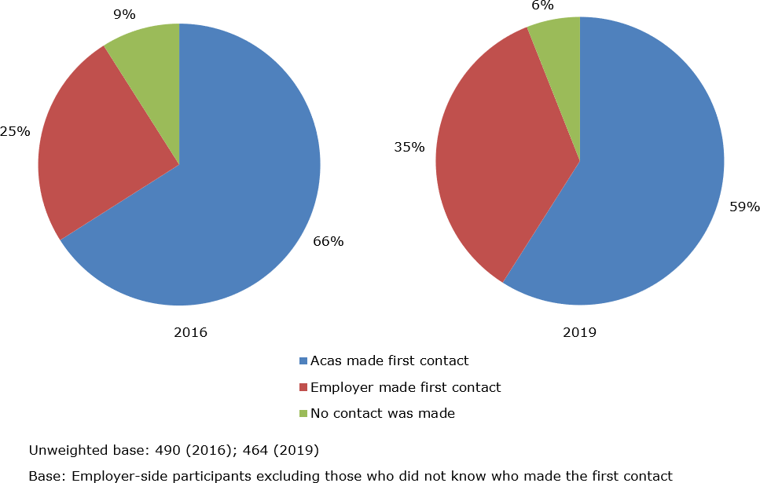

Where participants reported both receiving a notification letter and Acas making initial contact, they were asked how soon after receiving the letter this contact had been established.

Four in ten (39 per cent) claimant-side participants reported that Acas contact had been established between two working days and a week of receiving the letter. A quarter (24 per cent) reported that contact was established a week or more after receiving the letter and a similar proportion (23 per cent) said they didn’t know when contact was made. Over one in ten (15 per cent) reported that contact with Acas was established within two working days after receiving the letter. In 2016, these figures were very similar; with claimant-side participants most commonly reporting that Acas contact had been established between two working days and a week of receiving the letter (40 per cent).

Claimant-side participants involved in fast or standard track disputes were most likely report that contact with Acas had been established within one week, while claimant-side participants involved in open track disputes were most likely to report that contact has been established a week or more after receiving the letter. This suggests that for those involved in open track disputes, establishing contact with Acas takes longer than for those in fast and standard track disputes.29 This disparity may simply reflect variability in the scheduling for employment tribunal hearings (i.e. open track case hearings tend to be scheduled further in advance, thus affording the conciliator longer lead times for establishing contact than in fast and standard track cases).

Among employer-side participants, one in five (22 per cent) reported that Acas contact had been established a week or more after receiving the letter, and the same proportion (22 per cent) reported that Acas contact had been established between two working days and a week of receiving the letter – but half (48 per cent) said they did not know when contact was made. Only one in ten (8 per cent) reported that contact was established within two working days. In 2016, these figures were very similar, with employer-side participants most commonly reporting that they did not know when contact had been made (44 per cent).

Participants who reported no contact being made between them and Acas after the ET claim was submitted were asked whether any attempts were made by either side to contact each other.

The vast majority (83 per cent) stated that neither side had attempted to make contact; twelve per cent reported that both sides had tried to make contact and five per cent reported that they tried to contact Acas. The majority (71 per cent) of employer-side participants stated that neither side had attempted to make contact; twenty per cent reported that they had tried to make contact, and ten per cent reported that Acas had tried to make contact.30

### Uptake of post-ET1 conciliation

Claimants and representatives who had contact with Acas after the submission of the ET claim were asked whether they actually took part in the conciliation that was offered at that point.

Just over half (55 per cent) of claimant-side participants who had been in contact with Acas since the submission of their ET claim confirmed taking part in post-ET1 conciliation at this point. Thirty-five per cent said that they did not take part in conciliation, and nine per cent said they didn’t know.31

This figure of 55 per cent among claimant-side participants is significantly lower than in 2016, when take-up of post-ET1 conciliation stood at 73 per cent. Unlike in 2016 – when those in open track disputes were most likely to take part in ET1 conciliation – there were no significant differences in take up by track in 2019. However, consistent with the findings from the 2016 survey, where claimant-side participants reported having previously taken part in EC they were notably more likely to say that they had participated in post-ET1 conciliation: 68 per cent who participated in EC also took part in ET1 conciliation, compared with 42 per cent who did not take part in EC.

Uptake of post-ET1 conciliation among employer-side participants was similar to the uptake among claimant-side participants. Just under six in ten (58 per cent) employer-side participants who had been in contact with Acas since the submission

of the ET claim confirmed having taken part in conciliation at this stage. Three in ten (33 per cent) said they did not take part in conciliation, and nine per cent said they didn’t know. Again, this level of service uptake for post-ET1 conciliation is lower than the proportion of employer-side participants taking part in EC (78 per cent of those surveyed in 2019), possibly reflecting the fact that many of those employers most willing to engage with conciliation will have already reached settlements at EC.

Employer-side participants who reported having previously taken part in EC were also significantly more likely to say that they had participated in post-ET1 conciliation: 78 per cent who participated in EC also took part in ET1 conciliation compared to 47 per cent who did not participate in EC but subsequently took part in ET1 conciliation. These findings are also consistent with the findings from the 2016 survey.

### Reasons for not participating in post-ET1 conciliation

The most common reasons given by claimant-side participants for not taking part in post-ET1 conciliation were ‘the other side was not willing to negotiate’ (45 per cent) and ‘I knew that the employer would not be willing to engage’ (11 per cent). This matches the top two reasons given by participants in 2016.

Among employer-side participants, the top two reasons stated were ‘felt we had no case to answer to’ (25 per cent) and ‘not willing to negotiate’ (21 per cent), followed by ‘I felt that conciliation would not resolve the issue / would be a waste of time’ (16 per cent). Again, this closely matches the answers given in 2016.

These reasons differ from the rationales given by claimants in the EC survey for deciding against conciliation at that earlier point.32 Claimants who did not take part in EC mentioned a wider range of reasons, including ‘I knew that the employer would not be willing to engage’ and ‘The issue was resolved by the time Acas assistance was offered’. This suggests that at this earlier stage in a dispute resolution journey there are many reasons for non-participation, whereas by the ET stage most claimants who do not take part have a perception that the other side is not willing to negotiate (possibly informed by their prior experience at EC).

By contrast, on the employer-side at the EC stage, a clear majority (64 per cent) cited their reason for not participating in conciliation as being ‘I/employer had no case to answer to’. This is consistent with the top reason cited at the ET stage in 2015 and by employer-side participants in the 2019 EC survey.

### Determinants of taking part in post-ET1 conciliation

Throughout this report a series of regression analyses have been conducted to understand the factors associated with the likelihood of service users engaging with post-ET1 conciliation.33 This model examines the factors ‘driving’ whether claimants took part in conciliation at this stage (representatives were not included in the model). Note that this model measures associations between variables, not causation.

#### *Claimants*

The independent variables which were found to be determinants of whether claimants took part in post-ET1 conciliation are listed below in order of predictive strength:

* **Receiving a letter from the Acas conciliator**: Those who said they received a letter from the Acas conciliator saying they would be in contact to try and settle the case were associated with a higher likelihood of taking part in Acas conciliation at the post-ET1 stage
* **Participation in EC earlier in their dispute**: Claimants who agreed to take part in Early Conciliation earlier in the dispute were also associated with a higher likelihood of participating in post-ET1 conciliation
* **Claimant ethnic background**: If the claimant was from a white ethnic background, this factor was associated with a lower likelihood of participating in the offer of post-ET1 conciliation.

### Figure 26. Claimant participation in ET conciliation

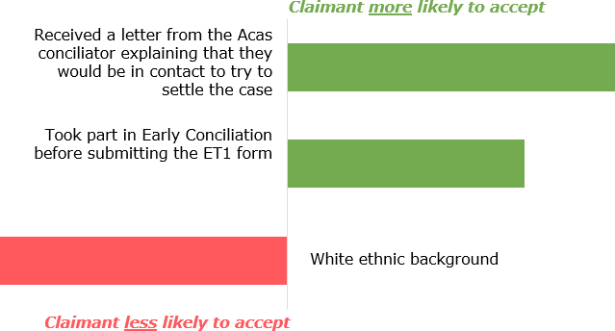

#### *Employers*

The independent variables which were found to be determinants of whether employers took part in post-ET1 conciliation are listed below in order of predictive strength:

* **Participation in EC earlier in their dispute**: Employers who agreed to take part in Early Conciliation earlier in the dispute were correlated with a higher likelihood of participating in post-ET1 conciliation
* **Receiving a letter from the Acas Conciliator**: There was a positive association with the likelihood of post-ET1 conciliation among employers who could not recall if they received a letter from the conciliator saying they would be in touch to resolve the case. The model also revealed an association between those who did recall receiving a letter and a higher likelihood of participation, however it did not meet the threshold for statistical significance. This suggests that both groups are more likely to participate in conciliation than those *not* receiving a letter from the conciliator

### Figure 27. Claimant participant in ET conciliation

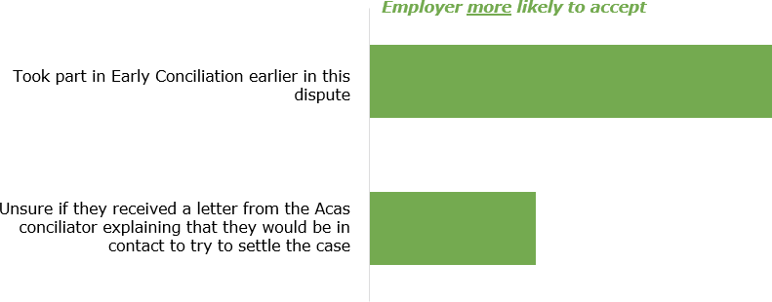

These models both highlight two key factors behind acceptance of post-ET1 conciliation: previous experience of conciliation through EC earlier in the process, and the importance of an initial letter from the conciliator after the submission of an ET1 form.

## THE POST-ET1 CONCILIATION EXPERIENCE

**Synopsis:** This chapter explores users’ experiences of post-ET1 conciliation, including contact with and perceptions of the Acas conciliator, as well as overall satisfaction with the conciliation process.

**Key trends at a glance**

* Telephone remained participants’ primary method of communication with the conciliator, although email use has risen significantly since 2016 and is higher still among representatives.
* A majority of those who took part in post-ET1 conciliation felt that the level of contact they had experienced was about right. Both sides agreed that the conciliator was usually available when needed.
* Ratings of the Acas conciliator remained largely positive across claimant and employer-side participants who had taken part in conciliation. Claimants remained the audience most likely to rate the conciliator positively across attributes while representatives were more likely to report that the conciliator ‘did not do this’ – perhaps reflecting this group’s greater experience and lesser requirements for support.
* There have been a number of significant, positive, shifts in conciliator ratings since 2016 – particularly among claimants. This may reflect a reversion from lower results recorded in the past wave or the impact of changes to the service user profile such as a lower proportion of representatives and higher volumes of fast track cases.
* Large majorities of both claimants and respondents reported satisfaction with the service provided by Acas, including majorities of those who did not settle their case in conciliation.

### Contact with the conciliator

Both claimant and employer-side participants who had contact with a conciliator after an ET claim was submitted were asked about this contact and their conciliator experience in general. As participants can struggle to differentiate between the different stages of conciliation, this was defined as any contact with Acas *after* the submission of an ET claim. However, when interpreting these findings, it is important to bear in mind that participants may have answered regarding their conciliator experience in general.34

As in 2016 a majority of claimant and employer-side participants reported contact with just one Acas conciliator throughout post-ET1 conciliation (both 71 per cent). A sixth reported speaking with two conciliators (16 per cent and 15 per cent respectively), while a small proportion (five per cent and three per cent) spoke with three or more. (Where users dealt with multiple conciliators, their case will have been handled by teams providing cover for conciliator absence; this survey pre- dates subsequent pilots of team-based service delivery ).35 Unlike in 2015, there were no significant differences between claimants, employers or their respective representatives, nor by track.

Three quarters of those who took part in EC kept the same conciliator for post-ET1 conciliation (73 per cent claimant-side and 65 per cent employer-side). One in ten

(11 per cent and nine per cent respectively) reported a different conciliator, while a fifth could not recall whether the conciliator was the same or different (17 per cent and 22 per cent).

Telephone and email remained the most popular methods for communicating with the Acas conciliator at the post-ET1 stage (see Table 24). While telephone remained the primary method of communication on the claimant side, email use rose significantly. This trend is stronger still on the employer side; these participants are now more likely to report online rather than telephone communication. This mirrors trends observed in the EC survey and a wider social shift to digital communications.

### Table 24. Modes of contact with the Acas conciliator

|  |  |
| --- | --- |
| Claimant side  All modes of contact Main method of with the conciliator contact with the (%) conciliator (%)  2016 **2019** 2016 **2019** | Employer side  All modes of contact Main method of with the conciliator contact with the (%) conciliator (%)  2016 **2019** 2016 **2019** |
| Telephone 93 **87** 65 **48** 86 **78** 54 **38**  Email 81 **77** 31 **40** 78 **78** 38 **47**  Letter 35 **24** 1 **3** 22 **14** 2 **1**  Face to face - **\*** - **-** - **-** - **-**  No contact 2 **2** 2 **2** 3 **4** 3 **4**  Don’t know 1 **1** 1 **7** 3 **2** 3 **10**  *Unweighted base 485* ***472*** *485* ***472*** *461* ***443*** *461* ***443*** | |
| Base: All claimants (and representatives) and employers (and representatives) who had contact with a conciliator after the ET claim was submitted | Statistically significant difference since 2016 |

There were a handful of significant differences of note:

* As in 2016, claimants and employers were more likely to report telephone as their main method of communication (51 per cent and 52 per cent respectively). Representatives were more likely to say email was their main method (44 per cent and 56 per cent).
* Nearly all claimant and employer-side participants who took part in post- ET1 conciliation used telephone as a means of communication (91 per cent and 87 per cent respectively).
* Those who reported that their case had been settled were more likely to report email as their main method of communication than those whose case had not been settled at the time of the survey (47 per cent and 51 per cent versus 32 per cent and 38 per cent respectively). Part of the reason for this may be because the later stages of conciliation are more likely to take place in writing, such as offering and agreeing settlement terms via email.

Unlike 2016, those who previously took part in EC were no more or less likely to communicate with the conciliator via email than those who did not.

In disputes where post-ET1 conciliation had taken place, participants were most likely to report that initiation of contact throughout the case had been equal between themselves and Acas (45 per cent of claimant-side participants reported this to have been the case and 54 per cent of employer-side participants said the same).

* Among claimant-participants, three in ten (30 per cent) reported that they had contacted Acas most of the time, while a fifth (22 per cent) said that Acas had most often initiated contact with them.
* Among employer-side participants, a quarter (25 per cent) reported contacting Acas most of the time, and a sixth (17 per cent) that Acas had mostly contacted them.

These patterns align closely with perceptions of contact reported in 2016 but differ to those reported in the EC survey. Both claimant and employer-side participants were less likely to report that Acas had initiated contact with them most of the time in post-ET1 conciliation, compared with EC.

Unlike 2016, there were no significant differences by case track, but there were across other subgroups of interest:

* Employers (and their representatives) who took part in post-ET1 conciliation and whose cases were settled were more likely to report that the initiation of contact was shared equally between themselves and Acas (58 per cent) than those who did not settle (42 per cent). A similar, but not statistically significant pattern, was observed among claimant-side participants in post- ET1 conciliation too (49 per cent vs 40 per cent).
* Participants in contact with more than one Acas conciliator were more likely to report that they contacted Acas most of the time (37 per cent) than those who had a singular point of contact at Acas (25 per cent). A quarter (23 per cent) of this group reported that Acas contacted them most of the time, although half of each audience said contact initiation had been shared equally (50 per cent and 51 per cent respectively).

As in 2016, employers were more likely than any other group to report that Acas had contacted them most of the time (29 per cent), although a little over half (53 per cent) reported that contact initiation had been shared equally.

Seven in ten claimants (and their representatives) and eight in ten employers (and their representatives) who took part in post-ET1 conciliation reported that they were happy with the amount of contact they received from Acas during their dispute (70 per cent and 81 per cent respectively). Among claimant-side participants, three in ten (28 per cent) said they would have wanted more (rising to 38 per cent among claimants themselves), while the figure on the employer side was 13 per cent. A small minority (one per cent and two per cent respectively) said they would have wanted less contact.

Across both claimant and employer-side participants, the proportion reporting that they were happy with the amount of contact received from Acas has dropped since 2016 (down seven points among claimant-side participants and five points among employer-side participants), although this change is not significant. As in 2016, claimants were more likely to report that they would have preferred more contact than any other audience – four in ten (38 per cent) said this.

Similarly, claimants (and their representatives) who did not reach a settlement through post-ET1 conciliation asked for more contact (38 per cent) than those who reached a settlement (22 per cent). Interestingly, this trend was not reflected among employers (and their representatives).

Those in contact with multiple conciliators were slightly more likely to request more contact than those in touch with one (24 per cent compared to 19 per cent) but this was not statistically significant. Seven in ten (71 per cent) reported that they were satisfied with the amount of contact they received. However, when we expand this group to include everyone in contact with a conciliator regardless of whether

conciliation took place we do see that those in touch with more than one conciliator would prefer more contact (31 per cent) when compared to those in touch with just one (20 per cent).

All claimants, employers and their respective representatives that were in touch with a conciliator post-ET1 submission tended to report that the conciliator had been available when needed. Seven in ten (69 per cent) claimant-side participants reported this to have been the case, while a similar proportion (65 per cent) of employer-side participants said the same. There has been little change in reported availability since 2016.

There were some significant differences within subgroups:

* Representatives were more likely to report that the Acas conciliator had been ‘always’ or ‘usually’ available than either claimants or employers. However a majority of both these groups reported that the conciliator had been always or usually available when needed.
* Those who took part in post-ET1 conciliation were more likely to report that the conciliator had been always or usually available than those who did not.
* Similarly, those who settled their case were more likely to report that the conciliator had been always or usually available than those who did not.
* Those in contact with one rather than multiple conciliators were also more likely to report that the conciliator was always or usually available (72 per cent vs 62 per cent).

In contrast to 2016, there were no significant differences by case track.

### Perceptions of the conciliator

Those who took part in post-ET1 conciliation were asked to rate their conciliator across a range of factors. As shown in Figure 28, ratings have risen significantly since 2016 among claimant-side participants across four of the five measures. Many of these increases reflect a return towards levels recorded in the 2012 IC survey.

### Figure 28. Ratings of the conciliator

Very good Fairly good Neither Fairly poor Very poor Did not do this

% Very

/ fairly good

+/-%

since 2016

Relaying proposals and offers to and from employer

/ claimant

Claimant side

50

22 7 4 5 12 73

+5

Employer side

54

24

9 3 4 7 78

-6

Helping you consider the pros and cons of resolving the issue without going to hearing

Claimant side

Employer side

66 +21

44 +4

17

26

28

6

4

19

14

4

7

9

21

45

Claimant side

Outlining the law as it applied to your case

43

18 9 5 4 21

61

+14

Employer side

20

12 12 6 6

43

33

+1

Explaining the tribunal proc ess

Claimant side

Employer side

3 4

12

15

20

60 +14

35 +10

22

4

5

9

16

44

46

Helping you understand the strengths and weaknesses of this potential claim

Claimant side

34

21 11 8 5 21

55

+17

Employer side

20

15 15 4 7

39

34

+4

Unweighted base: All claimants-side partic ipants and employers-side participants who took part in post-ET1 conciliation (257, 264)

Statistically significant difference since 2016

As shown in Figure 29, claimants are the most likely audience to rate the conciliator as very or fairly good. This reflects trends observed in the 2019 EC survey as well as the 2016 ET wave. Claimants rate the conciliator highest for explaining the tribunal process and lowest for helping them to understand the strengths and weaknesses of their claim (although a majority rate the conciliator as good at doing this). Scores show improvement since 2016, including significant increases for ‘relaying proposals and offers to and from employer / claimant’, ‘helping you consider the pros and cons of resolving the issue without going to hearing’, and ‘helping you understand the strengths and weaknesses of this particular claim’.

Employer representatives are the least likely audience to rate the conciliator as very of fairly good across most factors. However, rather than being more likely to rate the conciliator as poor, this group are instead more likely to report that the conciliator ‘did not do this’. Matching the pattern in 2016, rather than signalling an oversight by the conciliator, this may simply reflect the fact that not all actions are warranted in all cases. Given the legal background of most representatives (especially employer representatives), it is likely that they are more familiar with the tribunal process, and therefore require less assistance from conciliators than claimants or employers.

### Figure 29. Ratings of the conciliator

Very good Fairly good Neither Fairly poor Very poor Did not do this

% Very

/ fairly good

+/-%

since 2016

Relaying proposals and offers to and from employer

/ claimant

Claimants

Claimant reps Employers Employer reps

43

26

58

45

8 5 8 10

18 4 3 2 15

25 11 4 9 6

59

23

7 21 8

70

76

70

82

+12

+3

-15

-2

Helping you consider the pros and cons of resolving the issue without going to hearing

Claimants

Claimant reps Employers Employer reps

66 +11

65 +26

42

48

24

17

10 12 7 6

8 2

25

49 -6

|  |  |  |  |  |  |
| --- | --- | --- | --- | --- | --- |
| 30 | 20 | 17 | 7 | 13 | 14 |

41 +7

25

16

19 22

37

Outlining the law as it applied to your case

Claimants

Claimant reps Employers

47

23

9 7 7 7

38

28

19

13 9 3 38

12 11 11 19

Employer reps 16 8 12 3 4 57

70

50

47

24

+6

+13

-2

-1

Explaining the tribunal proc ess

|  |  |  |
| --- | --- | --- |
| Employers 28 24 12 9 7 20 | 52 | +2 |
| Employer reps 15 10 13 12 60 | 25 | +10 |
| Claimants 37 23 11 10 10 8 | 61 | +11 |

Claimants

Claimant reps

|  |  |  |
| --- | --- | --- |
| 49 23 8 6 8 6 | 72 | +4 |
| 38 7 10 4 41 | 45 | +11 |

|  |  |  |  |
| --- | --- | --- | --- |
| Helping you understand the  Claimant reps | 30 19 11 5 36 | 48 | +17 |
| of this potential claim Employers | 28 17 16 8 12 19 | 45 | -2 |
| Employer reps | 15 13 15 2 4 51 | 28 | +5 |

Unweighted base: All claimants, claimant reps, employers and employer reps who took part in post-ET1 conciliation (198, 59, 117, 147)

strengths and weaknesses

Statistically significant difference since 2016

As in 2016, there were a handful of significant differences among subgroups of interest:

* Claimant-side participants involved in fast or standard track cases were more likely than those involved in open track disputes to rate the conciliator as good across most metrics. There was little significant difference across track on the employer side, with the exception of ‘helping you understand the strengths and weaknesses of this potential claim’ where employer-side participants involved in standard track cases were more likely to rate the conciliator as good than those involved in open or fast track cases.
* Participants involved in cases that were settled following post-ET1 conciliation were more likely to rate the conciliator as good at ‘helping you understand the strengths and weaknesses of this potential claim’.
* Participation in EC earlier in the dispute did not have a signficiant impact on participant assessments of the conciliator
* When comparing across surveys, it is notable that while ratings for ‘outlining the employment law as it applies to your case’ have fallen in the EC survey, this is not the case at the post-ET1 stage.

Participants in post-ET1 conciliation were also asked to rate the conciliator across a range of professional attributes (see Figure 30). Ratings remain stable and high for all attributes, with a small increase in claimants agreeing that their conciliators were actively involved in seeking an agreement to settle:

### Figure 30. Ratings of the conciliator

Strongly agree Tend to agree Neither agree nor disagree

Tend to disagree Strongly disagree Don't know

Strongly

/ tend to agree

since 2016

Claimant side

Was trustworthy

Employer side

74

73

14 6 132

18 22 4

88

91

+2

+1

Listened carefully to what you had to say

Claimant side Employer side

87 +2

86 -2

65

22

6 1 43

66

21

6

2 32

Understood the

circumstances of the case

Claimant side

Employer side

55

52

28

29

6 3 6 2 83

7 3 6 4 80

+6

-5

Was actively involved in seeking an agreement to settle

Claimant side Employer side

81 +9

73 -6

57

24

7

5

4 3

47

26

4 4

6

13

Claimant side

59

20

Was knowledgeable

Employer side

49

25

11 4 33 79

14 3 3 8 73

+6

+2

Understood how you felt about the case

Claimant side Employer side

73 +3

75 0

52

21

13 4 6 5

52

24

9 2 5 9

Helped you decide whether or not to settle, without undue influence

Claimant side

Employer side

43

36

14

17

15 6 14 8 57

18 5 7 17 53

+3

-2

Unweighted base: All claimants-side partic ipants and employers-side participants who took part in post-ET1 conciliation (257, 264)

Statistically significant difference since 2016

Ratings were largely similar across subgroups, with a handful of exceptions:

* Claimant and employer representatives were more likely than those they represent to agree that the conciliator ‘listened carefully to what you had to say’, ‘was trustworthy’ and ‘understood the circumstances of the case’.
* Claimant-side participants involved in fast track disputes were more likely than those involved in standard or open track disputes to agree that the conciliator ‘was knowledgeable’, ‘understood the circumstances of the case’, and ‘helped you decide whether or not to settle your case without undue influence’.
* Employer-side participants involved in a case which settled through post- ET1 conciliation were more likely to agree that the conciliator ‘was actively involved in seeking an agreement to settle’ and ‘helped you decide whether or not to settle your case without undue influence’ than those who did not settle.
* Claimant-side participants who did not take part in EC prior to post-ET1 conciliation were more likely to agree that the conciliator was knowledgeable than those who did.

Big majorities of claimant and employer-side participants felt that the conciliator had been even-handed in how they dealt with the dispute (75 per cent and 85 per cent respectively). Compared with the 2016 survey, this represents an eight- percentage point drop among claimants, while there has been no movement on the employer-side. However, this fall on the claimant-side was offset by proportion who said the conciliator was on their side increasing from four to thirteen per cent – with claimants slightly more likely than reps to believe this was the case.

Employer-side participants were more likely to feel that the conciliator had been on the side of the claimant (11 per cent) than theirs (two per cent). Eight per cent of claimant-side participants said that Acas had been more on the side of the employer.

Reflecting trends observed in 2016, there were some significant differences across subgroups:

* Representatives remained more likely than those they represented to feel that the conciliator had been even-handed: 83 per cent of claimant representatives and 92 per cent of employer representatives said the conciliator had been even handed compared with 68 per cent of claimants and 71 per cent of employers who said the same.
* Claimant and employer-side participants involved in open track disputes were more likely to report that the conciliator had been even handed than those involved in fast or standard track disputes.
* Similarly, those who reached a settlement through post-ET1 conciliation were more likely to report that the conciliator had been even handed (80 per cent among claimant-side participants and 88 per cent among employer-side participants) than those who did not (65 per cent and 75 per cent respectively).

### Overall satisfaction with the service received from Acas

Both claimant and employer side participants who had contact with a conciliator after an ET claim was submitted were asked to rate their overall satisfaction with the service they received from Acas.

Eight in ten of those who proceeded to post-ET1 conciliation reported that they were satisfied with the service they received: 79 per cent on the claimant side and 81 per cent on the employer side.

### Figure 31. Satisfaction with the service received from Acas (post-ET1)

Extremely satisfied Very satisfied

Satisfied Neither satisfied nor dissatisfied

Dissatisfied Very dissatisfied

Extremely dissatisfied Don't know

%

Extremely

/ very / tend to be satisfied

+/-%

since 2016

Claimant-side

Employer-side

79 +5

81 -5

11

37

31

7 3 4 5 1

11

37

32

8 4 3 3 2

Unweighted base: All claimant-side partic ipants and employer-side participants who took part in post-ET1 conciliation (257, 264)

No significant change since 2016

As in the previous wave, satisfaction was lower among those who did not proceed to post-ET1 conciliation. Among claimant-side participants 62 per cent of those who dealt with a conciliator but ultimately did not engage in conciliation reported that they were satisfied with the service provided by Acas. For employer-side participants the comparable figure was 54 per cent.

Where conciliation took place, satisfaction was higher among those whose cases resulted in a settlement. Eighty-eight per cent of claimant-side participants and 86 per cent of employer-side participants who settled their case reported that they were satisfied, compared with 63 per cent of claimant-side participants and 67 per cent of employer-side participants who did not settle.

Focusing still on participants who took part in post-ET1 conciliation, claimant and employer representatives tended to report higher satisfaction than those they represented. Nine in ten (91 per cent) claimant representatives and employer representatives (89 per cent) said they were satisfied with the service they had received from Acas, compared with 70 per cent of claimants and 66 per cent of employers.

As in 2016, case track had a limited impact on satisfaction with the service provided by Acas. Employer-side participants involved in open or standard track disputes tended to report higher satisfaction than those involved in fast track disputes. This trend was not reflected among claimant-side participants.

Similarly, the number of conciliators in contact with a participant during post-ET1 conciliation did not have an impact on overall satisfaction: those in contact with one and multiple conciliators (i.e. teams providing absence cover) reported similar levels of satisfaction. A similar pattern was observed at EC stage for claimant-side participants, although employer-side participants in EC were more likely to say they were satisfied with the service provided if they had only had contact with one conciliator.

Among the minority who said they were dissatisfied with the service provided by Acas, the most common reason given for dissatisfaction was that the service or communication was seen to have been poor (59 per cent and 52 per cent of claimant and employer side participants respectively said the service had been poor; 50 per cent and 49 per cent said the communication had been poor).

Dissatisfied claimant-side participants were more likely to report that there had been minimal input from Acas (47 per cent) and that they were unhappy with the outcome (30 per cent), while dissatisfied employer-side participants were more likely to perceive that Acas had not been neutral (30 per cent).

## DETAILS OF ET CASE OUTCOMES

**Synopsis:** This chapter examines case outcomes and drivers of successful outcomes. It explores different case outcomes, including settlements, reasons for withdrawal, and what the tribunal hearing ordered for those whose cases proceeded to this point. Finally, it examines satisfaction levels with case outcomes.

### Key trends at a glance

* Around half of those surveyed, regardless of whether conciliation took place or not, reached a COT3 settlement and a further six per cent reached a private settlement. One fifth progressed to a hearing and twelve per cent of claims were withdrawn.
* Among claimants, driver analysis found that the key drivers of reaching a COT3 or private settlement were external: being involved in open and standard track cases as well as working with an employer for less than five years were associated with a higher likelihood of reaching a settlement.
* For employers, the key factors were internal and related to features of the case: agreeing Acas was important in moving the two sides together, good availability of the conciliators and equal levels of contact between the employer and Acas were associated with a higher likelihood of settlement. There was also a positive association between the likelihood of case settlement and the presence of a Trade Union or Employer representative within the organisation.
* All involved in fast track cases were less likely to settle than in open track cases – either proceeding to a hearing or receiving a default judgement in their favour.
* A majority of those who settled reported that this involved a financial payment to the claimant. The average (mean) value of any payment reported by claimant-side participants was £9,298 and the equivalent sum cited by employers was £8,005; a

£769 decrease and a £925 increase respectively, since 2016. By the time of the survey virtually all payments awarded had been made: this was the case for 98 per cent on the claimant side and 97 per cent on the employer side

* A majority of participants agreed that Acas’ involvement had been important in helping move the parties closer to resolving the dispute (a key factor behind successful case settlement). Similarly, where a settlement had been reached, they tended to agree that Acas’ involvement had been a factor in resolving the case.
* The ‘Acas effect’ – a measure of the number of cases where Acas’ assistance had aided a dispute avoiding going to a full employment tribunal – stood at 61 per cent in this wave, the same level recorded in 2016. Acas is increasingly attributed as a factor in case withdrawals although this may be related to the diminishing importance of cost after the abolition of tribunal fees.
* When a case progressed to a formal hearing, most claimant-side participants said it was because the employer had not been willing to negotiate. Employer-side participants tended to report that the case had gone to hearing because they had done nothing wrong, or the claimant had been unwilling to negotiate.
* A majority of the cases which progressed to a hearing were reported to have had been found in favour of the claimant. In most instances, a financial payment was awarded.
* Putting aside the service received from Acas, two-thirds of claimant-side participants and seven in ten employer-side participants reported that they were satisfied with the outcome of the case.

### Case outcomes

The outcome of participants’ ET cases – which is recorded by Acas – was also re- confirmed with both parties during the interview. This reported outcome measure is used for the analysis conducted throughout this chapter.

Given the nature of the sampling design – described in the technical appendix – findings cannot be combined from both sides to be representative of the entire universe of ET cases dealt with by Acas. As a result, the annual results published by Acas remain the definition source for the quantification of case outcome at the overall level.36

The proportion of claimant and employer-side survey participants who reported that their case had been settled through a COT3 stood at a little over half (both 52 per cent). A fifth (20 per cent) had progressed to a hearing. Fifteen per cent of claimant-side and 9 per cent of employer-side cases had been withdrawn, while five per cent and six per cent had been struck out. For three per cent of claimant- side and nine per cent of employer-side participants a private settlement had been reached. Settlement rates increase where analysis is restricted to just those taking part in post-ET1 conciliation – to 63 and 65 per cent respectively for claimant and employer-side participants.

### Drivers of successful case outcome

Four regression analyses were conducted to examine the factors ‘driving’ whether claimants and employers came to a settlement (either a COT3 or private settlement) in their case. Representatives were not included in either model.37 Note that this model measures associations between variables, not causation.

To provide understanding on the impact of ‘internal’ factors (those within Acas’ control, such as conciliator performance) and ‘external’ ones (e.g. claimant or employer characteristics), separate models have been established for both.

#### *Among claimants – internal factors*

Only one independent internal variable was found to be a determinant of whether claimants successfully settled their case:

* *Feeling Acas was important in moving the parties closer together*: Rating Acas’ ability to bring the two sides together as important to resolving the case was the only factor associated with a higher likelihood of a successful case resolution.

### Figure 32. Logistic regression results of internal factors determining claimant settlement

***Claimant more likely to have reached a settlement***

Acas involvement was important in helping move parties closer towards resolving the case

#### *Among claimants – external factors*

The independent external variables which were found to be determinants of whether claimants successfully settled their case are listed below in order of predictive strength:

* *Case track*: The strongest correlation in the model was with open track cases; this was associated with a higher likelihood of settling the case. A similar but weaker relationship was also observed for standard track cases
* *Tenure length*: Shorter-term employees were also more strongly correlated with a successful case outcome. Those who had worked with their employer for less than five years at the time they first contacted Acas were associated with a higher likelihood of successfully settling their case
* *Employment type*: Full-time employees were correlated with a lower likelihood of settling their case successfully

### Figure 33. Logistic regression results of external factors determining claimant settlement

Open track case

Worked for the employer for less than 5 years at the time of contact with Acas

Standard track case

***Claimant more likely to have reached a settlement***

Full time employee at the time of contacting Acas

***Claimant less likely to have reached a***

***settlement***

#### *Among employers – internal factors*

The independent internal variables which were found to be determinants of whether employers successfully settled their case are listed below in order of predictive strength:

* *Feeling Acas was important in moving the parties closer together*: Rating Acas’ ability to bring the two sides together as important to resolving the case was associated with a successful case resolution.
* *Availability of the Acas Conciliator*: If employers felt that their conciliators were ‘always, ‘usually’ or ‘sometimes’ available when needed then they were associated with a higher likelihood of a successful case resolution
* *Proactive contact with Acas*: A higher likelihood of a successful dispute outcome was also associated with cases where employers said that they contacted Acas as much as Acas contacted them. Another correlation – which was not statistically significant – associated those who contacted Acas most of the time with a higher likelihood of a positive outcome, suggesting that the main difference here lies between these two groups and those other employers who said that Acas normally got in touch with them about the case.

### Figure 34. Logistic regression results of internal factors determining employer settlement

***Employer more likely to have reached a settlement***

Acas involvement was important in helping move parties closer towards resolving the

case

The Acas conciliator/s were available always/usually/sometimes when needed

After the submission of the ET claim Acas and I contacted each other equally

#### *Among employers – external factors*

The independent external variables which were found to be determinants of whether employers successfully settled their case are listed below in order of predictive strength:

* *Presence of trade unions or staff associations*: This was sole external factor with influence on the likelihood of a successful dispute outcome. Employers with either a trade union or staff association in their workplace were correlated with a higher likelihood of reaching a successful case outcome.

### Figure 35. Logistic regression results of external factors determining employer settlement

***Employer more likely to have reached a settlement***

There are unions or staff- associations active in the

workplace

The models above highlight a number of key internal factors associated with improved chances of a successful case resolution, including the availability of the conciliator and Acas’ skill in bringing the two sides together. External factors of note include the case track, the presence of trade unions and length of employment tenure.

However, it is important to note the limited predictive power of all four models. The table below lists the ‘pseudo R-square’ values for each model. This is a measure of how much of the difference in the model is explained by the independent factors used and can be read like a percentage: the closer the value is to one, the more of the variation the model explains.

The values below show that a large majority of the variation in case outcome is due to factors which fall outside the models. This may speak to the variety of workplaces and environments that different service users are in during their conciliation.

|  |  |  |  |  |  |
| --- | --- | --- | --- | --- | --- |
| **Model** | | **Claimant -** | **Claimant -** | **Employer -** | **Employer -** |
| **internal** | **external** | **internal** | **external** |
| **Pseudo Square** | **R-** | 0.0781 | 0.1766 | 0.0456 | 0.0387 |

### Settlement details

Most participants who reached a settlement (either an Acas-agreed COT3 settlement or a private settlement) reported that financial compensation was a part of the agreement (82 per cent of claimant-side participants said this, as did 75 per cent of employer-side participants). A fifth (18 per cent) of claimant-side participants said they had received a reference, while 10 per cent of employer-side participants reported this to have been the case. For a minority (two per cent and one per cent respectively), an apology was issued or a letter of explanation (both one per cent). This reflects the commonly reported settlements at EC.

The reported outcome aligned closely with 2016, when a majority (86 per cent of claimant-side participants and 80 per cent of employer-side participants) said that financial compensation had been a part of the agreement and a quarter (28 per cent and 24 per cent) reported that a reference was given.

In contrast to 2016, claimant-side participants involved in open track disputes in 2019 were no less likely to report having received financial compensation than those involved in fast or standard track disputes. Claimants in standard or open track disputes remained more likely to have received a reference (22 per cent and 25 per cent).

Employer-side participants involved in open track disputes were less likely to report that financial compensation had been a part of the agreement, although two thirds still said this had been the case (65 per cent).

The average value of the financial settlements reported was £9,298 among claimant-side participants and £8,005 among employer-side participants. This represents a decrease of £769 for claimant-side participants and an increase of

£925 cited by employer-side participants since 2016, although there is wide variation beneath this mean: the median value was £3,000 among both claimants and employers.

The value of financial settlements differed significantly across case track (see Table 25). Those in open track disputes reported the highest settlement value, while those in fast track disputes reported the lowest. Note that the mean value of settlement for employer-side participants in open track disputes is likely skewed by the fact that almost half (46 per cent) could not recall the value of the settlement at the time of interview.

Across all case tracks, settlement values at the post-ET1 conciliation stage were on average higher than those received at the EC stage.

### Table showing value of financial settlements received Table 25. Value of financial settlements received

Almost all settlements had been paid by the time of the interview; 98 per cent of claimant-side participants and 97 per cent of employer-side participants agreed the settlement had been paid. This is marginally higher than at the EC stage, where 94 per cent overall said their private settlement had been paid by the time of the survey.

### Settlement details

Claimant and employer-side participants who did not reach a settlement were asked to think about their Acas conciliation experience as a whole (including both before and after the ET claim was submitted) and consider whether a settlement offer or proposal was made which they turned down.

A sixth (17 per cent) of claimant-side participants reported that an offer had been made which they turned down. A third (32 per cent) of employer-side participants said they had made an offer which had been rejected.

The proportion of participants reporting that a settlement offer had been made has decreased since 2016, down eight points among claimant-side participants, and ten points among employer-side participants.

### Role of Acas in resolving the case

At this point in the survey participants were asked to judge the importance of Acas’ involvement in their dispute in two ways:

* Helping move parties closer to resolving the dispute; and
* Helping them decide whether or not to settle the dispute.

As in 2016, six in ten (60 per cent) claimants (and their representatives) and half (52 per cent) of employers (and their representatives) said Acas’ involvement had been important in helping to move parties closer together (Figure 36).

### Figure 36. Importance of Acas in helping move parties closer towards resolving the dispute

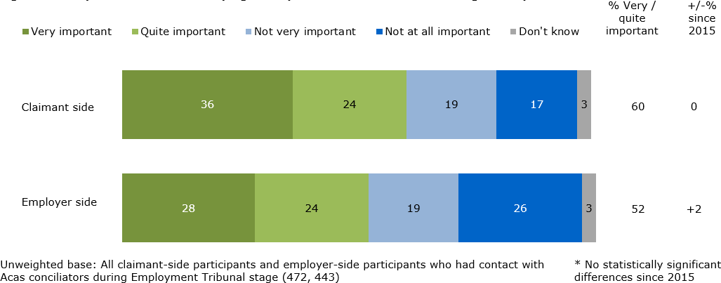

The perceived importance of Acas differed significantly across several groups:

* Ratings of Acas’ importance were highest among both claimant and employer-side participants involved in cases that settled with Acas (70 per cent and 66 per cent respectively). However, half (48 per cent) of claimant- side participants involved in cases that *had not* been settled at the time of interview also agreed that Acas’ involvement had been important, while a quarter of employer-side participants said the same (28 per cent), indicating that Acas’ conciliatory influence extends beyond the cases it settles directly.
* Those who had previously taken part in EC were also more likely to rate Acas’ involvement as important in helping to move parties closer towards resolving the dispute: 66 per cent and 59 per cent of claimant and employer- side participants reported this to have been the case.
* Claimant-side participants involved in fast track cases were more likely to rate Acas’ involvement as important (75 per cent) than those involved in open or standard track disputes (56 per cent and 53 per cent respectively). As in 2016, this trend was not reflected among employer-side participants.

A little over half (55 per cent) of claimant-side participants involved in disputes which had reached a settlement (either an Acas-agreed COT3 settlement or a private settlement) agreed that Acas’ involvement had been a factor in the decision to resolve the case. Among employers (and their representatives), 49 per cent reported this to have been the case. Scores have not changed significantly since 2016 among claimant-side participants, although they have improved among employer-side participants, up eight points (see Figure 37).

### Figure 37. Agreement that Acas’ involvement was a factor in the decision to resolve the case

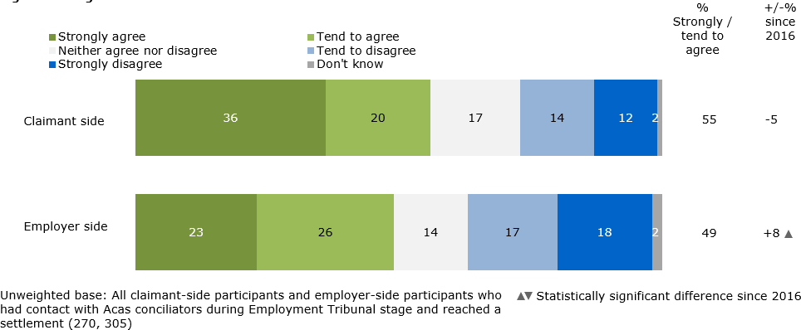

Results differed by track, with claimant-side participants involved in fast track cases more likely to agree that Acas’ involvement had been a factor in the decision to resolve than those involved in standard or open track cases (80 per cent, 57 per cent and 41 per cent respectively). Among employer-side participants, differences by track were less marked – those involved in fast or standard track disputes (59 per cent and 53 per cent respectively) were more likely than those involved in open track disputes (38 per cent) to rate Acas involvement as important.

As was the case in 2016, claimants remained more likely than their representatives to agree that Acas involvement had been a factor in the decision to resolve the case (71 per cent and 40 per cent). There was no significant difference in opinion between employers and their representatives.

### Reasons for case withdrawals

In addition to those whose ET cases avoided a hearing by means of a formal settlement, there is a further cohort of individuals who stopped short of proceeding to an Employment Tribunal because the claimant chose to formally ‘withdraw’ their case.

Among this group, the most common reason for choosing to withdraw the ET claim given by claimants was that the process was ‘too stressful to continue’ (37 per cent). A sixth (17 per cent) said they were worried about having to pay legal costs, and 15 per cent said that they did not think they would win.

In 2016, concern that the process would be too stressful was the third most common reason (17 per cent), behind thinking that that their employer would win a tribunal or that it would be a waste of time (25 per cent) and being put off by the tribunal fees which were then required (20 per cent). It should be noted here that comparison between the two waves should be taken extremely carefully owing to small base sizes for this group in each survey (50 in 2016 and 59 in 2019).

### Table 26. Claimant-side participant reasons for case withdrawal

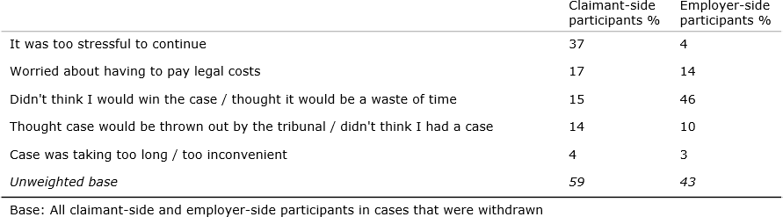

In contrast, when asked why they thought the claimant had withdrawn their case, almost half (46 per cent) of employer-side participants reported that it was because the claimant ‘didn’t think they would win the case / it would be a waste of time’. Just 14 per cent referenced legal costs, and four per cent stress. This ranking looked similar in 2016, with the claimant not thinking they would win being the most common rationale offered by employers.

Claimants (and their representatives) were next asked to what extent Acas had been a factor in helping them to reach the conclusion to withdraw. Just over half (56 per cent) felt Acas did not play a role in this decision, as did 65 per cent of employer-side participants. However, Acas’ role in withdrawals has increased since 2016 – although further research is required to understand if this is related to the abolition of fees or other elements of the service:

* Among all claimants, 44 per cent said Acas was a factor in their decision to withdraw – a significant increase from 2016 when 17 per cent said that same thing
* On the employer side 23 per cent cited Acas as a factor in their decision, an increase from nine per cent in 2016.

### Determining the ‘Acas effect’ in non-progression to an ET hearing

By combining separate outcome groups, it is possible to derive an estimate of the overall proportion of claimants (and representatives) who submitted an ET claim but did not go on to a tribunal hearing, for whom Acas was a factor in helping them to reach this conclusion – what might be thought of as the ‘Acas effect’. This figure can be derived by combining the following claimants together:

* Those who reached a COT3 settlement
* Those who reached a private settlement
* Those who did not reach a settlement, but also did not go on to a hearing and for whom Acas conciliation was a factor in helping to reach this conclusion.

Combining the data from these sources together would suggest that 61 per cent of cases experienced ‘the Acas effect’, the same as 2016.

### ET hearings

#### *Reasons for not reaching a settlement and instead proceeding to* an ET hearing

Two-thirds (67 per cent) of claimants who proceeded to a hearing said it was because the employer was not willing to negotiate. Nine per cent said the employer made them an offer of a settlement which was less than they were willing to accept, while six per cent (five participants in total, only one of whom reported taking part in conciliation) said Acas had not contacted them regarding a settlement.

By contrast, three in ten (29 per cent) employers said they had been unwilling to negotiate – they believed they had done nothing wrong. A sixth (16 per cent) said the claimant had been unwilling to negotiate, while the same proportion (16 per cent) said they had offered the claimant a settlement that had been rejected. 15 per cent said they had talked to Acas about settling but that they did not hear anything further (seven participants in total, five of whom reported taking part in conciliation).

The views of claimant and employer representatives aligned closely to those of the parties they represented, with claimant representatives most likely to report that the employer had been unwilling to negotiate (60 per cent), and employer representatives most likely to say that the employer had been unwilling to negotiate (27 per cent) or that the claimant had wanted to proceed to tribunal (also 27 per cent). Responses match closely with those given in 2016 for all audiences.

#### *What the tribunal ordered at the hearing*

Participants involved in cases that proceeded to tribunal were asked to say in whose favour the hearing had been decided. Two-thirds (66 per cent) of claimant-side participants reported that the tribunal hearing had been decided in their favour. Three in ten (29 per cent) said the hearing had been decided in favour of the employer, while five per cent said the case had been dismissed. In 2016 a more even split (51 per cent claimants to 48 per cent employers) was observed.

Among employer-side participants, it was reported that half (54 per cent) had been decided in favour of the employer, and two-fifths (42 per cent) in favour of the claimant. Four per cent had been dismissed. A very similar pattern was observed in 2016 (58:39 in the employer’s favour).

Outcome varied by case track among claimant-side participants, with those involved in fast track cases more likely than average to report that the hearing had been found in their favour (84 per cent). Among employer-side participants, there was no significant difference by case track, although the general trend reflects that seen among claimant-side participants. A very similar pattern was observed in 2016.

Across both sets of participants, it was reported that a financial payment was awarded in 91 per cent of cases found in favour of the claimant.38 Claimant-side participants reported an average (mean) award to the claimant of £6,914, while employer-side participants reported an average (mean) award to claimants of

£5,234.

### Satisfaction with case outcome

At this point in the survey, participants were asked to put the service received from Acas to one side and rate their overall level of satisfaction with the outcome of their case.

Employer-side participants tended to be more satisfied with their case outcome: almost three quarters (73 per cent) were satisfied, as were six in ten of those on the claimant side (62 per cent). Dissatisfaction was higher among claimants (30 per cent versus 15 per cent) too – although both audiences are satisfied overall. These levels of satisfaction remained consistent with 2016 (76 and 62 per cent respectively).

As might be expected, and mirroring trends observed in 2016, satisfaction varied across subgroups:

* Claimant and employer representatives were significantly more likely than the parties they represented to report that they were satisfied with the outcome of the case (78 per cent and 84 per cent reported this to have been the case, versus 52 per cent and 56 per cent of claimants and employers respectively).
* Perhaps unsurprisingly, claimant-side participants involved in cases that had been settled were more likely to report satisfaction with case outcome – 82 per cent compared to 39 per cent of those involved in cases where a settlement had not been reached. Interestingly there was no difference among employer-side participants in terms of overall satisfaction (73 per cent for both groups). This pattern mirrors the same pattern witnessed in 2016, suggesting employer satisfaction with the outcome of the case is less linked to settlement than it is for claimants.
* Employer-side participants involved in open or standard track disputes were significantly more likely than those involved in fast track disputes to report satisfaction with case outcome.

## IMPACT OF EC ON THE ET PROCESS

**Synopsis:** This chapter examines the potential interactions and impacts of EC on the ET process, and looks at the interplay of EC with the subsequent stage of post- ET1 conciliation.

### Key trends at a glance

* As in 2016, previous participation in EC continues to have a positive association with uptake of post-ET1 conciliation. Claimant and employer-side participants who had already taken part in EC were more likely to report taking part in post-ET1 conciliation compared to those who had not.
* The majority of claimant and employer-side participants who took part in *both* EC and had contact with a conciliator at the post-ET1 stage, had contact with the same conciliator on both occasions. There was little difference in ratings of the conciliator across most metrics between those who had versus those whom had not previously used EC – although among prior EC users, conciliator assessments were higher for those who maintained the same conciliator.
* Previous participation in EC made both claimant and employer-side participants more likely to agree that the service received from Acas before submission of the ET application had both prepared them for the process after submission and made it quicker to resolve the case once the claim was eventually submitted.
* Claimant-side participants who took part in EC were more likely than those who did not to report a settlement in post-ET1 conciliation (either a COT3 or private settlement). Employer-side participants taking part in EC were more likely to have settled too, albeit the difference here was not significant.
* Claimant and employer-side participants who previously took part in EC were also more likely to report that Acas’ involvement at the post-ET1 stage had been important in helping to move parties closer towards resolving the case, albeit these users were also more likely to report having since settled their case, so it may be that case outcome is an underlying explanatory factor in this difference.
* Unlike 2016, prior use of EC had no impact on reported satisfaction with the post-ET1 conciliation service across both claimant and employer-side participants. A clear majority of both audiences reported that they were satisfied with the service received – 8 in 10 for each.

Within previous chapters of this report there has already been some discussion of differences in service-users’ experiences of post-ET1 conciliation based on whether they had already taken part in EC, earlier in the dispute resolution journey. This chapter aims to consolidate and expand this analysis. It should be noted that the majority of the analysis that follows is bivariate, with participants in cases where EC took place compared with those where it did not. It is important to bear in mind that an observed correlation between two variables does not imply a cause-and- effect relationship, and therefore assumptions about causality cannot be made.

It is also important to remember that, despite being prompted at the start of the survey to consider all aspects of conciliation delivered *after* the submission of an Employment Tribunal claim, participants may have found it difficult to distinguish between the two stages of conciliation. The qualitative research conducted as part of the 2016 evaluation of post-ET1 conciliation found that participants generally

reported on what they took to be a single continuous service rather than two discrete phases. As such, participants’ experiences during EC may well have affected their ratings of post-ET1 conciliation.

Nevertheless, several positive associations between taking part in EC and ratings of the post-ET1 conciliation process are in evidence and these are discussed below.

### Role of EC in uptake of post-ET1 conciliation

It is possible to examine whether there is any association between taking part in EC and subsequently agreeing to take part in post-ET1 conciliation. The multivariate analysis included in Chapter 14 has already highlighted that the decision to take part (or not) in EC is a key determinant of whether parties take part in post-ET1 conciliation.

Similarly, bivariate analysis shows that claimant and employer-side participants who took part in EC were more likely to report that they had agreed to participate in post-ET1 conciliation compared to non-users of EC. Half (55 per cent) of all claimant-side participants reported having taken part in post-ET1 conciliation – this rose to two-thirds (68 per cent) among those who had already taken part in EC and stood at 42 per cent for those who had not. Among employer-side participants, six in ten (58 per cent) reported having taken part in post-ET1 conciliation – this rose to eight in ten (78 per cent) among those who had taken part in EC and was 47 per cent among those with no earlier use of EC. This pattern was also observed in 2016: on the claimant side, 80 per cent who had taken part in EC earlier in their dispute went on to use post-ET1 conciliation compared with 60 per cent of those without earlier use of EC. On the employer side these figures were 75 per cent and 41 per cent respectively.

Whilst this may imply that involvement in EC encourages participants to consider conciliation at a later stage, it may also reflect a difference in the type of participant that chooses to take part in conciliation at any point in the process – that is, a person’s choice to take part in EC may signal their openness to conciliate generally, rather than at that particular stage.

Of those who opted *not* to take part in post-ET1 conciliation, just a handful reported that their decision had been influenced by their experience of EC (five per cent of claimant-side and seven per cent of employer-side participants respectively). This suggests that using EC has little to no impact on a participant’s decision to reject post-ET1 conciliation.

### Perceptions of the conciliator

#### *Use of the same conciliator at EC and post-ET1 conciliation and* ratings of the conciliator

Three quarters (73 per cent) of claimant-side participants who had previously taken part in EC confirmed that they had been in touch with the same conciliator at the post-ET1 stage, while two thirds (65 per cent) of employer-side participants said the same. For one in ten (11 per cent and nine per cent respectively), a different conciliator was used at each stage. The claimant-side figures are the same as the 2016 level (also 73 per cent), while there was a slight rise on the employer-side from 56 per cent.

Participants in post-ET1 conciliation were asked to rate the Acas conciliator regarding seven factors relating to their personal attributes. These ratings did not differ significantly between those who had and had not taken part in EC. However, among the former group, those in contact with the same conciliator at both stages (across both claimant-side and employer-side participants) rated the conciliator’s post-ET1 performance more positively in the following areas than those who dealt with different conciliators:

* + - * Eighty-eight per cent of those in touch with the same conciliator at EC and post-ET1 agreed their conciliator ‘listened carefully to what you had to say’, compared with 77 per cent of those with different conciliators;
      * Similarly, 83 per cent of this group agreed the conciliator ‘Was actively involved in seeking an agreement to settle’, versus 69 per cent of those who did not have the same conciliator at the post-ET1 stage;
      * Sixty-one per cent of this group agreed their conciliator ‘Helped you to decide whether or not to settle your case, without undue influence’, almost double the level among those who were not in touch with the same conciliator post-ET1 (37 per cent). Disagreement with this statement was markedly lower for those who kept the same conciliator, too; 15 per cent disagreed, compared with 33 per cent who did not.

Participants were also asked how much they agreed that the conciliator had exhibited several different traits during post-ET1 conciliation. Here, there was just one significant difference between those who had and had not taken part in EC – claimant-side participants who had *not* taken part in EC were more likely to agree that the conciliator had been knowledgeable than those who had taken part in EC (74 per cent and 88 per cent respectively).

#### *Perceptions of conciliator even-handedness and availability*

All participants in post-ET1 conciliation were asked whether they believed that the conciliator had been more on their side, the side of the other party, or whether they had been even handed between the two. A majority of claimant and employer- side participants (75 per cent and 85 per cent respectively) said the conciliator had been even-handed.

These ratings do not differ significantly between those who participated in EC earlier in the dispute and those who did not: 75 per cent of claimant-side participants who took part in EC agreed that the conciliator had been even handed, while 74 per cent of those who did not take part in EC said the same. Among employers, the comparable figures were 84 per cent and 85 per cent respectively.

There was also no significant difference in perceptions of even-handedness based on the number of conciliators involved or whether participants in ET conciliation were in touch with the same conciliator as they had been during the EC process. However, for this latter group there was a slight difference, with those in touch with the same person across EC and post-ET1 (claimant and employer-side participants combined) more likely to rate the conciliator as even-handed (79 per cent) than those not (68 per cent).

Among claimant-side participants there was little difference in perceived availability of the conciliator by participation in EC: 71 per cent of claimant-side participants who took part in EC reported that the conciliator had been ‘always’ or ‘usually’ available – 67 per cent of those who did not take part in EC said the same.

Among employer-side participants, there was a significant difference in ratings of conciliator availability depending on whether or not EC had been used previously. Three-quarters (74 per cent) of those who took part in EC said the conciliator had been always or usually available during post-ET1 contact – six in ten (60 per cent) of those who had not taken part in EC said the same.

#### *Importance of the conciliator in moving parties together and* helping to resolve the case

Claimant and employer-side participants who took part in EC were more likely to report that Acas’ involvement in post-ET1 conciliation had been important in helping to move parties closer towards resolving the case. Two thirds (66 per cent) and six in ten (59 per cent) of claimant-side and employer-side participants respectively said Acas’ involvement had been important – 55 per cent and 48 per cent of those who had not taken part in EC said the same. However, given that those who took part in EC were generally more likely to report having settled their case, it may be that case outcome is at least somewhat of an explanatory factor in this difference.

Among those who dealt with the same conciliator during both phases (claimant and employer-side participants combined), 65 per cent said Acas had been important in bringing the sides together regardless of whether the dispute was resolved, compared with 56 per cent of those who dealt with different conciliators at each phase. This difference is not statistically significant.

### Parties’ own perceptions of the role of EC on the post-ET1 process

Claimants and employers were asked to think about their entire conciliation journey – including use of EC as well as post-ET1 conciliation – and evaluate how well the service they received before the submission of the ET application had prepared them for the process after submission.

Overall, 62 per cent of claimants agreed that the service they received from Acas before the submission of the ET claim ‘helped me feel prepared for the process after submission’; 26 per cent disagreed. This compares to 63 per cent and 16 per cent respectively in 2016. On the employer-side, just 27 per cent agreed with this statement and 39 per cent disagreed (46 per cent of employers had agreed with this statement in 2016). However, comparisons should be treated with care on the employer side as only 58 respondents answered this question in 2016. Among those taking part in EC previously, 66 per cent and 36 per cent of claimants and employers respectively agreed with the statement (see Fig 39 below).

Among those who retained the same conciliator at both EC and post-ET1 stages (claimant and employer side participants combined), levels of agreement were stronger than for those who did not: 60 per cent of the former group agreed that the service Acas provided prior to the submission of an ET application helped them feel prepared for the later stages, compared with 42 per cent of the latter group.

### Figure 38. Agreement that service received from Acas before ET application submitted helped prepare for the process after submission

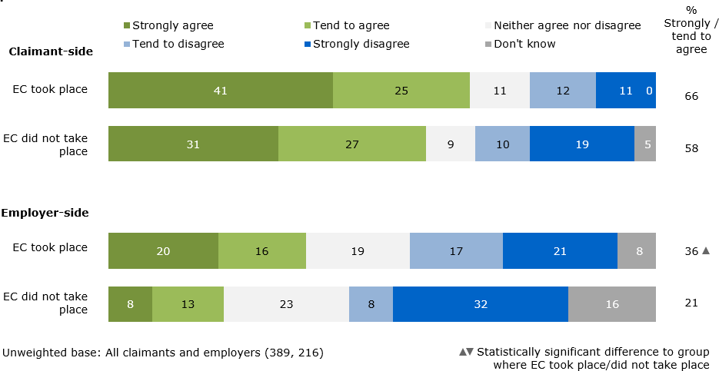

Claimants, employers and representatives appointed before the ET application was submitted were asked whether the initial Acas service had made it quicker to resolve the case once the claim was submitted. Overall, 50 per cent of claimant- side and 28 per cent of employer-side participants agreed that it had. For claimants and employers alone, these figures were 54 per cent and 29 per cent respectively, which compare to 54 and 46 per cent in 2016. However, again, we must take into account the low base size for employers in 2016 when interpreting trend data.

Participation in EC made both claimant and employer-side participants more likely to agree that the service received from Acas before submitting an ET application had made it quicker to resolve the case once the claim had been submitted: 56 per cent and 40 per cent of claimant and employer-side participants who took part in EC respectively reported this to be the case – this dropped to 44 per cent and 19 per cent among those who had not taken part in EC.

### Figure 39. Agreement that service received from Acas before ET application submitted made it quicker to resolve case once the case was submitted

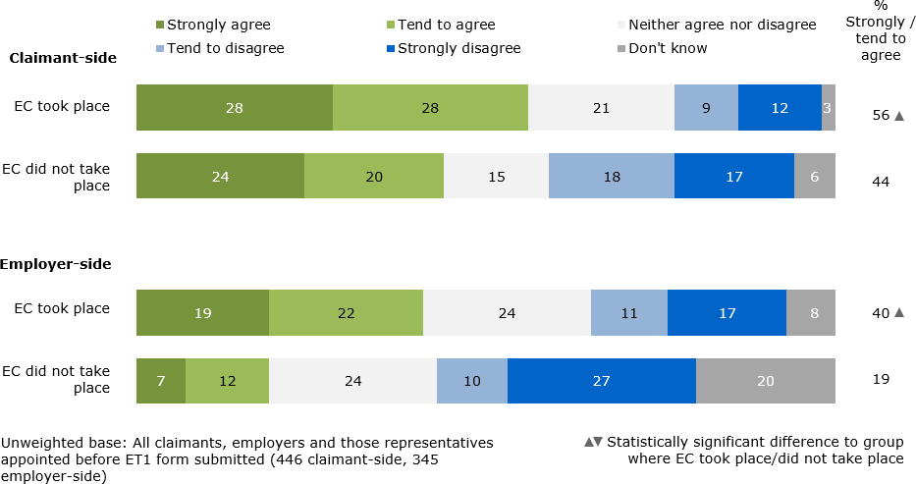

### The use of EC and ET1 conciliation outcomes

As in 2016, it should be acknowledged that regardless of whether EC had taken place for claimant-side participants, their most common outcome at the post-ET1 stage was a settlement (52 per cent). Even so, it is notable that among those claimants who had previously taken part in EC, reports of a settlement at the ET stage rose to 57 per cent, while it fell significantly to 47 per cent among those who had not. On the employer-side, the overall settlement rate was also 52 per cent, increasing to 56 per cent among those where EC had taken place and falling to 49 per cent where it had not.

In contrast with 2016, where prior EC use was associated with a lower rate of withdrawals, there were no significant differences this time. 14 per cent of claimant-side EC participants reported a withdrawal compared to 16 per cent of non-EC participants. On the employer-side these numbers were 7 and 11 per cent respectively. Here we should acknowledge that the sample size of withdrawals is low – 59 on the claimant-side and 43 on the employer-side and therefore care should be taken with comparisons. The number of conciliators involved in the case and presence of the same conciliator pre and post ET submission also had no impact on withdrawals

### Prior use of EC and satisfaction with the post-ET1 conciliation service

Unlike 2016, prior use of EC had no impact on reported satisfaction with the post- ET1 conciliation service across either claimant or employer-side participants. Close to eight in ten (78 per cent) claimant-side participants who took part in EC reported that they were satisfied with the post-ET1 conciliation service received, while a similar proportion (81 per cent) of those who had not taken part said the same. Among employer-side participants, the comparable ratings were 83 per cent and 79 per cent respectively.

However, satisfaction was lower among those who did not retain the same conciliator at the EC and post-ET1 stages (claimant and employer-side participants combined) – two thirds of this group (66 per cent) were satisfied with the post-ET1 conciliation service, significantly lower than those who had continuity of conciliators (82 per cent). Once again we must consider the relatively small base size of those working with different conciliators across phases here (n=52) but the directional story is clear. This suggests a contrast with the experiences of those who worked with multiple conciliators (i.e. in cases where team cover was provided for conciliator absence), who give equally high satisfaction scores as those where only one conciliator is used (8 in 10 satisfaction for each).

## CONSEQUENCES OF POST-ET1 CONCILIATION AND FUTURE ACAS USAGE

### Synopsis:

This final chapter considers some of the longer-term consequences of conciliation, particularly the provision of information to employers and their subsequent implementation of new policies, procedures or working practices. It goes on to examine anticipated future re-use of Acas conciliation services by the parties.

**Key trends at-a-glance**

* As in 2016, the majority of all participants – claimants, employers and both sets of representatives – envisaged that they would make use of Acas conciliation again if they became engaged in another dispute in the future.
* Also consistent with 2016 – and reflecting the fact that it is not a primary aim of conciliation – most employer-side participants reported that they had not received information or advice from their Acas conciliator to help prevent them from encountering another similar case in the future. Perhaps as a result, a relatively low proportion of employer-side participants reported that they had updated or implemented any new procedures as a result of advice from their Acas conciliator.
* However, among a minority of employer-side participants there are signs of lasting change as a consequence of participation in post-ET1 conciliation. For example, among those who were dealing with an ET claim for the first time – which might reflect a desire from employers to protect themselves from future disputes if they have never gone through the process before – and among those who work for organisations with only one site in GB
* The majority of employers who reported receiving information or advice from their Acas conciliator also reported being satisfied with the Acas service.

### Provision of information by the conciliator

Although it is not the primary aim of conciliation – which focuses on resolving the workplace dispute at issue – unrepresented employers were asked whether the Acas conciliator had provided them with any information or advice which they believed would help them avoid having to deal with another case of this type in the future.

Four fifths (79 per cent) reported that they had not received any information or advice of this kind, while two in ten (18 per cent) said that they had. This is consistent with 2016, when 23 per cent reported being given such information and 75 per cent said they had not.

Employers with one workplace in the UK were significantly more likely than those with multiple sites to report that Acas had provided information that would help them avoid having to deal with a similar case again (24 per cent compared to 13 per cent). The same is also true for employers who did not have trade unions or

staff associations present in their workplace (21 per cent compared to four per cent who were members).

### Implementation of new procedures

Employers were also asked whether they had updated or implemented any new policies, procedures or practices as a result of guidance from their Acas conciliator. Two in ten (22 per cent) reported that they had, a figure which did not differ across case tracks and was down slightly from three in ten (27 per cent) in 2016. Those who settled their case (27 per cent) were more likely to say they had implemented new policies than those that had not (18 per cent). It should be noted that the overall 2019 figure (22 per cent) rises to 31 per cent if we restrict analysis to just those employers who actually took part in conciliation at this stage.

As in 2016, employers dealing with an ET claim for the first time were more likely to have implemented new policies, procedures or practices as result of the conciliator’s guidance than was the case for employers with prior experience of responding to an ET claim (27 per cent compared with 16 per cent). This may reflect a heightened desire from employers to protect themselves from future disputes if they have never gone through the process before.

Employers from organisations with only one site in the UK were also significantly more likely to have implemented new policies, procedures or practices as a result of the guidance from the Acas conciliator than was the case for multi-site employers (29 per cent compared to 16 per cent respectively). The same was also true for employers who were not members of trade unions or staff associations (25 per cent compared to eight per cent who were members).

### Future use of Acas conciliation services

All participants were asked whether they would make use of conciliation services from Acas if they were involved in a similar situation in the future.

Eighty-six per cent of claimant-side participants said that they would use Acas conciliation in the future if needed: 69 per cent said they ‘definitely’ would do so and 17 per cent said they ‘probably’ would. Thirteen per cent of claimant-side participants ruled against making future use of Acas conciliation (this group’s cases had mostly not settled). This is consistent with the findings from 2016.

Similarly, nine in ten (88 per cent) employer-side participants said that they would make use of Acas conciliation if they were involved in a similar situation in the future: 63 per cent said they ‘definitely’ would do so and 24 per cent judged that they ‘probably’ would. Just nine per cent of employers said they would not make use of conciliation again, in line with the findings from 2016. (Again, those not settling their dispute were less likely to envisage using conciliation in the future).

On both sides, representatives were even more likely than claimants or employers to anticipate making future use of Acas conciliation. This is consistent with the findings from 2016 and augurs well for the service given that representatives are most likely to find themselves ‘in a similar situation in the future’, given the nature of their role:

* 98 per cent of claimant representatives (80 per cent ‘definitely’ and 17 per cent ‘probably’ would) compared with 78 per cent of claimants (of which 61 per cent ‘definitely’ would and 17 per cent ‘probably’ would);
* 96 per cent of employer representatives (74 per cent ‘definitely’ and 22 per cent ‘probably’ would) compared with 75 per cent of employers (of which 47 per cent ‘definitely’ would and 28 per cent ‘probably’ would).

### Figure 40. Whether participants would make use of conciliation services from Acas if they were involved in a similar situation in future

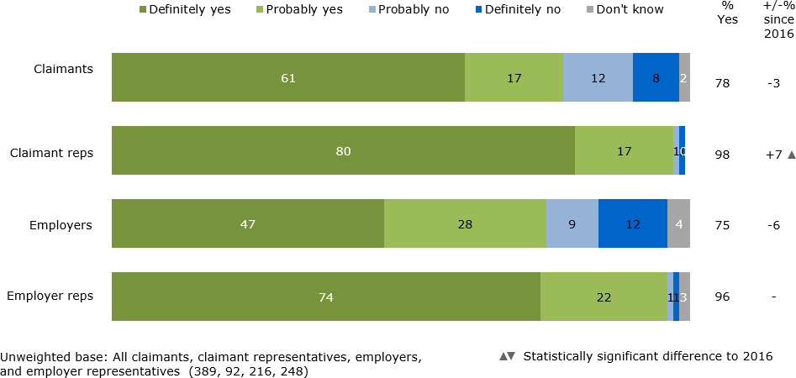

Elsewhere, participants who took part in post-ET1 conciliation were more likely than non-users to envisage that they would make use of Acas conciliation if involved in a similar situation in the future, although agreement was high across both groups:

* 90 per cent of claimants who took part in post-ET1 conciliation compared with 81 per cent of claimants who did not;
* 94 per cent of employers who took part compared with 80 per cent of employers who did not.

Those involved in cases that reached a settlement were also more likely to anticipate using conciliation services from Acas again in the future, compared with those who were party to cases that did not settle:

* 94 per cent of claimant-side participants who reached a settlement compared with 76 per cent of those who did not;
* 93 per cent of employer-side participants who reached a settlement compared with 79 per cent of those who did not.

In line with the findings from 2016, this implies that participants who have a positive experience of the conciliation process are most likely to make use of Acas again in the future, should the need arise.

Among employer-side participants, those who had previously had an ET claim made against them were significantly more likely to report that they would make use of Acas conciliation in the future (86 per cent compared with 67 per cent with no prior experience of responding to an ET claim). Additionally, employer-side participants who worked for an organisation with an HR department were significantly more likely to anticipate using Acas conciliation again (92 per cent, compared with 83

per cent for those without an HR department). Despite these small differences, both figures show a high level of intended reuse.

As in 2016, employer-side participants involved in open track cases were significantly more likely to say that they would make use of Acas conciliation in the future than were those in fast track cases (93 per cent compared with 80 per cent). Additionally, this year, those involved in standard track cases were also significantly more likely to want to use Acas conciliation again in the future comparted to party to fast track cases (89 per cent compared to 80 per cent).

In contrast to the findings from the 2016 survey, there were no differences among employer-side participants when comparing those who had previously taken part in EC with those who had not – in 2019, this factor had no bearing on anticipated future use of Acas conciliation services. This relationship was also absent among claimants, as it had been in 2016.

Although there were no differences in respect of dispute track at the overall level, claimants who were party to fast track cases were significantly more likely to report that they would ‘definitely’ make use of Acas conciliation services in the future, compared to claimants in open or standard track cases (75 per cent compared to 60 per cent and 70 per cent respectively).

Among employers the picture from 2016 was reversed: this time, employers in fast track cases were less likely to say they would use Acas conciliation again – 80 per cent said this was the case, compared with 89 per cent of employers in standard track cases and 93 per cent of those in open track cases.

## ACAS INDIVIDUAL CONCILIATION 2019 – CONCLUSIONS ACROSS BOTH EVALUATIONS

When seeking to draw conclusions across both evaluations, the first thing that stands out is the consistency of findings compared with their previous waves in 2015 and 2016. Despite significant change to the legal and policy background, the findings show a consistent user profile and similar key metrics, such as the rate of settlements achieved through conciliation. Similarly, the Acas service continues to achieve high satisfaction ratings across EC and post-ET1 conciliation for all audiences – claimants, employers and representatives of each. More broadly, participants in conciliation recognise the important role Acas plays in bringing the two sides of a dispute together, regardless of whether a settlement is reached, and are highly likely to use the service again in the future should the need arise.

This short chapter seeks to expand on some of these points and offer some learnings for Acas to consider as the service evolves in the future.

Before assessing the service provided by Acas and its role in delivering settlements in more detail, it is important to acknowledge that whilst the demographic and firmographic profile of claimants and employers involved in disputes is largely unchanged from past waves, **the proportion of claimants and employers using representatives in disputes has changed markedly**. For example, in post-ET1 conciliation the proportion of claimants and employers using representation has fallen sharply, though it remains much larger than at the EC stage. A key factor behind this appears to be an increase in the proportion of fast track cases reaching this stage compared with 2016 (when ET fees were in force); as parties in fast track cases are less likely to use representatives. Such evolutions in the Acas service user base should be considered carefully when planning future service provision, as the motivations and needs of different audiences are not always aligned, and their perception of the service provided is not always the same. Put simply, the needs and expectations of representatives can sometimes differ from unrepresented claimants and employers and this should be factored into the conciliator approach.

Nuances in needs and perceptions also exist within audience too. For example, claimant representatives are generally less experienced in dealing with disputes than those representing employers; the former are more likely than the latter to be family members or friends rather than professionals and so they may sometimes require more support from conciliators. Meanwhile, within the unrepresented claimant universe, BAME survey participants are more likely to say they were involved in more challenging open track cases than those from White backgrounds. While there can be no ‘one size fits all’ approach to planning service provision for different audiences within the user base, it is useful to be aware of some of the complexity involved, which is outlined in further detail in the above report.

Turning to the service provided by Acas, **both evaluations continue to show a positive relationship between participation in Acas conciliation services and achieving a settlement**. There is a correlation between the stages of conciliation, with those reaching the ET phase more likely to take part in post-ET1 conciliation if they have previously taken part in EC, even though a settlement was not reached at that earlier point. These positive relationships highlight the

importance of encouraging claimants, employers and representatives into conciliation as early as possible in the process.

Service users’ motivations are another important aspect to resolving disputes: typically, representatives appear more open to settling a dispute than claimants and employers. They are more likely to enter EC with negotiation, rather than solely reaching tribunal, as an explicit aim and more likely to reach a settlement at the post-ET1 stage. Motivations also vary by track, with claimant-side participants in fast and standard cases more likely to submit the EC notification form to see if a settlement can be reached, without any intention of proceeding to a tribunal, than those in open track cases. Therefore, the details of the case and motivations of participants at the outset can play a significant role in the outcome and should be noted by conciliators early on.

However, there is consistent evidence across both surveys (now and in 2015/6) that **the service provided by Acas has a significant role to play in driving positive outcomes**. In addition to the fact that participation in EC or post-ET1 conciliation can lead to settlements, regression analysis at both the EC and post- ET1 stages highlight that agreeing ‘Acas involvement was important in helping move parties closer towards resolving the case’ is a key driver of settlements among claimants and employers. Other important parts of the service include: the quality of information provided at the EC form submission stage, which is a key driver of settlements among claimants at EC; and conciliator availability, which is important for employers at both the EC and ET stage. More explicitly, at the EC stage around eight in ten of those settling agreed that Acas’ involvement was a factor in the decision to resolve the case (one in ten disagreed), while in post-ET1 conciliation half agreed (one in three disagreed).

Of course, there are barriers to achieving a settlement that are not always within Acas’ control. Across both surveys, the lack of a willingness of the other side to negotiate is often cited as a key reason a settlement did not take place whilst the employer-side commonly indicates a lack of a willingness to settle because they believe they did nothing wrong.

The evaluations reconfirm that **the service provided by Acas has an important role in preventing employment disputes from developing further**. They also paint a positive picture of service satisfaction among all audiences. At both EC and post-ET1 stages and across all audiences, eight in ten service users are satisfied with the service provided. This figure is a slight decline for employers compared with previous waves of research (down six points at EC and five points at post-ET1) but it remains the case that service satisfaction is high. The full report details how these satisfaction scores vary by subgroup.

There are three priorities when considering how service evaluation scores can be secured and improved: to maintain and prioritise those areas that drive high satisfaction scores, to address audiences where satisfaction scores are weaker, and to tailor the service to different audience needs where appropriate to do so.

Before exploring these priorities in greater detail, it is important to note that satisfaction with the service is directly affected by the outcome of the case: those settling their case at EC and post-ET1 tend to be more satisfied with the service provided than those who do not. One reading of this relationship is that focusing solely on settling cases would increase service satisfaction scores further – however the data reveals this is a circular relationship, where the service provided by Acas can influence the outcome. Therefore, the steps Acas can take in improving the

service it provides will help drive positive outcomes, which in turn frame how some participants view the service they received.

The EC evaluation highlights some priorities: among claimants, a key driver of satisfaction is agreement that ‘the information provided by Acas at the EC form submission stage helped claimants understand how the EC process worked’39. Similarly, claimants who agreed that EC sounded suitable to their case when they discussed it with the ECSO were also more likely to give higher satisfaction scores. For employers, the availability of conciliators and method of contact (telephone) drive positive satisfaction scores. These findings show that for claimants providing clear information at the early stages of conciliation is among the most important steps to take,40 while for employers ensuring conciliators are available when they are needed throughout the process is key.

Agreement that ‘Acas involvement was important in helping move parties closer towards resolving the case’ was also a key driver of satisfaction with the service for both audiences. This means that although specific elements of the service and how it is delivered matter, the skill of the conciliator in bringing the two sides together during the conciliation process itself (and be seen to do so) is also highly important.

### Early Conciliation

Across EC, a pattern of strongly positive findings emerges. Among both the claimant and employer-side clear majorities agree that the conciliators were available when needed, were even-handed and offered the right level of contact. Claimant and employer-side participants in conciliation are also much more likely to rate the conciliator as ‘good’ rather than ‘poor’ on a host of service attributes. An exception was seen over the extent to which service users felt that their conciliator ‘explained the employment law as it applied to my problem’, where the proportion saying ‘good’ fell significantly – however this finding is not repeated at post-ET1, nor is it a key driver of EC outcome or satisfaction with the service. Therefore, it does not appear to be a great cause for concern other than to make sure this happens where appropriate.

Another key trend observed is **the growth in importance of email as a method of communication**. Both claimant and employer-side participants are more likely to recall using it as their main means of communicating with conciliators, which is a change from previous evaluations. Yet at the same time, telephone is still the main method used in most cases. Regression analysis suggests that there is a relationship between use of email and an increased likelihood of reaching a settlement among employers – yet the relationship is weaker than others and the correlation may be influenced by other factors that also influence the use of email. This should also be balanced with the fact that for employers, phone contact is most strongly associated with higher service satisfaction. These findings reflect the fact that communication with service users needs to be tailored to individual circumstances: majorities of all audiences (claimants, employers and representatives) use both telephone and email at different points in the process, so improving service satisfaction will be about ensuring they are used at the right time and the right amount.

There are some key differences between service user types that suggest ways the service could be tailored. Representatives are more likely that others to use email as their main method of communication – this is particularly true among employer representatives, perhaps reflecting that they are more likely than claimant representatives to be legal or trade union professionals. Unrepresented claimants,

especially those in open track cases, are the most likely to say they would have wanted more contact from the conciliators – although clear majorities of all groups were happy with the level of contact. These points reinforce that, although the overall service is generally very well-received, the exact nature and frequency of communication could be tailored further to individual circumstances.

Another important aspect of the data from these evaluations covers **the use of multiple conciliators** as this is a key area of development for the service. At the time of the surveys, team-based conciliation pilots had not begun, so sample sizes are small – 92 claimant-side users and 96 employer-side users. The data suggests that these multiple conciliator users experienced a less satisfactory service. For example, across both audiences this group were less satisfied with the timeliness of communication received, more likely to want more communication from conciliators and more likely to say that they had to initiate contact with Acas most of the time than those in contact with only one conciliator. Satisfaction overall was weaker among employer-side participants dealing with more than one conciliator compared with those dealing with just one, although this relationship was not observed for claimants. It is important to note too that satisfaction is high among both single and multiple conciliator users.

It is important to note that those dealing with multiple conciliators in the survey did so for uncontrolled and unexpected reasons such as cover for staff absence, so these findings cannot provide a definitive answer for the likely impact of any future changes in Acas’ service model.41 However they do show the importance of clearly setting user expectations for service delivery at the outset of any new system and in tailoring the service to individual needs where possible.

The survey also shows similar user experiences of the service between claimants from different ethnic backgrounds. The small base size of claimants from Black, Asian and minority ethnic (BAME) backgrounds means the scope of this analysis is limited; but the data shows no significant differences between this group and claimants from White ethnic backgrounds on key metrics including even- handedness of the conciliator, satisfaction with the service overall and likelihood to use Conciliation again. There is however a difference between these groups on case type – BAME participants are more likely than those from White ethnic backgrounds to be part of more complicated ‘open track’ disputes.

### Post-ET1 conciliation

In the post-ET stage too, many of the themes above are also observed. **Overall satisfaction among those taking part in conciliation at this stage is high** (eight in ten) and those participating in conciliation rate Acas conciliators positively across a range of personal attributes. Clear majorities rate conciliators as even- handed, available when needed and say they offered the appropriate amount of communication. Echoing the EC experience, claimants were more likely than representatives and employers to say they wanted more communication with conciliators (around four in ten), although this did not differ by case track. Finally, there are also signs at the post-ET1 stage that those dealing with more than one conciliator experience a slightly inferior service than those in touch with just one, although here there were no differences in overall satisfaction between single and multiple conciliator users.

Another finding similar to the EC survey is the fact that there are no significant differences in claimant experience by ethnicity. However, this finding should be interpreted carefully as the base size of claimants from BAME backgrounds is less

than 100 overall, and smaller still when filtering to only those who took part in post-ET conciliation.

The post-ET1 results also highlight two additional areas of consideration – the role of prior EC in post-ET1 conciliation and the positive impact of using the same conciliator across both stages of conciliation. **Those moving to the post-ET1 phase who had previously taken part in EC were more likely to choose to participate in post-ET1 conciliation and to then go on to settle their dispute**, although their levels of satisfaction with the service were the same as other groups. While this may partially reflect the motivations of the participant (such as being more open to a settlement), it is also encouraging that those in the post-ET1 stage of their dispute remain willing to try conciliation again, even where it did not result in a settlement at EC. The evaluation also shows the positive effect of continuity in conciliators, with **users who recalled using the same person at the EC and post-ET1 stages showing higher levels of satisfaction across several measures** than those who used different conciliators at each stage. Although the base size for those using different conciliators at each stage is small42, this does suggest that conciliators establishing a rapport with service users over time can lead to a better user experience.

A consistent message from the research, across both the EC and ET phases, is that use of conciliation services can lead to better outcomes. Whilst the decision to accept or reject conciliation can be driven by the personal motivations of those involved or the perceived motivations of the other side, driver analysis shows that there are steps Acas can take to encourage acceptance. At the EC stage, claimants who agreed that the EC notification form provided information that was helpful in understanding the process were more likely to accept the offer of EC. At the post- ET1 stage, there was a positive relationship between those receiving a warm-up letter from Acas and using conciliation. In both cases, this highlights that the quality of Acas contact at the outset of a case can have an effect on the decision to take part in conciliation and therefore the eventual outcome.

Looking across both phases of the research we can draw two broad conclusions. The first is that **the quality of early contact between Acas and potential service users is vital in helping to drive uptake of the service** and in forging strong relationships between the conciliator and user that can lead to a positive service experience. The second is that there is no ‘one size fits all’ when it comes to service delivery. The user base is diverse and different levels and methods of communication are preferred within it – for instance, as in EC email is growing in importance as a communications channel, but representatives more likely to use it than others.

This highlights the importance of offering a personalised service where possible, as well as setting clear expectations at an early stage around how the participant- conciliator relationship will work, especially in terms of frequency and method of contact. The data also suggests that using one conciliator, within EC and post-ET1 conciliation and across both phases, leads to a better user experience – the insight from this is that the rapport and relationship building is key, a factor which could be usefully employed in single and multiple-conciliator service models

**In conclusion, these results offer a strongly positive picture of the Acas individual conciliation service user experience**. Satisfaction levels are high, the frequency, nature and quality of contact are well-received and Acas can demonstrate a clear role in helping to drive positive case outcomes. There are also signs in this report that some employers are changing their working practices and

procedures as a result of involvement with Acas, pointing to further and lasting impacts from conciliation – although this is the case only for a minority, meaning there is scope to do more in this area. High levels of satisfaction require continued effort to be maintained, and the surveys outline key areas for consideration as Acas looks to continue – and build on – their continued positive results.

## ENDNOTES

1 It is important to note that participants may not recall correctly if they took part in post-ET1 conciliation. There are examples in the survey data of participants who reported not taking part in post-ET1 but nevertheless reported reaching a settlement. This may suggest that the reported level of contact and engagement with Acas is an underestimate

2 Early Conciliation may also be initiated by employers who think that someone might make a tribunal

claim against them – although in nearly all cases it is the employee (claimant) who makes first contact. Employer-instigated EC accounts for <5% of all EC cases and falls beyond the immediate scope of this evaluation

3 This information could be missing if the claimant participant: engages or disengages with their representative at any point prior to, throughout or after EC, failed (or chose not) to divulge the fact that they are represented, sought a direct dialogue with Acas in spite of being represented or confused having received specific legal advice with being represented.

4 This balance reflects a change in the composition of cases overall, as well as the impact of sample cleaning and the removal of ineligible cases – for more information see the technical note

5 160 (of 704) claimants gave an ethnicity other than White. While this is a reasonable base size, the requirements for statistical significance are high as the overall base size against which we are comparing is also reasonably small.

6 In 2019, the EC notification form was redesigned to reduce inappropriate notifications and give users

a better understanding of the EC service at the point of notifying. However, the sample for this survey was drawn before this reform and therefore everyone surveyed had used the old version of the notification form.

7 All those surveyed used the old version of the notification form, which has since been redesigned

8 This deadline can be extended if Early Conciliation takes place. Additionally, in equal pay cases and cases of failure to pay statutory redundancy payments, the deadline is six months less one day. However, the detailed jurisdictional breakdown is not collected in the survey, nor recorded in the Acas management information used to sample the survey, so analysis cannot be conducted at this level.

9 EC cases that were recorded on Acas management information systems as being employer-initiated were excluded from the sample, in recognition of their low incidence and atypical character.

10 Acas’ Management Information reports provide the definitive figures for EC take up: deviation from this in the survey is likely due to claimants who accepted and then withdrew from EC and, in responding to the survey, perceived that their limited engagement with the process constituted non- use/ ‘rejection’.

11 At the point of fieldwork, Acas had not begun its team-based conciliation pilots, meaning that those with multiple conciliators were likely due to circumstances such as cover for staff absence. The survey wording for this section was amended for those with multiple conciliators to ask about experience with “conciliators” rather than “the conciliator”

12 It should be noted that some participants might count the ECSO as a conciliator, meaning that this may be an overestimate of the proportion who spoke to multiple conciliators.

13 It should be noted here that reps are more likely to use written communication than claimants or employers are therefore the increase in the proportion of reps in the sample this year may be a factor in this increase. See Introduction for more information on sample composition comparisons between 2015 and 2019.

14 Note that some participants may be counting COT3 settlement letters when thinking about written communication.

15 It is important to bear in mind that since most representatives have a legal background, rather than signalling an oversight by the conciliator, this may simply reflect the fact that not all actions are warranted in all cases.

16 The survey wording was amended for those with multiple conciliators to ask about experience with “conciliators” rather than “the conciliator”. Even so, it is possible that participants interpreted the question as referring to their main/allocated conciliator.

17 Claimant-side participants and employer representatives were asked “How much of your time in total did you spend on the workplace problem from the time you submitted your notification up until you received official notification that conciliation had finished?”, while employers were asked “how much time in total did you / directors and senior management / other staff spend on this case?” and answers for each of these options were aggregated to reach a total figure.

18 Acas outcome data for 2018-19 showed that 13 per cent of EC cases resulted in a COT3 settlement, 64 per cent did not (but neither did they progress to Tribunal), and 24 per cent progressed to Tribunal

[https://www.acas.org.uk/media/6267/Acas-Annual-Report-2018---](https://www.acas.org.uk/media/6267/Acas-Annual-Report-2018---2019/pdf/CCS001_CCS0419948884-001_ACAS_ARA_2018-19_Accessible_v2.pdf) [2019/pdf/CCS001_CCS0419948884-001_ACAS_ARA_2018-19_Accessible_v2.pdf](https://www.acas.org.uk/media/6267/Acas-Annual-Report-2018---2019/pdf/CCS001_CCS0419948884-001_ACAS_ARA_2018-19_Accessible_v2.pdf)

19 A full breakdown of case outcomes as reported by claimant-side and employer-side users in the survey are shown in the technical report

20 A binary logistic regression analysis was used: this is a technique which examines the relationships between a ‘dependent’ variable (in this case, whether the EC case was resolved successfully through a settlement) with multiple ‘independent’ variables (factors which might influence the dependent variable, such as the track of a claimant’s dispute) to identify the most influential factors. Further detail is available in the technical appendices.

21 For the EC survey, the claimant-side and employer-side samples used different selection rules to exclude cases the where claimants may have been in contact with Acas but ultimately decided not to proceed with the case (and therefore employers would never have known of their initial intention to bring one). As a result, rates of settlement differ between claimant and employer samples.

22 A binary logistic regression analysis was used: this is a technique which examines the relationships between a ‘dependent’ variable (in this case, whether the EC case was resolved successfully through a settlement) with multiple ‘independent’ variables (factors which might influence the dependent variable, such as the track of a claimant’s dispute) to identify the most influential factors. Further detail is available in the technical appendices.

23 N.B. This outcome is taken from data in the Acas Management Information (MI) system. In a small minority of cases, the outcome recorded in the survey differed to that recorded by Acas (questions were asked in the survey to collect this). The analysis in this section uses a combination of MI outcome categories and survey data to reach conclusions.

24 The base size for employer demographics in 2016 was 99.

25 Note that some solicitors/barristers are instructed by a Trade Union or be Trade Union appointed, so this may be an underestimate of Trade Union representation per se.

26 77 (of 389) claimants gave an ethnicity other than White. These small base sizes mean that there is a high level of uncertainty that any differences exist in the wider population, and caution should be taken ascribing meaning to statistical significance found.

27 N.B. When considering these results, it should be noted that an Acas conciliator cannot attempt

contact with either party until the ET1 – which the claimant submits to the employment tribunal – has been copied to Acas.

28256 claimants and 151 claimant representatives.

29 N.B. base sizes here are low (61 fast track, 48 open track and 66 standard track)

30 We should acknowledge here that this is just what survey participants reported. It may well be that contact was attempted by Acas but the survey participant was unaware of this contact for some reason e.g. wrong number or missed call.

31 It is important to note that participants may not recall correctly if they took part in post-ET1 conciliation. There are examples in the survey data of participants who reported not taking part in post-ET1 but nevertheless reported reaching a settlement. This may suggest that the reported level of contact and engagement with Acas is an underestimate.

32 The questions in the EC survey asked participants why they had decided not to use Acas conciliation, while these questions asked why participants had not taken part; a subtle distinction which should be borne in mind when making comparisons between results

33 A binary logistic regression analysis was used: this is a technique which examines the relationships between a ‘dependent’ variable (in this case, whether someone takes part in conciliation) with multiple ‘independent’ variables (factors which might influence the dependent variable, such as the track of a claimant’s dispute) to identify the most influential factors. Further detail is available in the technical appendices.

34 It should also be noted that, where a case has already gone through EC, the same Acas conciliator will (in most cases) be assigned to the post-ET1 case, and therefore will already be known to both parties. This may influence ratings given by participants during the ET survey.

35 The survey wording for this section was amended for those with multiple conciliators to ask about experience with “conciliators” rather than “the conciliator”

36 Acas outcome data for 2018-2019 showed that 22 per cent of post-ET1 conciliation cases had been settled and a COT3 issued, 9 per cent had proceeded to Employment Tribunal and 7 per cent had been withdrawn. The majority (62 per cent) remained in progress at the time of reporting. [https://archive.acas.org.uk/media/6205/Individual-Conciliation-Update-April-2018---December-](https://archive.acas.org.uk/media/6205/Individual-Conciliation-Update-April-2018---December-2018/pdf/Individual_Conciliation_Update_-_2018-19_Q3.pdf) [2018/pdf/Individual_Conciliation_Update_-_2018-19_Q3.pdf](https://archive.acas.org.uk/media/6205/Individual-Conciliation-Update-April-2018---December-2018/pdf/Individual_Conciliation_Update_-_2018-19_Q3.pdf)

37 A binary logistic regression analysis was used: this is a technique which examines the relationships between a ‘dependent’ variable (in this case, whether the conciliation case was resolved successfully through a settlement) with multiple ‘independent’ variables (factors which might influence the dependent variable, such as the track of a claimant’s dispute) to identify the most influential factors. Further detail is available in the technical appendices.

38 The number of survey respondents in this scenario is small: 68 claimant-side and 30 employer-side

39 Since the 2019 survey, Acas has launched a new EC notification form that puts greater emphasis on explaining the EC process with a more user-centred design. The data in this report suggests that this is an important and worthwhile exercise.

40 It should be noted that other factors drive claimant satisfaction too such as agreement that “Acas involvement was important in helping move parties closer towards resolving the case” and “Acas involvement was important in helping me to decide on how to proceed with this dispute” but the importance of the early stages of the process here are clear.

41 Acas began piloting team-based conciliation for fast track cases after these surveys took place.

42 52 survey participants across all claimant, employer and rep groups that took part in conciliation at the ET stage recalled using a different conciliator than at the EC stage.