Acas collective conciliation evaluation 2023
Technical report

Authors: Joe Killick, Bernard Steen (NatCen social research)

Overview
The research involved 3 main elements:
- A Theory of Change was developed for the collective conciliation service. This was used to inform the survey design, the qualitative interviews, and the analysis.
- A survey of 241 collective conciliation customers.
- Qualitative interviews with 26 collective conciliation customers.
This document provides detail on each of these elements.

Theory of Change
A Theory of Change was developed for the collective conciliation service, shown in the figure below. A Theory of Change sets out how a service is expected to bring about its intended short and medium-term outcomes, and its intended longer-term impacts. It does this by spelling out each step in the causal process, alongside the assumptions that have to hold for one step to lead to the next. By designing the data collection and analysis around the Theory of Change, we are able to determine the extent to which it accurately describes a real causal process. This enables more robust conclusions about the extent to which the collective conciliation service is achieving its aims.
The Theory of Change was developed in collaboration between NatCen and Acas. This process involved a workshop with a broad range of stakeholders at Acas.
The Theory of Change makes the following key assumptions:
Short-term outcome:
- for any industrial action to be paused, we assume industrial action was likely
Medium-term outcomes:
- for employees to secure better working conditions, higher salaries, and so on, as per the terms of settlement, we assume that settlement terms are honoured
- for the workforce to become more equanimous, better engaged and better performing, we assume that they are aware of, understand and approve of the settlement terms
- for the relationship between the parties to be 'reset', we assume that the service helped to address these relations, rather than just solving an immediate deadlock
Impacts:
- for employers and employees to be saved from the financial costs of collective conflict, we assume that avoiding conflict leads to lower financial costs
- for employers and employees to be saved from the emotional and social costs of collective conflict, we assume that emotional costs were real for all those involved
- for a positive economic impact to be produced, we assume that avoiding conflict is net positive to the Exchequer in the long run
- for organisations to enjoy better employment relations on an ongoing basis, we assume that the service restored employment relations sustainably, rather than just producing a short-term fix
- for greater appetite to use Acas services in future to be produced, we assume that the parties' subjective assessments of Acas were positive
Figure 1: Theory of Change
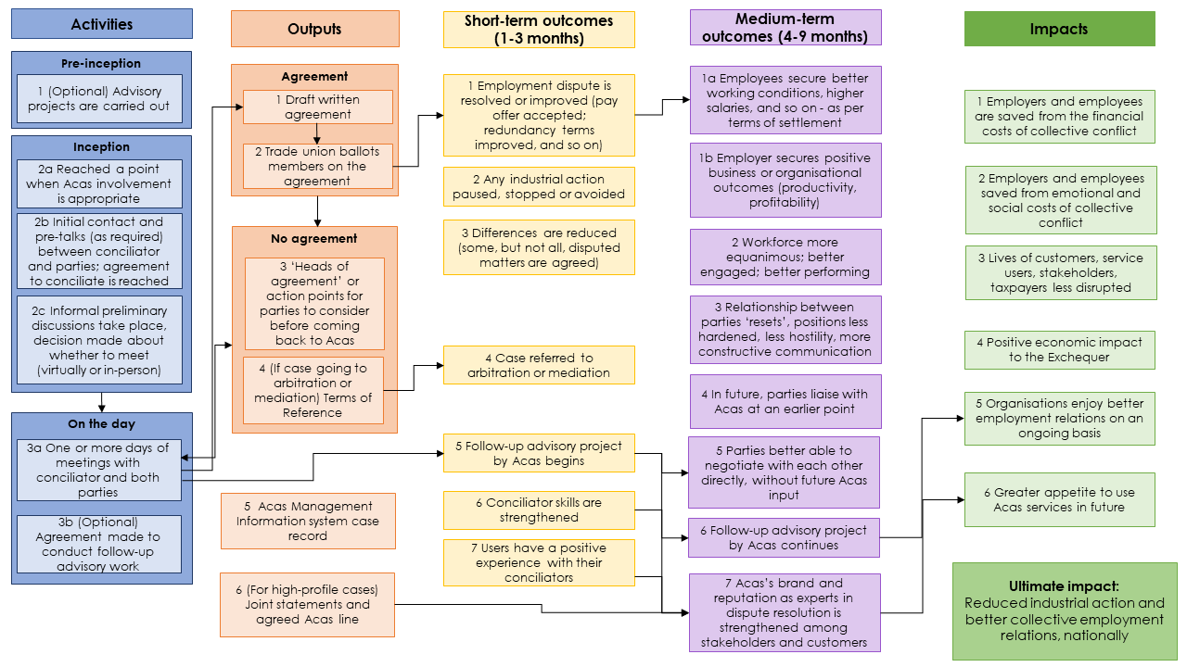
A full text description of the Theory of Change is available in the Appendix.

Quantitative research
A survey was conducted with collective conciliation customers, where they were invited to reflect on their most recent dispute involving Acas, including the nature of the dispute, the reason they involved Acas, how the dispute unfolded, the outcome, and their views on the process, among other topics. The survey largely replicated the questionnaire used in the 2016 evaluation, but did include some changes.
  - Development work
Updates to the 2016 questionnaire were informed by the Theory of Change. The research team identified key areas of the Theory of Change that were not covered by the questionnaire and developed new questions accordingly.
Cognitive interviews were conducted with 6 collective conciliation customers to test new survey questions, and to test the advance email. Following the cognitive interviews, minor adjustments were made to both the questionnaire and the advance email.
  - Sample
In order to generate the sample, Acas extracted records of all collective conciliation cases that were recorded on its management inform systems as having been closed between 1 April 2022 and 9 September 2023, liaising with conciliators to clean case records and fill in blank contact information. Cases were deemed ineligible for the survey and were removed from the sample at this point if the conciliator confirmed that:
- Circumstances surrounding the case were especially sensitive, for example the parties were back in a live dispute, or;
- The case did not involve joint meetings or substantive discussions with both sides e.g. some group employment tribunal cases may fall short of this definition.
The resulting file provided to NatCen comprised 516 in-scope disputes, with each dispute involving at least two parties. After cleaning by NatCen, the final sample comprised 730 unique customers, encompassing both employers and employee representatives. Some customers appeared against multiple different disputes in the sample, but each customer was only interviewed once. In order to determine which dispute to interview repeat users about, NatCen implemented the following rule:
- Disputes with a higher 'case status' were prioritised over lower ones. The priority order is as follows (with the first being the highest level of priority): Interview completed about that dispute with the other party, appointment booked for interview with the other party, no contact made with the other party, and the other party will not be interviewed. This meant that if one party was interviewed about one dispute, the other party was shown the same dispute.
- Where 'case status' values are equal, the most recent dispute was prioritised.
An advance email was sent by NatCen on 16 November 2023 to all 730 unique customers, inviting them to take part in the survey.
  - Fieldwork and response
Fieldwork was initially conducted by telephone only, to match the approach taken in the 2016 evaluation. Telephone fieldwork began on 22 November 2023. However, the initial rate of response was lower than expected, and some participants asked whether they could complete the survey online instead. As a result, the research team decided to add an online option. Small changes were made to some survey questions to ensure that the questions worked online as well as by phone. A summary of participant communication and survey milestones is presented in Table 1 below.
Table 1: Participant communication and survey milestones
Date | Milestone | Survey mode
16 Nov 2023 | Initial invitation – Advance email sent by NatCen | Telephone
22 Nov 2023 | Start of telephone fieldwork | Telephone
07 Dec 2023 | First reminder – Emails and SMS messages sent by NatCen  Online survey option added | Mixed – telephone and online
14 Dec 2023 | Second reminder (mentioning online option) – Emails and SMS messages sent by NatCen | Mixed – telephone and online
11 Jan 2024 | Third reminder – Emails sent by Acas; SMS messages sent by NatCen | Mixed – telephone and online
01 Feb 2024 | Final reminder (mentioning charitable donation) – Emails sent by Acas; SMS messages sent by NatCen; paper letters sent by NatCen | Mixed – telephone and online
09 Feb 2024 | Close of fieldwork | Mixed – telephone and online
Fieldwork closed on 9 February 2024. As shown in Table 2, of the 730 customers invited to take part in the survey, 241 responded, giving a response rate of 33%.
Table 2: Survey response
 | Employers | Employee representatives | Total
Total issued cases | 410 | 320 | 730
Telephone completion | 54 | 48 | 102
Online completion | 69 | 70 | 139
Total completed interviews | 123 | 118 | 241
Response rate | 30% | 37% | 33%
There were three main reasons for non-response. The most common reason was simply being unable to make contact with the customer, despite multiple emails, texts and phone calls: this accounts for 279 of the 489 non-respondents. The second most common reason was that no phone number was available for the customer, or the phone number was incorrect, and we were not given the correct details by the person we spoke to: this accounts for 143 of the non-respondents. The third most common reason was customers stating that they did not want to take part: this accounts for just 65 of the non-respondents.
If we remove those for whom there was no phone number available, or the phone number was incorrect and we were not given the correct details by the person we spoke to, the adjusted response rate is 41%.
Note that participants were not offered a direct financial incentive to take part. However, for the last two weeks of fieldwork, to boost response, a £10 donation to Cancer Research UK was offered for each participant that completed the survey. This was communicated via an email to all customers in the sample and via physical letters to those who had not yet completed the survey and for whom we had a postal address on file. As a result, £2,410 was donated to Cancer Research UK.
  - Weighting
Responses were weighted to ensure that employers and employee representatives were given equal weight in the analysis. Some survey questions asked for factual information about disputes, rather asking about the views of the customer. For these questions, a separate weight was used to account for the fact that some customers were interviewed about the same dispute, that means in some cases both an employer and an employee representative were interviewed about the same dispute.
  - Analysis
Most of the quantitative analysis was descriptive. Only differences between groups that were statistically significant at the 95% level were reported, although differences that were significant at a lower level but fit into a broader set of findings were noted.
In some instances, simple regressions were run to check that differences between groups were not explained by an obvious confounder. Where this is the case, it is noted in the text.
The 2016 data was appended to the 2023 data to enable comparisons between the two years. Again, only differences that were statistically significant at the 95% level were reported.

Qualitative research
After having completed the survey questionnaire, customers were invited to take part in further qualitative research. It was initially intended that interviews and focus groups would take place. Interviews were intended to draw out detailed insights and probe around specific disputes. Focus groups with employee representatives were also planned, as it was hoped that they would facilitate discussion and reflection on issues and themes that cut across disputes. However, the focus groups were unable to take place as a low number of customers who responded to the survey opted in for the qualitative research and for those who did it was not possible to find suitable dates and times. Additional interviews were therefore undertaken instead.
  - Recruitment
Twenty-six customers were recruited, comprising 14 employers and 12 employee representatives. Customers were selected to ensure a range of sectors, organisation sizes, prior experience with the collective conciliation service, and different levels of satisfaction with the service. No financial incentive was offered to encourage response. Tables 3a to 3d show the achieved sample.
Table 3a: Qualitative interviews – Prior experience of collective conciliation
Prior experience of collective conciliation | Employers | Employee representatives | Total
First time user | 3 | 3 | 6
Repeat user | 11 | 9 | 20
Table 3b: Qualitative interviews – Sector
Sector | Employers | Employee representatives | Total
Private | 10 | 7 | 17
Public | 3 | 5 | 8
Third | 1 | 0 | 1
Table 3c: Qualitative interviews – Organisation size
Organisation size | Employers | Employee representatives | Total
1 to 249 | 4 | 4 | 8
250 to 1999 | 7 | 4 | 11
2000+ | 3 | 3 | 6

Table 3d: Qualitative interviews – Satisfaction with the service
Satisfaction with the service | Employers | Employee representatives | Total
Low | 3 | 2 | 5
Medium | 5 | 3 | 8
High | 6 | 7 | 13

  - Fieldwork
Qualitative interviews were conducted online or by telephone. The interviews were guided by topic guides that were developed in advance of fieldwork. The guides were structured around the customer journey and were informed by the Theory of Change. Despite the interviews being guided by this document, interviewers let conversations flow naturally and were also guided by the participants.
  - Analysis
A framework approach to qualitative data management was used to facilitate case-and-theme-based analysis of the transcribed in-depth interviews. This involved developing an analytical framework as a basis for organising summarised data from interviews into a series of matrices. The broad structure for the analytical framework reflected the overall customer journey, with a separate matrix for each step. Our analytical approach allowed us to build a picture of the service across the steps of the customer journey and explore the interaction between different steps, for example how features of service delivery are perceived to affect impacts.
For the Acas collective conciliation survey questionnaire and interview topic guides, email: research@acas.org.uk

Appendix: Text description of the Theory of Change
The Theory of Change model shows the various activities that lead to outputs, which in turn lead to short-term outcomes (1 to 3 months), which bring about medium-term outcomes (4 to 9 months), which ultimately cause impacts.
Each element links to all subsequent elements in the causal pathway, except where an arrow indicates a more circumscribed pathway.
There are 6 activities –
One optional pre-inception activity:
- advisory projects are carried out
3 activities at the point of inception:
- reached a point when Acas involvement is appropriate
- initial contact and pre-talks as required, between conciliator and parties – agreement to conciliate is reached
- informal preliminary discussions take place, a decision is made about whether to meet (virtually or in-person)
2 on-the-day activities:
- one or more days of meetings with conciliator and both parties
- agreement made to conduct follow-up advisory work (optional)
These lead to 6 outputs –
2 outputs in the case of agreement:
- draft written agreement (emanating from on-the-day meetings)
- this leads to the trade union balloting members on the agreement
2 outputs in the case of no agreement:
- heads of agreement or action points for parties to consider before coming back to Acas (linking to or from on-the-day meetings)
- Terms of Reference (if the case is going to arbitration or mediation)
2 additional outputs:
- Acas management information system case record
- joint statements and agreed Acas line for high-profile cases
These lead to 7 possible short-term outcomes (1 to 3 months):
- where the trade union balloted on the agreement, the employment dispute may be resolved or improved, for example the pay offer is accepted, redundancy terms are improved
- any industrial action paused, stopped or avoided
- differences are reduced, with some but not all disputed matters agreed
- where Terms of Reference were agreed, the case is referred to arbitration or mediation
- any follow-up advisory project by Acas that was agreed begins
- conciliator skills are strengthened
- users have a positive experience with their conciliators
These lead to 5 medium-term outcomes (4 to 9 months):
- where the dispute was resolved, employees secured better working conditions, for example higher salaries as per terms of the settlement
- the employer secures positive business or organisational outcomes, for example productivity, profitability
- the workforce is more equanimous, better engaged or better performing
- the relationship between parties resets, positions are less hardened, there is less hostility, more constructive communication
- in future, parties liaise with Acas at an earlier point
Plus 2 additional medium-term outcomes where a follow-up advisory project was started:
- parties are better able to negotiate with each other directly, without future Acas input
- follow-up advisory project by Acas continues
Plus 1 further medium-term outcome where joint statements and an agreed Acas line were produced in high-profile cases, or where conciliator skills were previously strengthened:
- Acas's brand or reputation as experts in dispute resolution is strengthened among stakeholders and customers
These lead to 4 impacts:
- employers and employees are saved from the financial costs of collective conflict
- employers or employees are saved from emotional or social costs of collective conflict
- lives of customers, service users, stakeholders or tax payers are less disrupted
- there's a positive economic impact to the Exchequer
Plus 1 further impact where a follow-up advisory project by Acas had previously continued:
- organisations enjoy better employment relations on an ongoing basis
Plus one further impact where Acas's brand or reputation as experts in dispute resolution was previously strengthened among stakeholders and customers:
- greater appetite to use Acas services in future
Plus an ultimate impact for the entire Theory of Change:
- reduced industrial action and better collective employment relations nationally

